**Contents**

**1. START INIT-POS AND LOG IN** **3**

1.1 LOGGING IN WITH AN ADMIN ACCOUNT 3

Every system has both admin side and user side. The admin side is for all the control and operations whereas the user side is the terminal side for performing the functionalities. Start the system from admin side using the respective link provided to you. (example:http://192.168.1.107/posellav5/index.php). Use your credentials when the login screen appears. The login screen is shown below. 3

HQ LOGIN 3

If you directly want to login to the HQ page, select the option ‘HQ’ in first field, use your username and password and login to the HQ page. The HQ’s home page appears like the figure shown below. It has a dashboard, people, utilities, reports and settings in the menu bar. We will discuss the HQ page in detail later. The HQ page which follows is shown below: 4

SHOP LOGIN 5

The next option available for you is the ‘shop’. If you want to login to the shop, click on select option for ‘shop’ as shown in figure below: 5

FIG 1.1.4: SELECT SHOP 6

**2. SETTINGS** **8**

2.1 SETUP 8

2.1.1 AREA 8

2.1.2 SALES DEPARTMENT 13

2.1.3 PRODUCTION DEPARTMENT 16

2.1.4 SHOPS 20

2.1.5 ROUNDING 23

2.1.6 SETTINGS 27

2.1.7 TAX 33

2.1.8 CURRENCY 37

2.1.9 TERMINAL 41

2.1.10 KITCHEN 45

2.1.11 UNIT OF MEASURE(UOM) 49

2.1.12 REASONS 53

2.1.13 STOCK ITEM CATEGORY 57

2.1.14 PROFIT CATEGORY 61

2.2 PRODUCTS 65

2.2.1 ITEM CLASS 65

2.2.2 MENU 71

2.2.3 STOCK AND SALE ITEM 76

2.2.4 COMBO CONTENTS 83

2.2.5 ITEMS CLASS DISPLAY ORDER 89

2.2.6 SALE ITEM DISPLAY ORDER 90

2.2.7 HOT ITEM DISPLAY ORDER 94

2.2.8 CHOICE 95

2.2.9 SALE ITEM CHOICE 99

2.3 STOCK CONTROL 102

2.3.1 STOCK IN AND OUT ITEMS 102

2.3.2 INCOMING STOCK APPROVAL 104

2.3.3 STOCK REQUEST TO SHOP 105

2.3.4 STOCK TRANSFER 107

2.3.5 STOCK RETURN 107

2.4 PROMOTIONS 109

2.4.1 DISCOUNT 109

2.4.2 VOUCHERS 111

2.5 PAYMENT 113

2.5.1 CREDIT CARD 114

2.6 CUSTOMER 117

2.6.1 CUSTOMER TYPE 117

2.6.2 CUSTOMERS 119

2.7 USERS 121

2.7.1 USER GROUP 122

2.7.2 USERS 124

2.8 PEOPLE 126

2.8.1 EMPLOYEE CATEGORY 126

2.8.2 EMPLOYEE 128

2.8.3 SHOP SHIFT 130

**3. REPORTS** **132**

3.1 DAY END REPORT 132

3.2 HOURLY SALES REPORT 134

3.3 DAILY SALES REPORT 135

3.4 SALES REPORT BY GROUPS 136

3.5 TAX REPORT 137

3.6 ORDERS 138

3.7 DAILY EXPENSES 139

3.8 CUSTOMER WISE SALES 140

3.9 BILL WISE SALES 141

3.10 WAITER WISE REPORT 142

3.11 TALLY EXPORT 143

3.12 LOCATION WISE REPORT 144

**4. UTILITIES** **145**

4.1 SHOP TARGET 145

4.2 TABLE LOCATION 146

## **1. START INIT-POS AND LOG IN**

### 1.1 LOGGING IN WITH AN ADMIN ACCOUNT

### Every system has both admin side and user side. The admin side is for all the control and operations whereas the user side is the terminal side for performing the functionalities. Start the system from admin side using the respective link provided to you. (example:http://192.168.1.107/posellav5/index.php). Use your credentials when the login screen appears. The login screen is shown below.

### HQ LOGIN

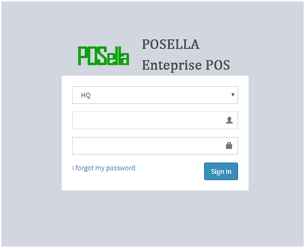

FIG:1.1.1 LOGIN

The figure (FIG 1.1.1) shows the initial login screen which has three text fields, First one , to select either the Head Quarters or to select the shop. Second field is to type the username and last one to type the password. Use the ‘sign in’ button to login to the home page. First, let's discuss the case of HQ which is discussed below:

#### If you directly want to login to the HQ page, select the option ‘HQ’ in first field, use your username and password and login to the HQ page. The HQ’s home page appears like the figure shown below. It has a dashboard, people, utilities, reports and settings in the menu bar. We will discuss the HQ page in detail later. The HQ page which follows is shown below:

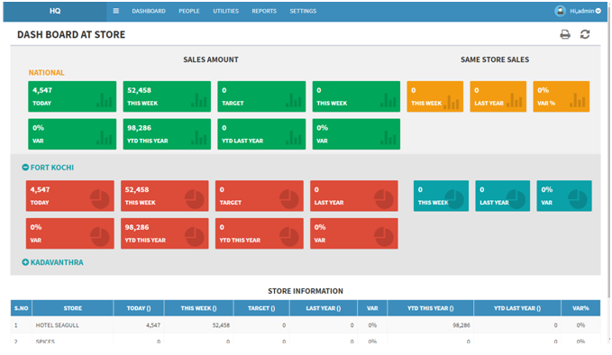FIG 1.1.2 HOME PAGE IN HQ

### SHOP LOGIN

#### The next option available for you is the ‘shop’. If you want to login to the shop, click on select option for ‘shop’ as shown in figure below:

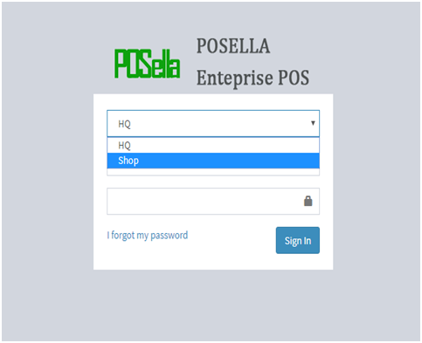

FIG 1.1.3: LOGIN FOR SHOP

When we select the option ‘shop’, another select option appears which is shown below. The user name and password following the select option will be the same. Enter your user name and password in the respective fields.

Select an option other than HQ. In the figure we can see that shop is given other than HQ. ‘Shop’ actually refers to the shop you have. When we select shop, the screen changes to the following manner:

#### 

#### FIG 1.1.4: SELECT SHOP

You can see that another select box is displayed below the shop. In the select box a list is displayed which consists of the hotels under your management. You can select a particular hotel into which you have to login. In the image shown above, there are two hotels, hotel SEAGULL and hotel SPICES , both owned by a single owner.

If you want to login to hotel SEAGULL, select the option SEAGULL and proceed to login using the personal username and password you have. If you want to login to hotel SPICES, select the option SPICES and proceed to login using the personal username and password you have. The figure below helps you to login. The figure provides you just an example of user name ‘admin’.

### 

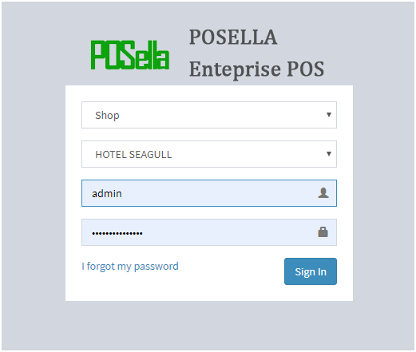

FIG 1.1.5: FILLING ALL FIELDS

When all fields are completed, click the ‘sign in’ button to login and proceed to the next page which is the ‘home page’.

Finally login to your shop. The home page gets displayed when you login, is shown below:

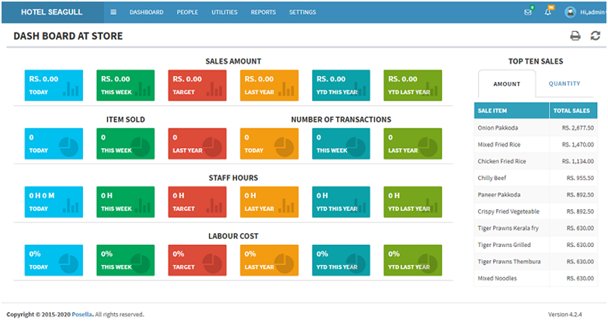FIG 1.1.6: HOME PAGE OF SHOP

## **2. SETTINGS**

After logging to the dashboard(fig1.1.2), click on settings given in the navigation bar. The screen will be displayed as:

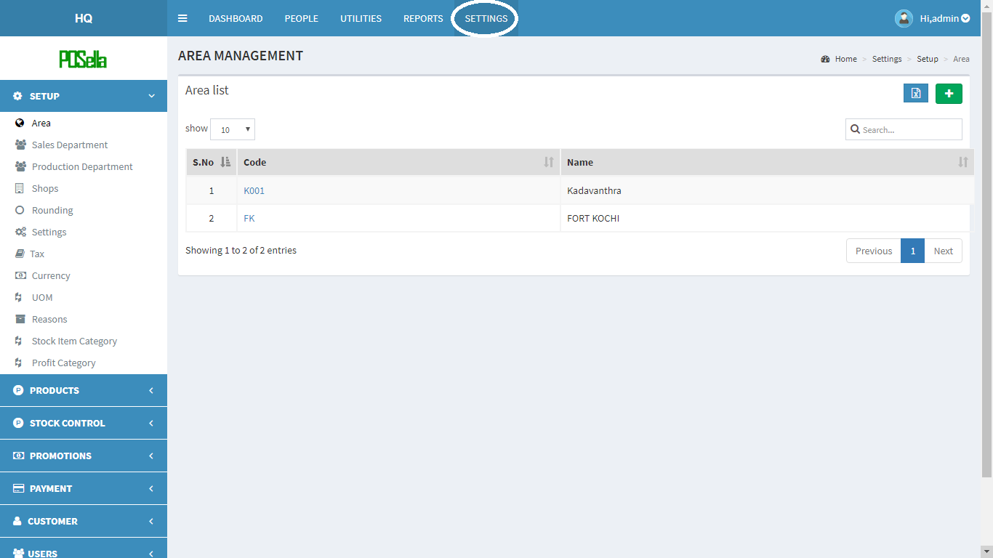 FIG 2 SETTINGS

### 2.1 SETUP

#### 2.1.1 AREA

Area is the first module covered under section ‘setup’. When we click on Area, fig.2.1.1 will get displayed. We can see the list of areas we already added to the database displayed as ordered list on screen

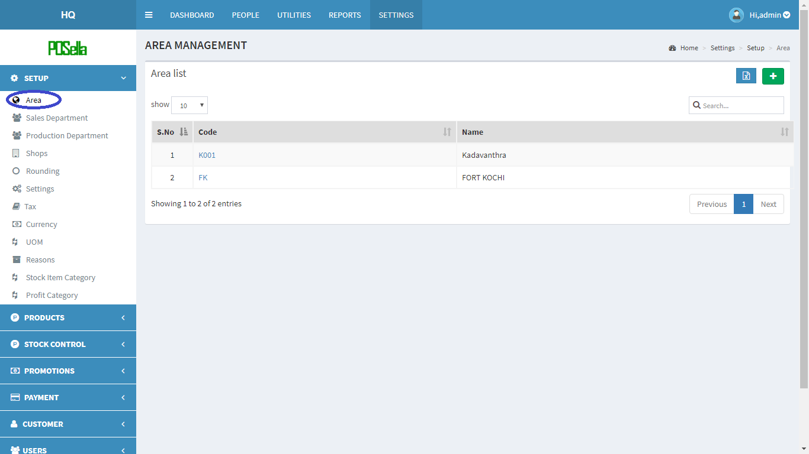

FIG 2.1.1.1 AREA

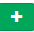

To **add** a new Area, at the rightmost corner, you can see .Click on the button to add our area(location).

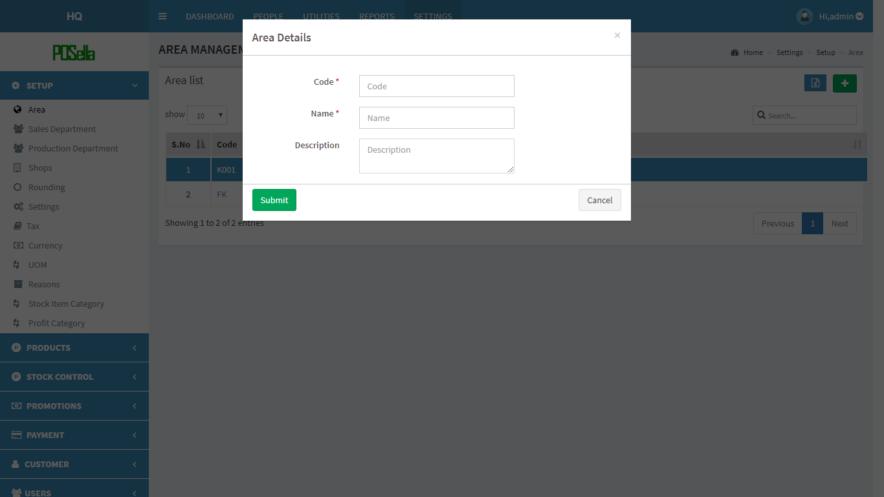

FIG 2.1.1.2 ADD AREA

The fields are ‘code’ , ‘name’ and ‘description’. You can fill up the respective code, the name of your place and description, if any. After filling, click submit button to add record to database. Otherwise click cancel. After filling, your newly added details will also get displayed as the next number in the list. If you want to **view** any detail in particular, click on the code shown next to the serial number. Then details get displayed as shown example.

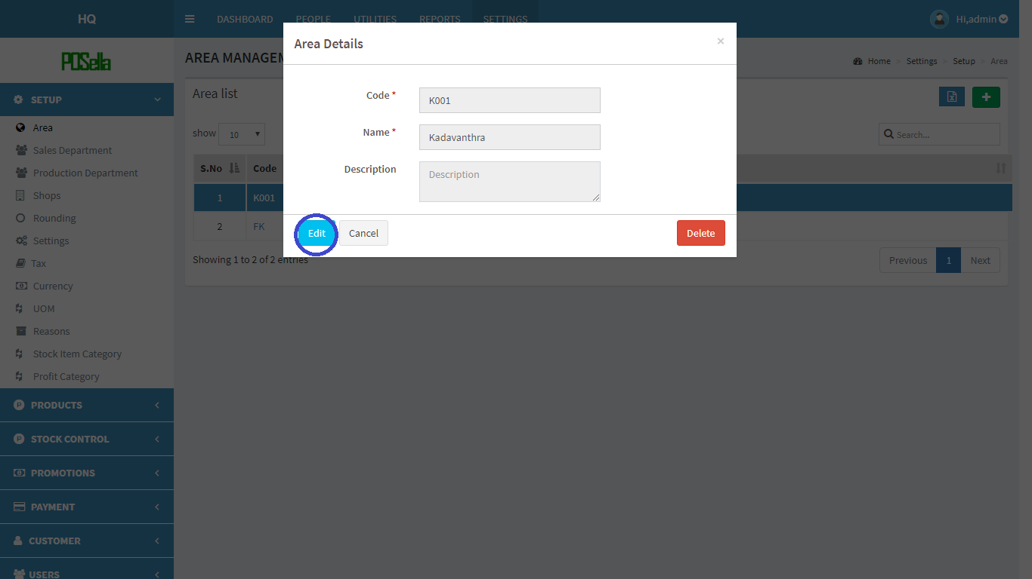

FIG 2.1.1.3 VIEW AREA

In the pop up screen, your selected area’s details get displayed with an option to ‘**edit**’ or ‘**delete**’.Click on the edit button, if an editing required.

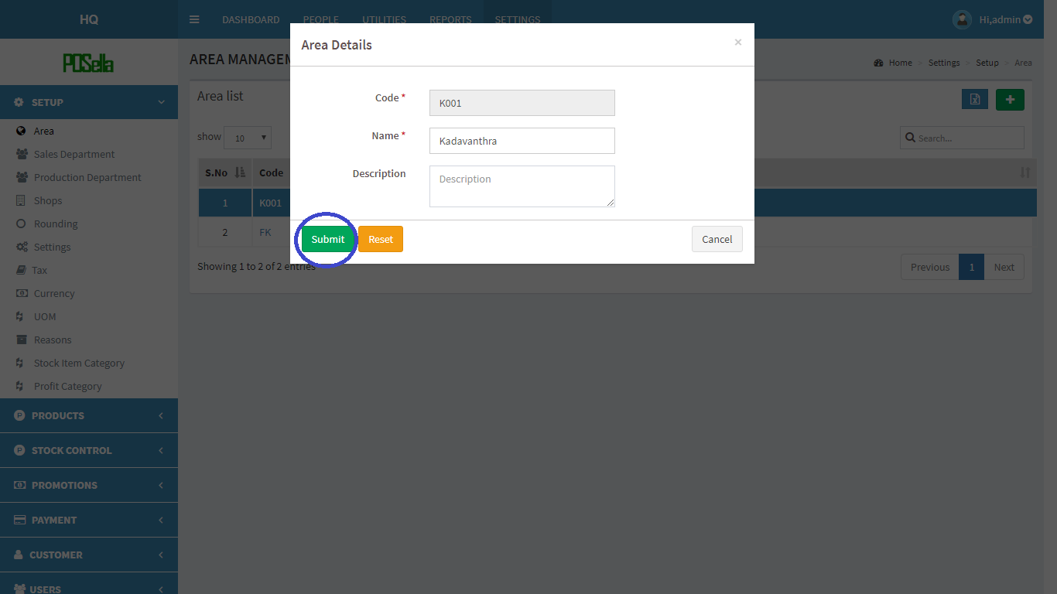

FIG 2.1.1.4 EDIT DETAIL

Click on submit button to **edit** details. Otherwise click ‘reset’.

If you want to **delete** a record, then click on the delete option given in fig 2.1.1.3.

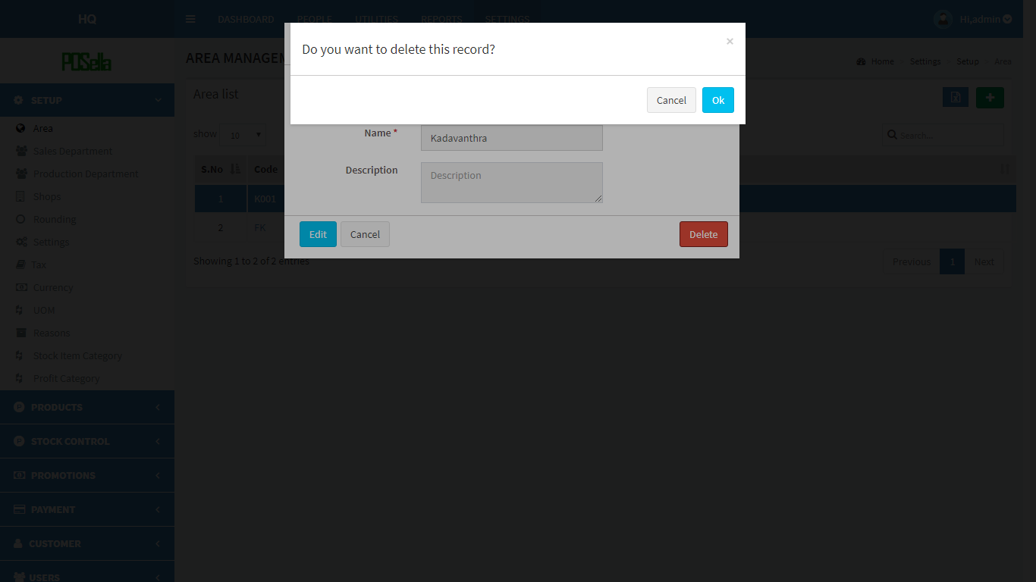

FIG 2.1.1.5 DELETE DETAIL

An additional pop up appears on top of the delete option where you have to click **ok**, if you want to delete otherwise click cancel.

To **export** an area list, click on the blue  button in the rightmost corner. Then a pop up gets displayed

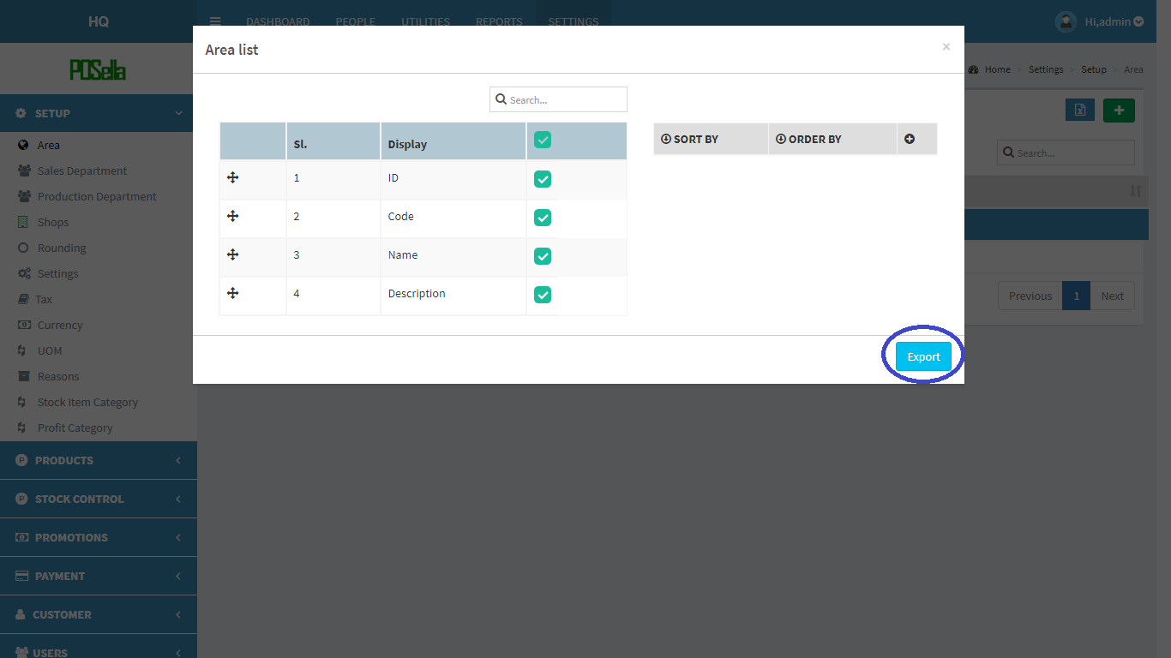

FIG 2.1.1.6 EXCEL EXPORT

Select the relevant options and click the ‘**export**’ button . The excel sheet gets downloaded.

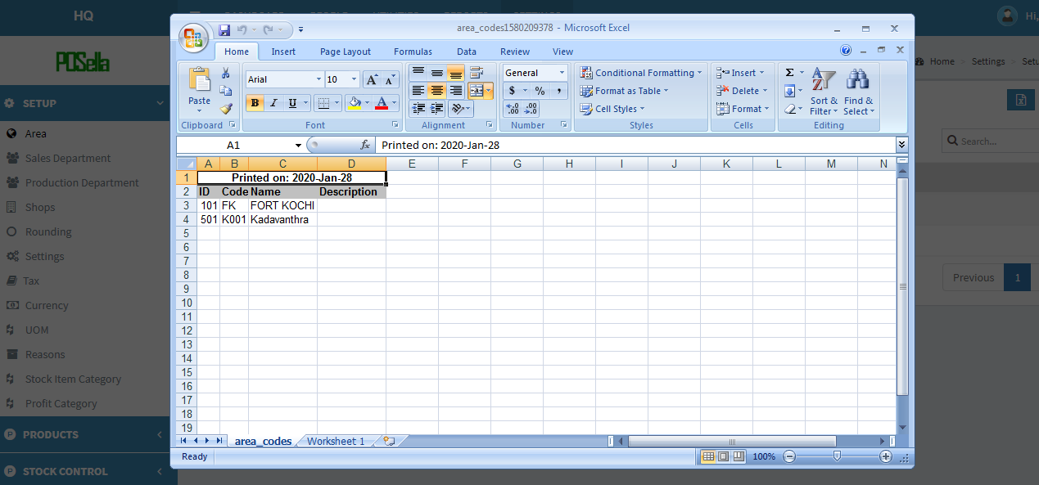FIG 2.1.1.7 EXCEL REPORT

#### 2.1.2 SALES DEPARTMENT

Click on the sales department, the list of department gets displayed as shown in figure.

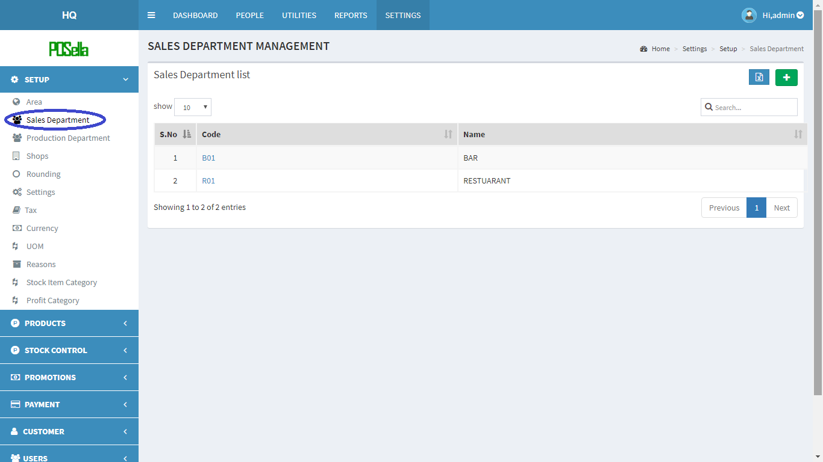

FIG 2.1.2.1 SALES DEPARTMENT



To **add** a new department, at the rightmost corner, you can see a . Click on the button to add the department.

A pop up window appears:

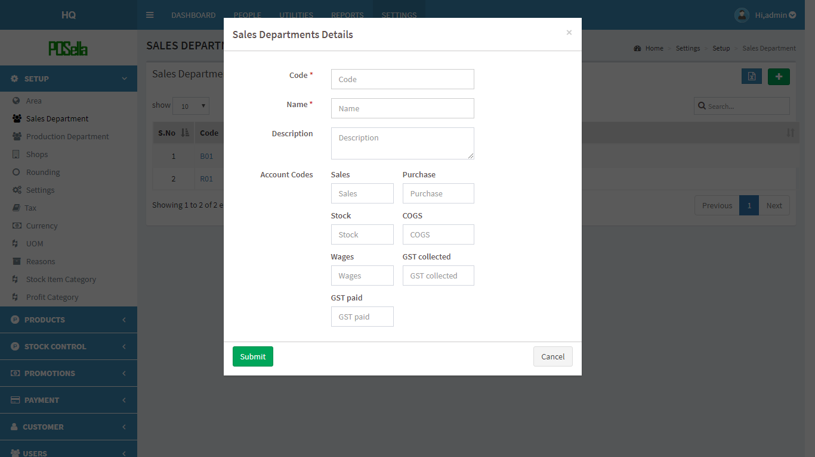

FIG 2.1.2.2 ADD DEPARTMENT

Fill the blank fields and click submit button to create a new department. Otherwise click the cancel button. To **view**, **edit** and **delete** a particular department click on code in fig 2.1.2.1. A pop up window appears:

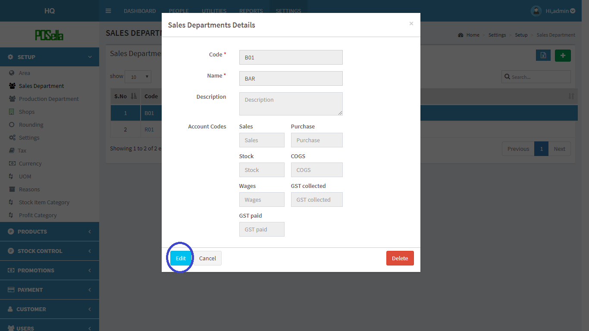

FIG 2.1.2.3 VIEW DEPARTMENT

Click **edit** to edit details. Another pop up window appears:

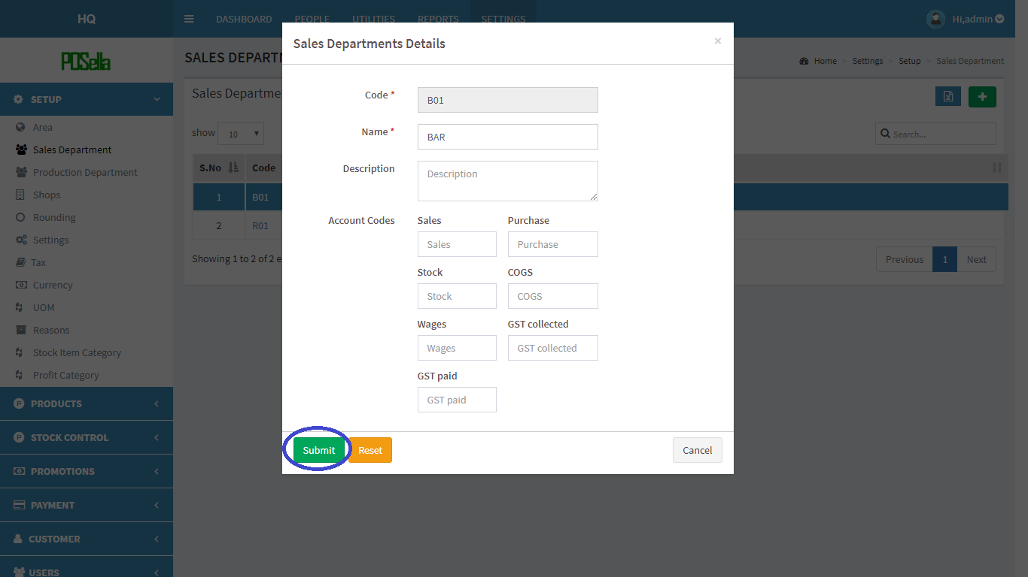

FIG2.1.2.4 EDIT DEPARTMENT

Click submit button to update changes made. If you want to **delete** a department, click on the delete button in fig 2.1.2.3. When delete button is clicked, another pop-up appears:

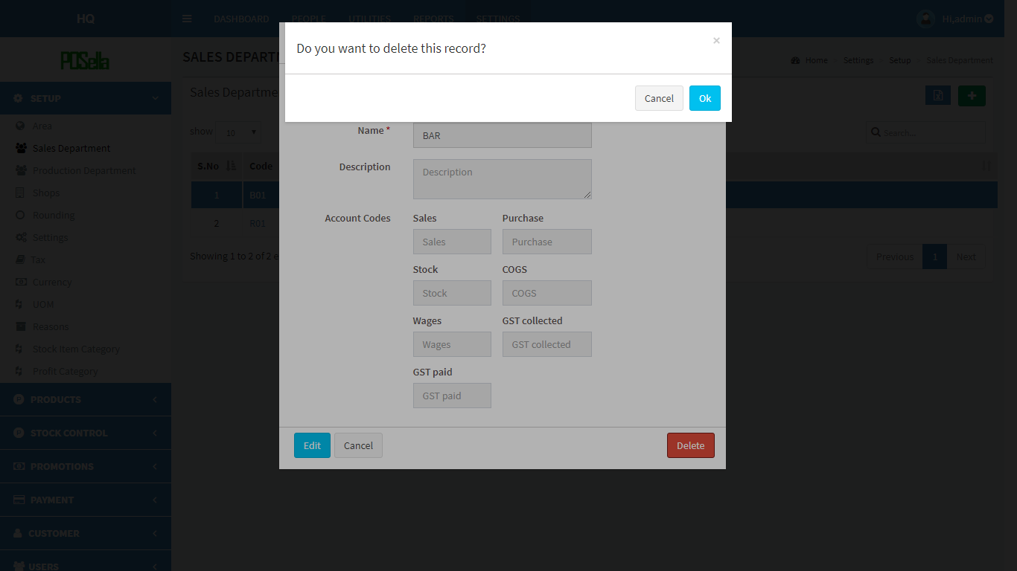

FIG 2.1.2.5 DELETE DEPARTMENT

Confirm **delete** by clicking ‘OK’ otherwise cancel.

To **export** an area list, click on the blue button given aside to  button in the right corner. Then a pop up gets displayed .

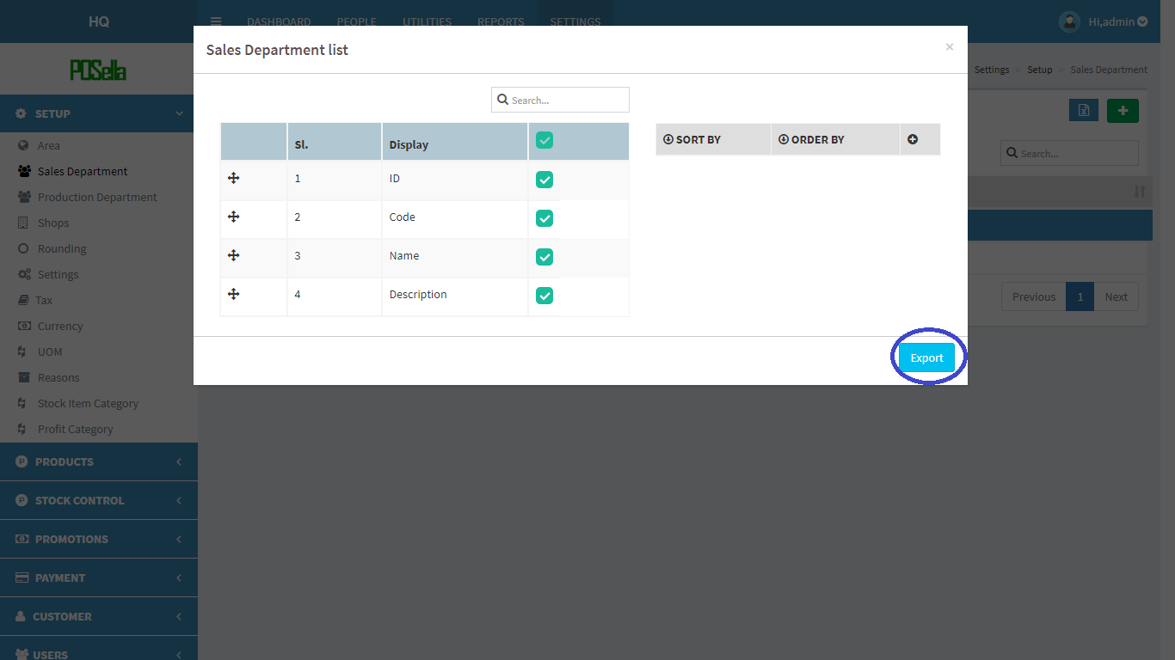

FIG 2.1.2.6 EXPORT EXCEL

Select the relevant options and click the ‘**export**’ button . The excel sheet gets downloaded.

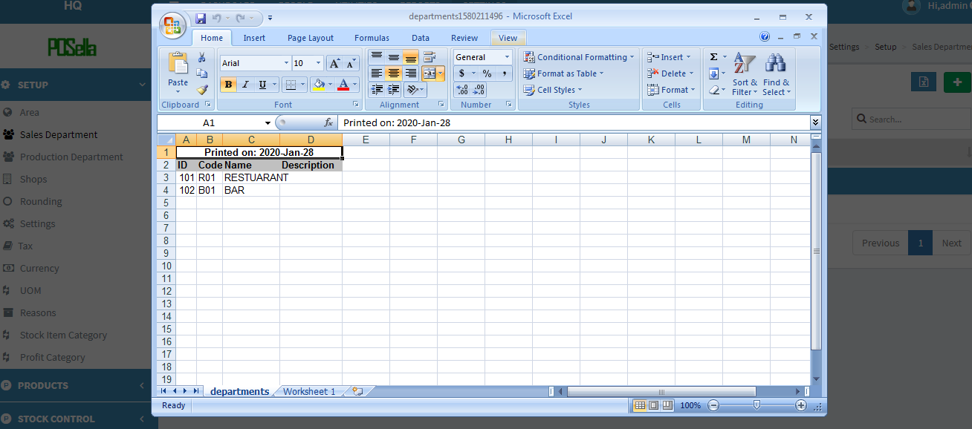

FIG 2.1.2.7 EXCEL REPORT

#### 2.1.3 PRODUCTION DEPARTMENT

Click on the sales department, the list of department gets displayed as shown in figure.

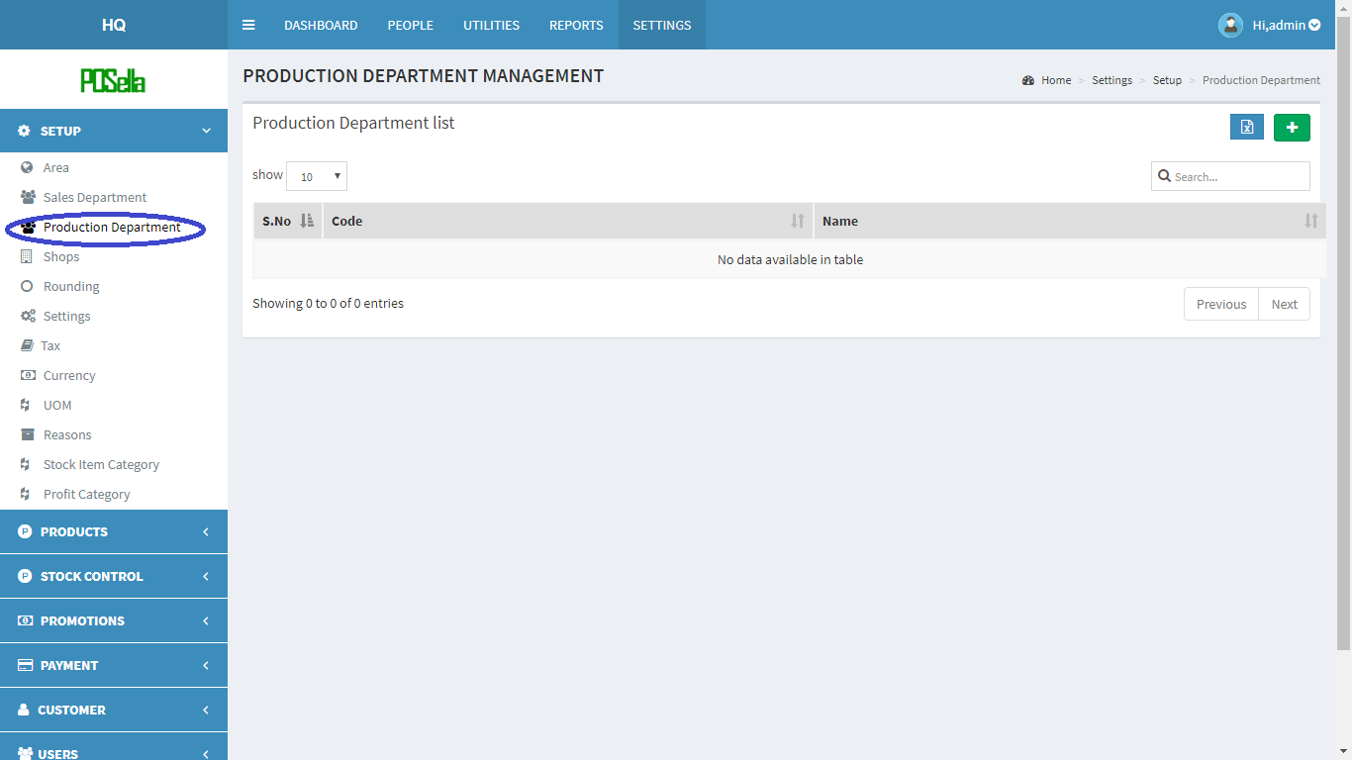

FIG 2.1.3.1 PRODUCTION DEPARTMENT

To **add** a new department, at rightmost corner, you can see a  in green colour background. Click on the button to add the department.

A pop up window appears:

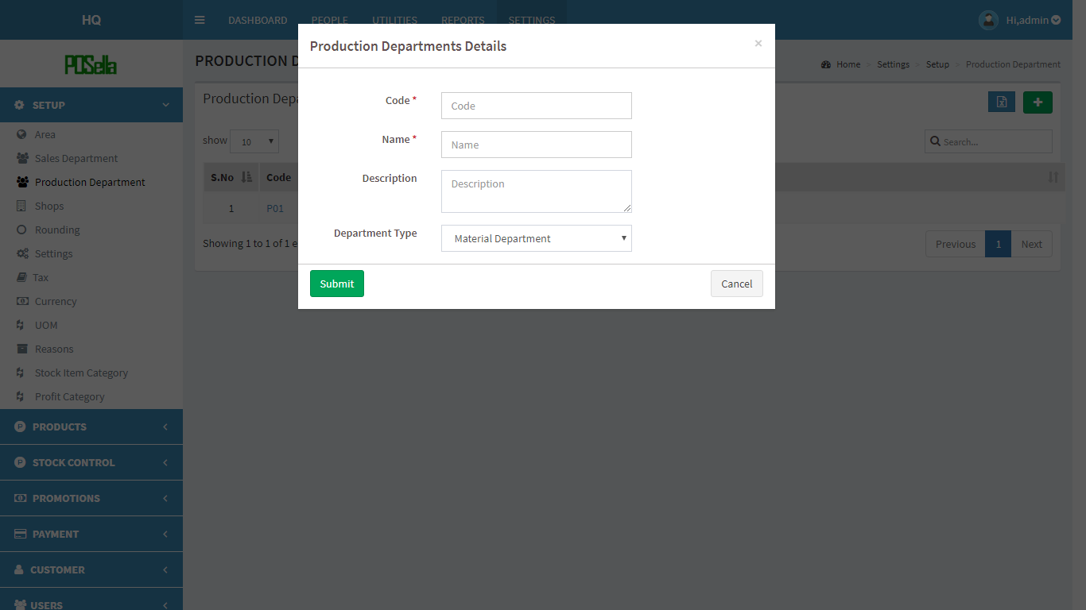

FIG 2.1.3.2 ADD DEPARTMENT

Fill the blank fields and click submit button to create a new department. Otherwise click the cancel button. To **view**, **edit** and **delete** a particular department click on code in fig 2.1.3.1 . A pop up window appears:

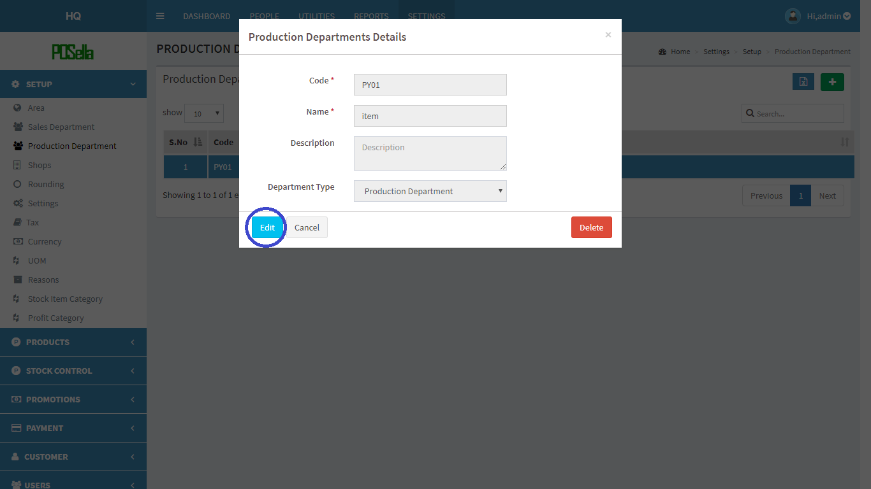

FIG 2.1.3.3 VIEW DEPARTMENT

Click **edit** to edit details. Another pop up window appears:

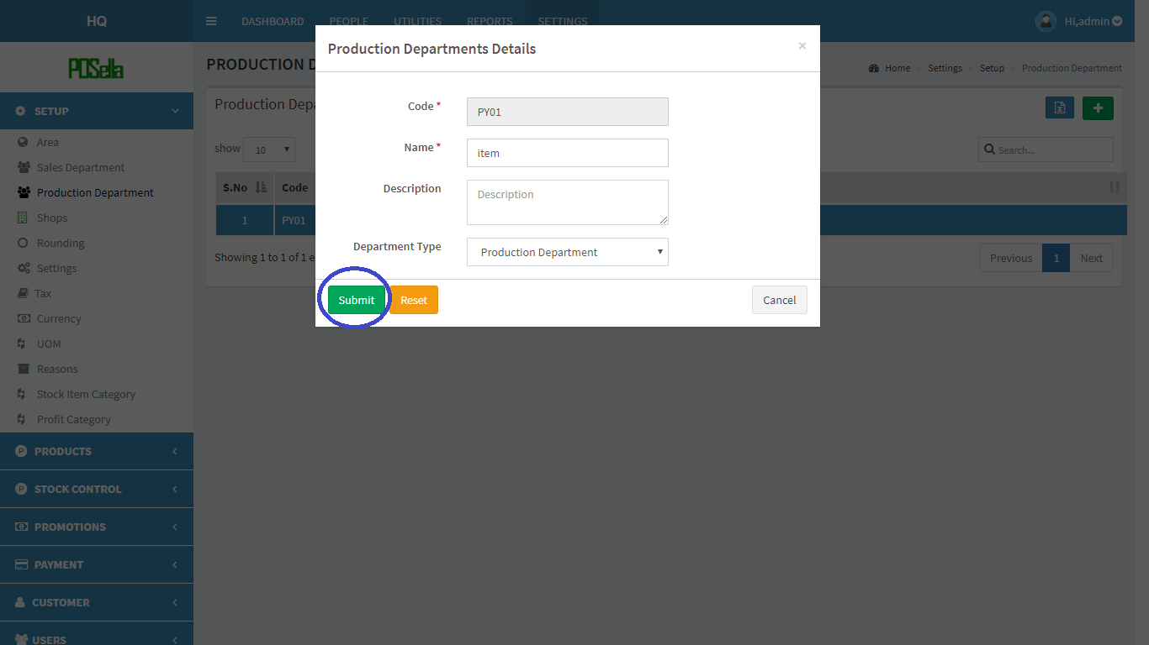

FIG2.1.3.4 EDIT DEPARTMENT

Click submit button to update changes made. If you want to **delete** a department, click on the delete button in fig 2.2.2. When delete button is clicked, another pop-up appears:

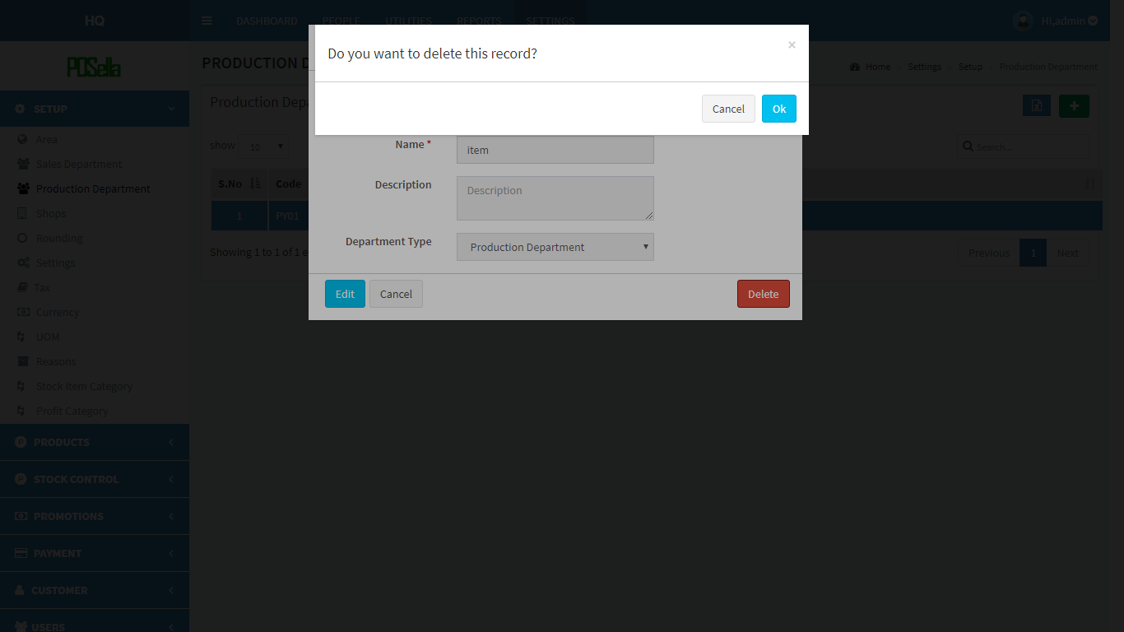

FIG 2.1.3.5 DELETE DEPARTMENT

Confirm **delete** by clicking ‘OK’ otherwise cancel.



To **export the production** list, click on the blue button given.

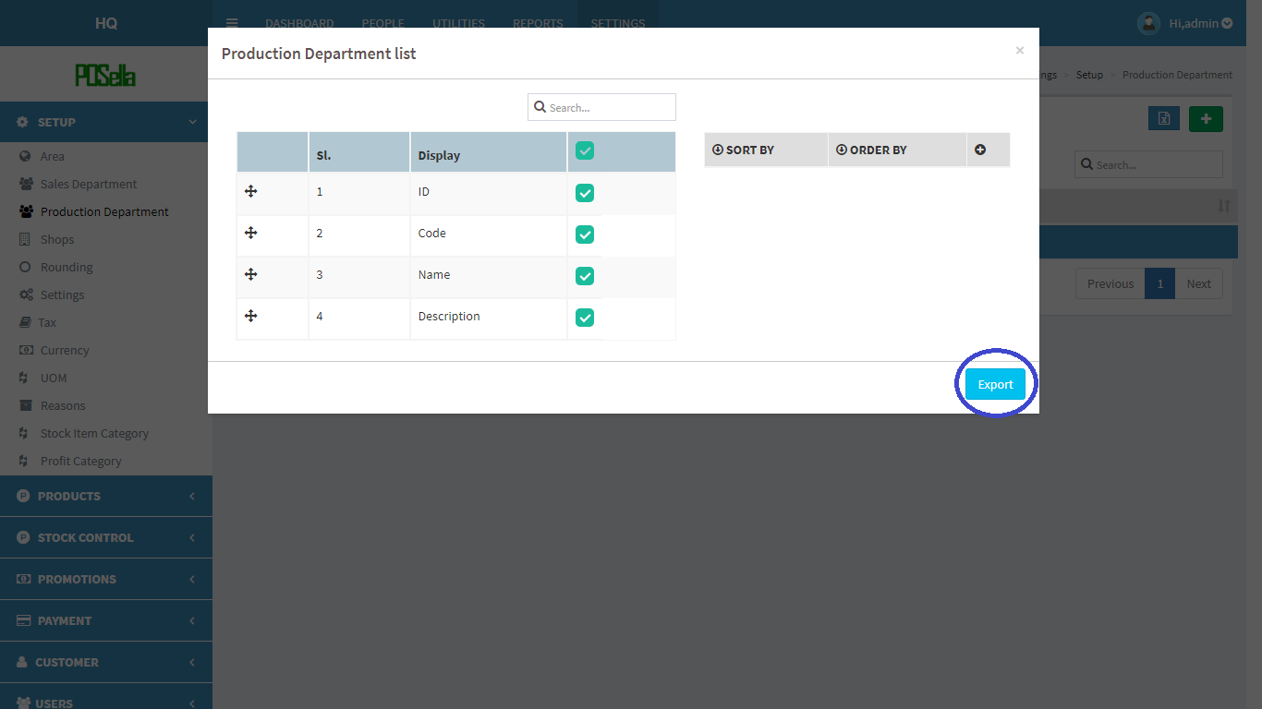

FIG 2.1.3.6 EXPORT EXCEL

Select the relevant options and click the ‘**export**’ button . The excel sheet gets downloaded.

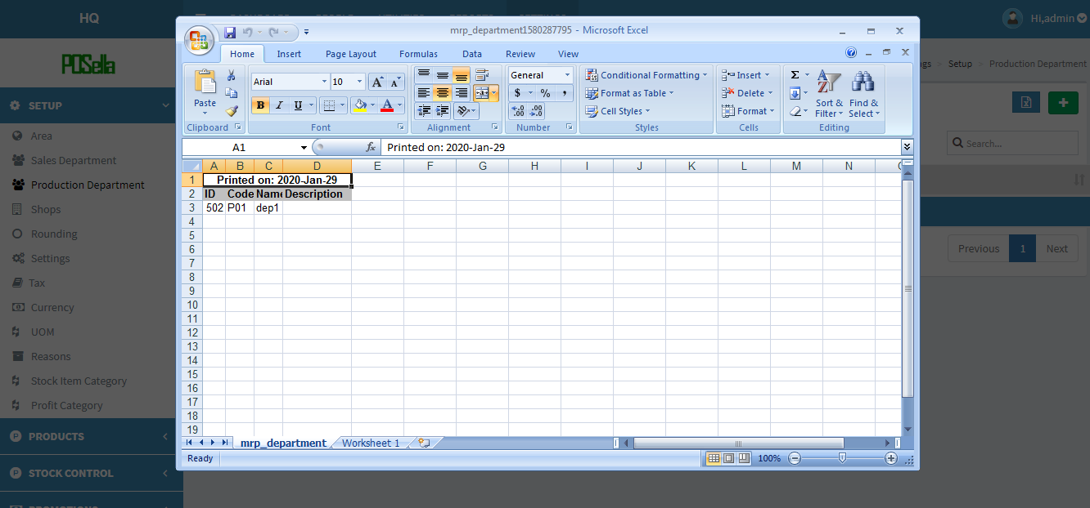

FIG 2.1.3.7 EXCEL REPORT

#### 2.1.4 SHOPS

Click on the Shops, the list of shops gets displayed as shown in figure.

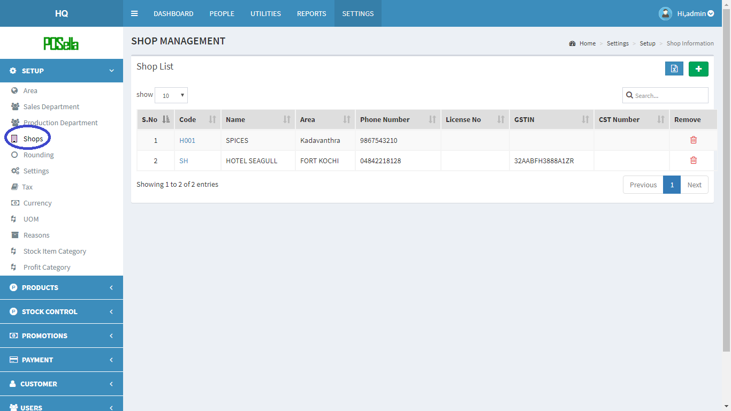

FIG 2.1.4.1 SHOPS



To **add** a new shop, at the rightmost corner, you can see .Click on the button to add shop.The screen changes and form appears.

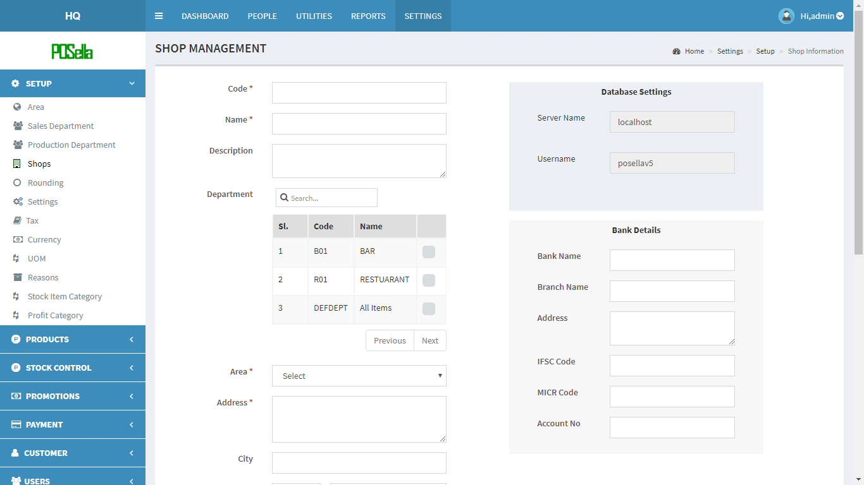

FIG 2.1.4.2 ADD SHOP

Fill the required fields and click the update button to create a new shop. Otherwise click the cancel button. To **view** and **edit** a particular shop click on ‘code’ in fig 2.1.4.1 . A pop up window appears:

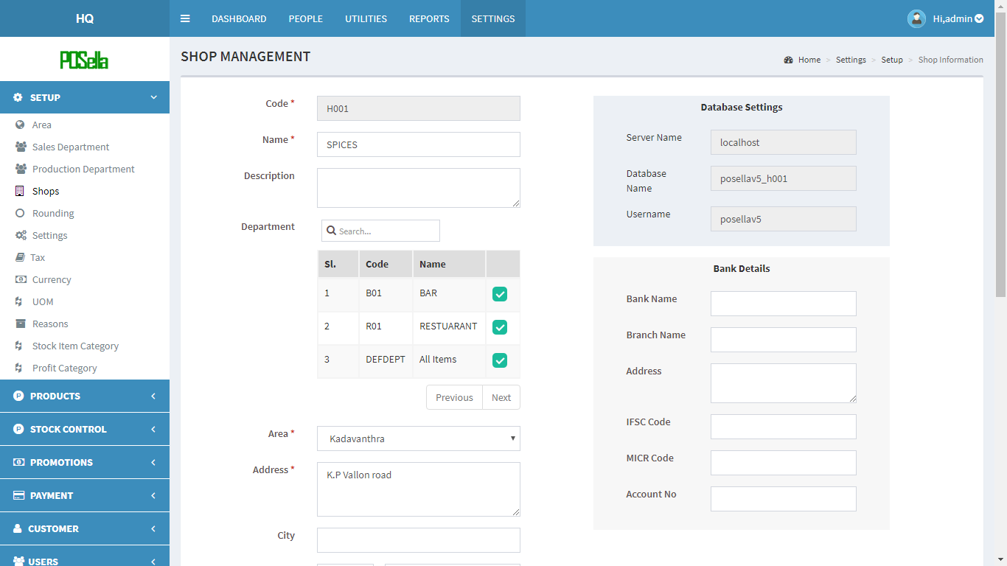

FIG 2.1.4.3 VIEW AND EDIT SHOP

Click **update** to edit details.

If you want to **delete** a shop, click on the delete symbol provided in table in fig 2.1.4.1 When delete button is clicked, another pop-up appears:

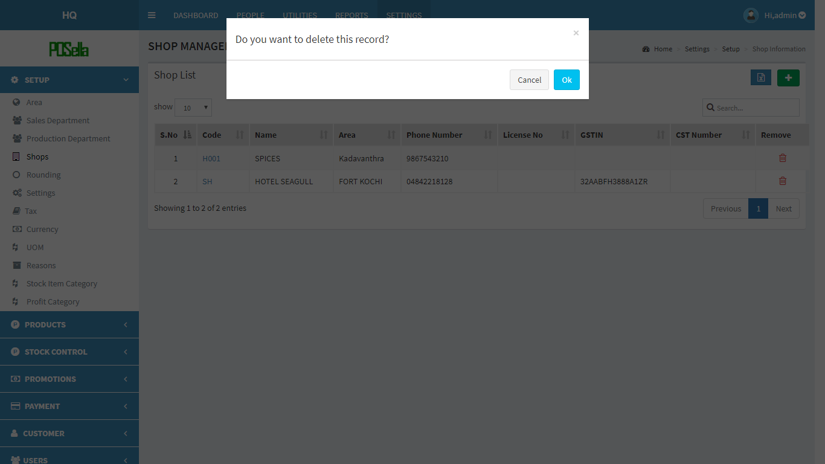

FIG 2.1.4.5 DELETE SHOP

Confirm **delete** by clicking ‘OK’ otherwise cancel.

To **export** shop list, click on the blue button in  the right corner. Then a pop up gets displayed .

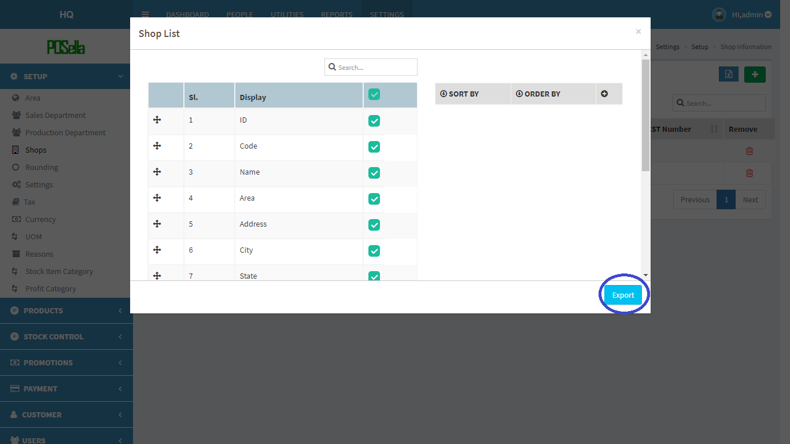

FIG 2.1.4.6 EXPORT EXCEL

Select the relevant options and click the ‘**export**’ button . The excel sheet gets downloaded.

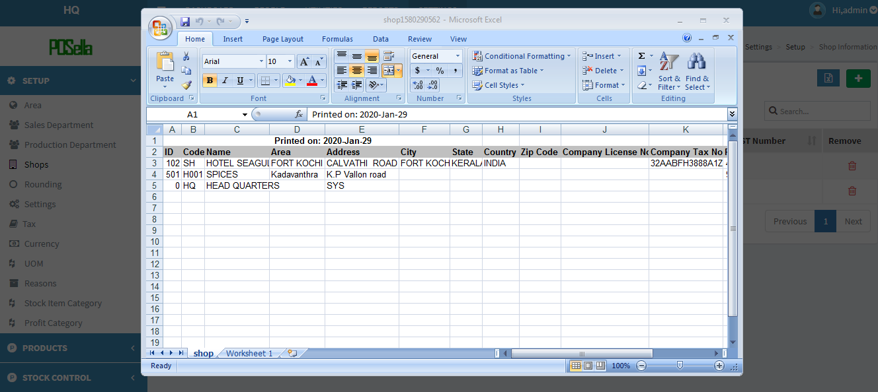

FIG 2.1.4.7 EXCEL REPORT

#### 2.1.5 ROUNDING

Click on the sales Rounding, the list of roundings gets displayed as shown in figure.

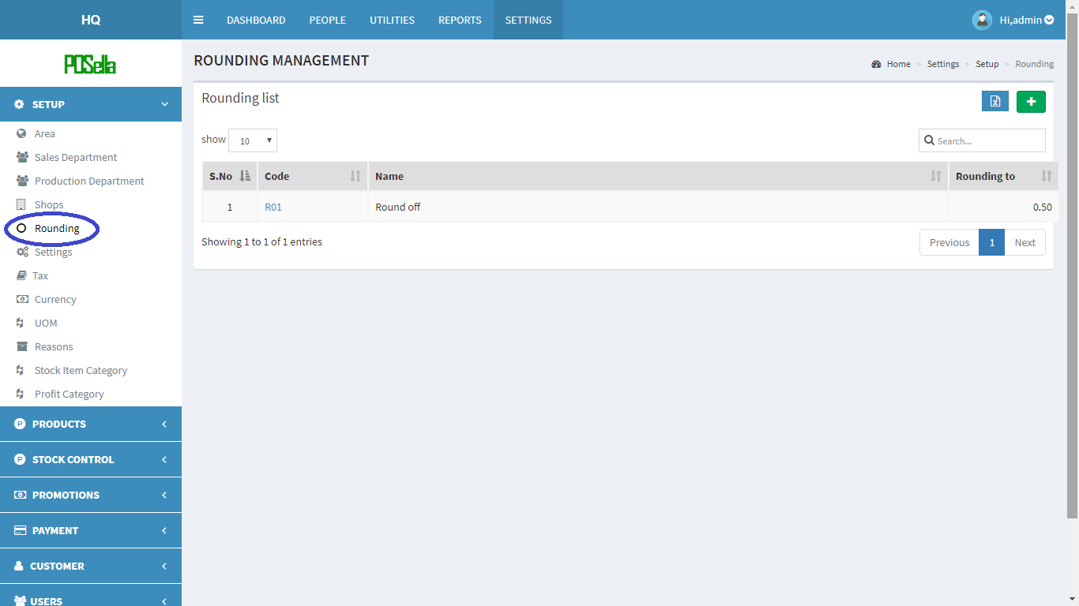

FIG 2.1.5.1 ROUNDING

To **add** a new rounding method, at rightmost corner, you can see a  in green colour background. Click on the button to add rounding.

A pop up window appears:

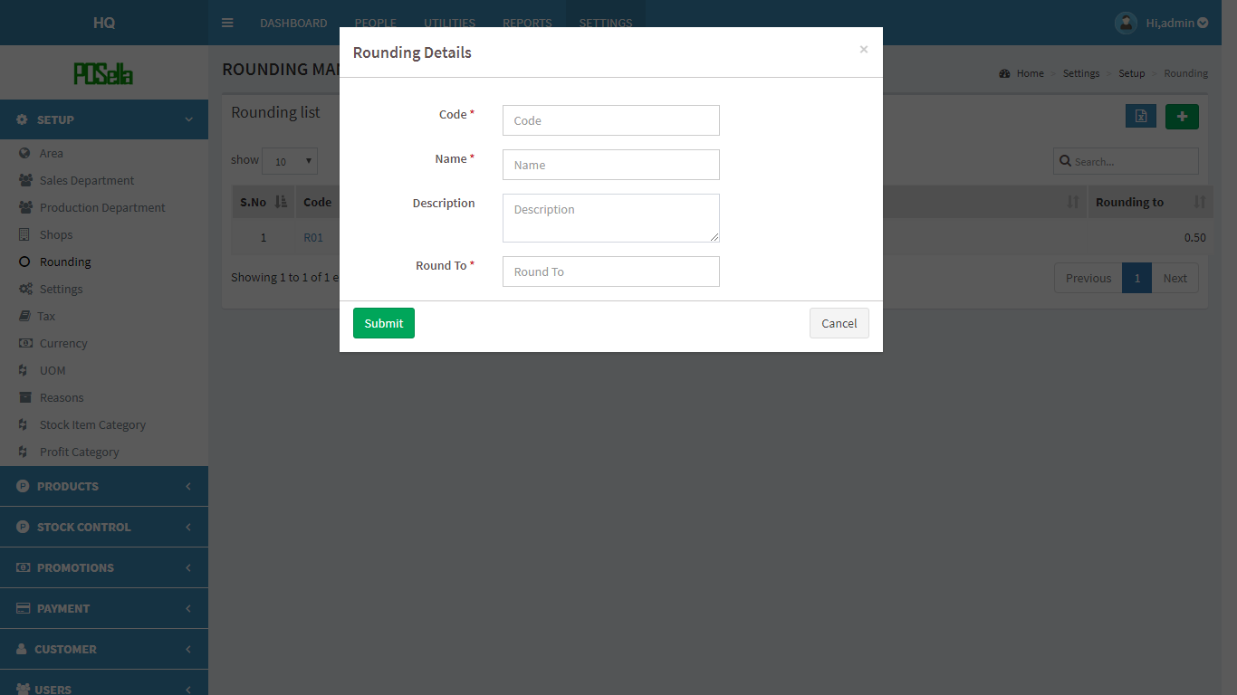

FIG 2.1.5.2 ADD ROUNDING

Fill the blank fields and click submit button to create a new rounding. Otherwise click the cancel button. To **view**, **edit** and **delete** a particular rounding method. Click on code in fig 2.1.5.1 . A pop up window appears:

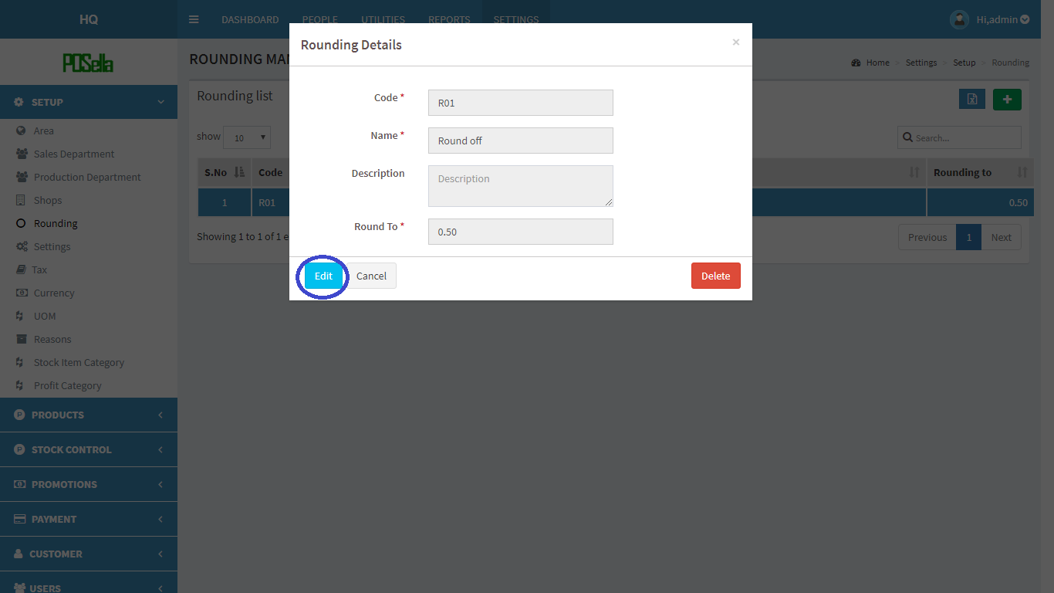

FIG 2.1.5.3 VIEW ROUNDING

Click **edit** to edit details. Another pop up window appears:

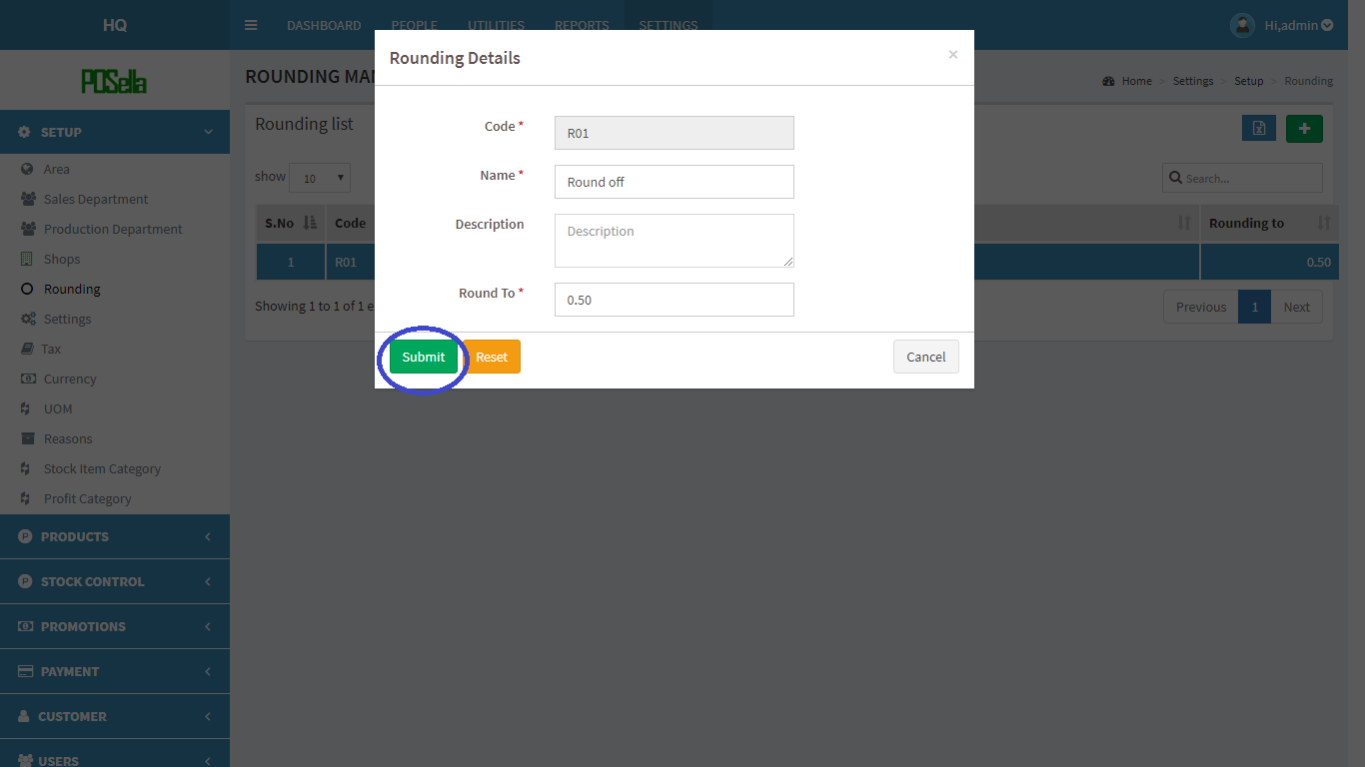

FIG2.1.5.4 EDIT ROUNDING

Click submit button to update changes made. If you want to **delete** a rounding method, click on the delete button in fig 2.1.5.3. When delete button is clicked, another pop-up appears:

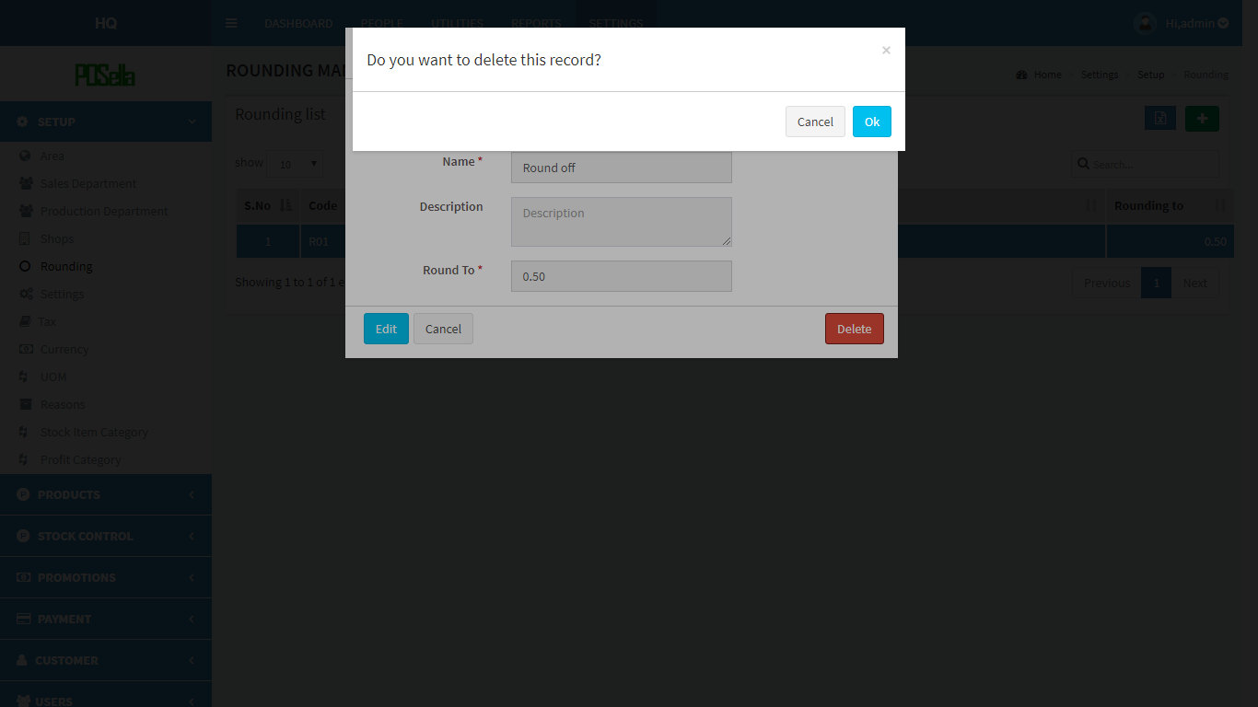

FIG 2.1.5.5 DELETE ROUNDING

Confirm **delete** by clicking ‘OK’ otherwise cancel.

To **export the rounding** list, click on the blue button ‘****’ in the right corner. Then a pop up gets displayed .

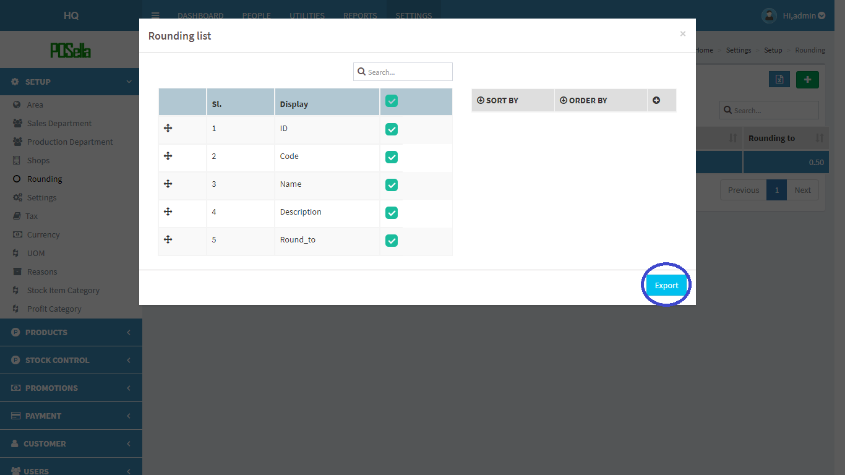

FIG 2.1.5.6 EXPORT EXCEL

Select the relevant options and click the ‘**export**’ button . The excel sheet gets downloaded.



FIG 2.1.5.7 EXCEL REPORT

#### 2.1.6 SETTINGS

Click on the Settings, the four types of settings get displayed as shown in figure.

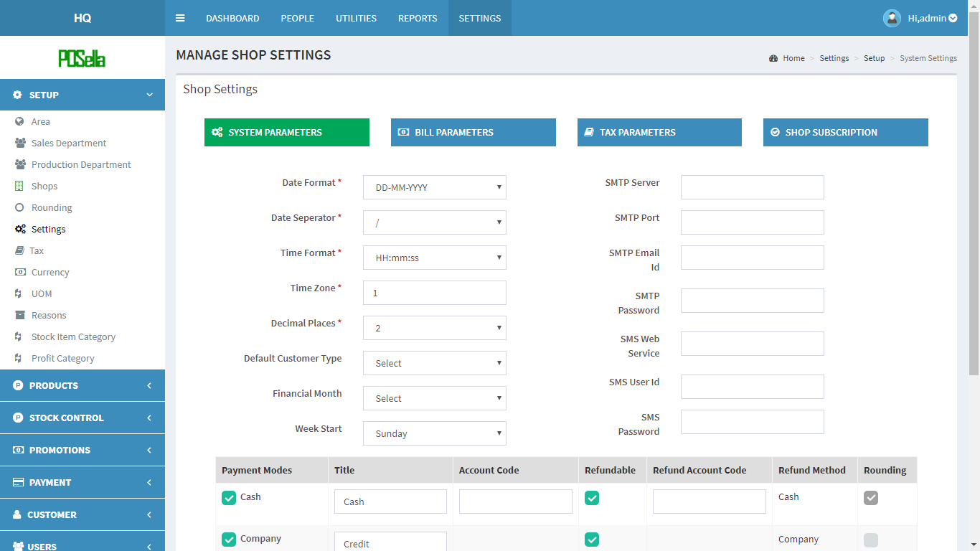

FIG 2.1.6.1 SETTINGS

The four types of settings are:

* System Parameters
* Bill Parameters
* Tax parameters
* Shop Subscription

**System Parameters**

The screen gets displayed as shown below:

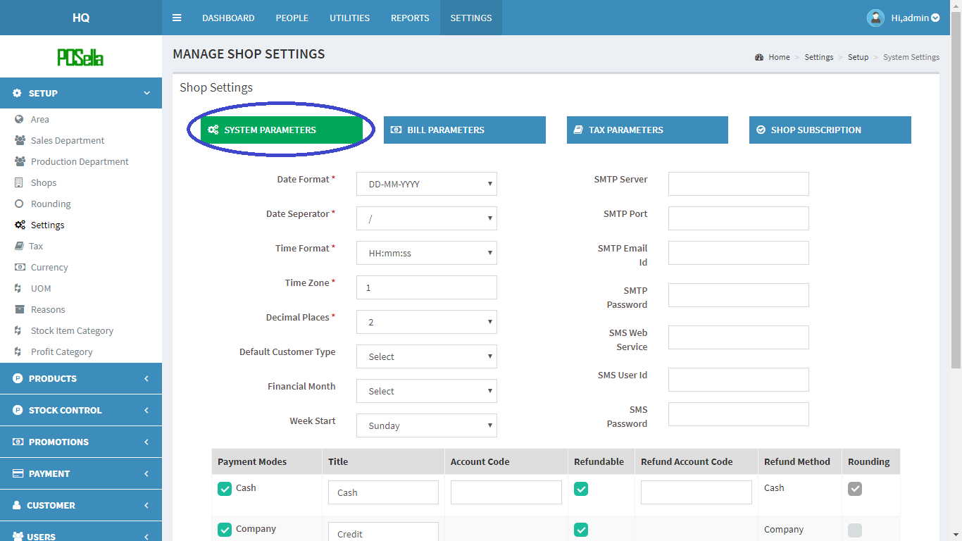

FIG 2.1.6.2 SYSTEM PARAMETERS

The system parameters refers to those parameters which are used to set some of the system details such as server details, date settings etc. The way we set the details on the web side gets reflected in the terminal side.

The fields in system parameters are explained as a table as shown below:

|  |  |
| --- | --- |
| **FIELD NAME** | **EXPLANATION** |
| Date Format | Commonly used :DD-MM-YYYY, MM-DD-YYYY and YYYY-MM-DD |
| Date Separator | Commonly used: / or . or - |
| Time Format | Commonly used: HH.mm, HH:mm:ss, H:mm:ss and HH mm |
| Time Zone | Commonly st as 1 |
| Decimal places | Commonly st as 2 |
| Default Customer Type | Here default customer is walk in |
| Financial Month | A month which we set annually as financial month generally april |
| Week start | The start day of sale in a week usually sunday |
| SMTP Server | The server connection establishment |
| SMTP Port | Port number of server |
| SMTP Email id | Email id is used as the username for connection |
| SMTP Password | Password setting |

Table for System parameters

Other than the above fields, payment modes are also specified within system parameters.

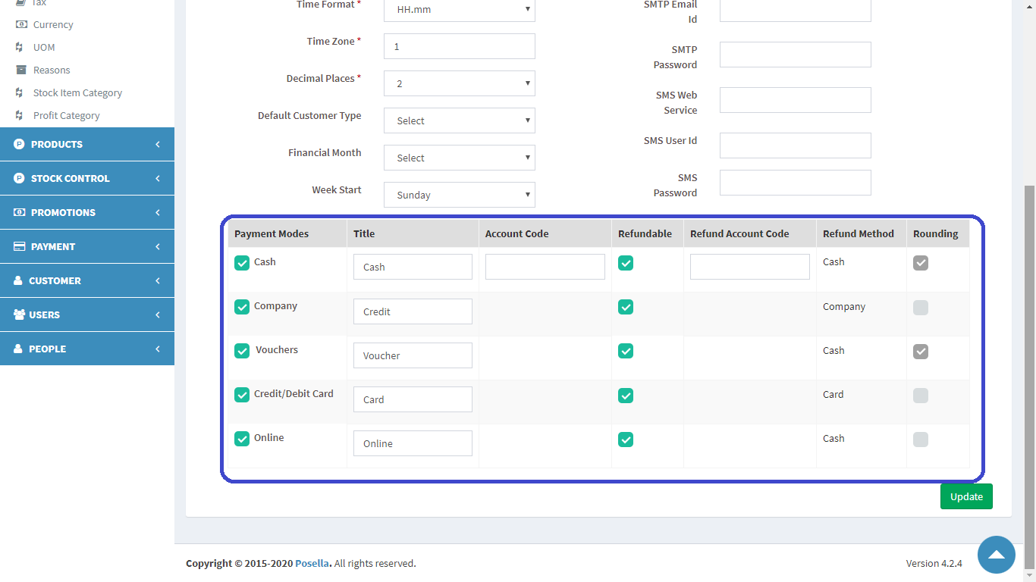

FIG 2.1.6.3 PAYMENT MODES

The payment modes are decided according to the user's requirement. It includes cash, credit/debit card, company, vouchers or online. All these are the different payment modes used. The user can decide which modes can access priorities like refund, rounding etc.

Finally , click the update button to update the changes.

**Bill Parameters**

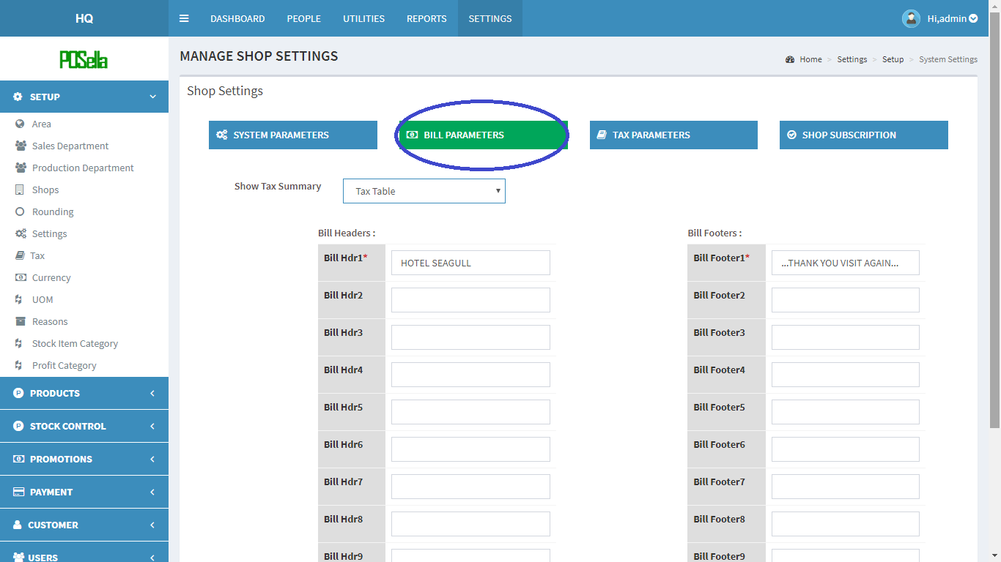

FIG 2.1.6.4 BILL PARAMETERS

Bill parameters include the way we want a bill to be displayed. We can set the title, address etc. in the header section and some captions in the footer section. Since each user has their own requirement, ten header and footer sections are provided and you can use it according to your necessity.

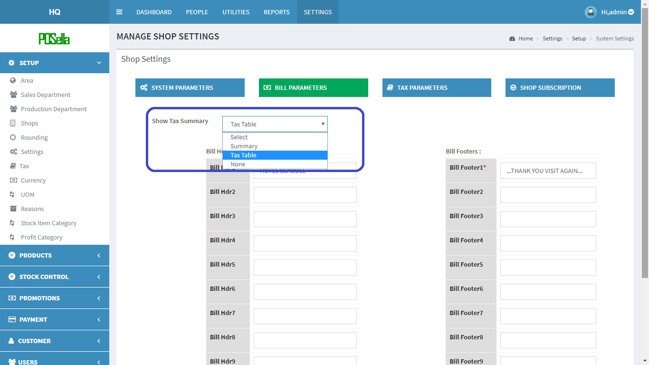

FIG 2.1.6.5 SHOW TAX SUMMARY

Show tax summary has three options: none, summary and tax table

None - No tax summary is used before submission

Summary - Tax will be shown on the bill as a whole and not specifically as cgst , sgst or cess.

Tax Table- Tax on bill will be displayed as cgst, sgst and cess specifically.

Finally click the update button to submit the changes.

**Tax parameters**

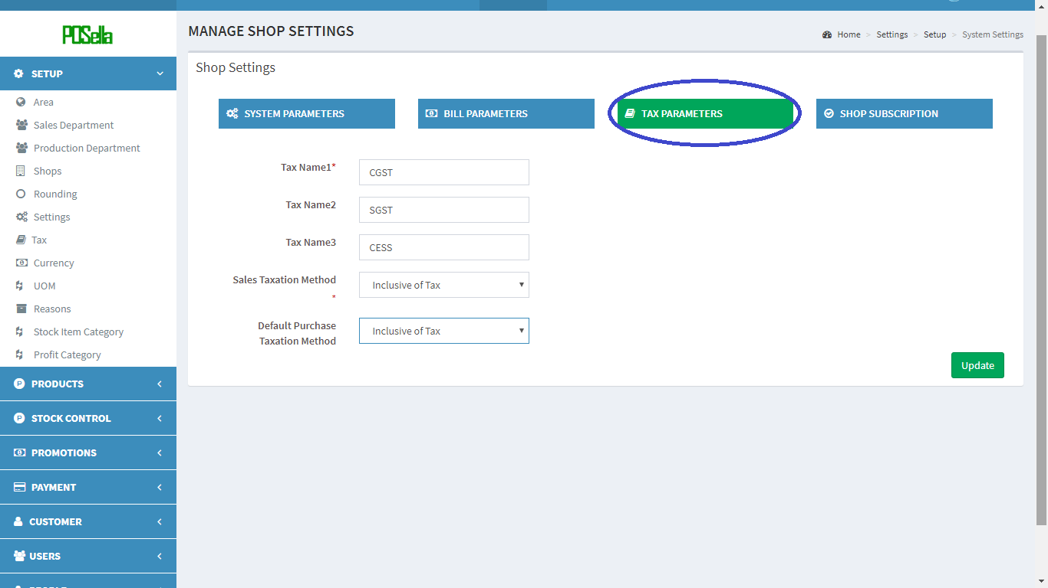

FIG 2.1.6.6 TAX PARAMETERS

The Tax parameters include cgst , sgst and cess which is set by default. Additional two fields are Sale Taxation Method and Default Purchase Taxation method.

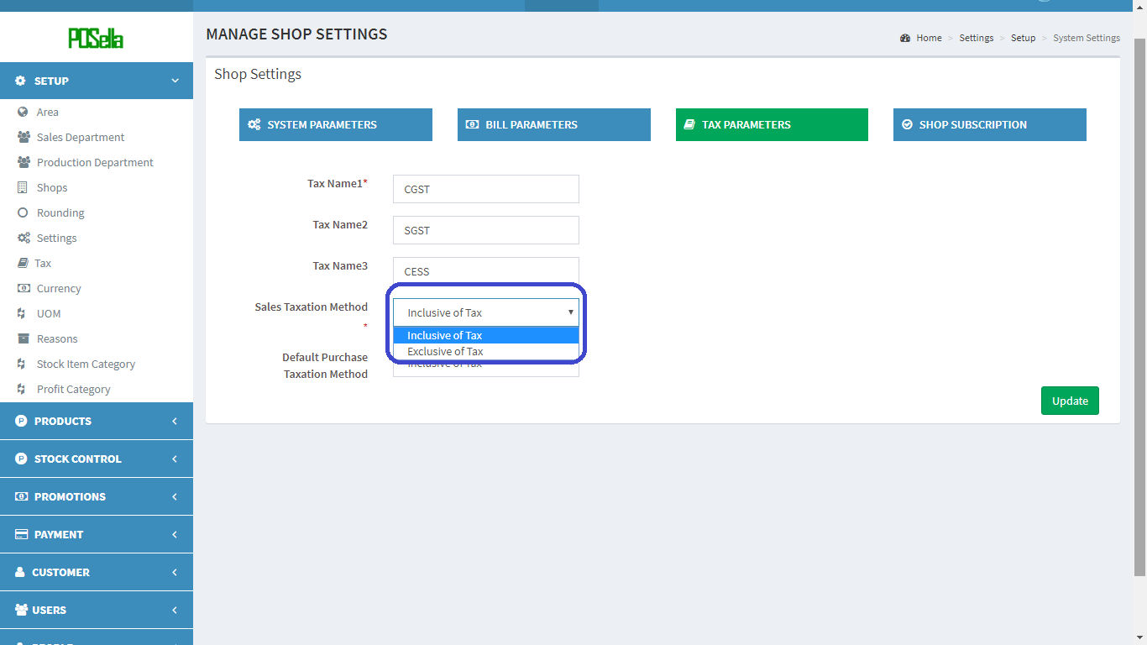

FIG 2.1.6.6 SALE TAXATION METHOD

**The Sale Taxation method** includes two options: : ‘Inclusive of Tax and ‘Exclusive of Tax’.

Some items have inclusive tax and some have exclusive tax. So, when we add an item to the list, we will get the option to select inclusive or exclusive tax, which we are setting over here.

**Default Purchase Taxation Method** includes two options: : ‘Inclusive of Tax and ‘Exclusive of Tax’.

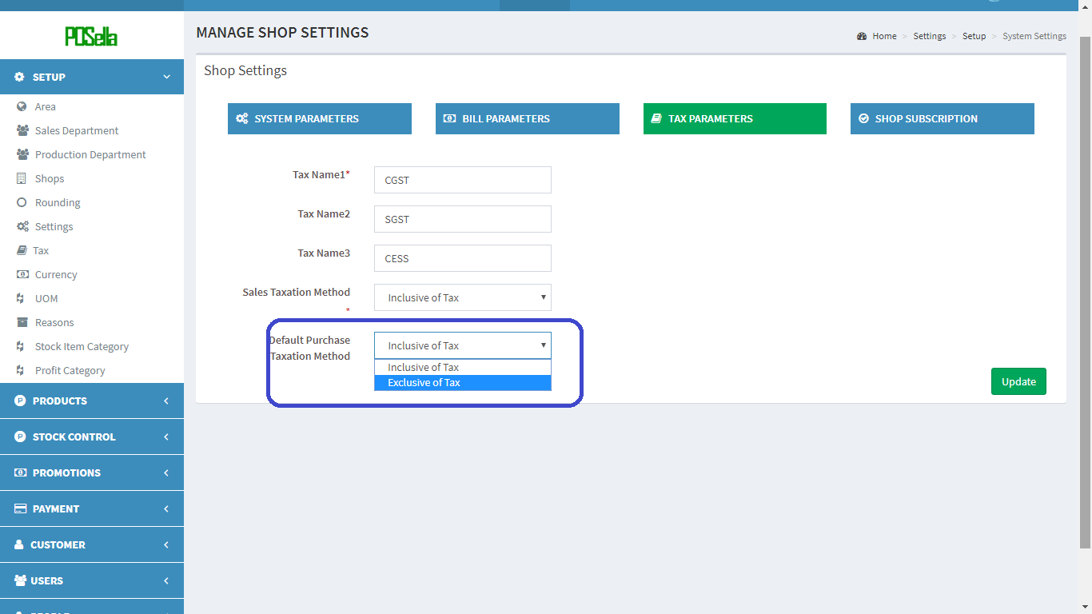

FIG 2.1.6.6 DEFAULT PURCHASE TAXATION METHOD

Finally, click update to submit the changes.

#### 2.1.7 TAX

Click on the Tax, the list of Taxes gets displayed as shown in figure.

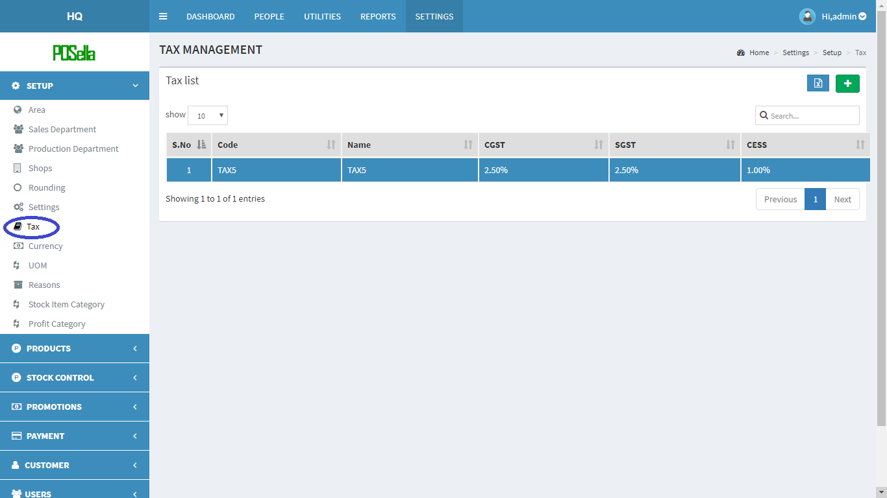

FIG 2.1.7.1 TAX

To **add** a new Tax, at rightmost corner, you can see a  in green colour background. Click on the button to add rounding.

A pop up window appears:

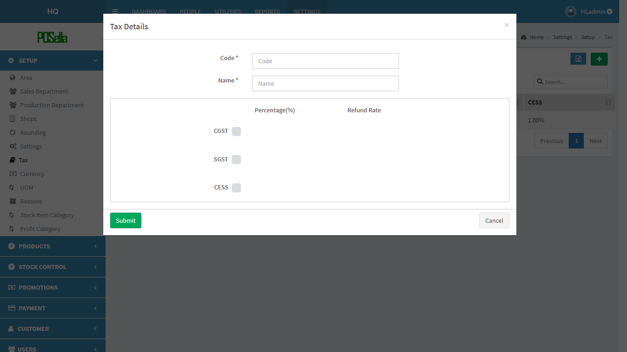

FIG 2.1.7.2 ADD TAX

Fill the blank fields and click submit button to create a new Tax. Otherwise click the cancel button. To **view**, **edit** and **delete** a particular Tax. Click on code in fig 2.1.7.1 . A pop up window appears:

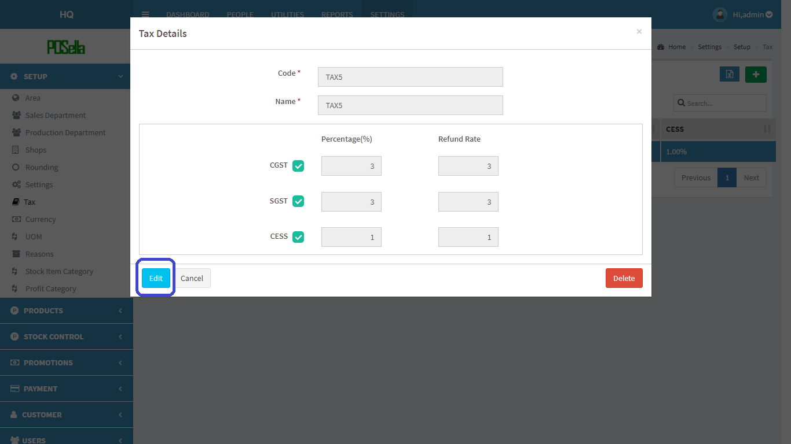

FIG 2.1.7.3 VIEW ROUNDING

Click **edit** to edit details. Another pop up window appears:

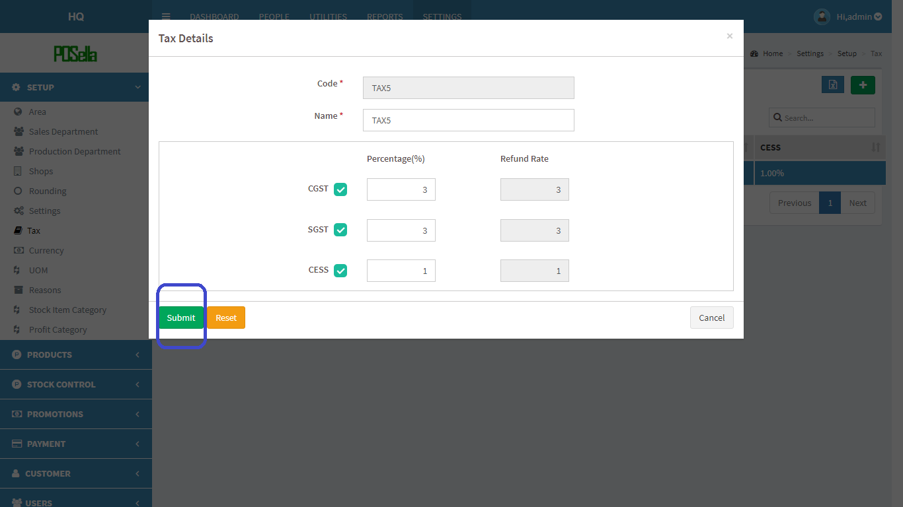

FIG2.1.7.4 EDIT TAX

Click submit button to update changes made. If you want to **delete** a Tax, click on the delete button in fig 2.1.7.3. When delete button is clicked, another pop-up appears:

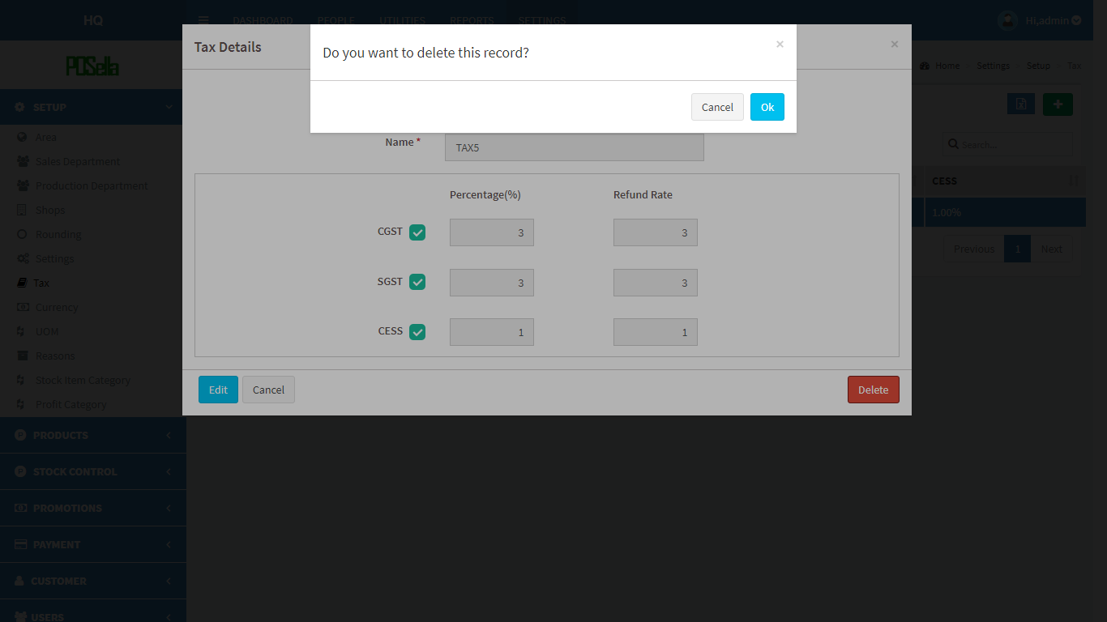

FIG 2.1.7.5 DELETE TAX

Confirm **delete** by clicking ‘OK’ otherwise cancel.

To **export** Tax list, click on the blue button  in the right corner. Then a pop up gets displayed .

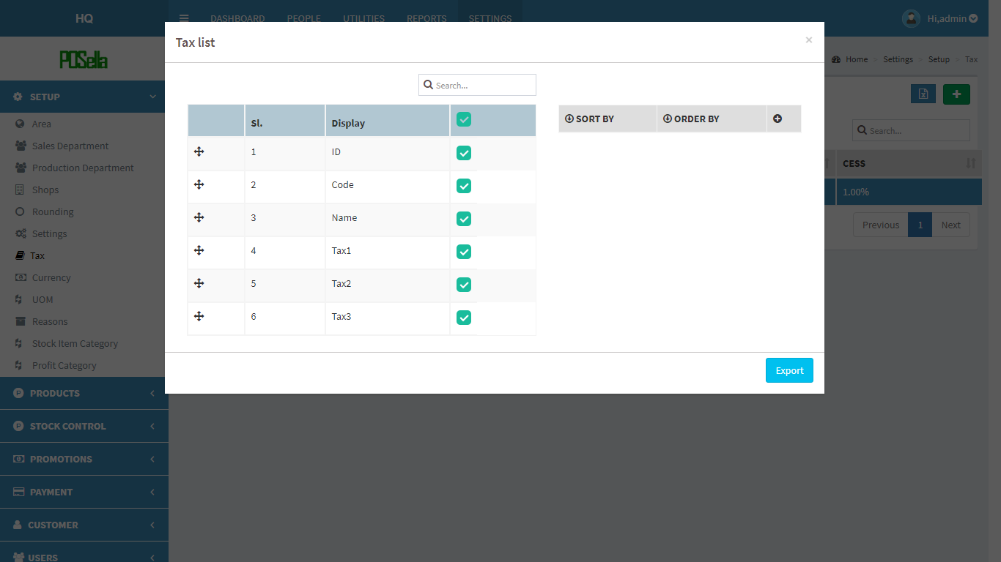

FIG 2.1.7.6 EXPORT EXCEL

Select the relevant options and click the ‘**export**’ button . The excel sheet gets downloaded.

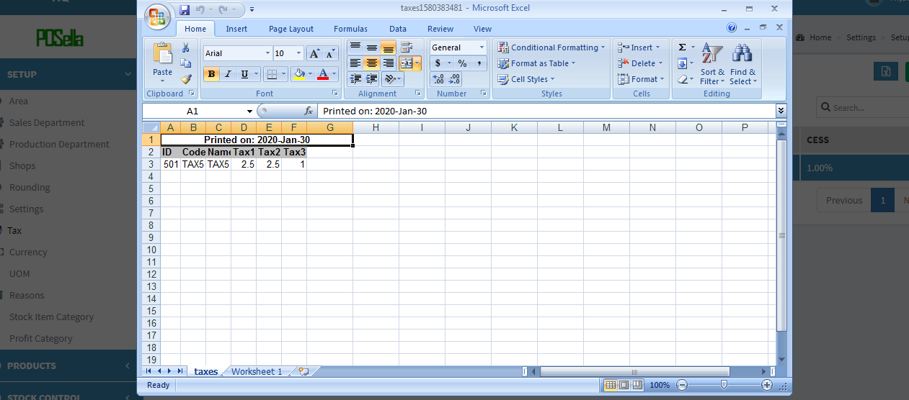

FIG 2.1.7.7 EXCEL REPORT

#### 2.1.8 CURRENCY

Click on the Currency, the list of Currencies gets displayed as shown in figure.

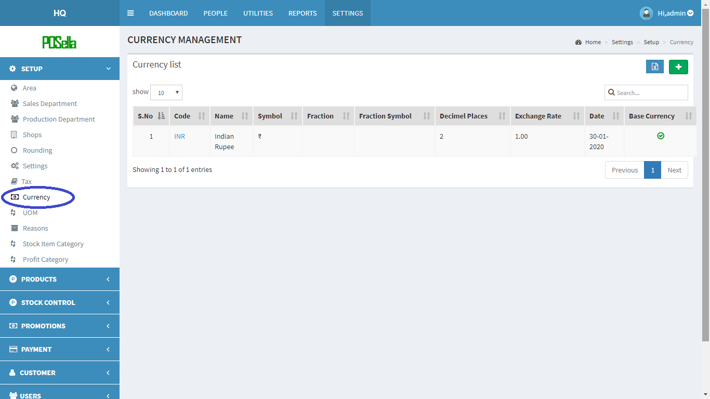

FIG 2.1.8.1 CURRENCY

To **add** a new Currency, at rightmost corner, you can see a  in green colour background. Click on the button to add rounding.

A pop up window appears:

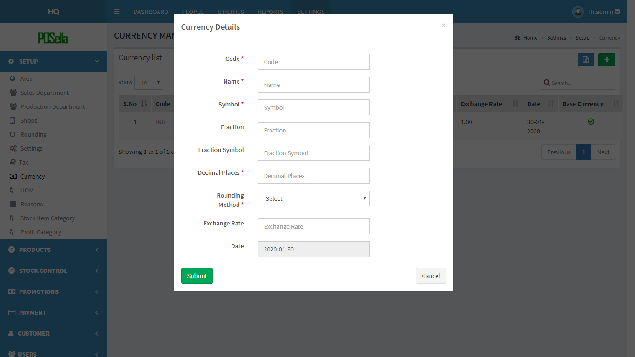

FIG 2.1.8.2 ADD CURRENCY

Fill the blank fields and click submit button to create a new Currency. Otherwise click the cancel button. To **view**, **edit** and **delete** a particular Currency. Click on code in fig 2.1.8.1 . A pop up window appears:

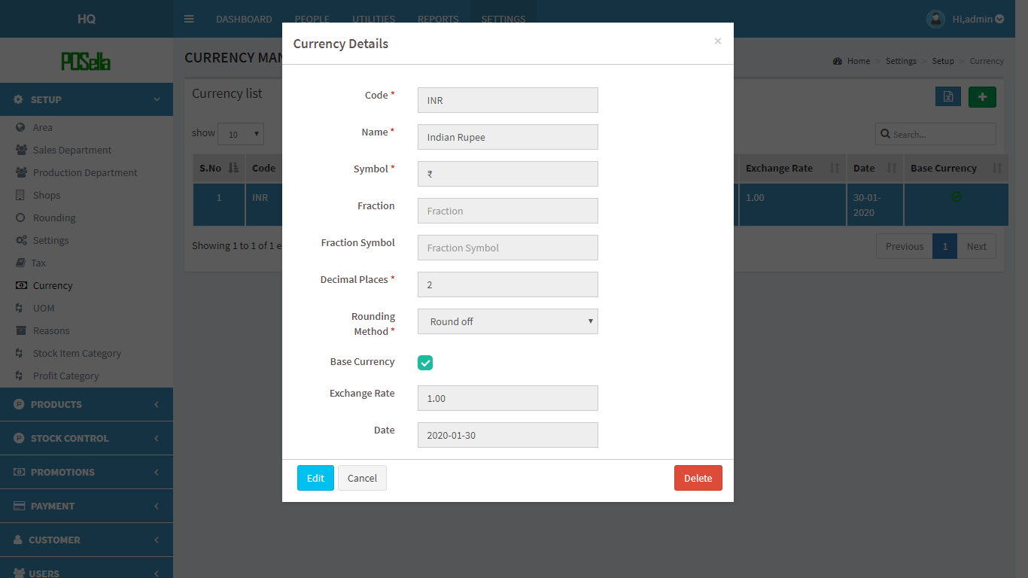

FIG 2.1.8.3 VIEW CURRENCY

Click **edit** to edit details. Another pop up window appears:

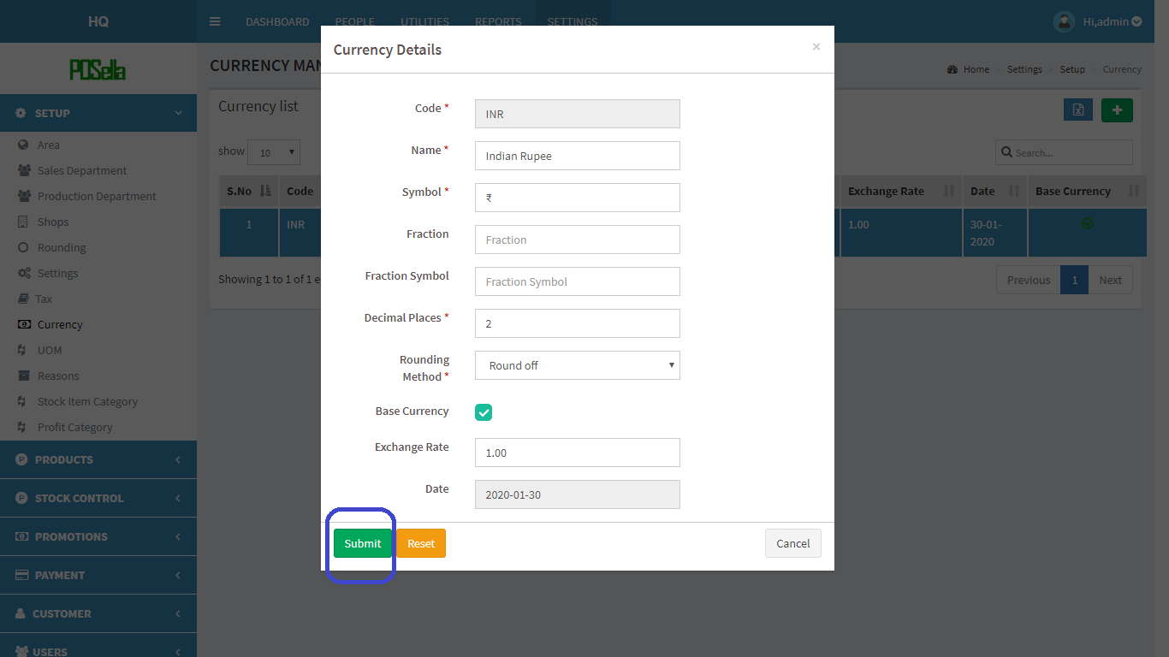

FIG2.1.8.4 EDIT CURRENCY

Click submit button to update changes made. If you want to **delete** a Currency, click on the delete button in fig 2.1.8.3. When delete button is clicked, another pop-up appears:

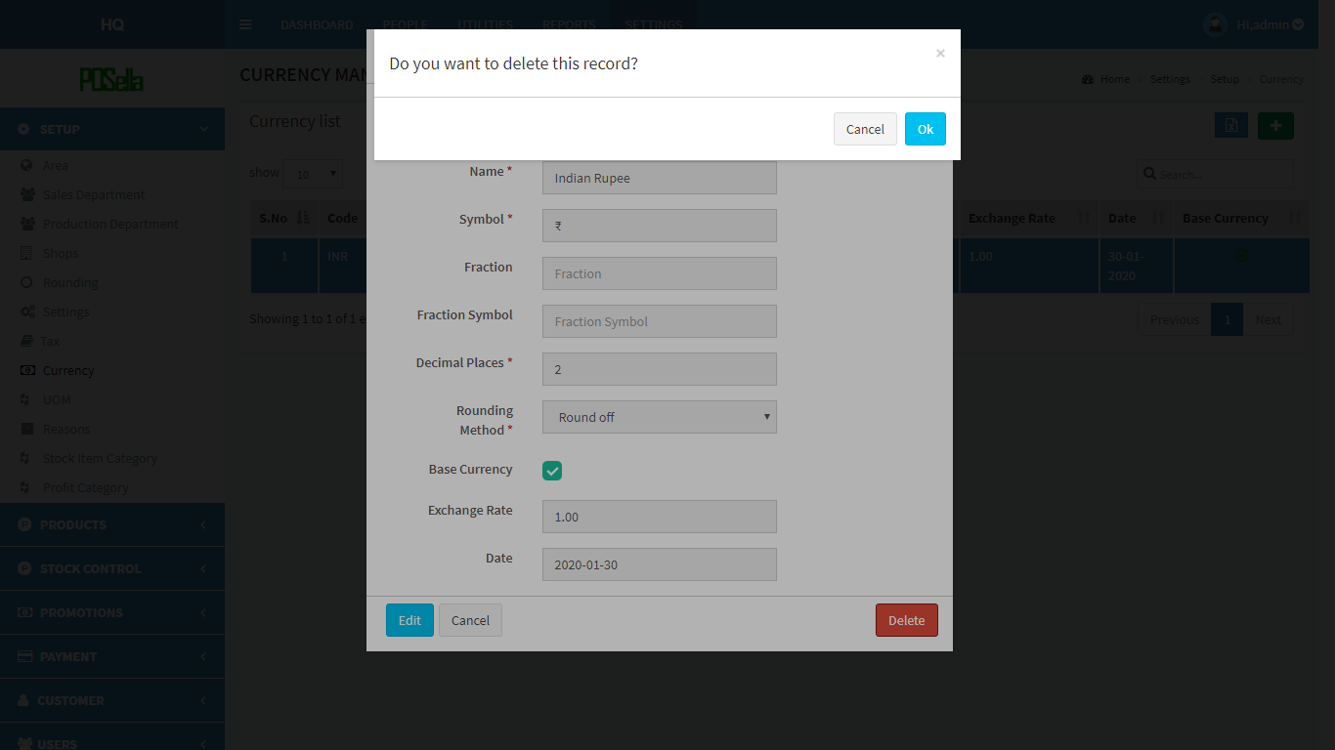

FIG 2.1.8.5 DELETE CURRENCY

Confirm **delete** by clicking ‘OK’ otherwise cancel.

To **export** currency list, click on the blue button  in the right corner. Then a pop up gets displayed .

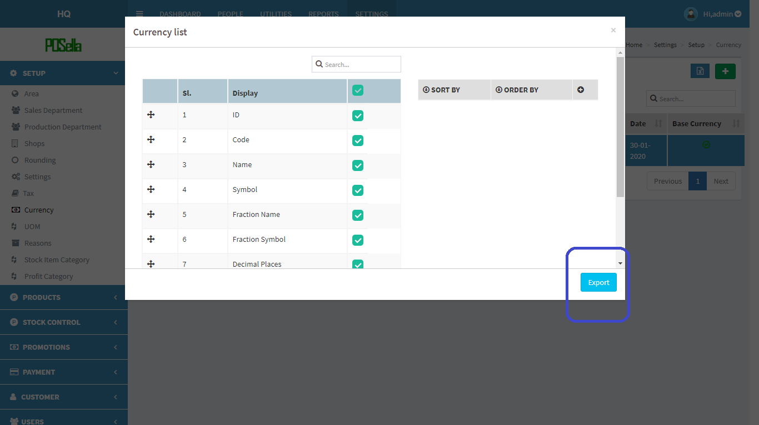

FIG 2.1.8.6 EXPORT EXCEL

Select the relevant options and click the ‘**export**’ button . The excel sheet gets downloaded.

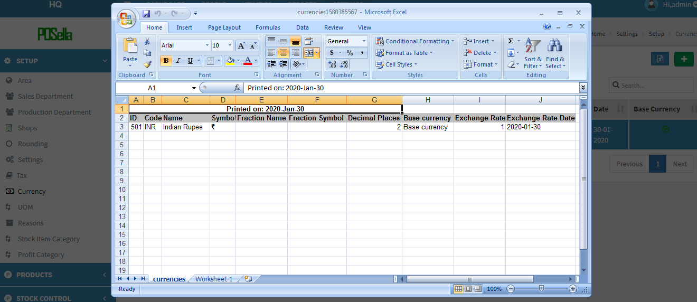

FIG 2.1.8.7 EXCEL REPORT

#### 2.1.9 TERMINAL

Click on the Terminal, the list of Terminals gets displayed as shown in figure. Terminal is an option available only in the **Shop** and not in HQ

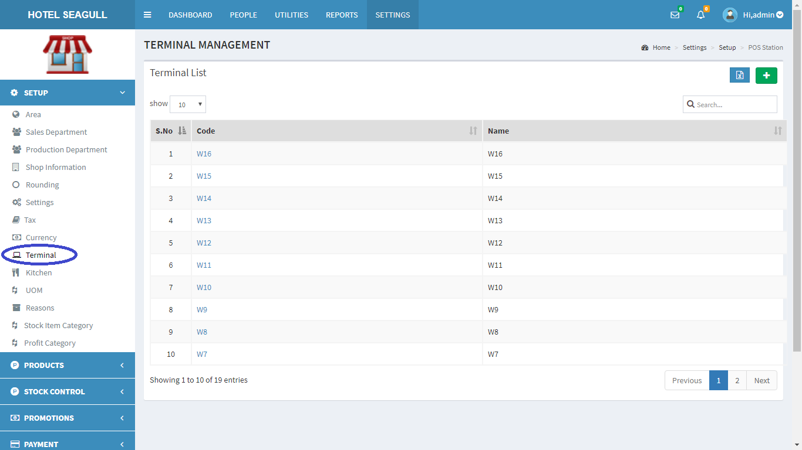

FIG 2.1.9.1 TERMINAL

To **add** a new Terminal, at rightmost corner, you can see a  in green colour background. Click on the button to add Terminal.

A pop up window appears:

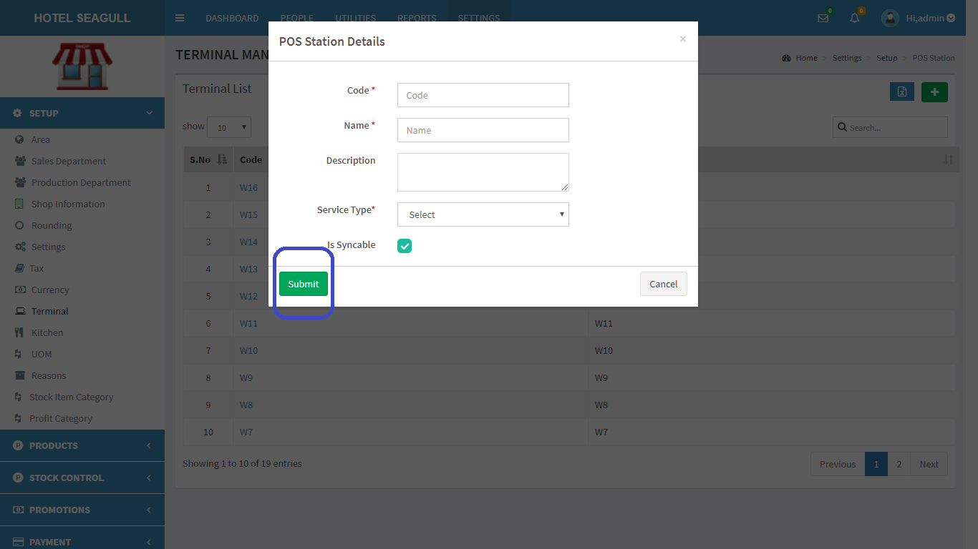

FIG 2.1.9.2 ADD TERMINAL

Fill the blank fields and click submit button to create a new Terminal. Otherwise click the cancel button. To **view**, **edit** and **delete** a particular Terminal. Click on code in fig 2.1.9.1 . A pop up window appears:

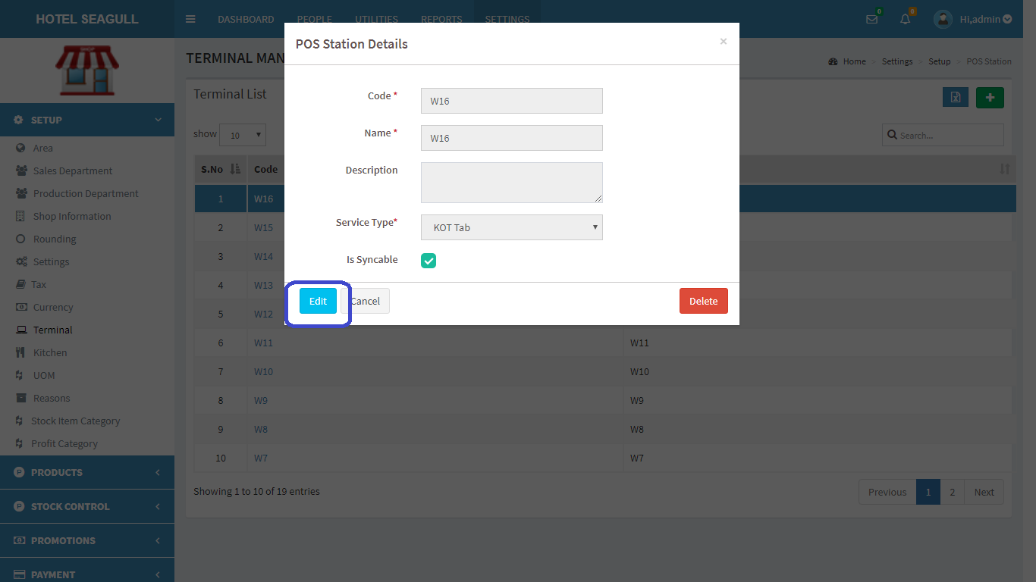

FIG 2.1.9.3 VIEW TERMINAL

Click **edit** to edit details. Another pop up window appears:

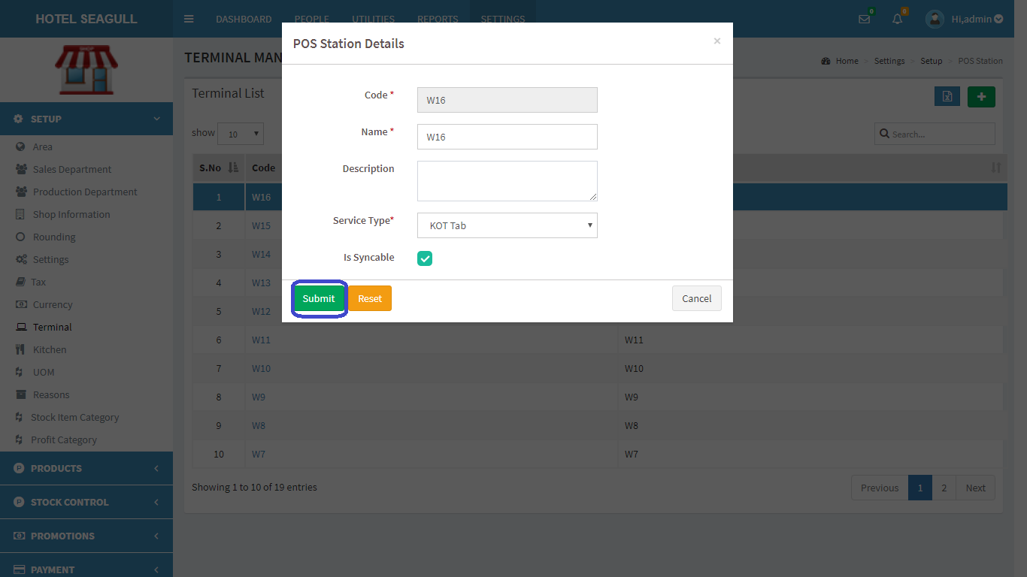

FIG2.1.9.4 EDIT TERMINAL

Click submit button to update changes made. If you want to **delete** a Terminal, click on the delete button in fig 2.1.9.3. When delete button is clicked, another pop-up appears:

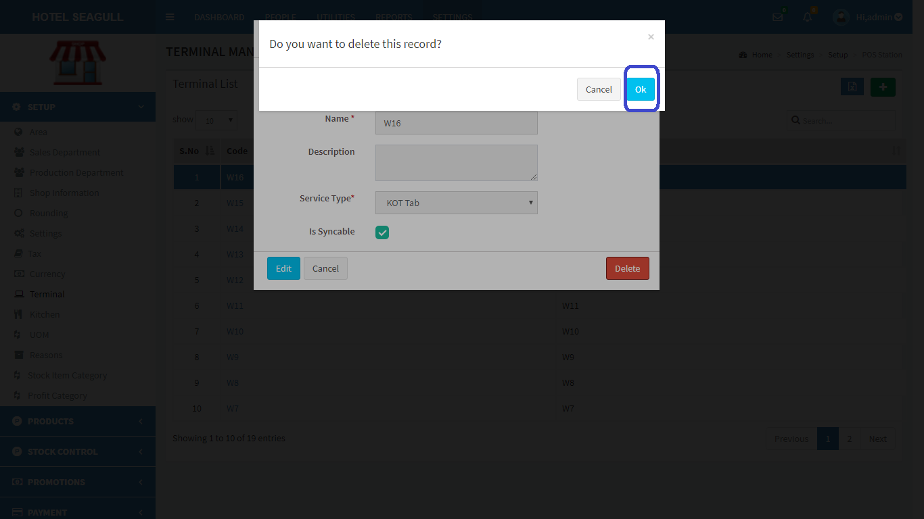

FIG 2.1.9.5 DELETE TERMINAL

Confirm **delete** by clicking ‘OK’ otherwise cancel.

To **export** Terminal list, click on the blue button  in the right corner. Then a pop up gets displayed .

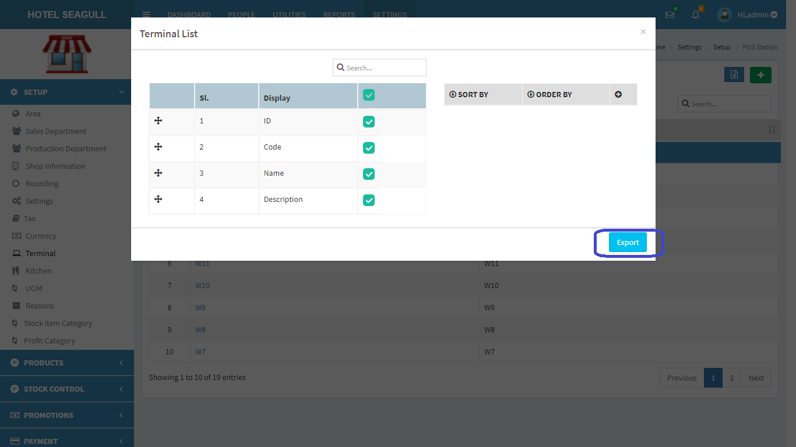

FIG 2.1.9.6 EXPORT EXCEL

Select the relevant options and click the ‘**export**’ button . The excel sheet gets downloaded.

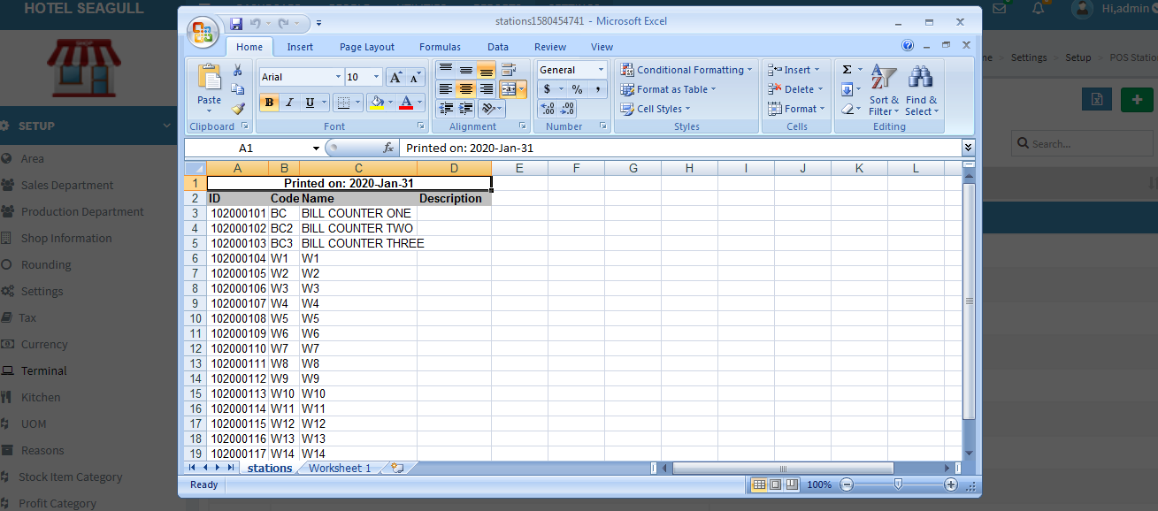

FIG 2.1.9.7 EXCEL REPORT

#### 2.1.10 KITCHEN

Click on the Kitchen, the list of kitchens gets displayed as shown in figure. Kitchen is an option available only in the **Shop** and not in HQ.

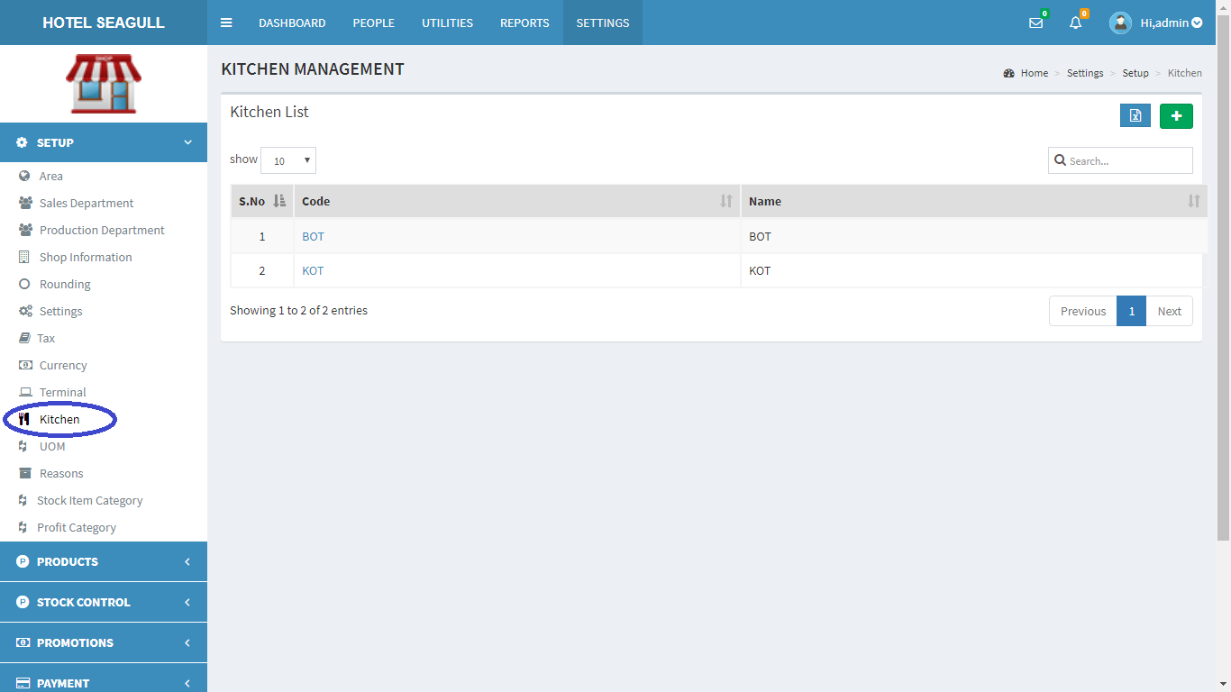

FIG 2.1.10.1 KITCHEN.

To **add** a new Kitchen, at rightmost corner, you can see a  in green colour background. Click on the button to add Kitchen.

A pop up window appears:

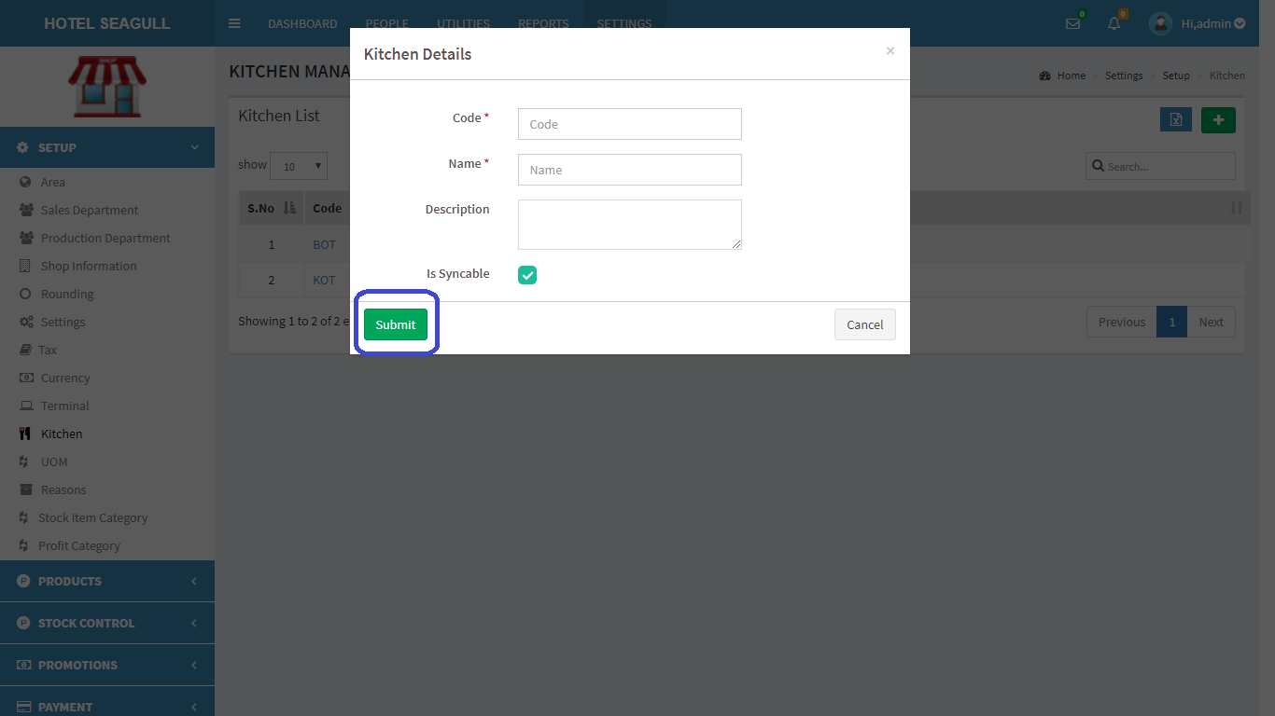

FIG 2.1.10.2 ADD KITCHEN

Fill the blank fields and click submit button to create a new Kitchen. Otherwise click the cancel button. To **view**, **edit** and **delete** a particular Kitchen. Click on code in fig 2.1.10.1 . A pop up window appears:

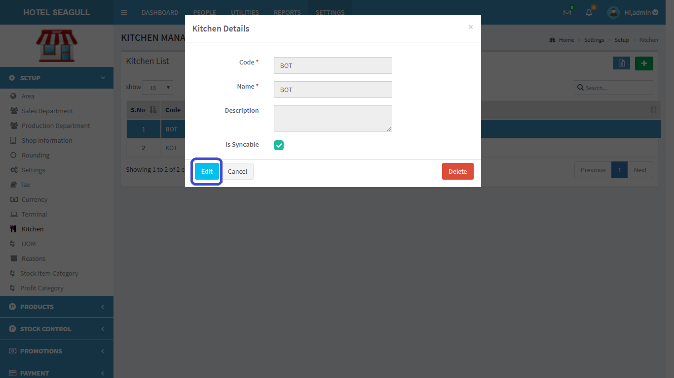

FIG 2.1.10.3 VIEW KITCHEN

Click **edit** to edit details. Another pop up window appears:

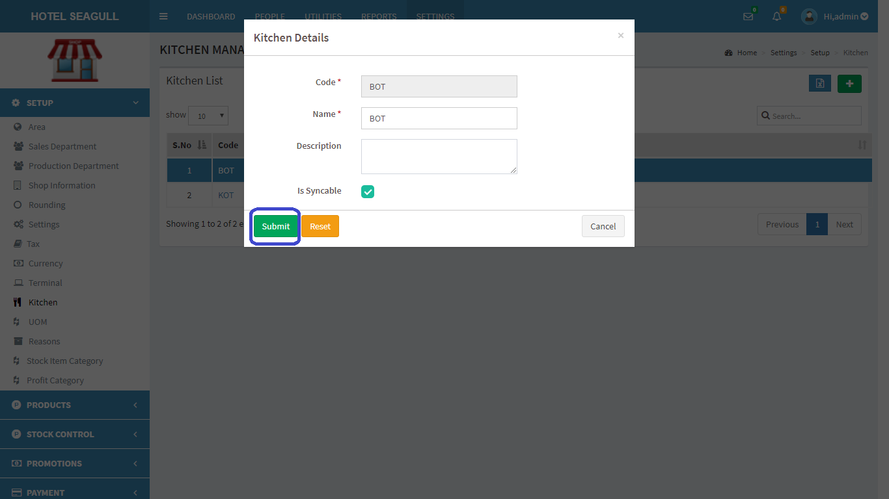

FIG2.1.10.4 EDIT KITCHEN

Click submit button to update changes made. If you want to **delete** a Kitchen, click on the delete button in fig 2.1.10.3. When delete button is clicked, another pop-up appears:



FIG 2.1.10.5 DELETE KITCHEN

Confirm **delete** by clicking ‘OK’ otherwise cancel.

To **export** kitchen list, click on the blue button  in the right corner. Then a pop up gets displayed .

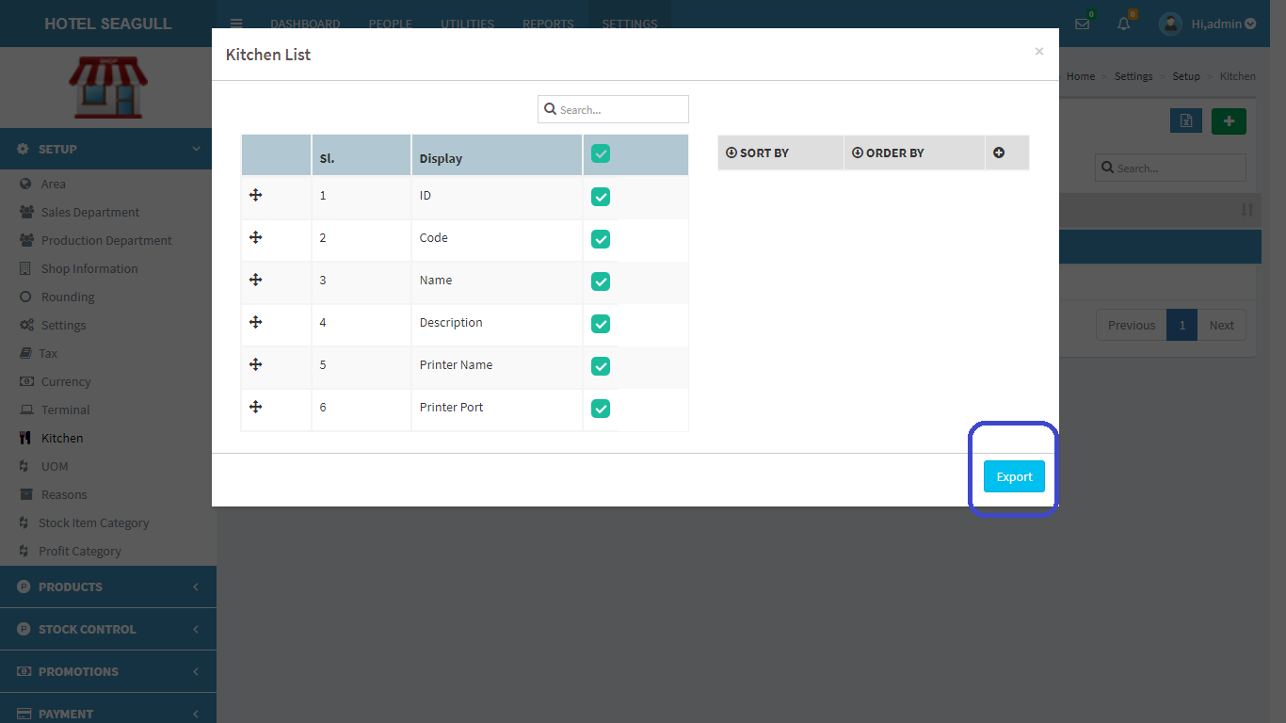

FIG 2.1.10.6 EXPORT EXCEL

Select the relevant options and click the ‘**export**’ button . The excel sheet gets downloaded.

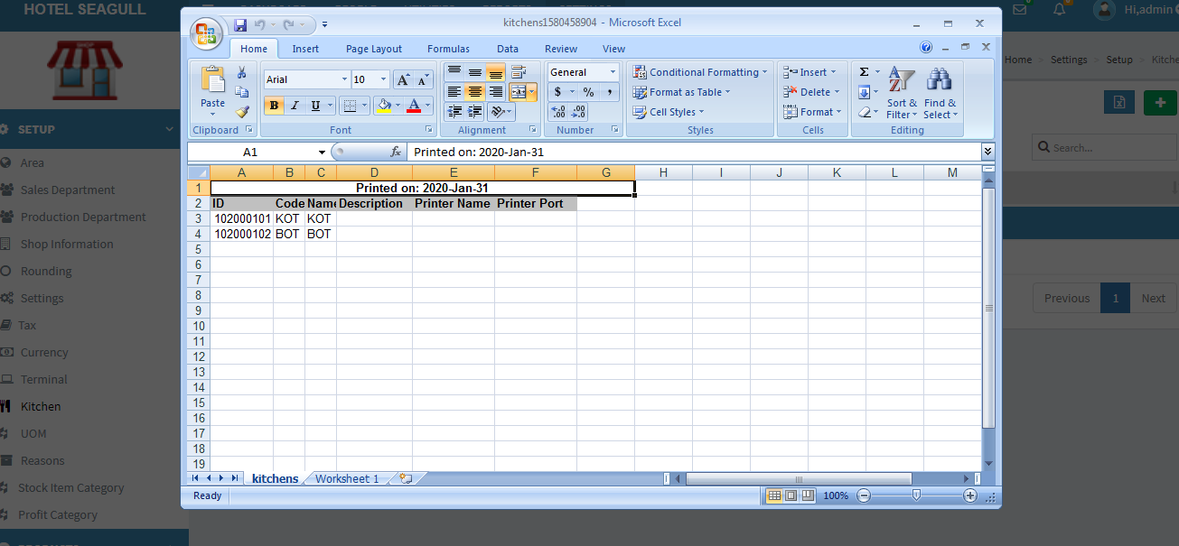

FIG 2.1.10.7 EXCEL REPORT

#### 2.1.11 UNIT OF MEASURE(UOM)

Click on the UOM, the list of UOM gets displayed as shown in figure. UOM is an option available in both **Shop** and  **HQ**. UOM are used to quantify the inventory items and enables them to track them. It's a physical unit (like kg, dozen, meter etc.) in which we measure and manage different items.

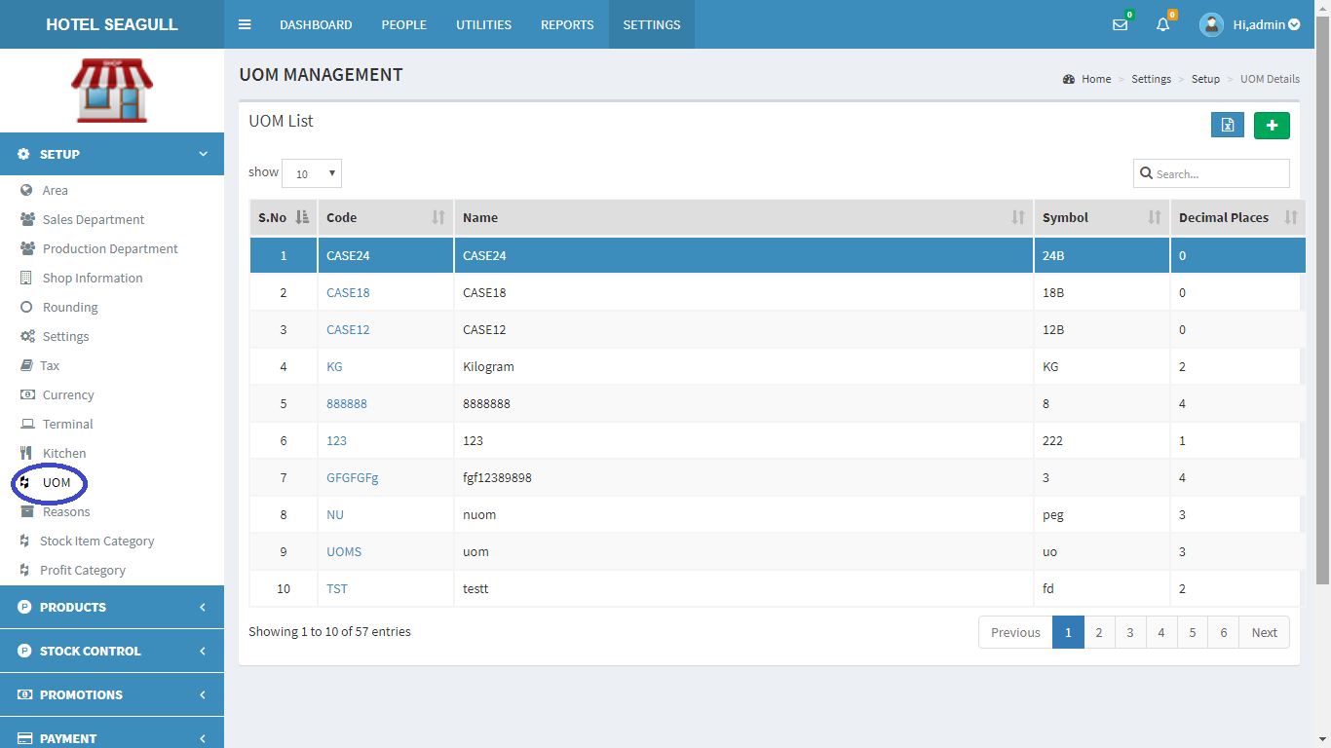

FIG 2.1.11.1 UOM

To **add** a new UOM, at rightmost corner, you can see a  in green colour background. Click on the button to add UOM.

A pop up window appears:

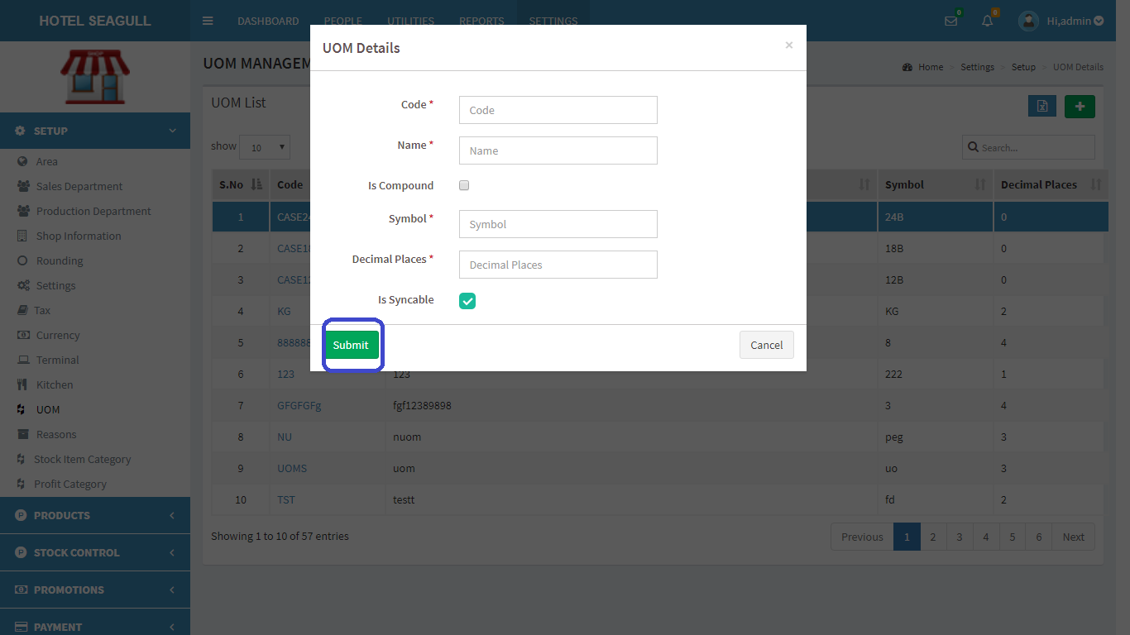

FIG 2.1.11.2 ADD UOM

Fill the blank fields and click submit button to create a new UOM. Otherwise click the cancel button. To **view**, **edit** and **delete** a particular UOM. Click on code in fig 2.1.11.1 . A pop up window appears:

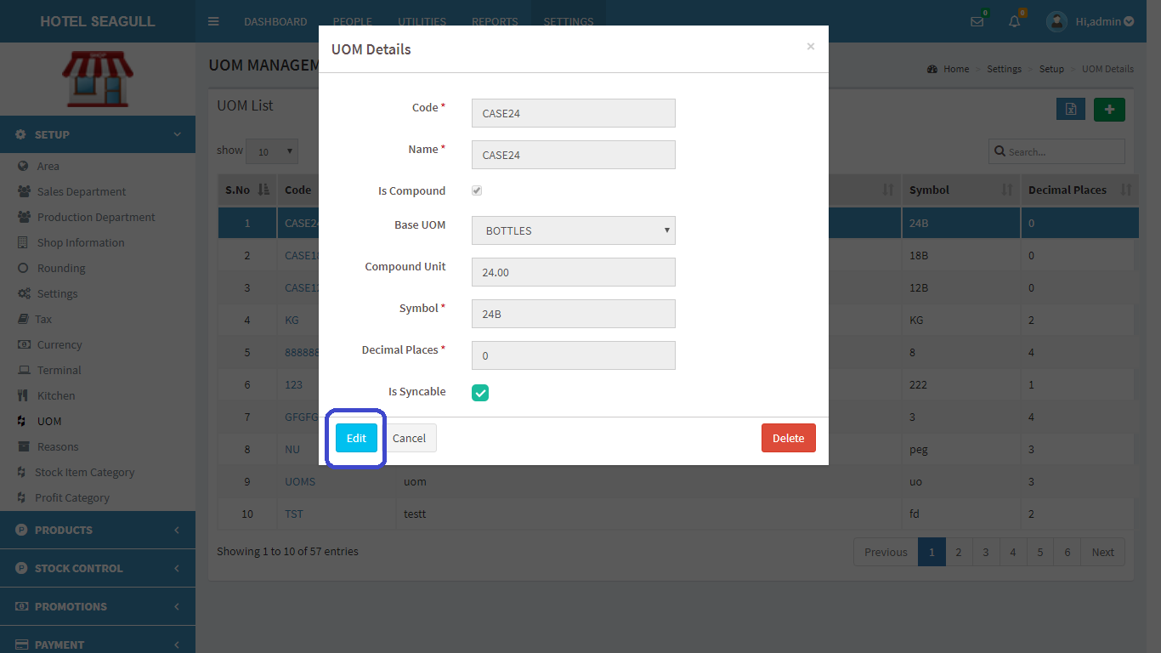

FIG 2.1.11.3 VIEW UOM

Click **edit** to edit details. Another pop up window appears:

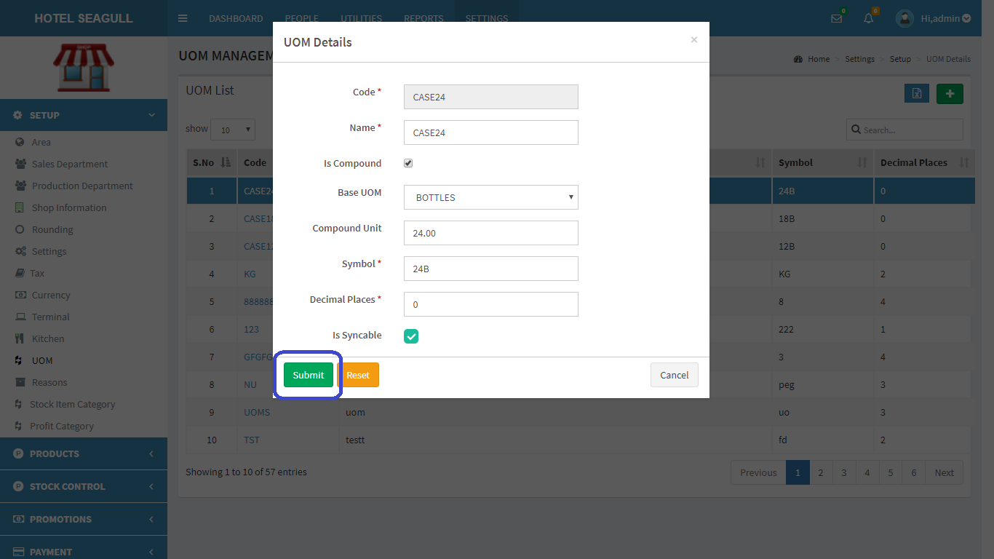

FIG2.1.11.4 EDIT UOM

Click submit button to update changes made. If you want to **delete** a UOM, click on the delete button in fig 2.1.11.3. When delete button is clicked, another pop-up appears:

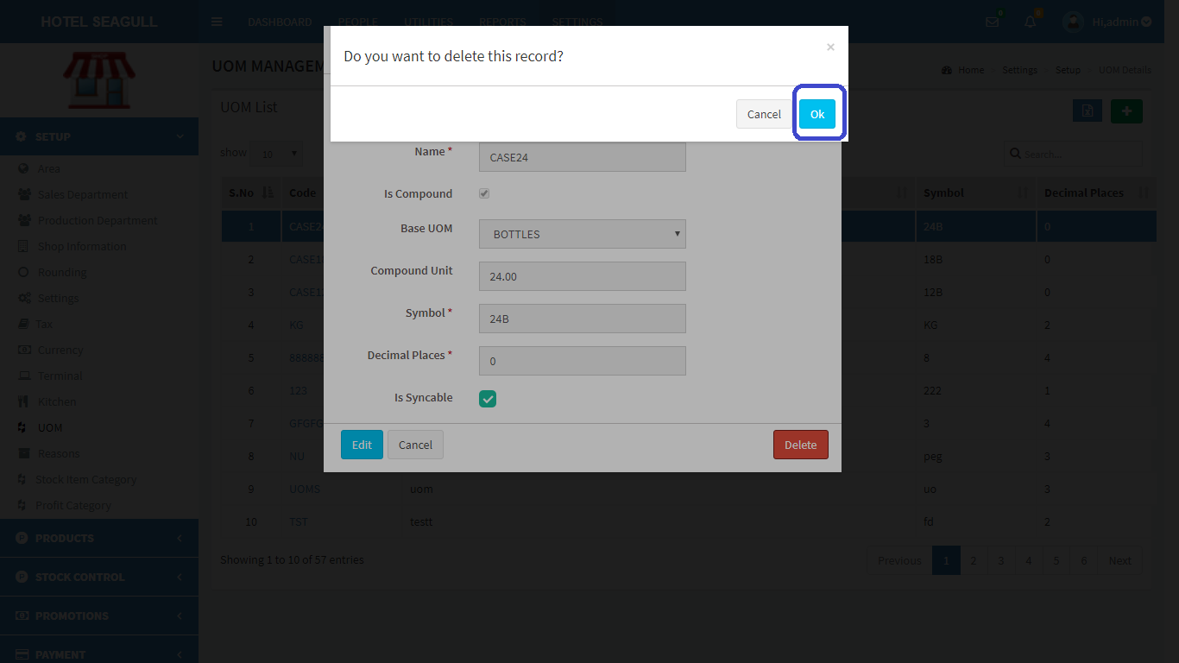

FIG 2.1.11.5 DELETE UOM

Confirm **delete** by clicking ‘OK’ otherwise cancel.

To **export** UOM list, click on the blue button  in the right corner. Then a pop up gets displayed .

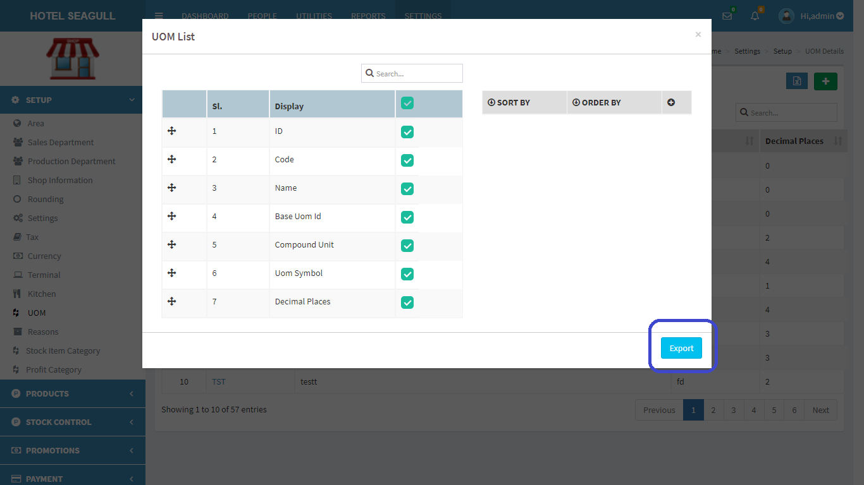

FIG 2.1.11.6 EXPORT EXCEL

Select the relevant options and click the ‘**export**’ button . The excel sheet gets downloaded.

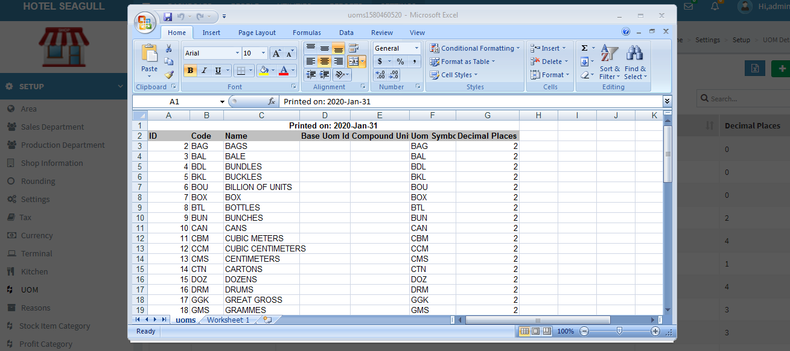

FIG 2.1.11.7 EXCEL REPORT

#### 2.1.12 REASONS

Click on Reasons, the list of Reasons gets displayed as shown in figure. Reasons can be of different types like reason for discount, reason for refund etc.

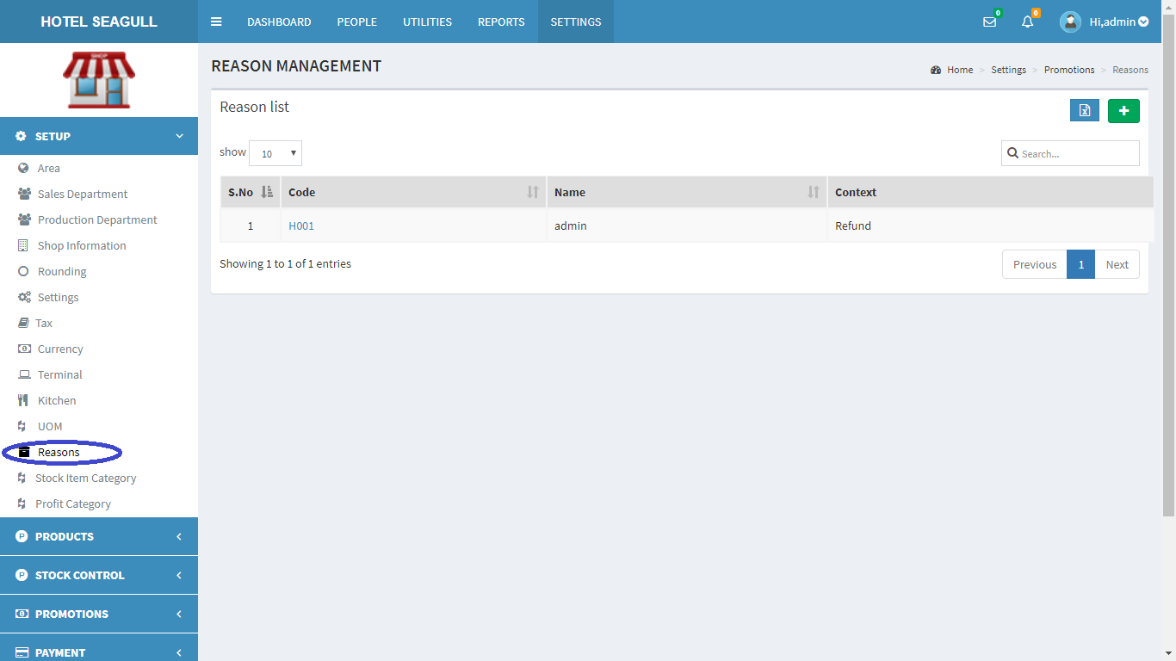

FIG 2.1.12.1 REASON

To **add** a new Reason, at rightmost corner, you can see a  in green colour background. Click on the button to add Reason.

A pop up window appears:

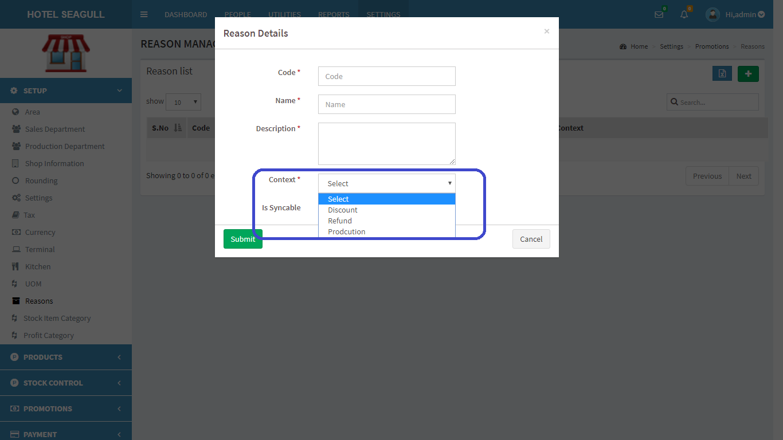

FIG 2.1.12.2 ADD REASON

Fill the blank fields and click submit button to create a new Reason. The field circled in blue color is the ‘context’ which has some options like reason for discount, refund or production. Otherwise click the cancel button. To **view**, **edit** and **delete** a particular Reason, click on the code in fig 2.1.12.1 . A pop up window appears:

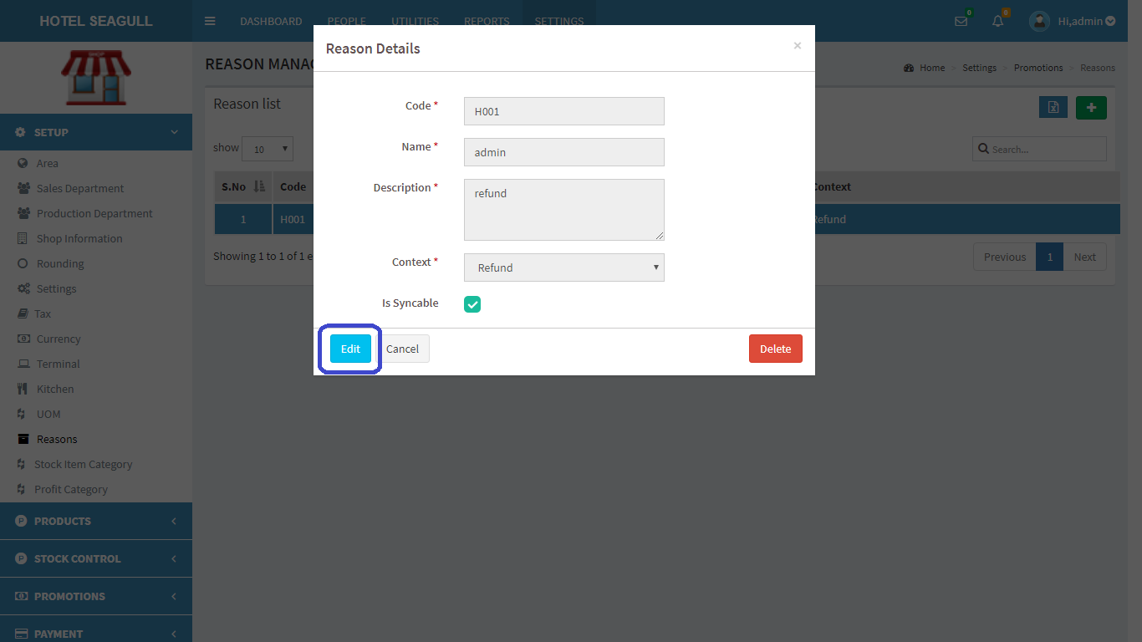

FIG 2.1.12.3 VIEW REASON

Click **edit** to edit details. Another pop up window appears:

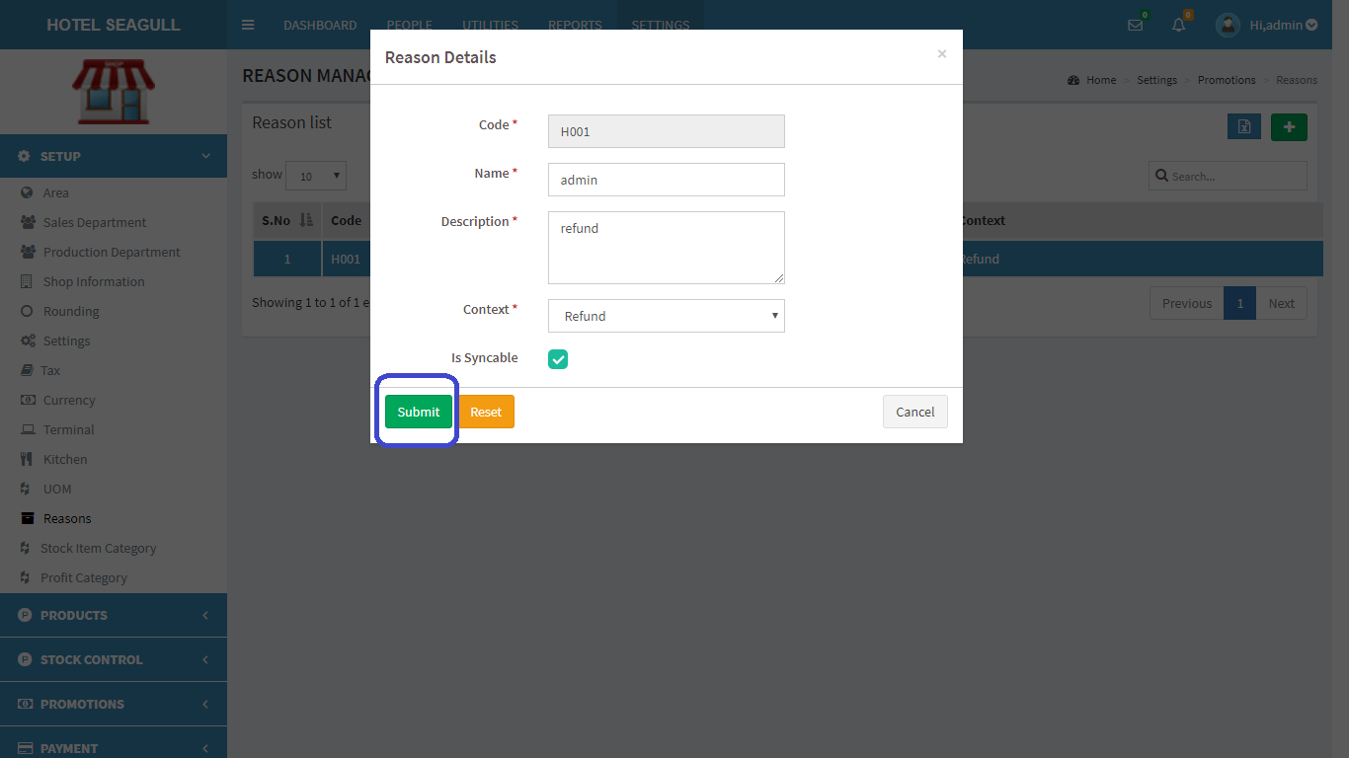

FIG 2.1.12.4 EDIT REASON

Click submit button to update changes made. If you want to **delete** a Reason, click on the delete button in fig 2.1.12.3. When delete button is clicked, another pop-up appears:

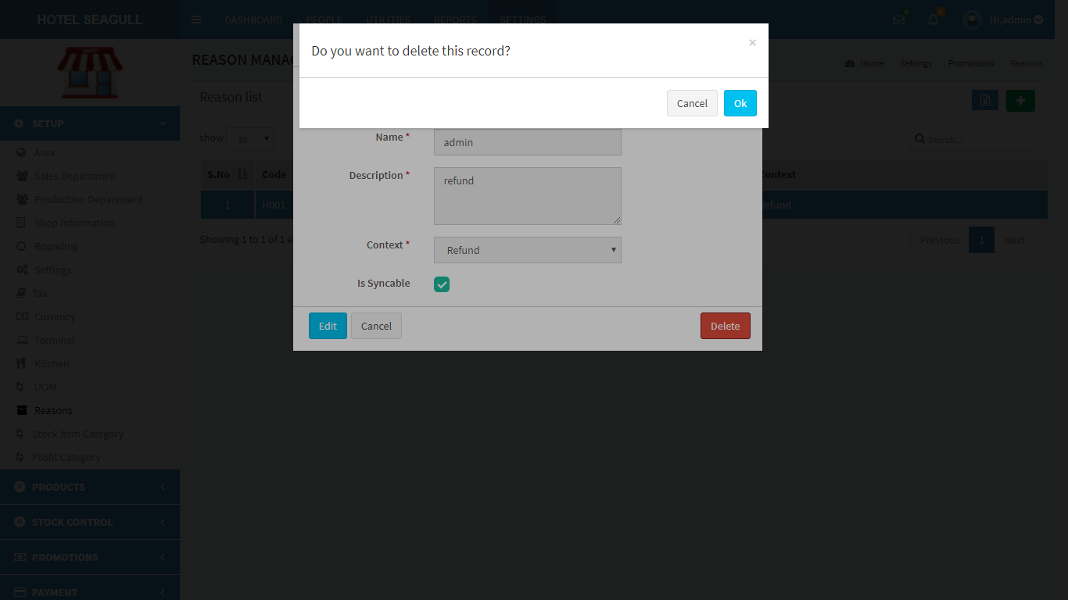

FIG 2.1.12.5 DELETE REASON

Confirm **delete** by clicking ‘OK’ otherwise cancel.

To **export** Reason list, click on the blue button  in the right corner. Then a pop up gets displayed .

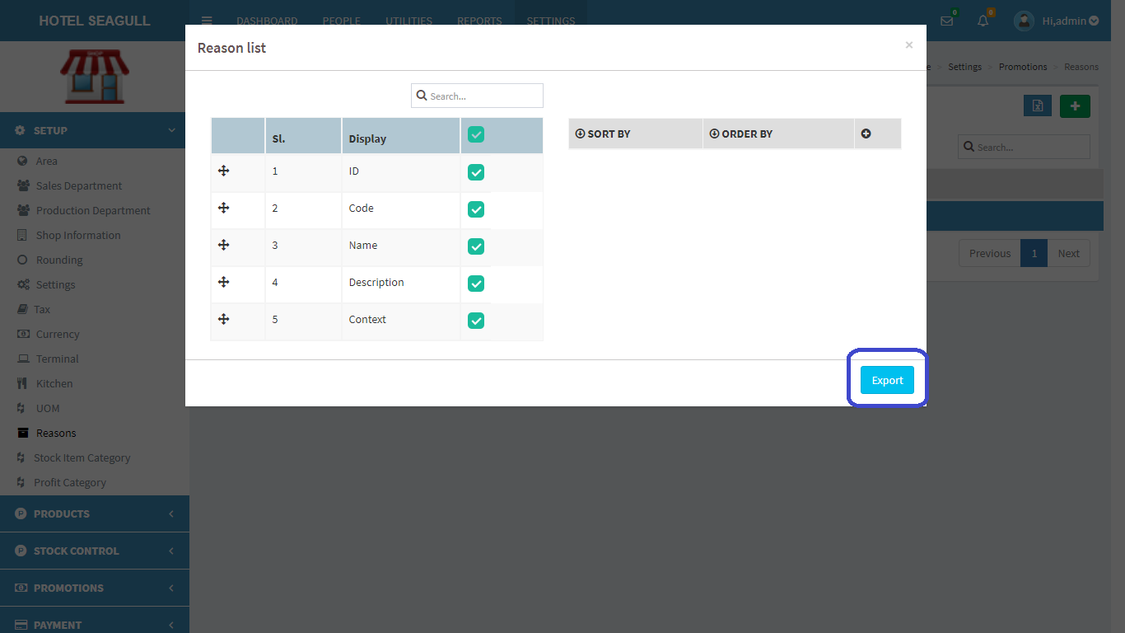

FIG 2.1.12.6 EXPORT EXCEL

Select the relevant options and click the ‘**export**’ button . The excel sheet gets downloaded.

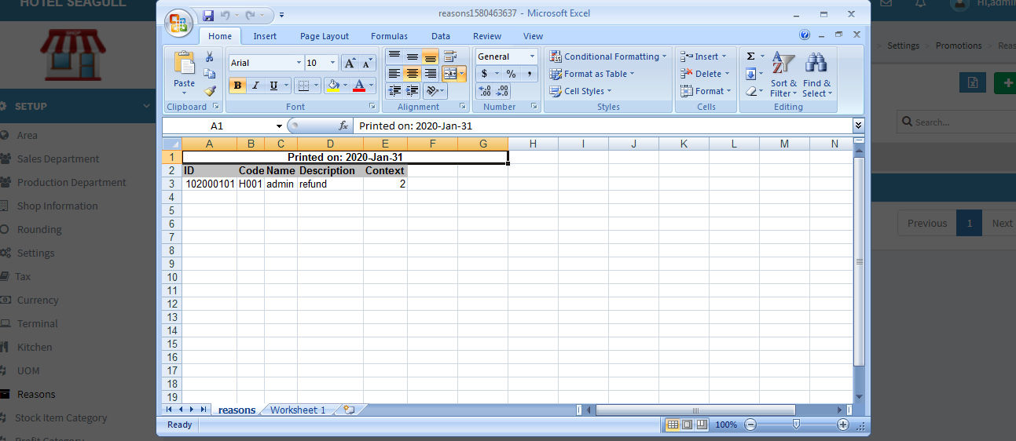

FIG 2.1.12.7 EXCEL REPORT

#### 2.1.13 STOCK ITEM CATEGORY

Click on the Stock item category, the list of stock gets displayed as shown in figure.

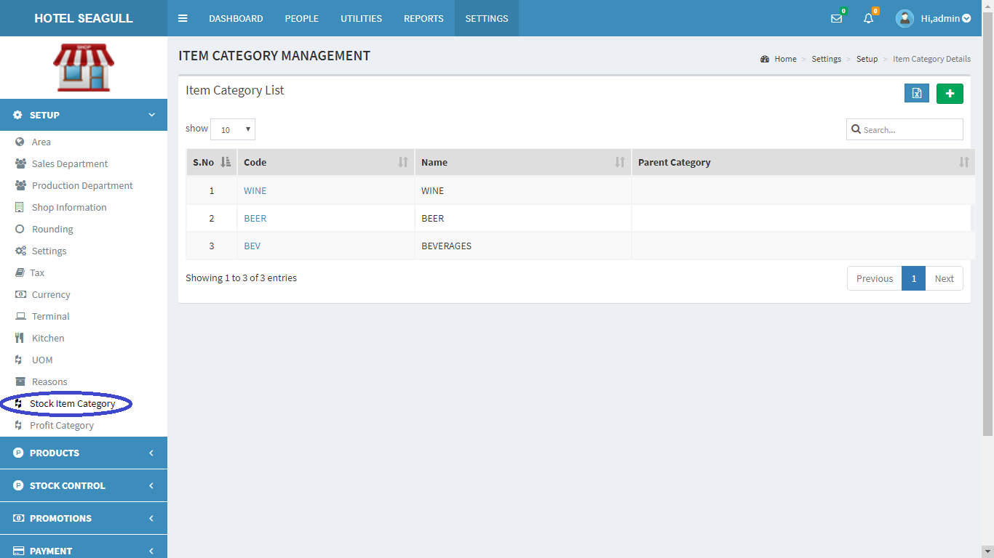

FIG 2.1.13.1 STOCK ITEM CATEGORY

To **add** a new stock item, at rightmost corner, you can see a  in green colour background. Click on the button to add stock items.

A pop up window appears:

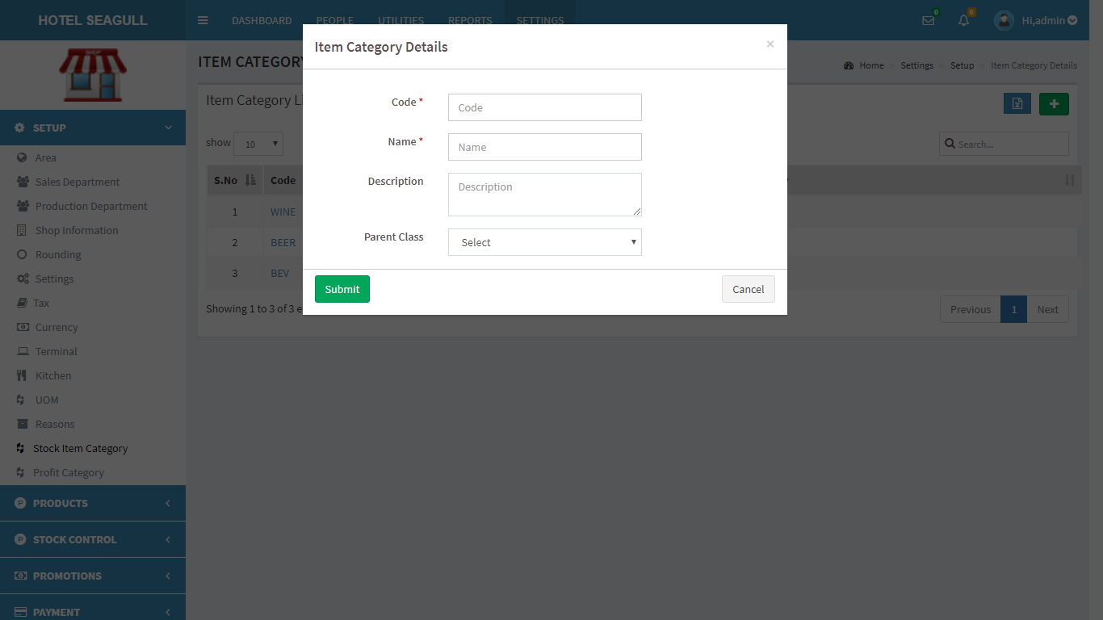

FIG 2.1.13.2 ADD STOCK ITEM

Fill the blank fields and click submit button to create a new stock item. To **view**, **edit** and **delete** a particular stock item, click on the code in fig 2.1.13.1 . A pop up window appears:

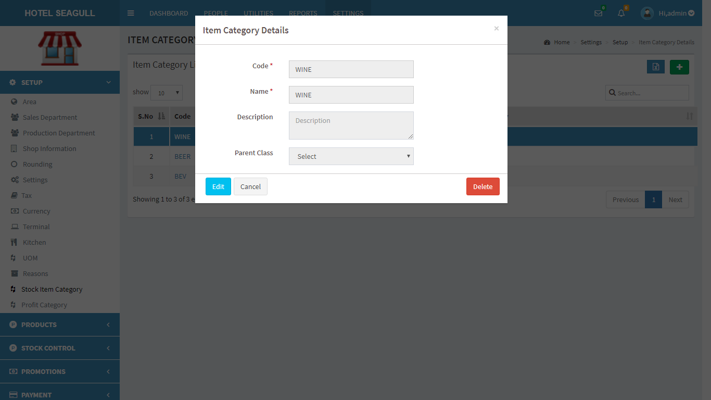

FIG 2.1.13.3 VIEW STOCK ITEM CATEGORY

Click **edit** to edit details. Another pop up window appears:

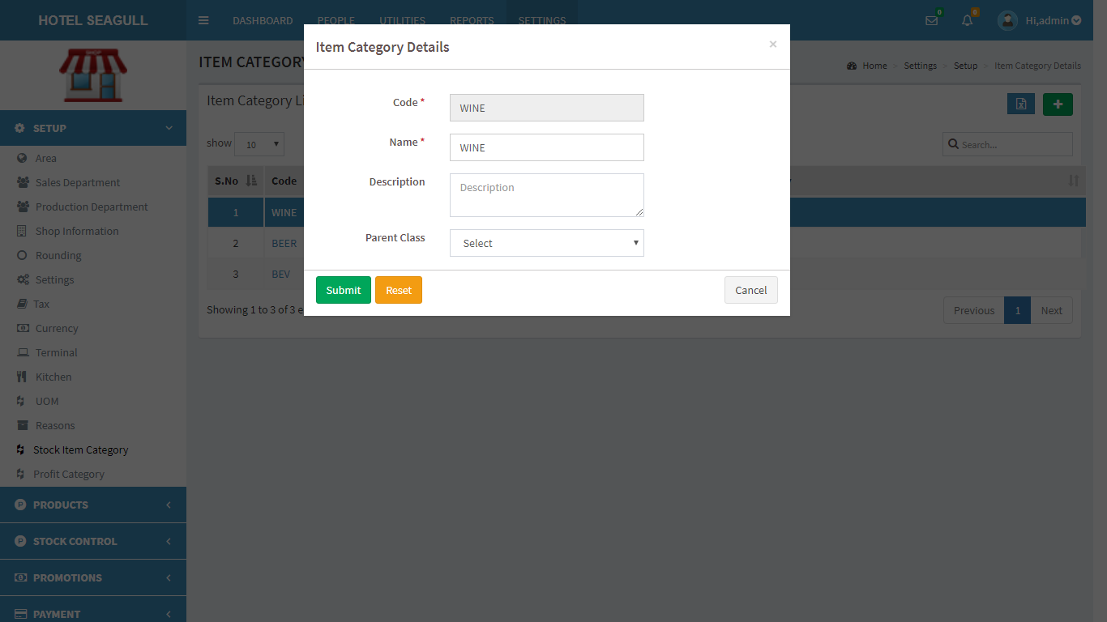

FIG 2.1.13.4 EDIT STOCK ITEM

Click submit button to update changes made. If you want to **delete** a stock, click on the delete button in fig 2.1.13.3. When delete button is clicked, another pop-up appears:

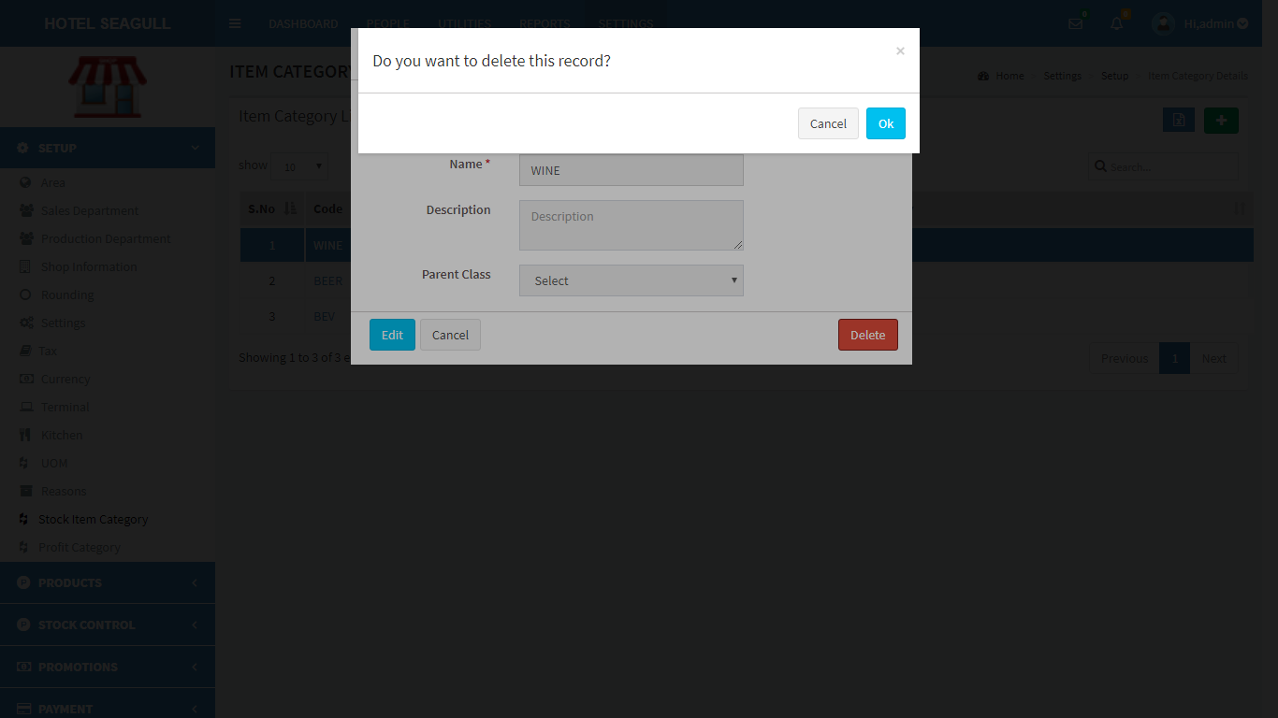

FIG 2.1.13.5 DELETE STOCK ITEM

Confirm **delete** by clicking ‘OK’ otherwise cancel.

To **export** stock item list, click on the blue button  in the right corner. Then a pop up gets displayed .

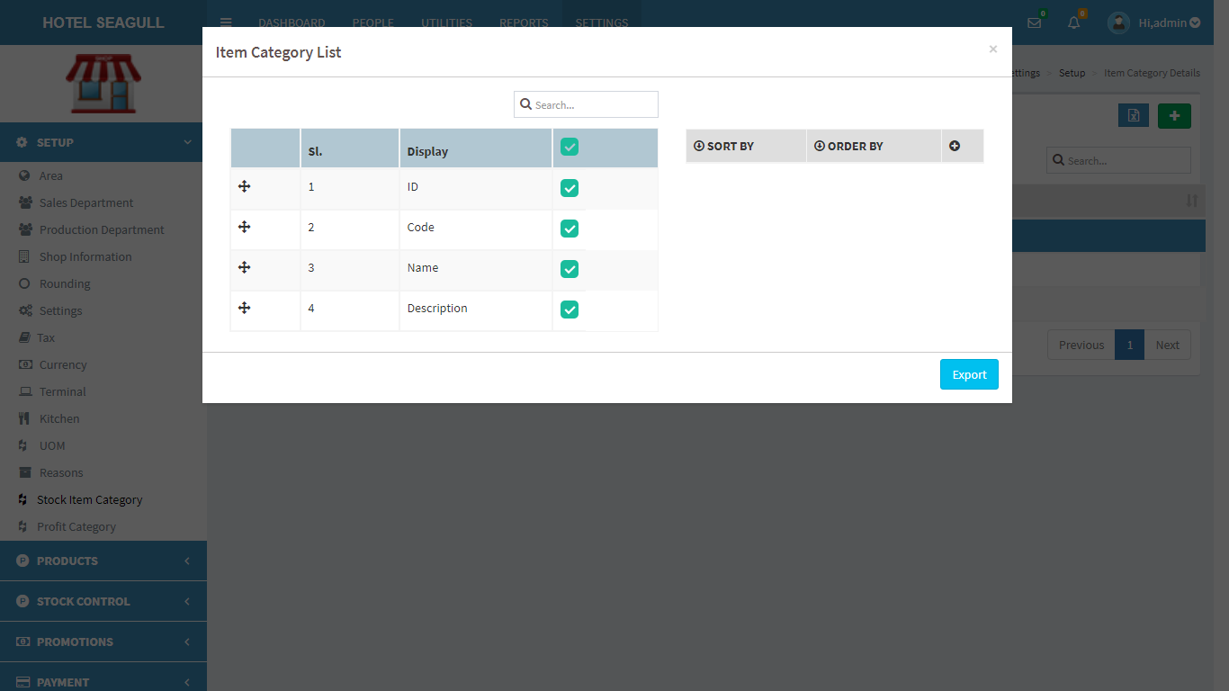

FIG 2.1.13.6 EXPORT EXCEL

Select the relevant options and click the ‘**export**’ button . The excel sheet gets downloaded.

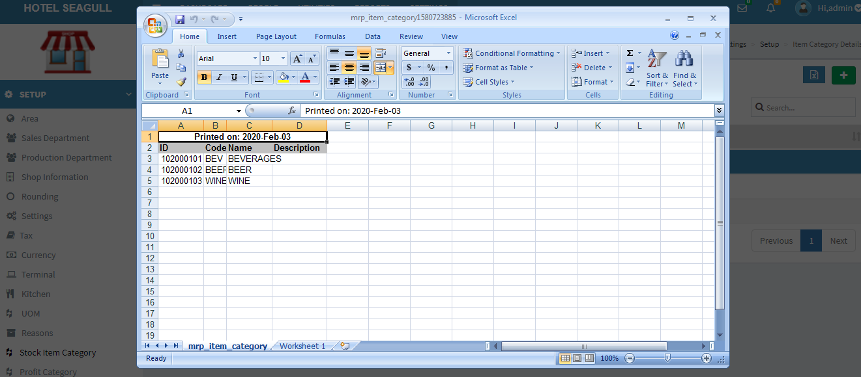

FIG 2.1.13.7 EXCEL REPORT

#### 2.1.14 PROFIT CATEGORY

Click on the Profit category, the list of profits gets displayed as shown in figure.

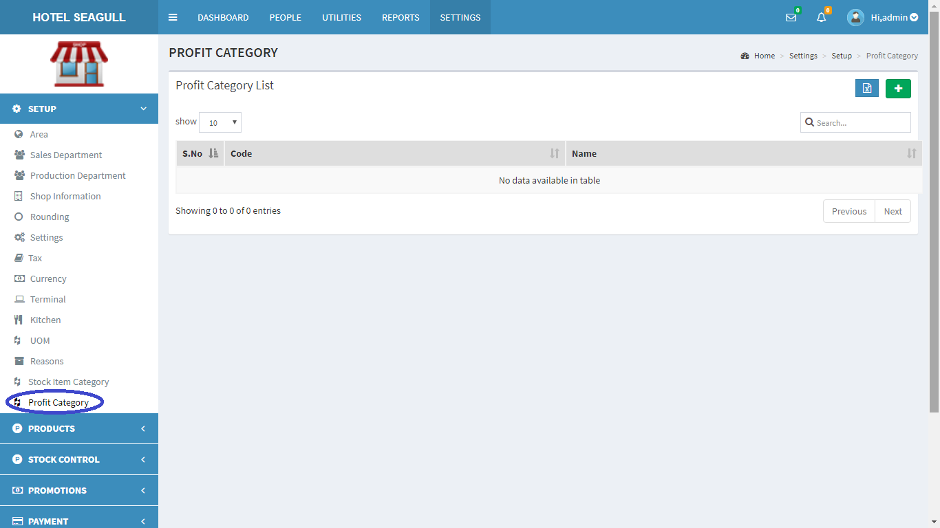

FIG 2.1.14.1 PROFIT CATEGORY

To **add** a new profit, at rightmost corner, you can see a  in green colour background. Click on the button to add profit.

A pop up window appears:

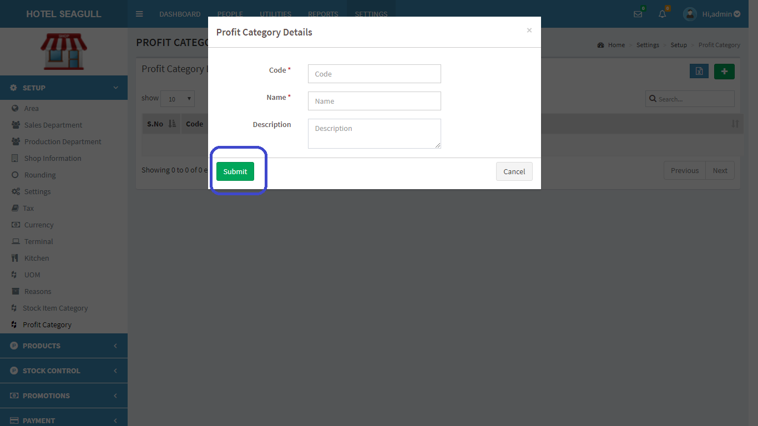

FIG 2.1.14.2 ADD PROFIT

Fill the blank fields and click submit button to create a new profit. To **view**, **edit** and **delete** a particular profit, click on the code in fig 2.1.14.1 . A pop up window appears:

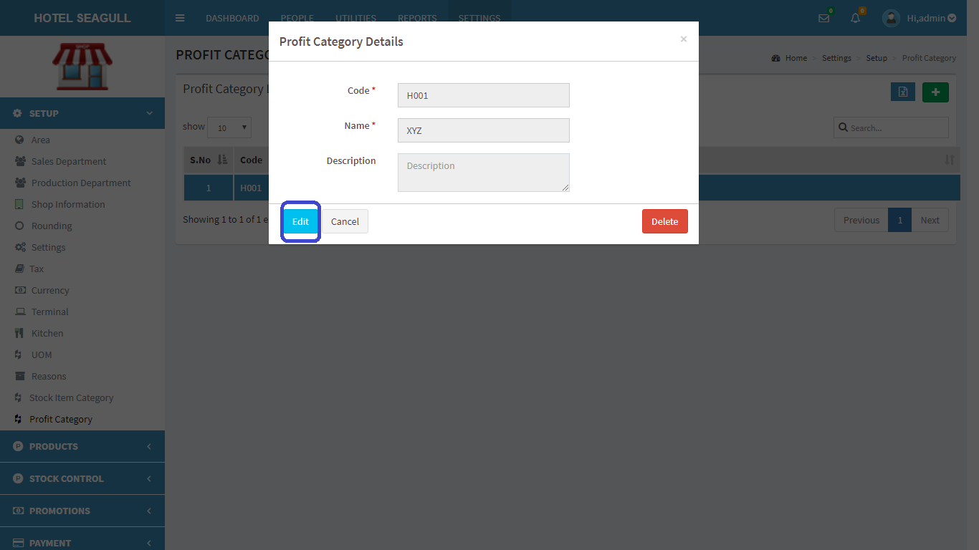

FIG 2.1.14.3 VIEW PROFIT CATEGORY

Click **edit** to edit details. Another pop up window appears:

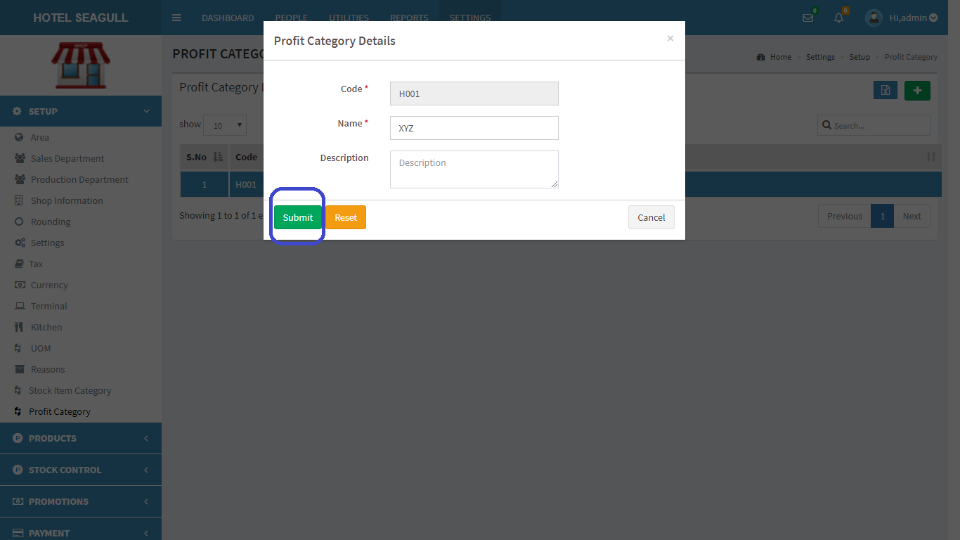

FIG 2.1.14.4 EDIT PROFIT

Click submit button to update changes made. If you want to **delete** a profit, click on the delete button in fig 2.1.14.3. When delete button is clicked, another pop-up appears:

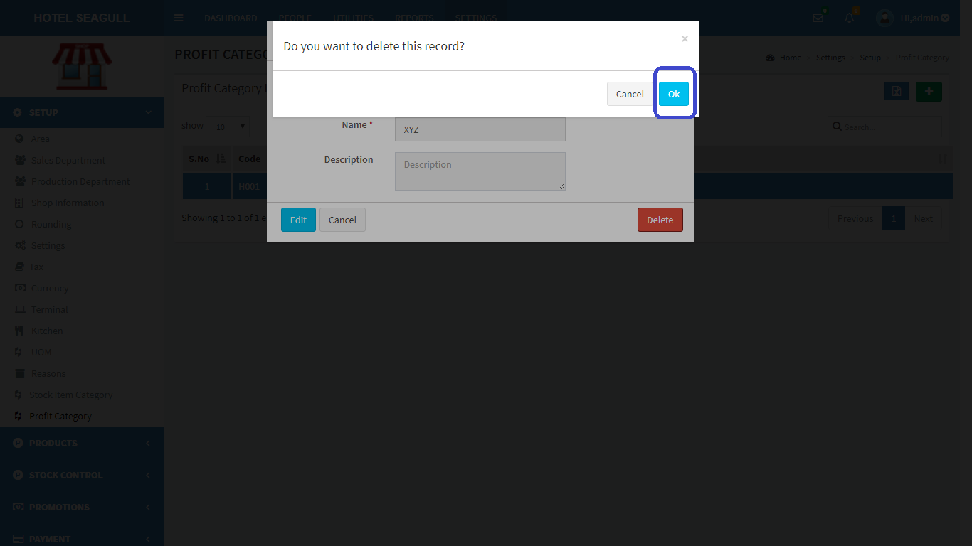

FIG 2.1.14 .5 DELETE PROFIT

Confirm **delete** by clicking ‘OK’ otherwise cancel.

To **export** profit, click on the blue button  in the right corner. Then a pop up gets displayed .

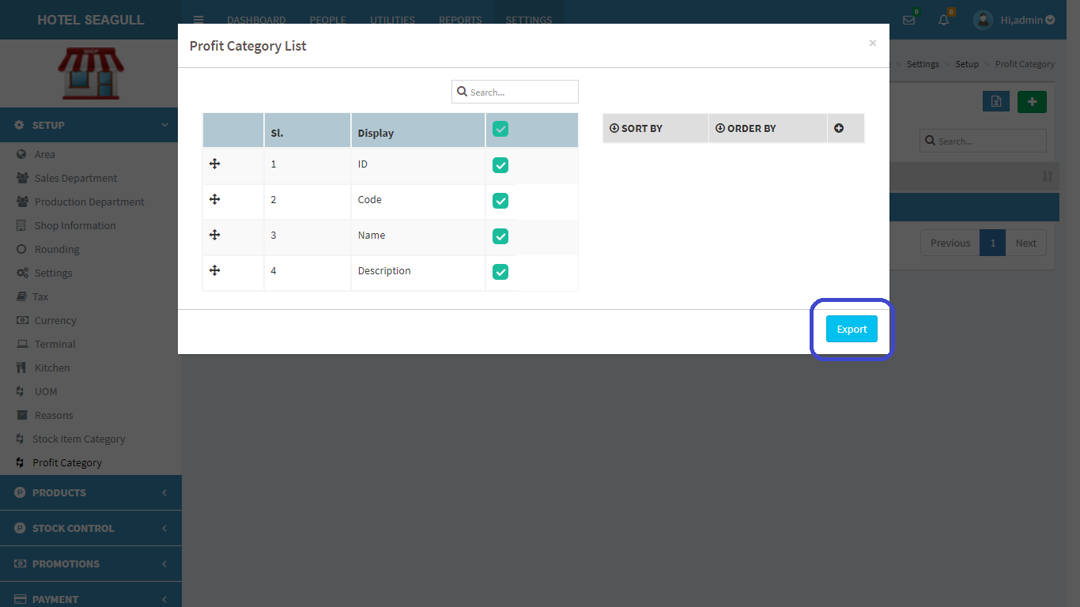

FIG 2.1.14.6 EXPORT EXCEL

Select the relevant options and click the ‘**export**’ button . The excel sheet gets downloaded.

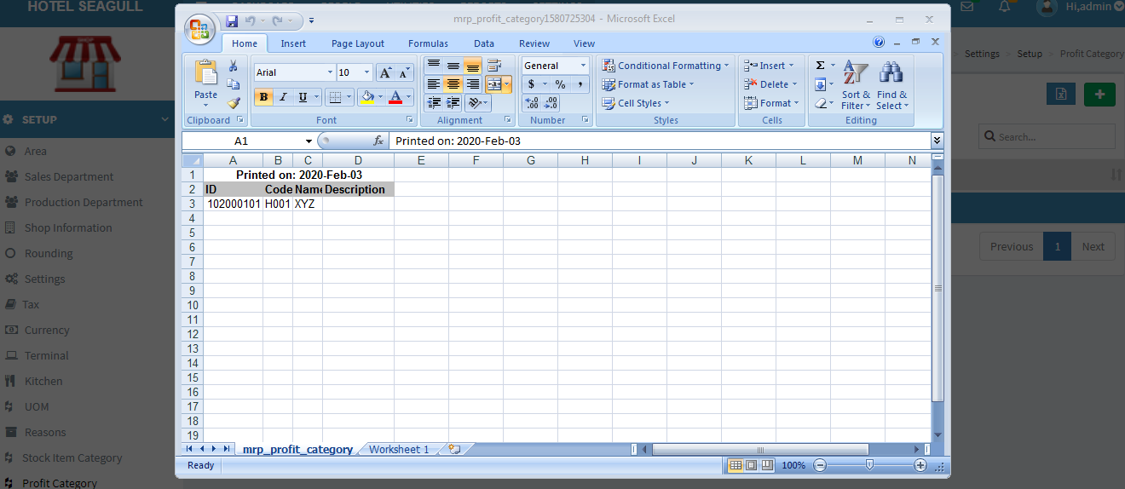

FIG 2.1.14.7 EXCEL REPORT

### 2.2 PRODUCTS

Click the **products** in the settings menu to view the details like item class,menu, stock,sale items,etc.,

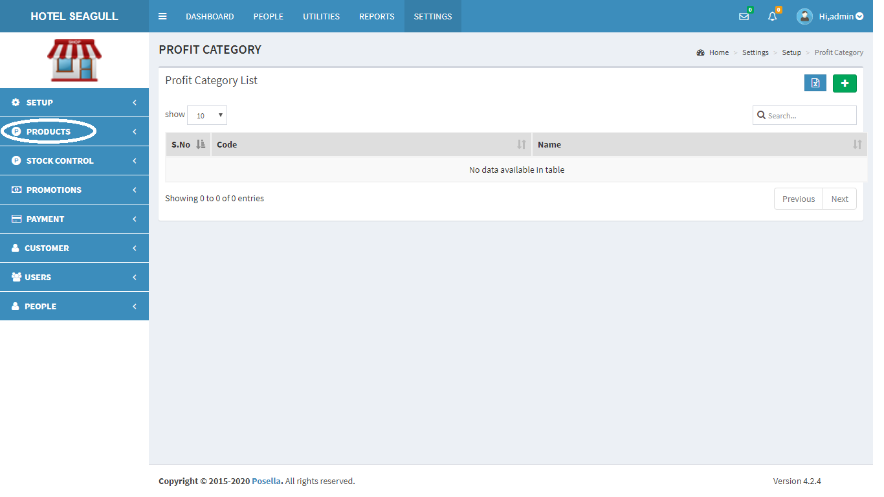

FIG 2.2 PRODUCTS

#### 2.2.1 ITEM CLASS

Click on the Item class, the list of Item class gets displayed as shown in figure. Item class actually refers to the various classifications of items. One item class may contain hundreds of varieties of that class.

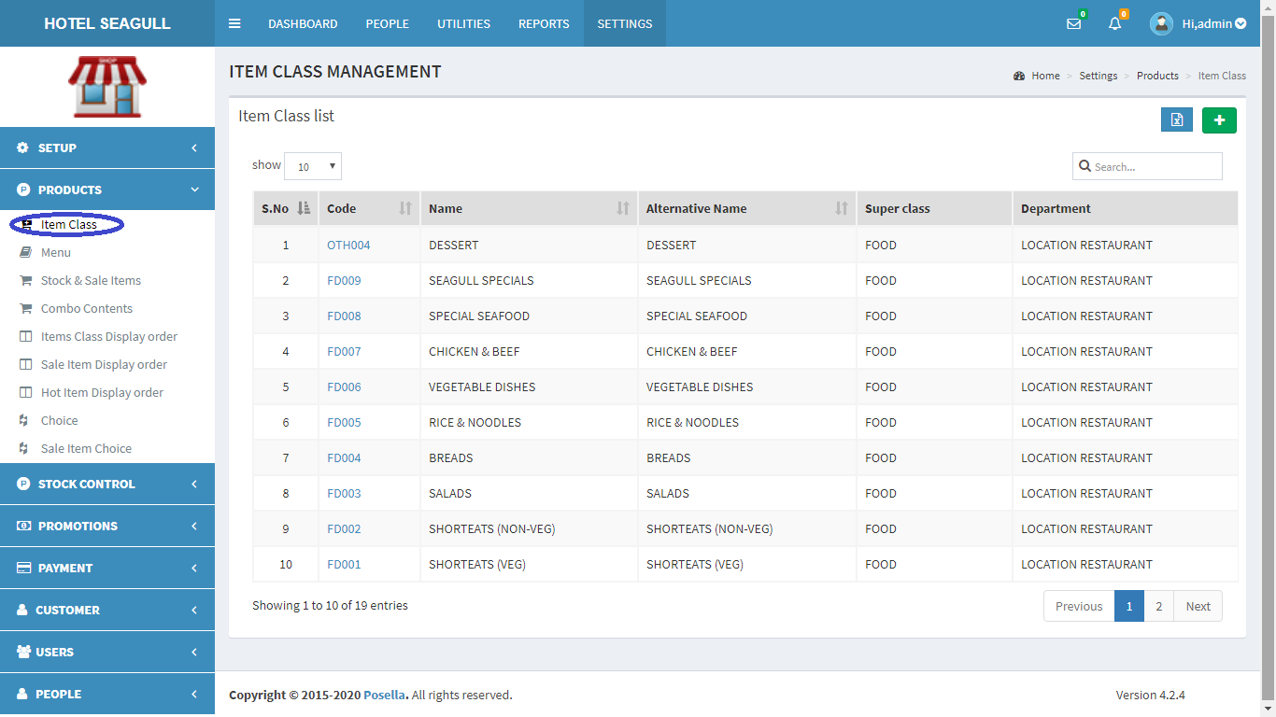

FIG 2.2.1.1 ITEM CLASS

To **add** a new Item class, at rightmost corner, you can see a  in green colour background. Click on the button to add a new class.

A pop up window appears:

GENERAL

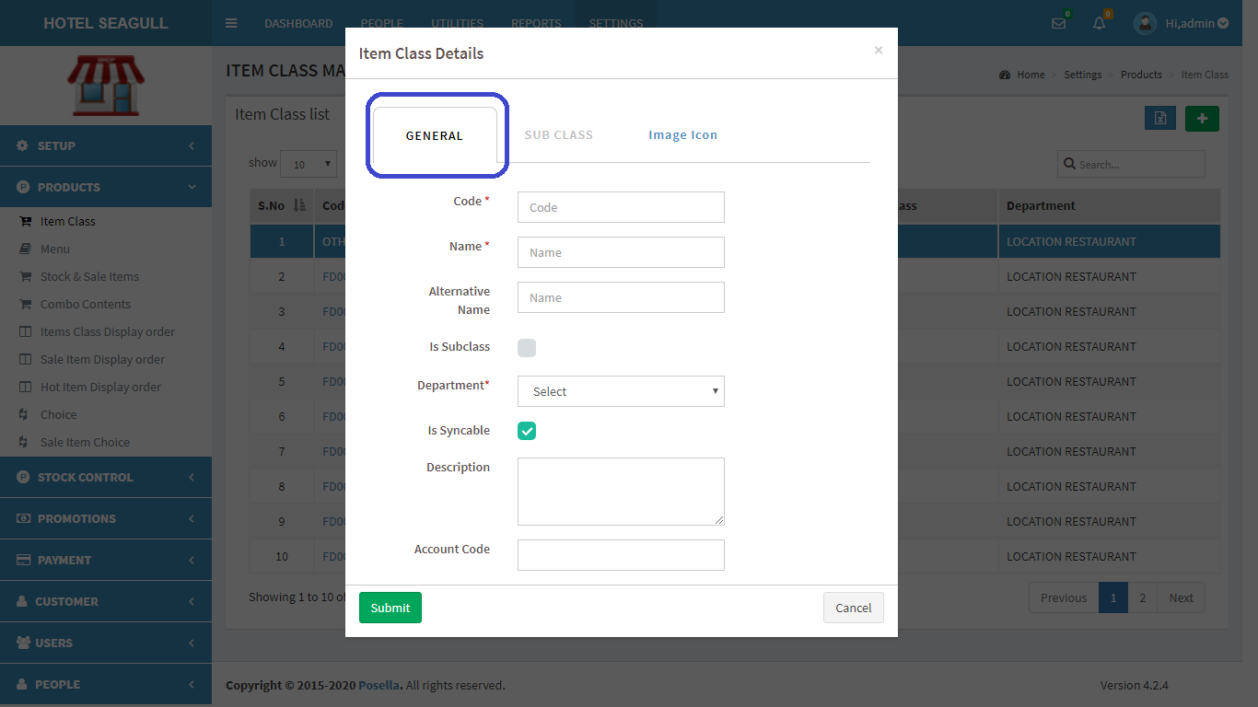

FIG 2.2.1.2 ADD ITEM CLASS(GENERAL)

The **General** category has some common details which need to be filled. Especially code, name of the Item class etc. If it's a subclass, please enable it by giving a tick mark. Department is a mandatory field and chooses the accurate department(bar.restaurant etc). Finally click the submit button.

IMAGE ICON

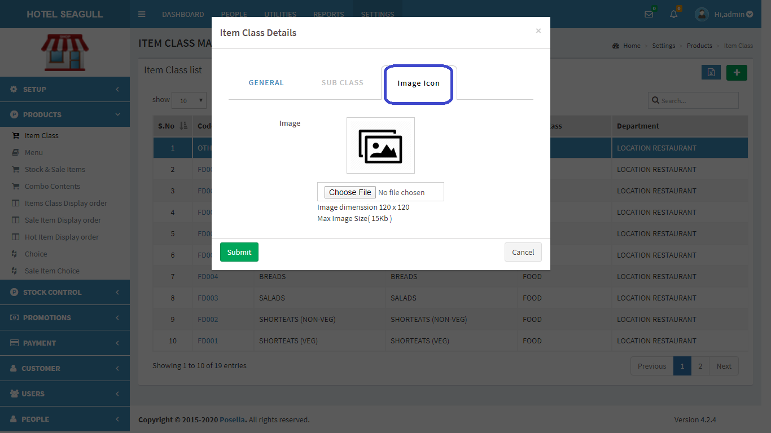

FIG 2.2.1.3 ADD ITEM CLASS(IMAGE ICON)

**Image icon** means we can add a suitable image for the item class according to our choice.Fill the blank fields and click submit button to create a new Item class.

To **view**, **edit** and **delete** a particular Item class, click on the code in fig 2.2.1.1 . A pop up window appears:

GENERAL

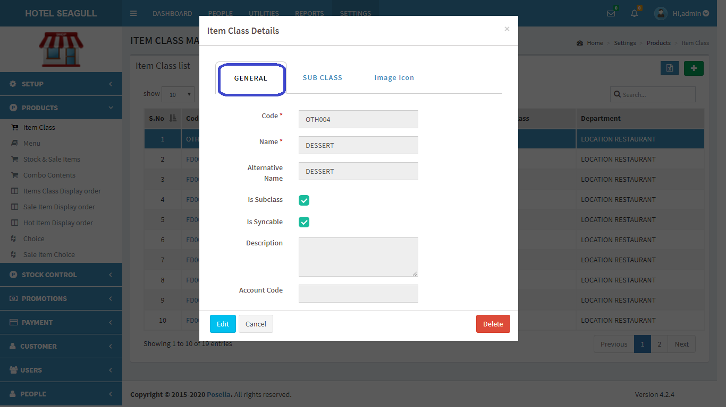

FIG 2.2.1.4 VIEW ITEM CLASS(GENERAL)

In **General**, we can edit the details filled in general category. Click **edit** to edit details. Another pop up window appears:

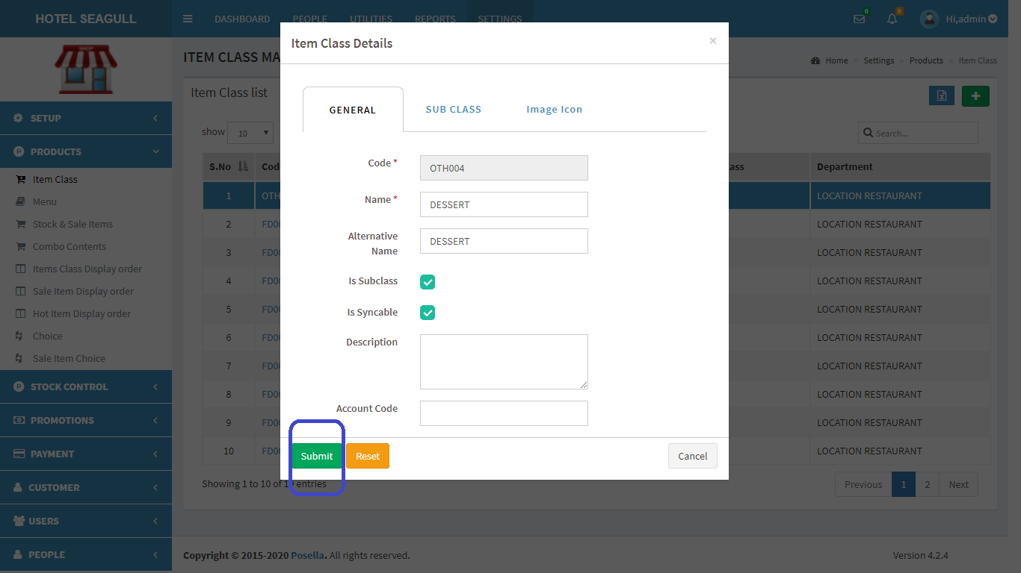

FIG 2.2.1.5 EDIT ITEM CLASS(GENERAL)

IMAGE ICON

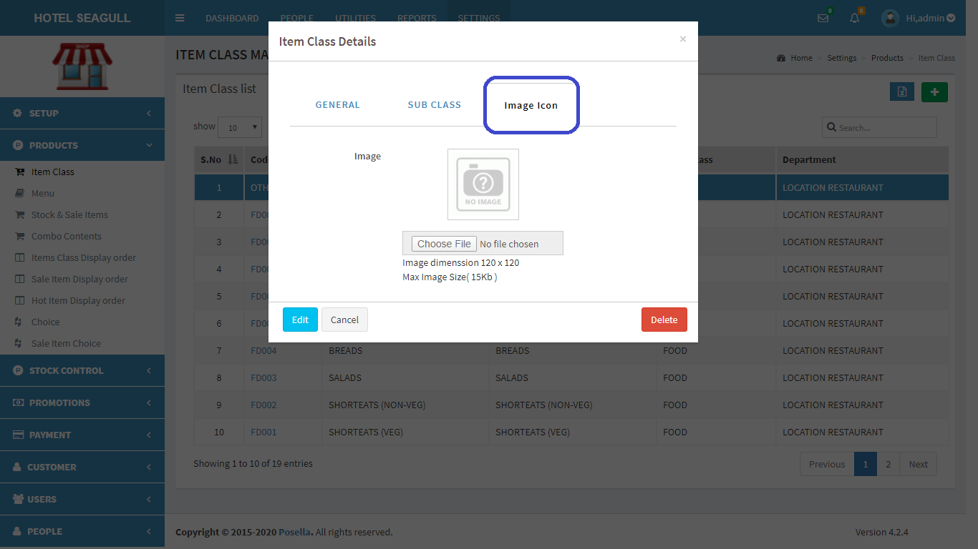

FIG 2.2.1.6 VIEW ITEM CLASS(IMAGE ICON)

In the **Image icon**, we can edit the image. Click **edit** to edit image. Another pop up window appears:

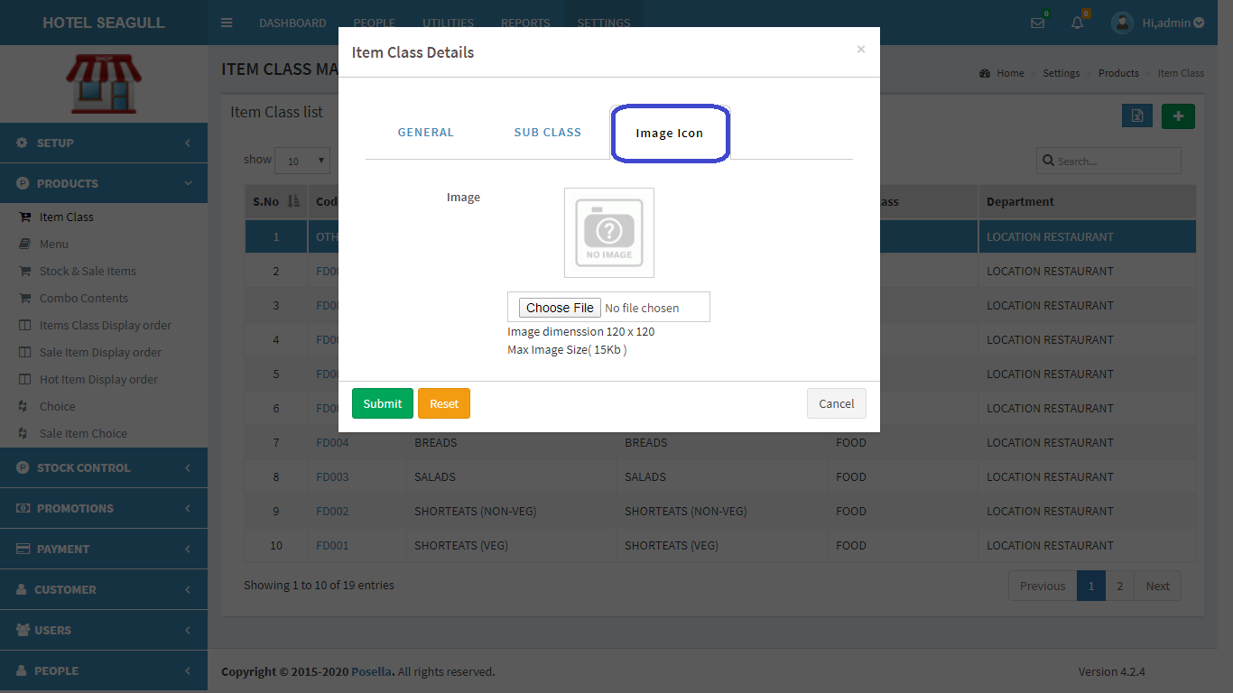

FIG 2.2.1.7 EDIT ITEM CLASS(IMAGE ICON)

Click submit button to update changes made. If you want to **delete** an Item class, click on the delete button in fig 2.2.1.4. When delete button is clicked, another pop-up appears:

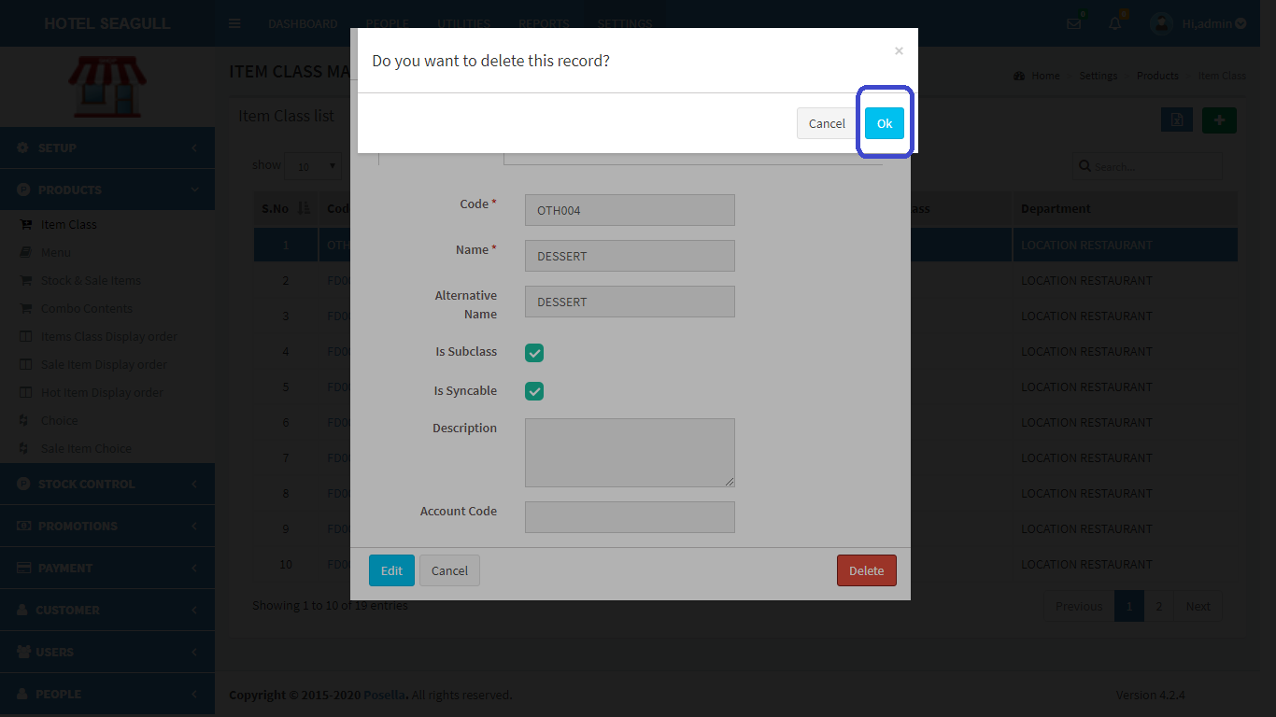

FIG 2.2.1.8 DELETE ITEM CLASS

Confirm **delete** by clicking ‘OK’ otherwise cancel. To **export** Item class, click on the blue button  in the right corner. Then a pop up gets displayed .

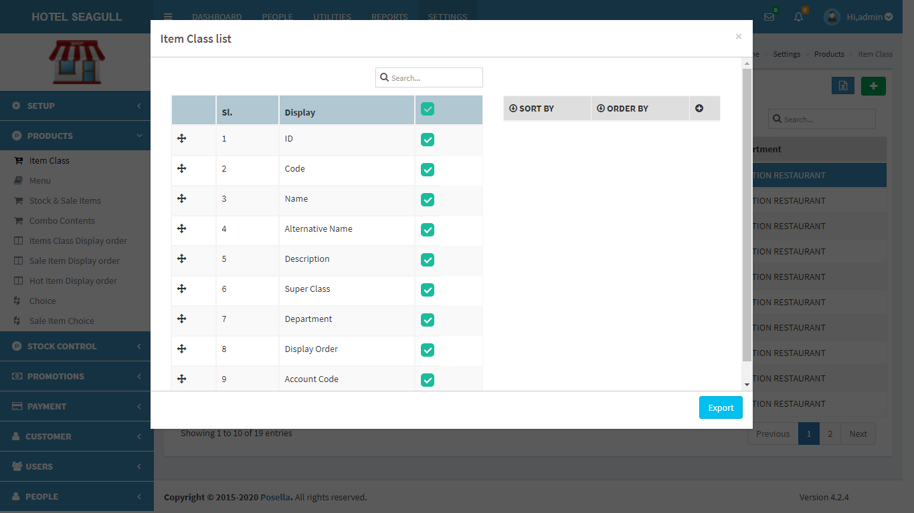

FIG 2.2.1.9 EXCEL EXPORT

Select the relevant options and click the ‘**export**’ button . The excel sheet gets downloaded.

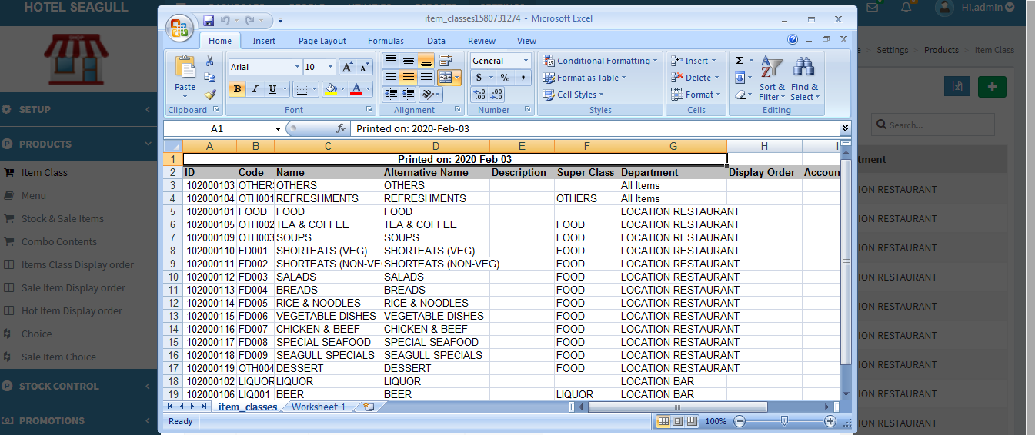

FIG 2.2.1.10 EXCEL REPORT

#### 2.2.2 MENU

Click on the Menu, the list of Menu gets displayed as shown in figure.

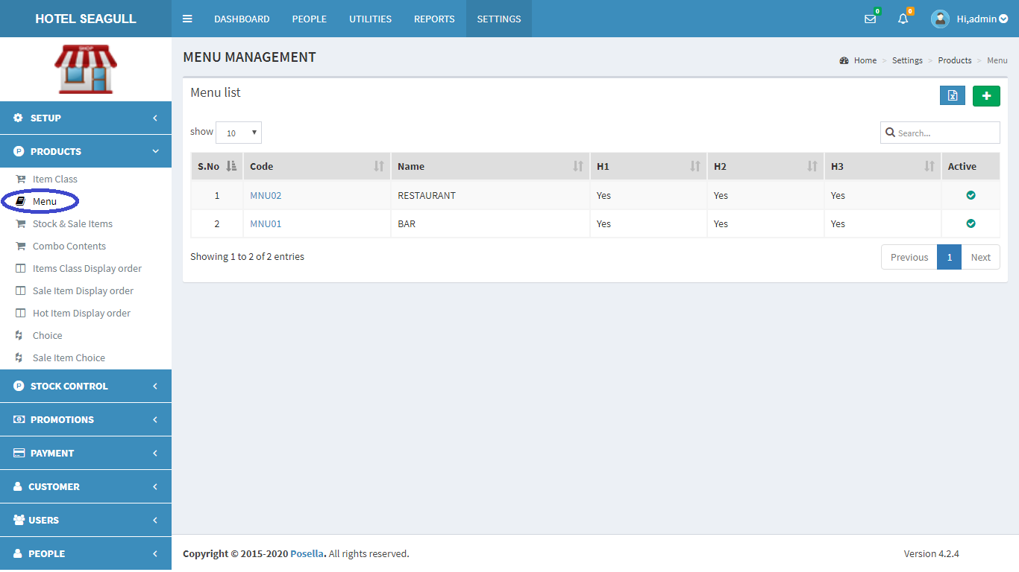

FIG 2.2.2.1 MENU

To **add** a new Menu, at rightmost corner, you can see a  in green colour background. Click on the button to add a new menu. A pop up window appears:

GENERAL

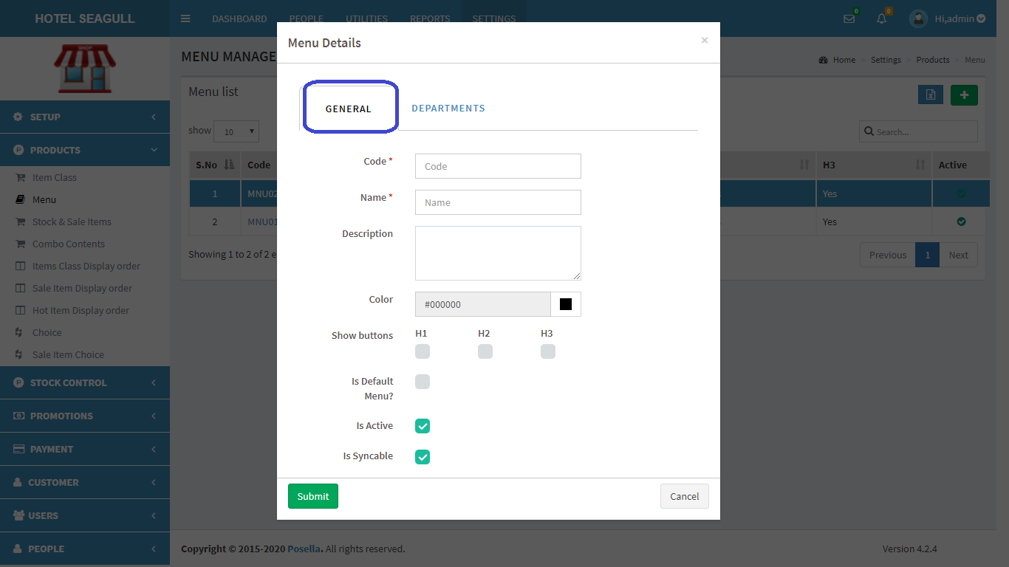

FIG 2.2.2.2 ADD MENU(GENERAL)

In **General**, fill out the mandatory fields like code and name. You can choose the color using a color picker. After the color button, you can see a ‘show button’ option with three options h1, h2, h3. This refers to the hot items in hotels. In a hotel there will be some hot items for breakfast, lunch and dinner. Items which are sold the most are coming under this category. Some items may be sold in three sections like mineral water. So in that case we have to enable h1, h2 and h3.

DEPARTMENTS

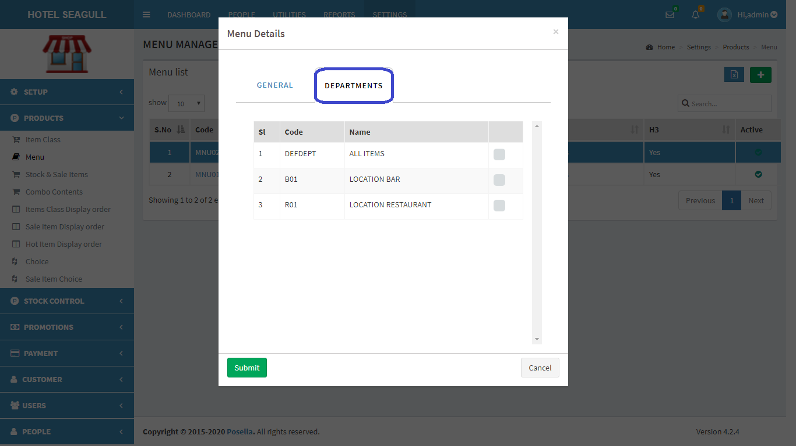

FIG 2.2.2.3 ADD MENU(DEPARTMENT)

In **Departments,** we can choose the department in which we need the menu. Department can be location bar, location restaurant etc. Fill the blank fields and click submit button to create a new Menu.

To **view**, **edit** and **delete** a particular Menu, click on the code in fig 2.2.2.1 . A pop up window appears:

GENERAL

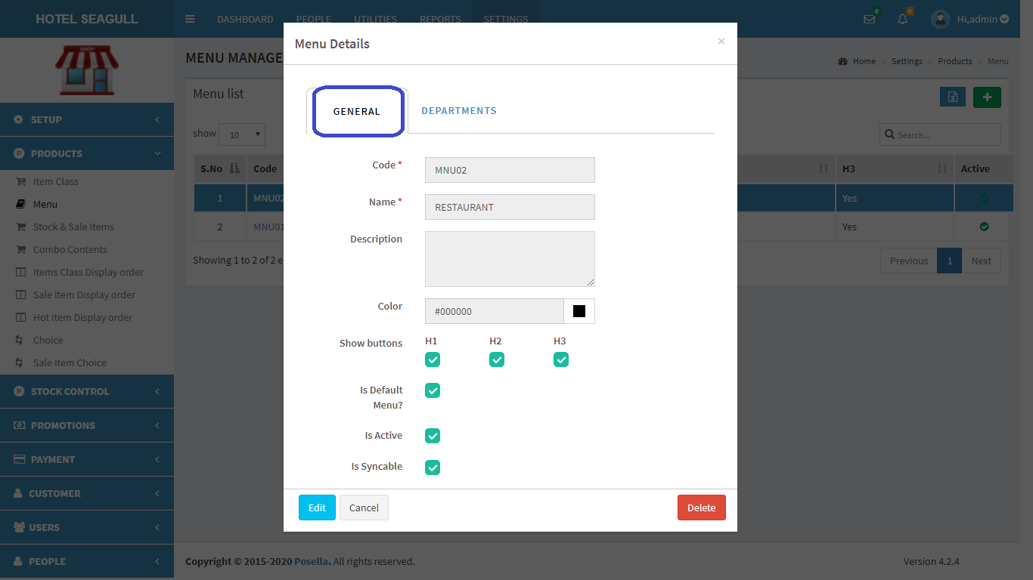

FIG 2.2.2.4 VIEW MENU(GENERAL)

Click on the edit button and a new pop-up appears:

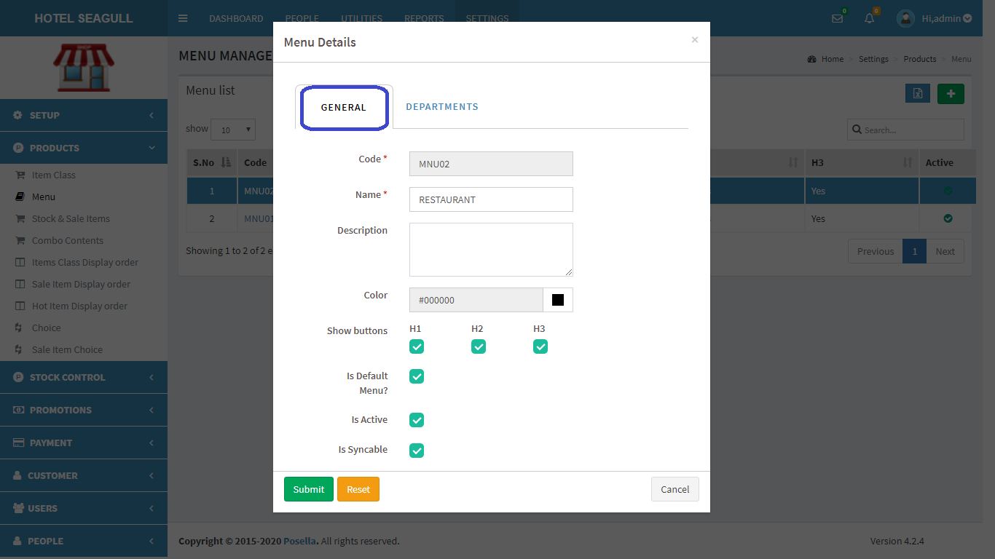

FIG 2.2.2.5 EDIT MENU(GENERAL)

DEPARTMENT

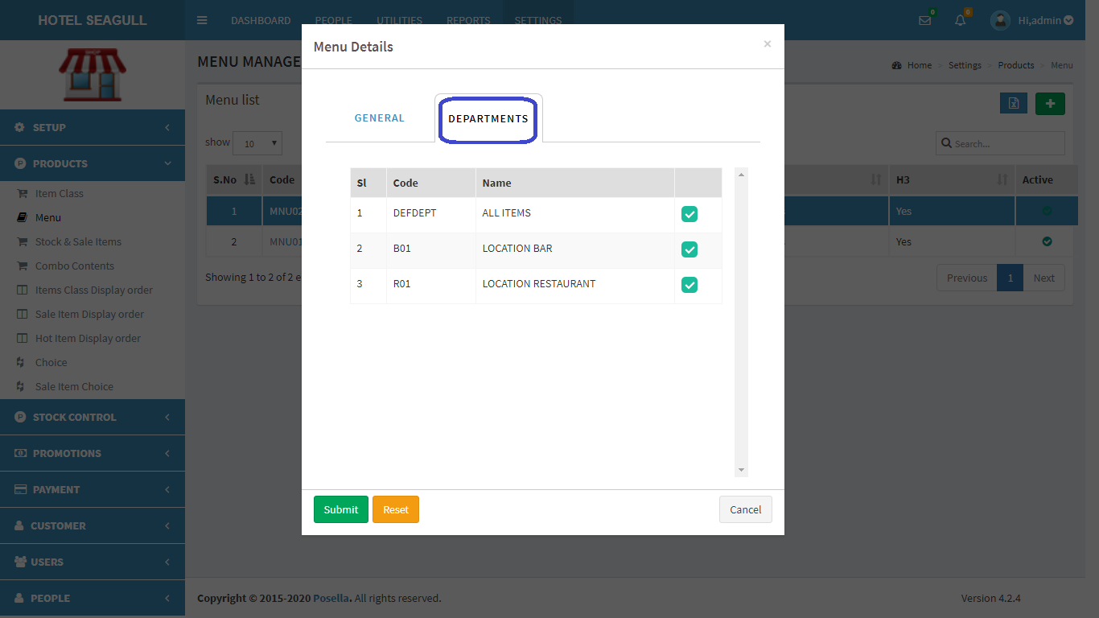

FIG 2.2.2.6 EDIT MENU(DEPARTMENT)

**Department** editing helps us to edit the department. Click on submit to update changes.

If you want to **delete** a Menu, click on the delete button in fig 2.2.2.4. When delete button is clicked, another pop-up appears:

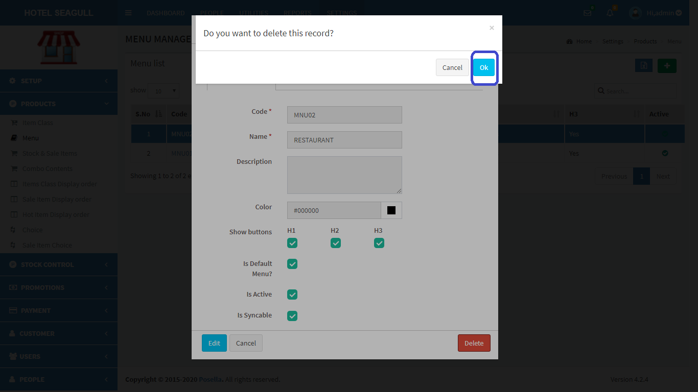

FIG 2.2.2.7 DELETE MENU

Confirm **delete** by clicking ‘OK’ otherwise cancel. To **export** Menu, click on the blue button  in the right corner. Then a pop up gets displayed .

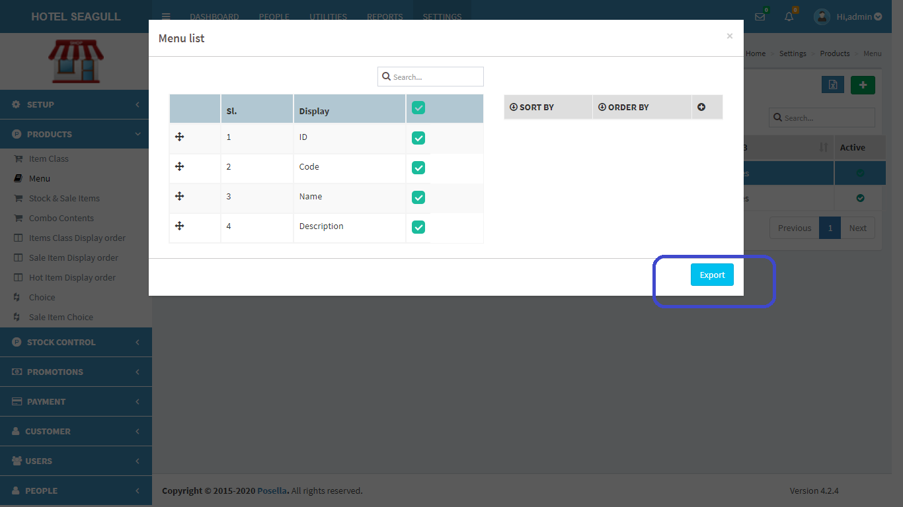

FIG 2.2.2.8 EXCEL EXPORT

Select the relevant options and click the ‘**export**’ button . The excel sheet gets downloaded.

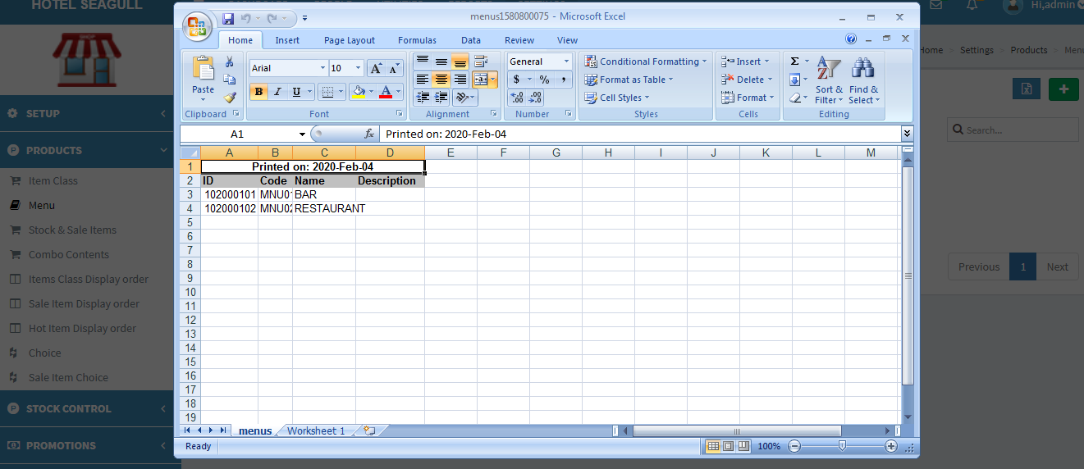

FIG 2.2.2.9 EXCEL REPORT

#### 2.2.3 STOCK AND SALE ITEM

Click on the Stock and sale item, the list of Items gets displayed as shown in figure.

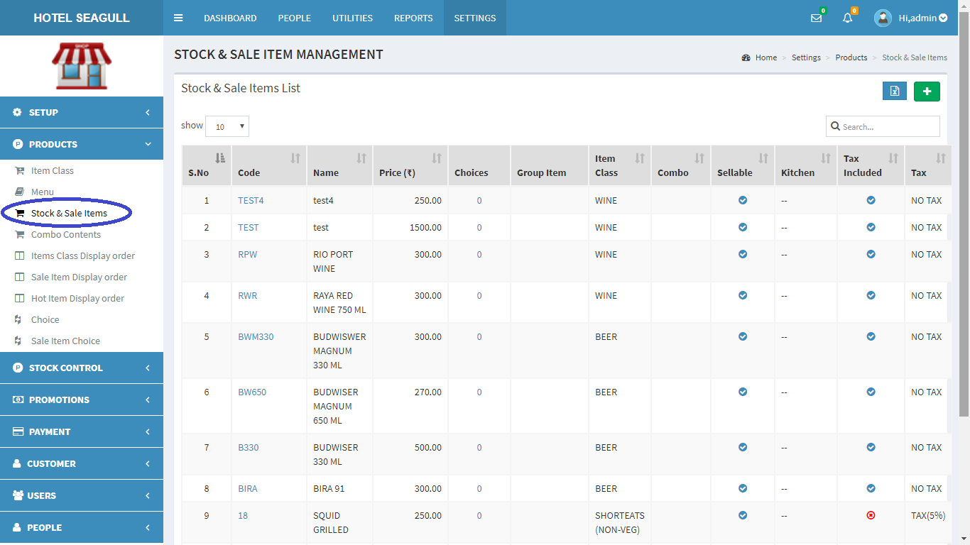

FIG 2.2.3.1 STOCK AND SALE ITEM

To **add** a new Sale item, at rightmost corner, you can see a  in green colour background. Click on the button to add a new sale item. There are 6 options available for adding a sale item.

A pop up window appears:

GENERAL1

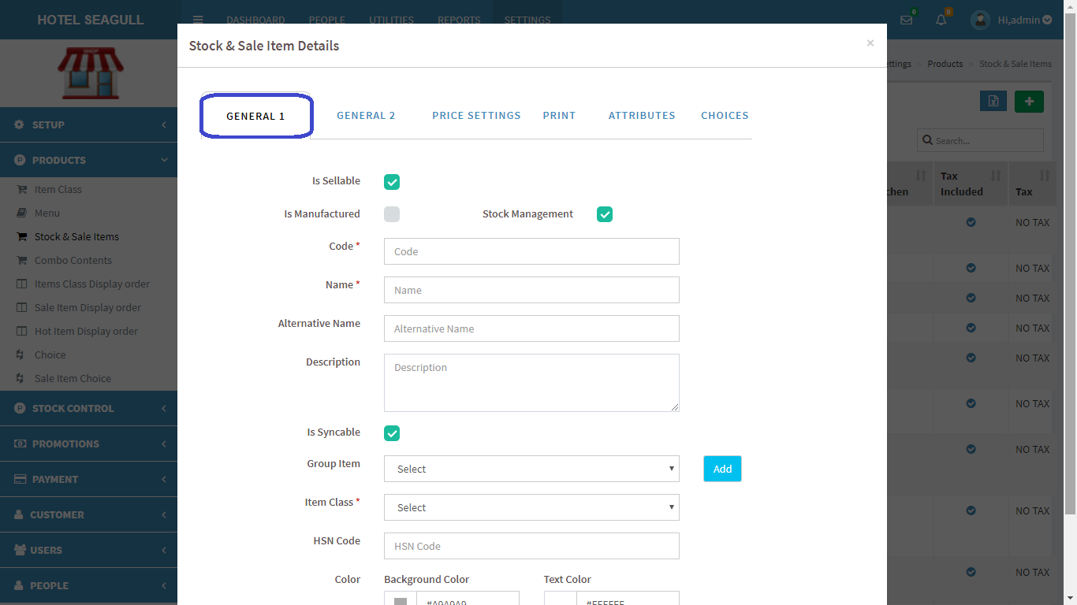

FIG 2.2.3.2 ADD SALE ITEM(GENERAL 1)

**General 1** has so many common options like code, name, category in which item falls(group), Item class etc.

GENERAL 2

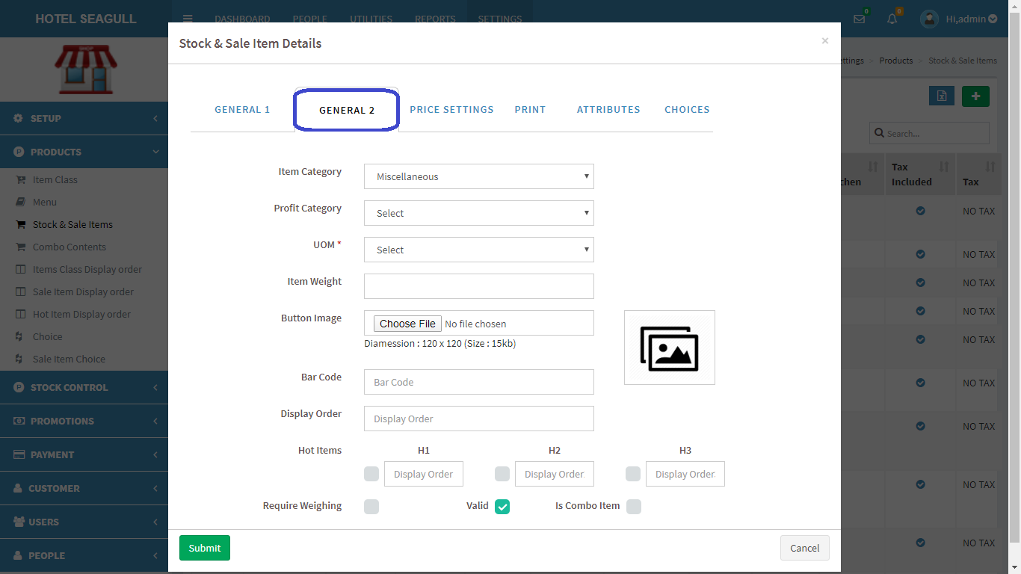

FIG 2.2.3.3 ADD SALE ITEM(GENERAL 2)

**General** 2 has so many options like Item category, profit category, UOM, etc. Another important option is the button image which we can upload from our system. The view we occupy on the terminal side is the result of what we set on the web side. Next important option is the hot items. We can enable hot items for each item according to the hotel's requirement. For some items we have to enable h1, h2 and h3 as some items are available in breakfast, lunch and dinner. After filling the mandatory fields, click submit button.

PRICE SETTINGS

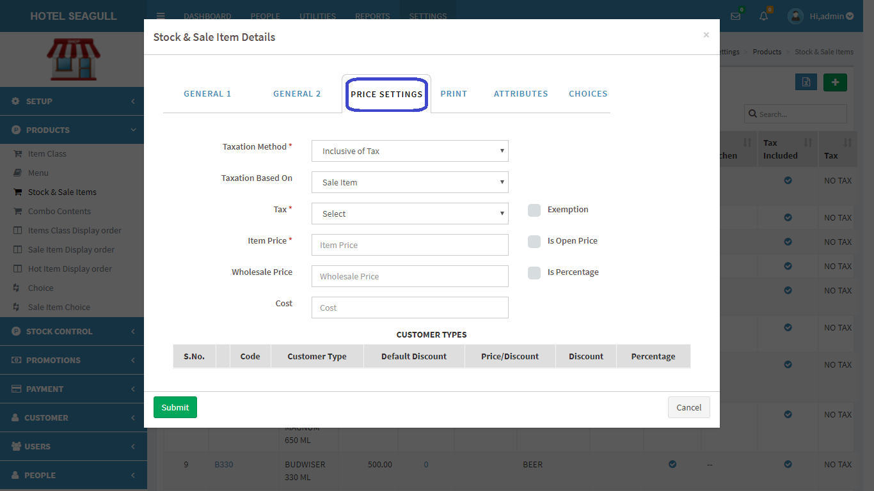

FIG 2.2.3.4 ADD SALE ITEM(PRICE SETTINGS)

Fill the mandatory fields in price settings like Taxation method where we have to select the option whether item is inclusive or exclusive of tax. Next mandatory field is Tax where you select the type of tax allocated for the item. Fill up the Item price for it and click submit.

**PRINT**

The settings for printing the bill. In print, we can see a field named ‘print to kitchen’ . If we enable ‘print to kitchen’ a copy of order gets printed to respective kitchen(KOT or BOT). Next option ‘kitchen’ is to print the bill either to KOT or BOT.

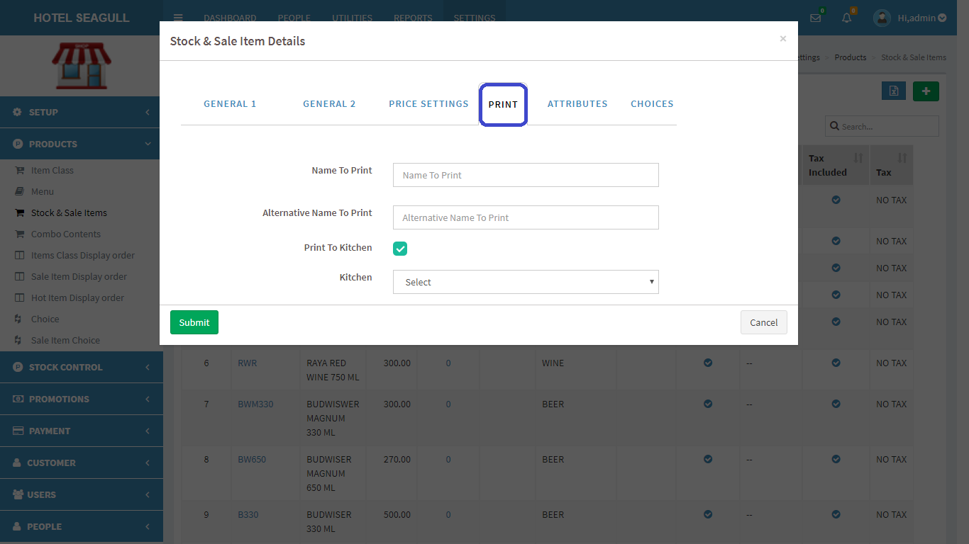

FIG 2.2.3.5 ADD SALE ITEM(PRINT)

ATTRIBUTES

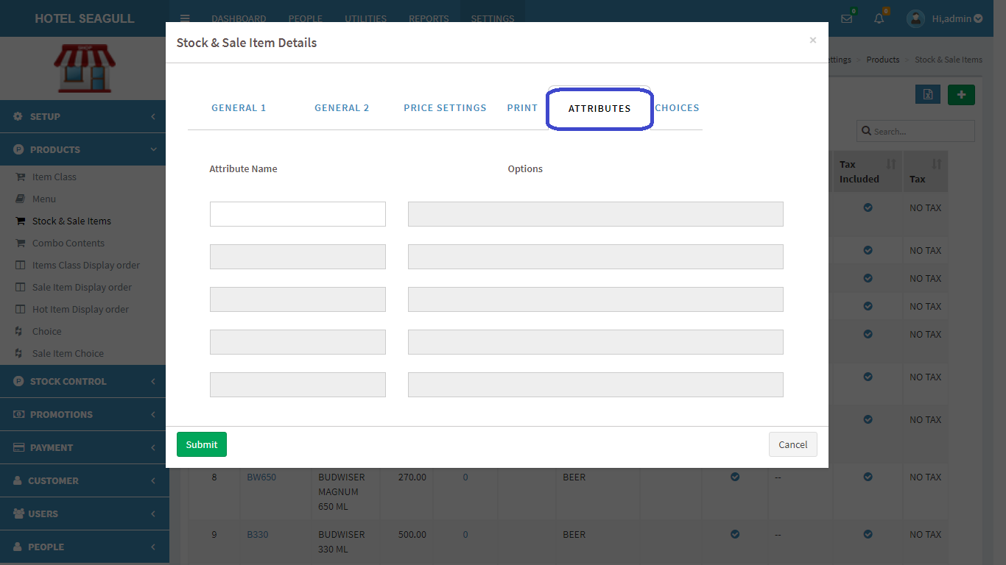

FIG 2.2.3.6 ADD SALE ITEM(ATTRIBUTES)

Attributes are of different types like some people need strong tea, some need more spicy food etc. Attributes get changed according to a customer’s requirement. In figure , we can see a field for attribute name and area to write the attribute. Fill the space given and click submit.

CHOICES

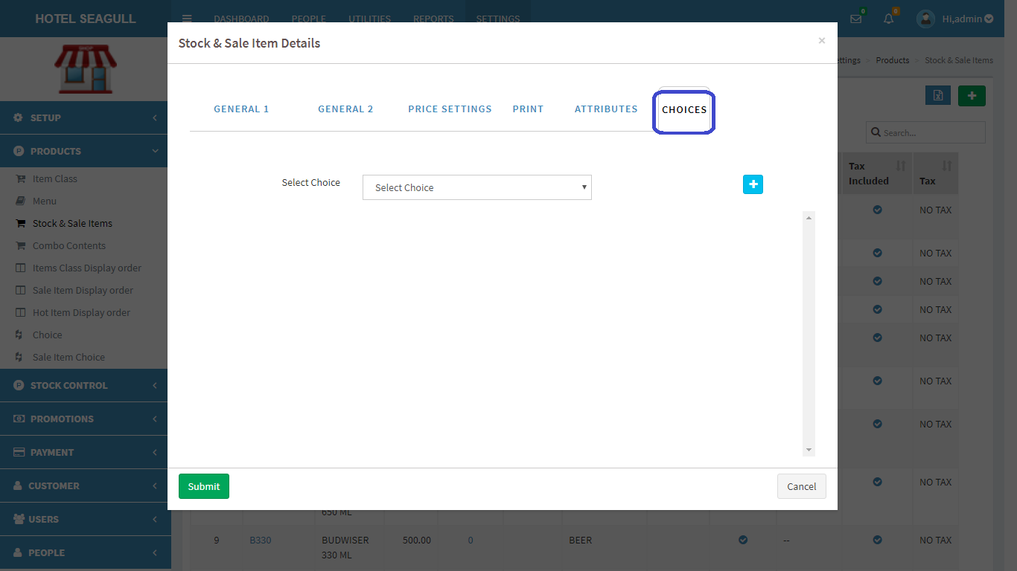

FIG 2.2.3.7 ADD SALE ITEM(CHOICES)

In choices we have to select a choice from options available. Choices are added manually(2.2.8). Fill the blank fields and click submit button to create a new Sale item.

To **view**, **edit** and **delete** a particular Sale item, click on the code in fig 2.2.2.1 . A pop up window appears:

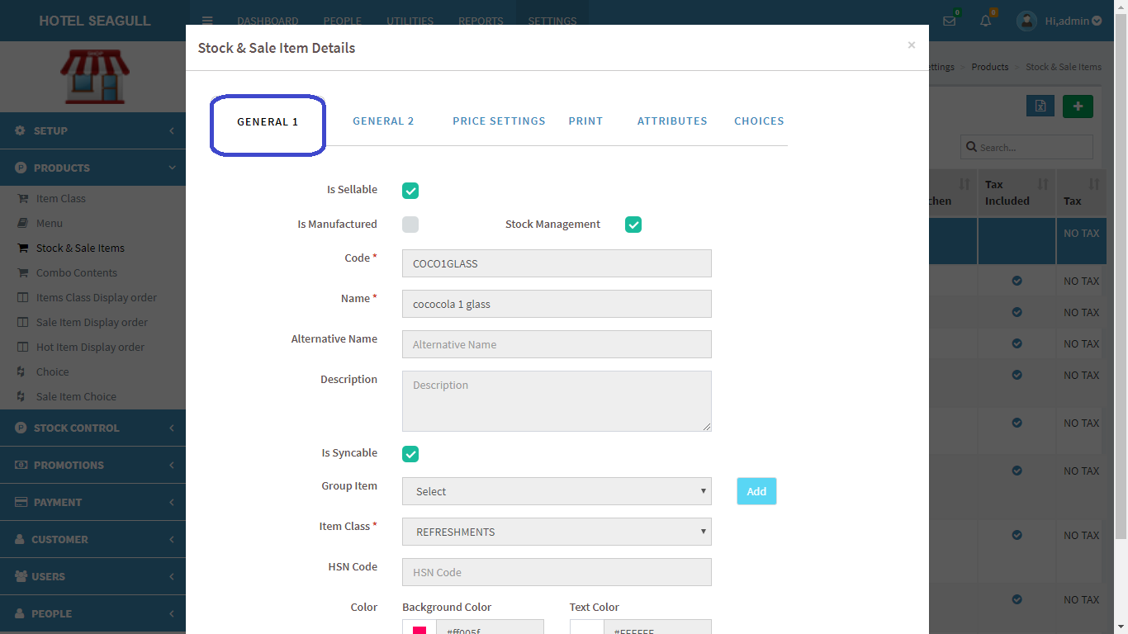

FIG 2.2.3.8 VIEW SALE ITEM

Click **edit** to edit details. Another pop up window appears:

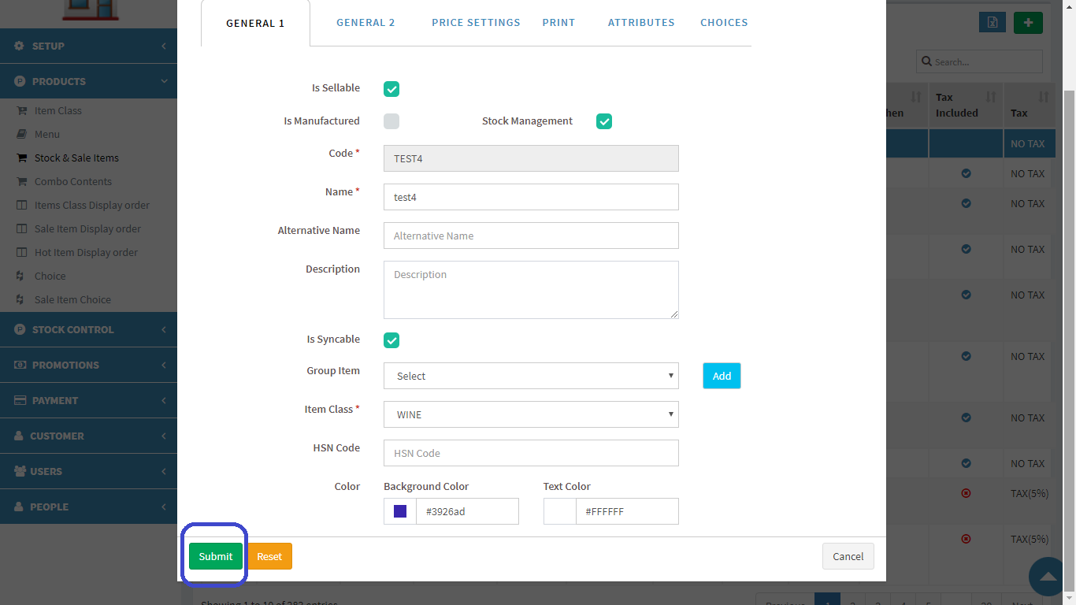

FIG 2.2.3.9 EDIT SALE ITEM

Similarly do edit for **general2**, **price settings**, **print**, **attributes**, **choices**.

Click submit button to update changes made. If you want to **delete** a Sale item, click on the delete button in fig 2.2.3.8. We have to delete each forms separately by choosing each one(general1, general2, price settings, print, attributes, choices).When delete button is clicked, another pop-up appears:

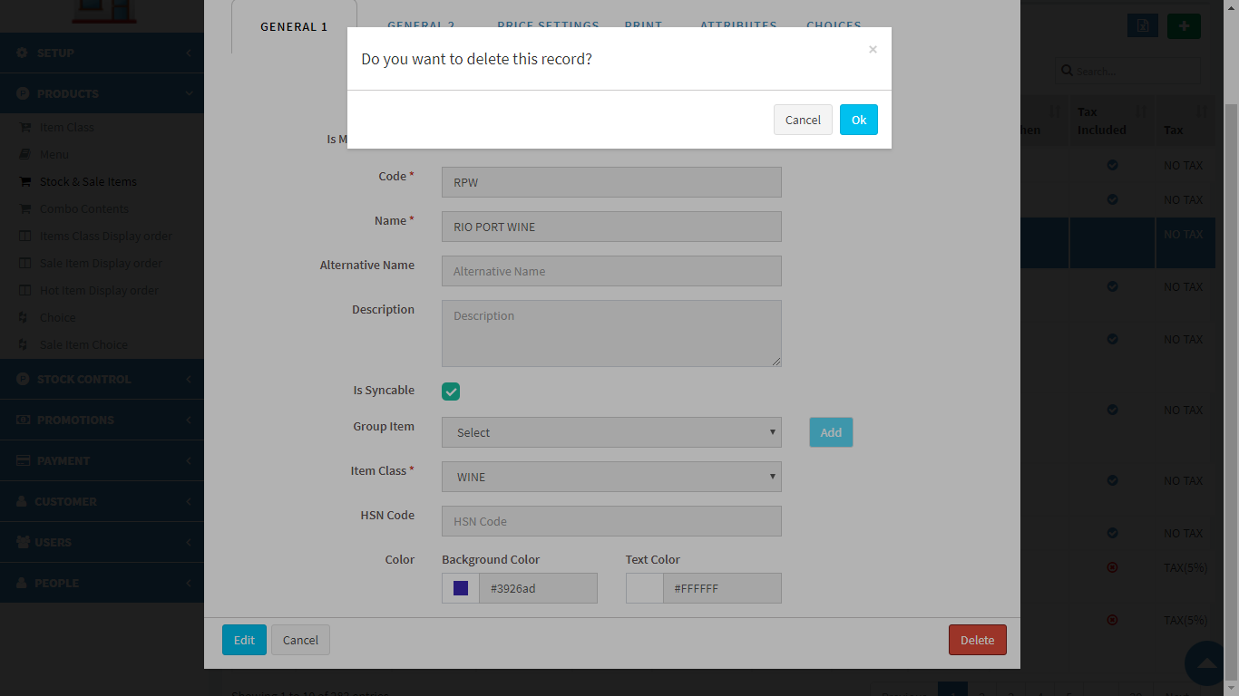

FIG 2.2.3.10 DELETE SALE ITEM

Confirm **delete** by clicking ‘OK’ otherwise cancel. To **export** Sale item, click on the blue button  in the right corner. Then a pop up gets displayed .

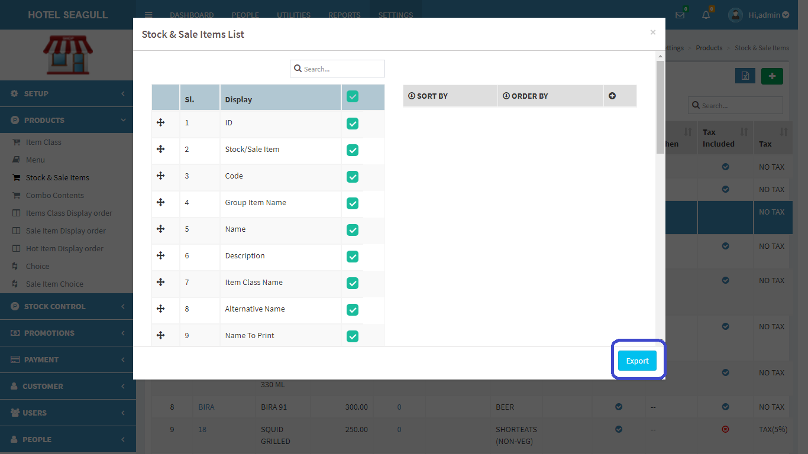

FIG 2.2.3.11 EXCEL EXPORT

Select the relevant options and click the ‘**export**’ button . The excel sheet gets downloaded.

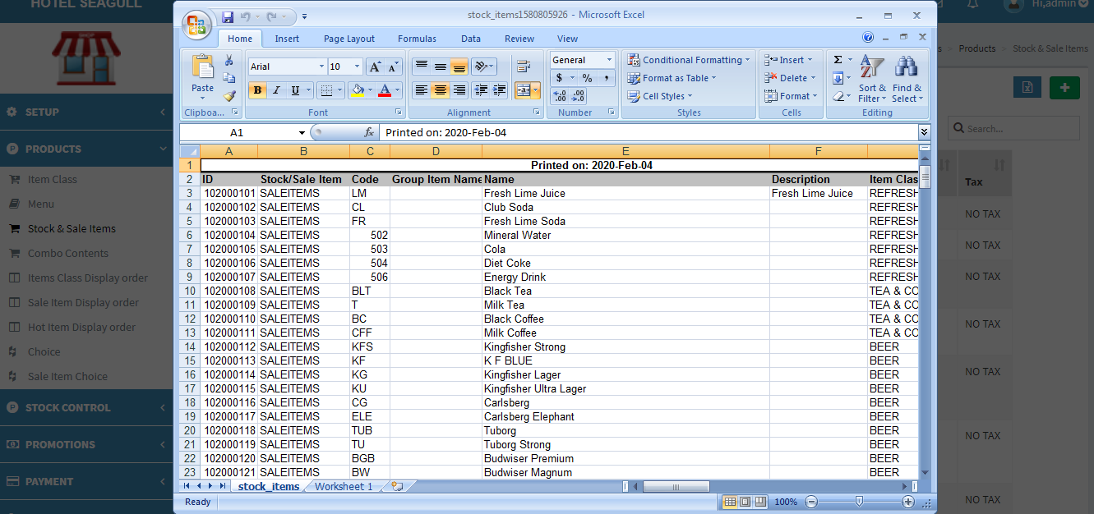

FIG 2.2.3.12 EXCEL REPORT

#### 2.2.4 COMBO CONTENTS

Combo contents refers to the offers that a restaurant provides(combo offers).

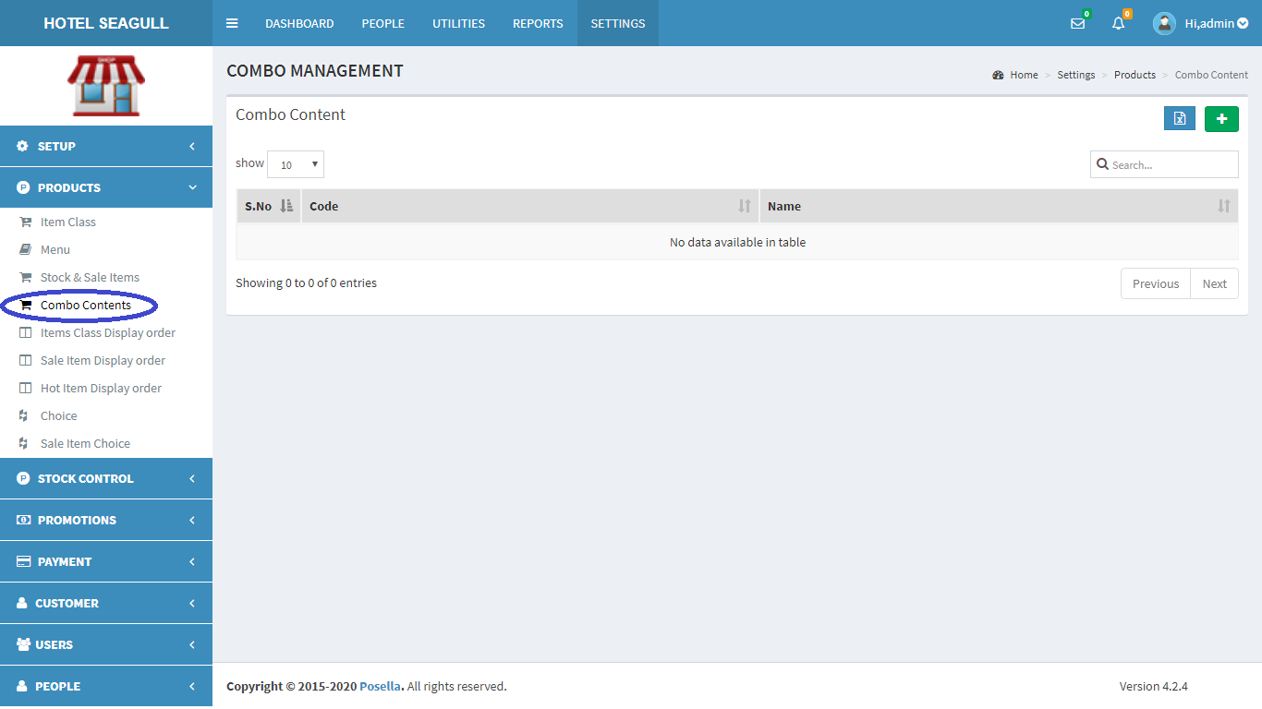

FIG 2.2.4.1 COMBO CONTENTS

To **add** a new Menu, at rightmost corner, you can see a  in green colour background. Click on the button to add a new menu. A pop up window appears:

GENERAL

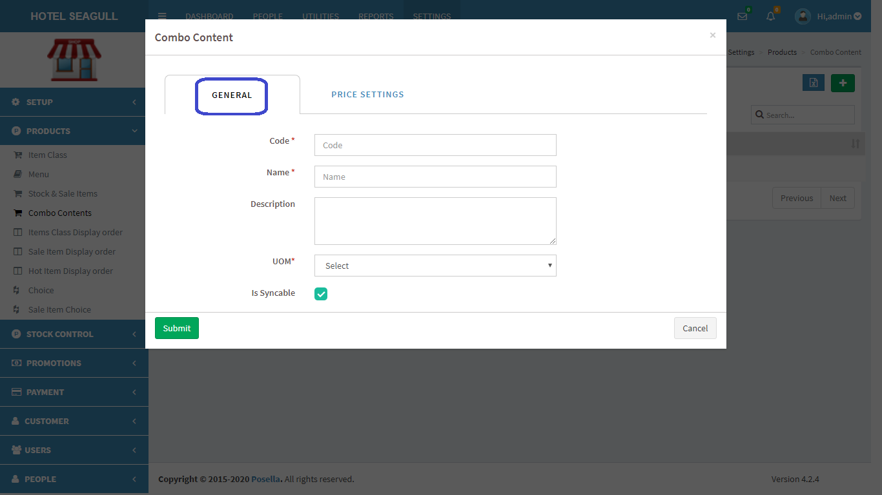

FIG 2.2.4.2 ADD COMBO CONTENT(GENERAL)

Fill the mandatory fields in **general , and** click the submit button.

PRICE SETTINGS

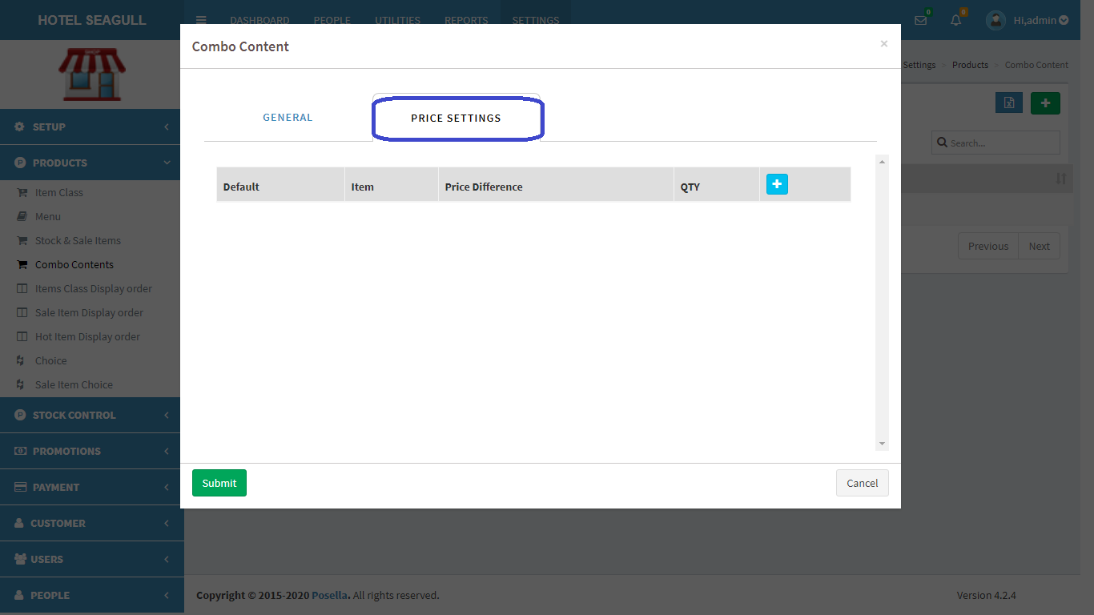

FIG 2.2.4.3 ADD COMBO CONTENT(PRICE SETTINGS)

Click on the  at right most corner to add a new combo content.

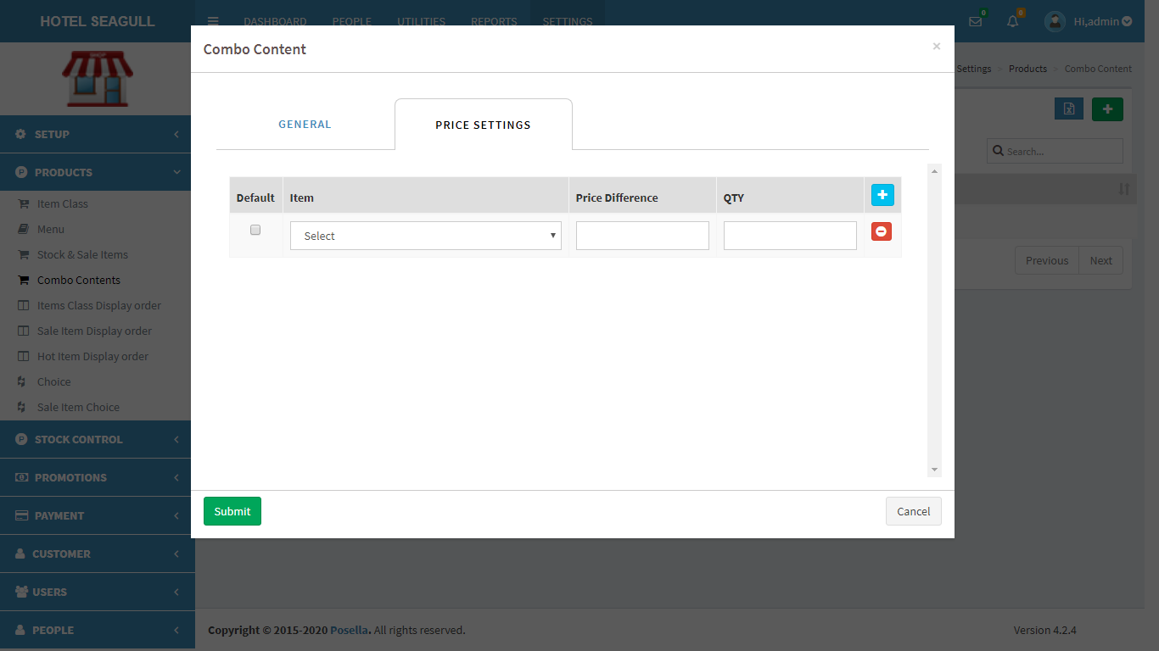

FIG 2.2.4.4 ADD COMBO CONTENT(PRICE SETTINGS)

Click on the ‘select’ option and choose an item from the list.

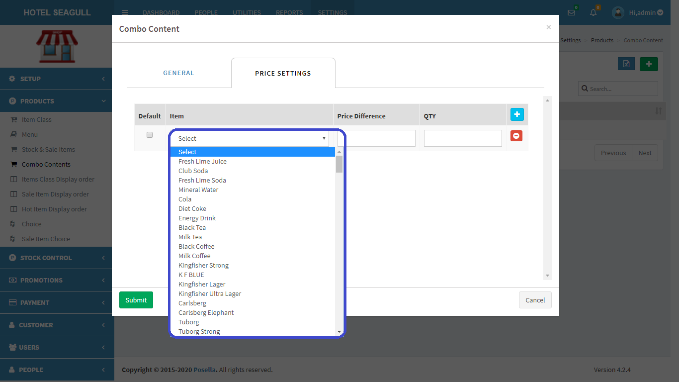

FIG 2.2.4.5 ADD COMBO CONTENT(SELECT ITEM)

Fill the other fields ‘price difference’ and ‘quantity’ and click submit to add combo content.If you want to add another item to the same combo content, before clicking submit, choose another item by clicking again .

To edit and delete a combo content, click on the ‘code’ provided in fig 2.2.4.1 and a pop-up appears.

GENERAL

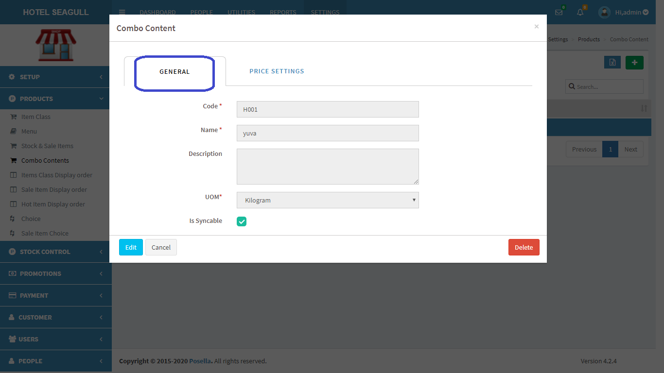

FIG 2.2.4.6 VIEW COMBO CONTENT(GENERAL)

Click on the ‘edit’ button and next pop-up appears:

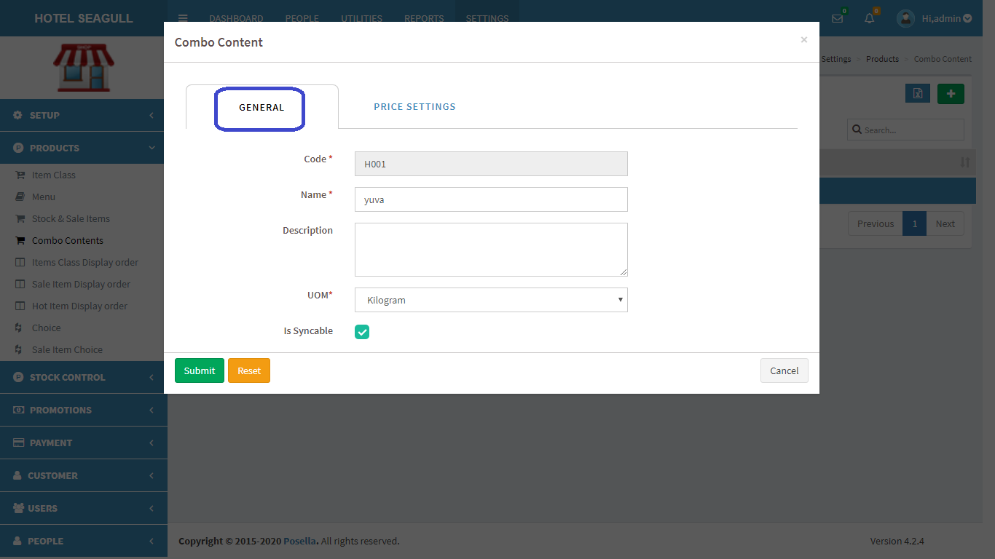

FIG 2.2.4.7 EDIT COMBO CONTENT(GENERAL)

Click on the submit button to make changes.

PRICE SETTINGS

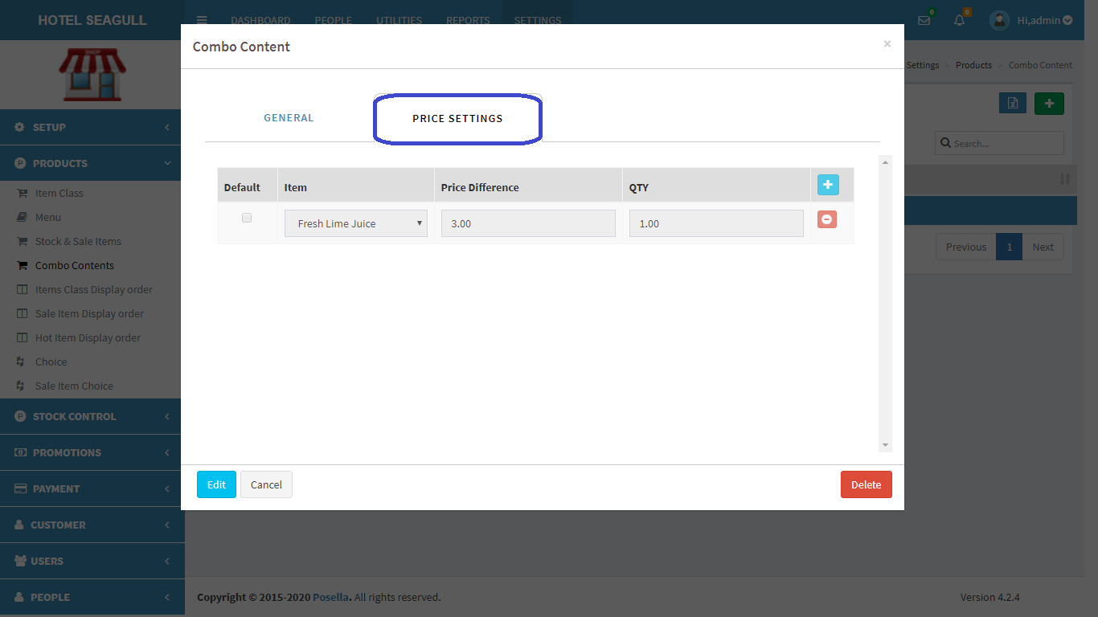

FIG 2.2.4.8 VIEW COMBO CONTENT(PRICE SETTING)

Click on the ‘edit’ button and next pop-up appears:

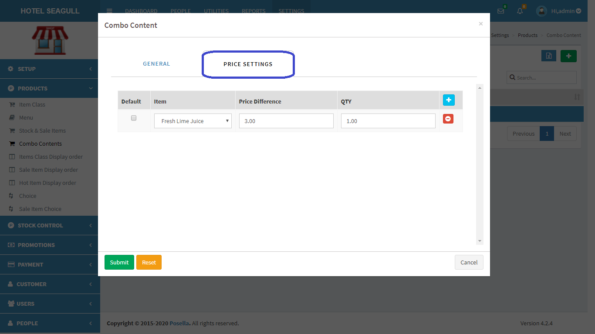

FIG 2.2.4.9 EDIT COMBO CONTENT(PRICE SETTING)

Click on the submit button to make changes.

Click submit button to update changes made. If you want to **delete** a Combo content, click on the delete button in fig 2.2.3.8. We have to delete each forms separately by choosing each one(general,, price settings).When delete button is clicked, another pop-up appears:

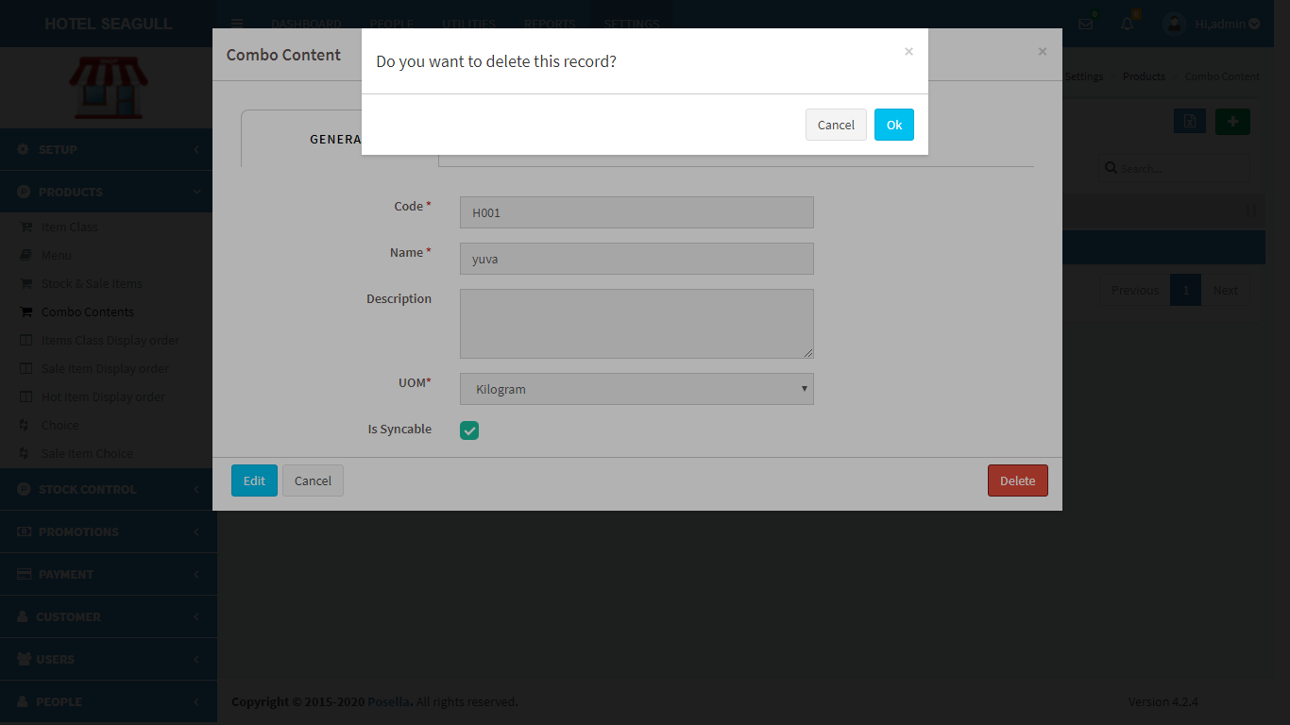

FIG 2.2.4.10 DELETE COMBO CONTENT

Confirm **delete** by clicking ‘OK’ otherwise cancel. To **export** Combo content, click on the blue button  in the right corner. Then a pop up gets displayed .

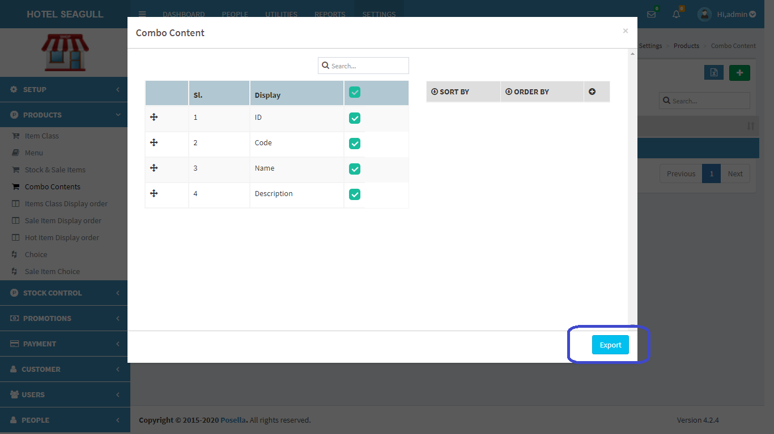

FIG 2.2.4.11 EXCEL EXPORT

Select the relevant options and click the ‘**export**’ button . The excel sheet gets downloaded.

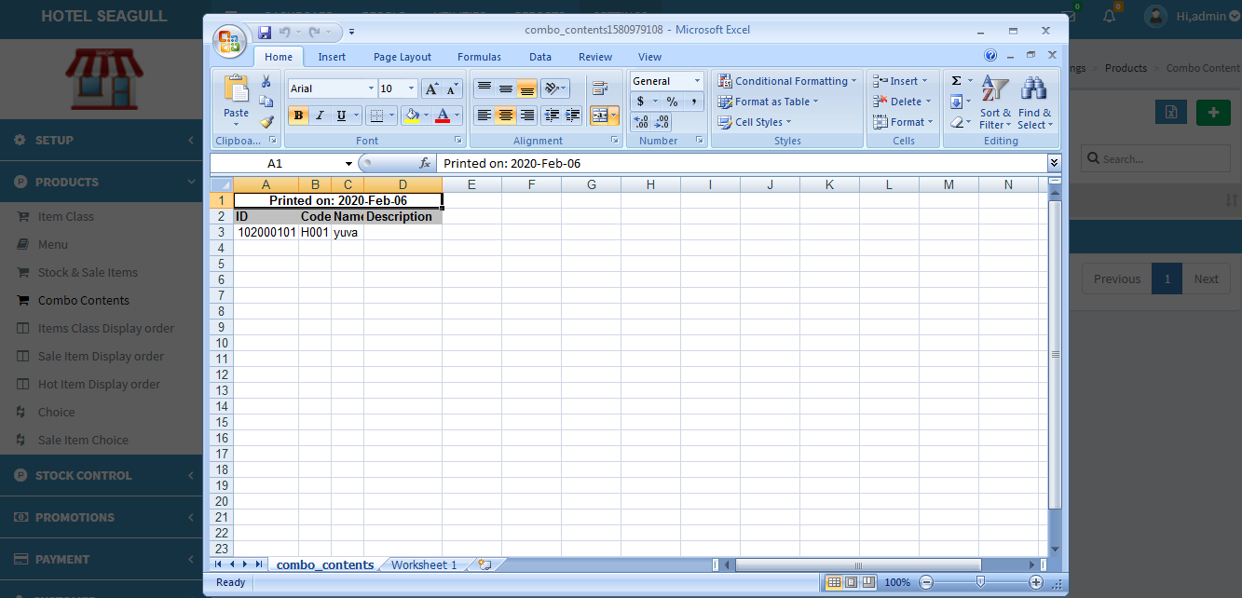

FIG 2.2.4.12 EXCEL REPORT

#### 2.2.5 ITEMS CLASS DISPLAY ORDER

It means the order in which we want the item class to be displayed on the terminal side.

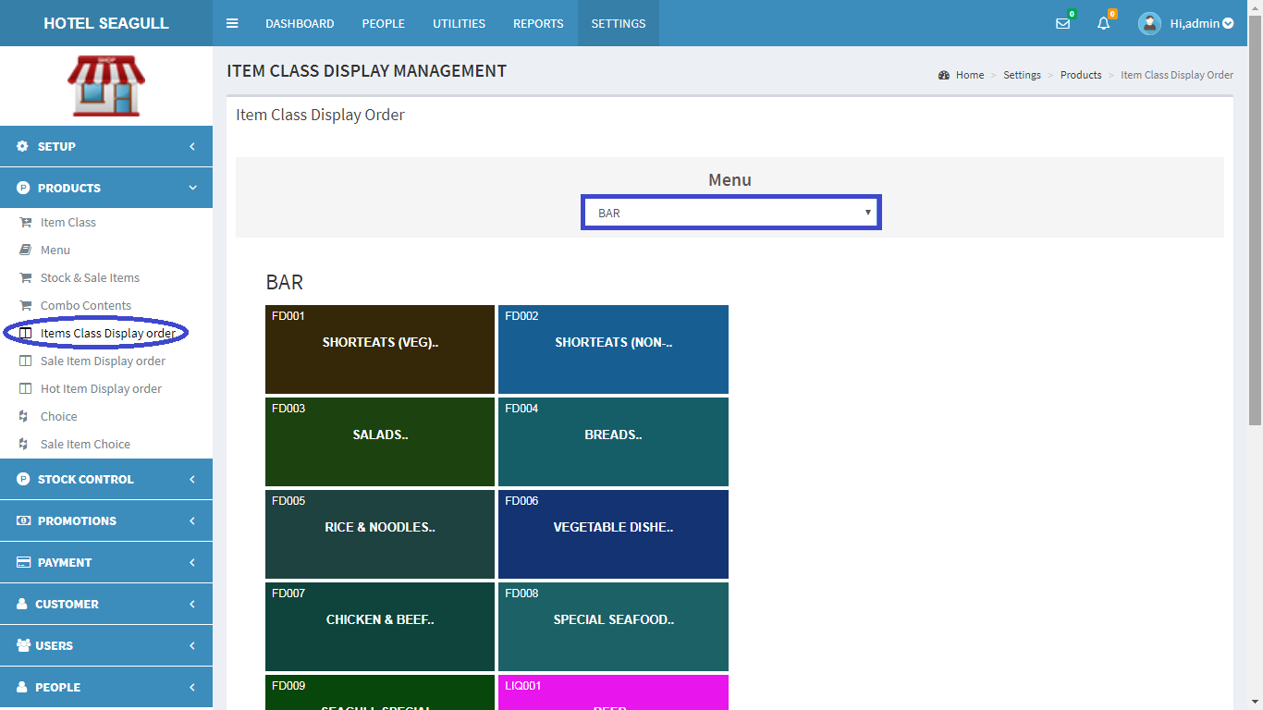

FIG 2.2.5.1 ITEM CLASS DISPLAY ORDER(BAR)

If we are choosing ‘bar’ from the select option, the list of items will get displayed and we can change the position of the items by dragging it from one place to another.

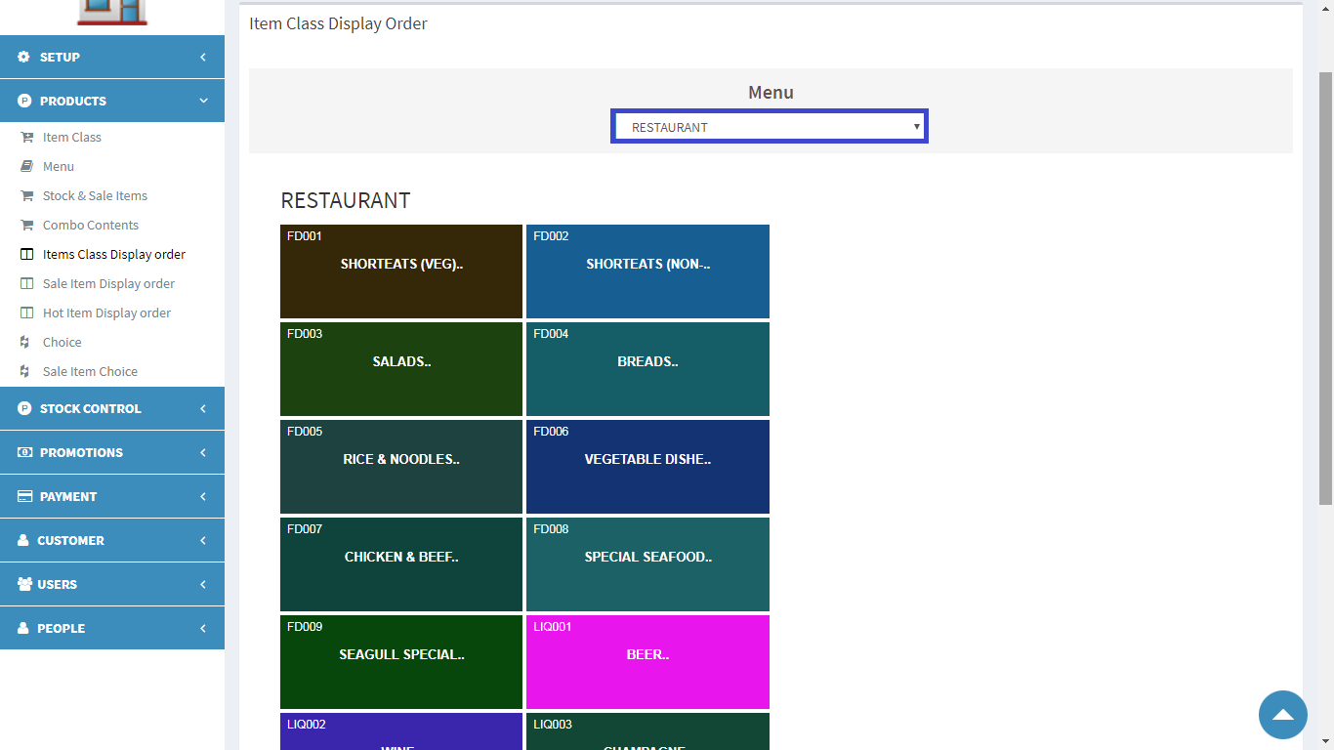

FIG 2.2.5.2 ITEM CLASS DISPLAY ORDER(RESTAURANT)

#### 2.2.6 SALE ITEM DISPLAY ORDER

It means the order in which we want the sale items to be displayed on the terminal side.

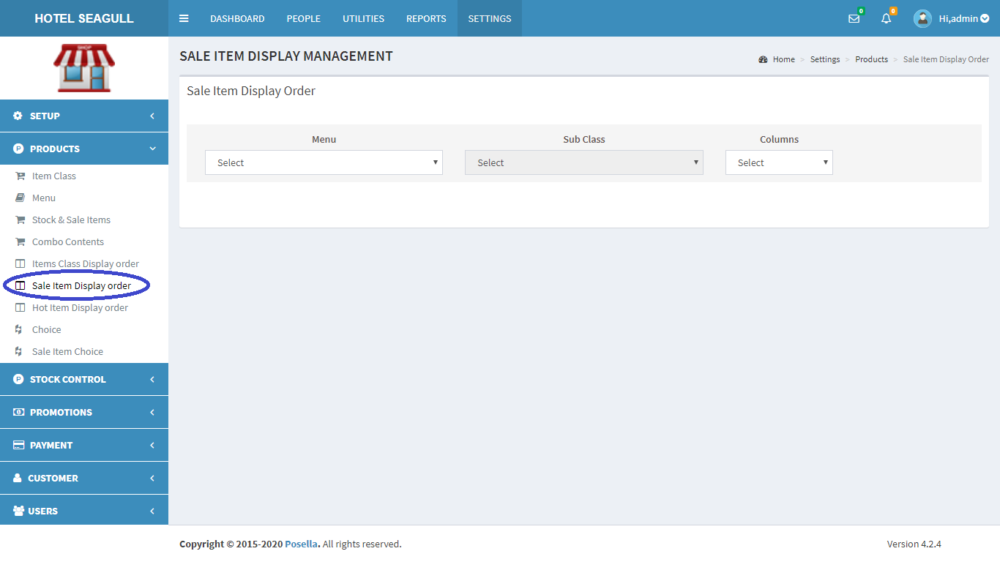

FIG 2.2.6.1 SALE ITEM DISPLAY ORDER

Select an option either Bar or Restaurant from option as shown below:

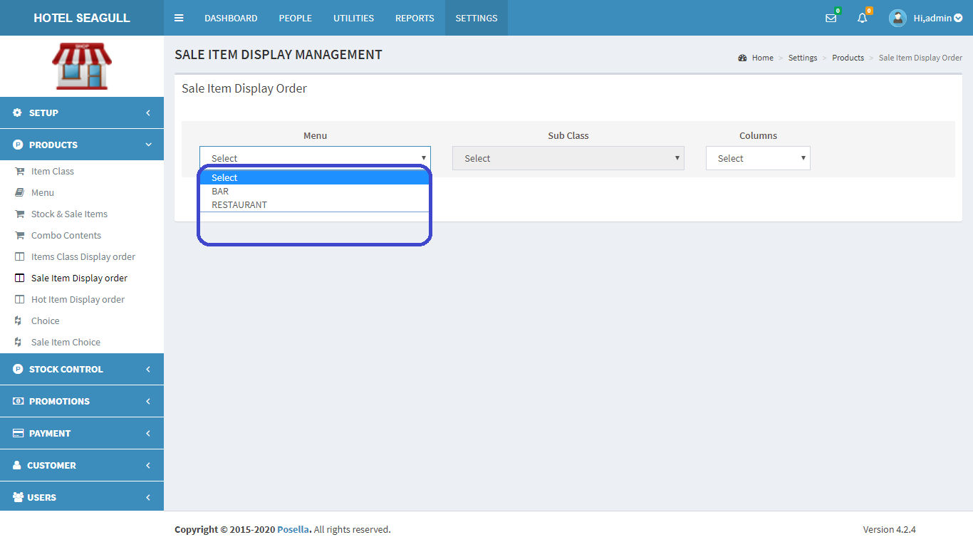

FIG 2.2.6.2 SALE ITEM DISPLAY ORDER (CHOOSE OPTION)

BAR

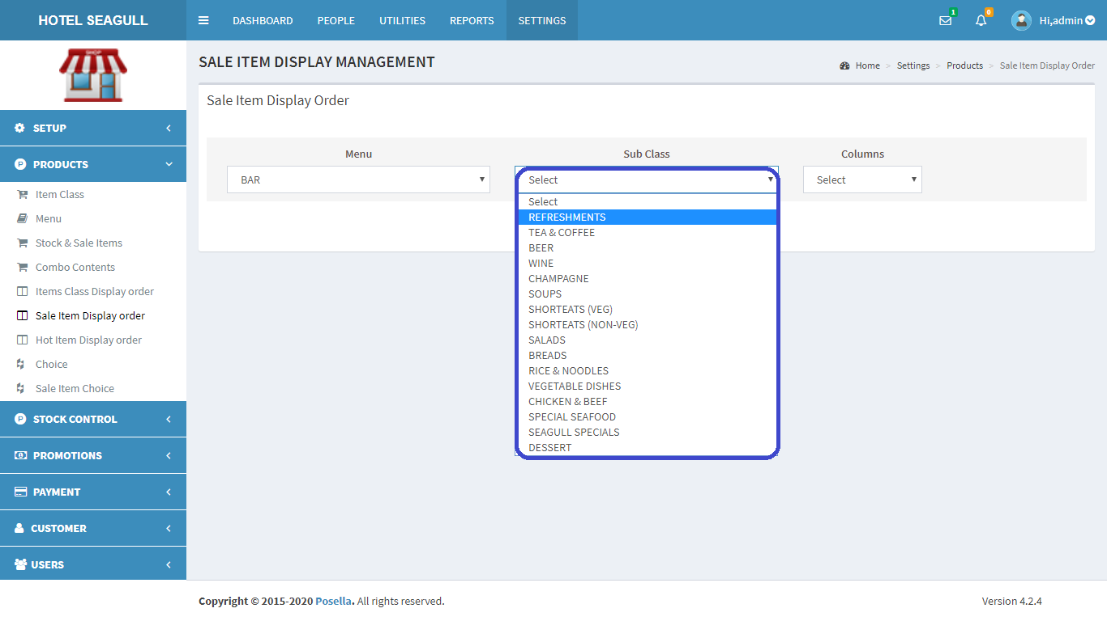

FIG 2.2.6.3 SALE ITEM DISPLAY ORDER (CHOOSE SUBCLASS)

Choose subclass from next option and items gets displayed as shown below:

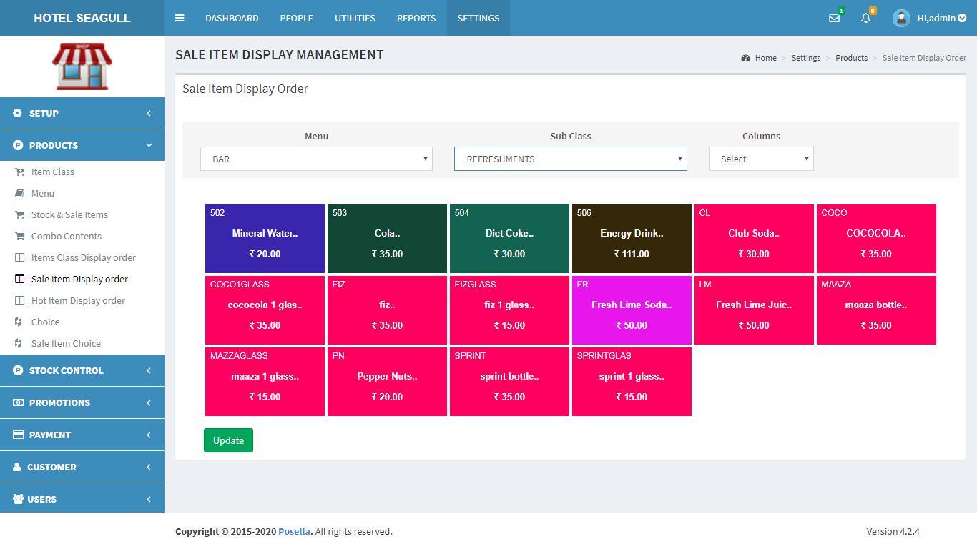

FIG 2.2.6.4 SALE ITEM DISPLAY ORDER (BAR)

If you want to choose the number of columns you need , choose it from the next option:

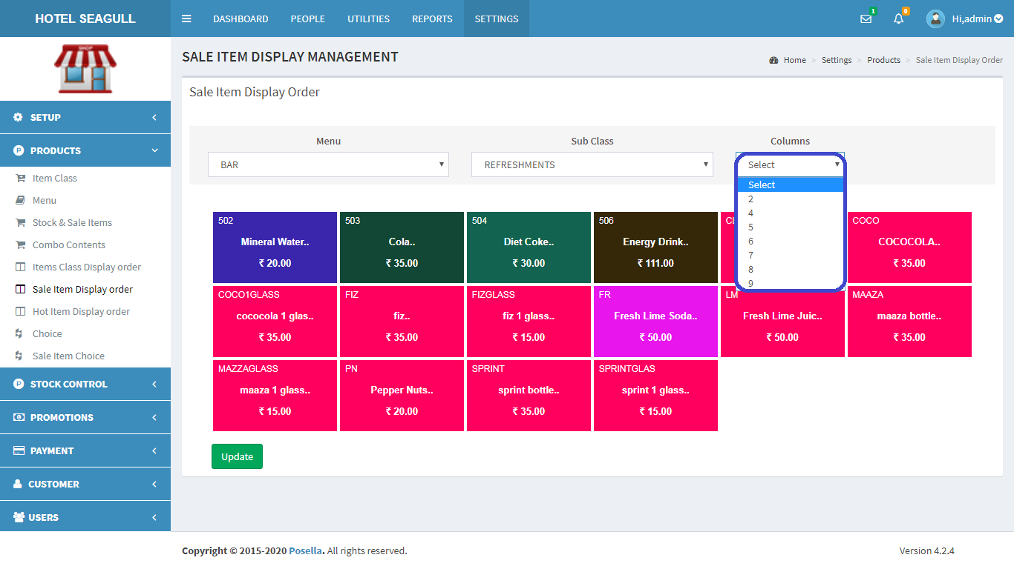

FIG 2.2.6.5 SALE ITEM DISPLAY ORDER (COLUMN)

RESTAURANT

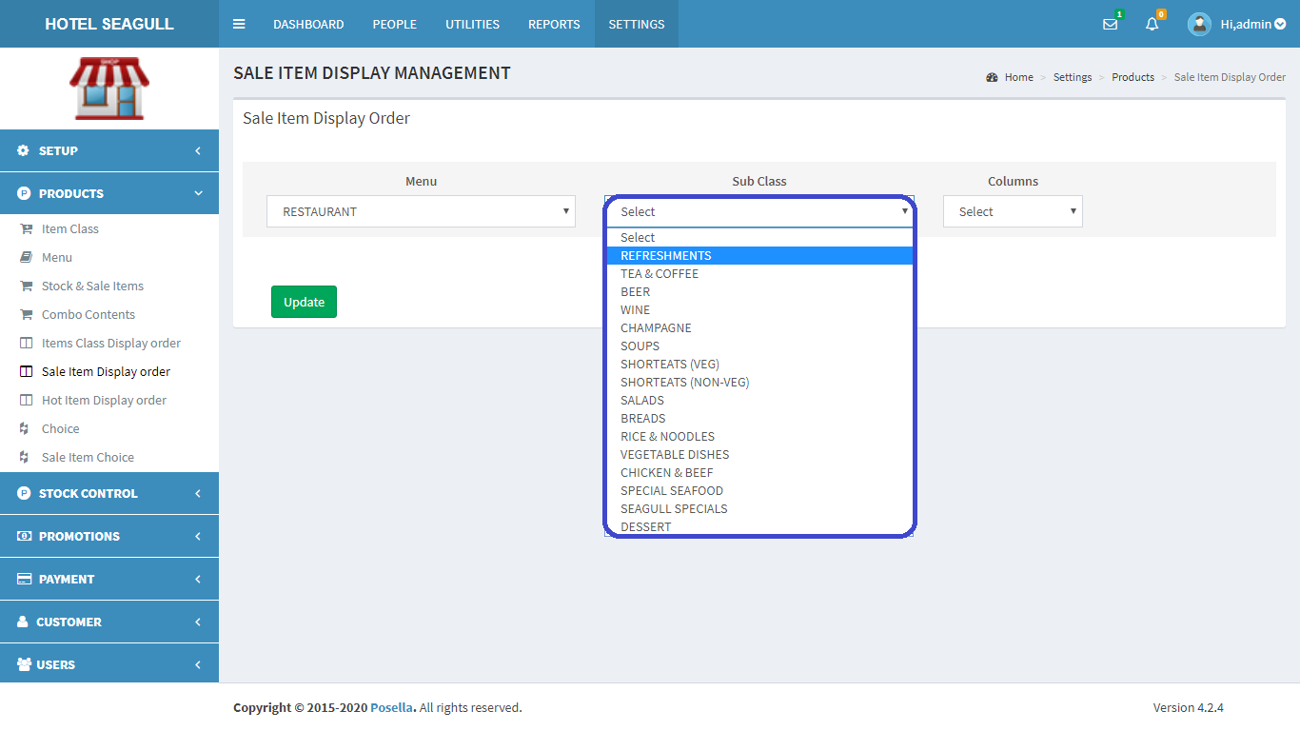

FIG 2.2.6.6 SALE ITEM DISPLAY ORDER (CHOOSE SUBCLASS)

Choose subclass from next option and items gets displayed as shown below:

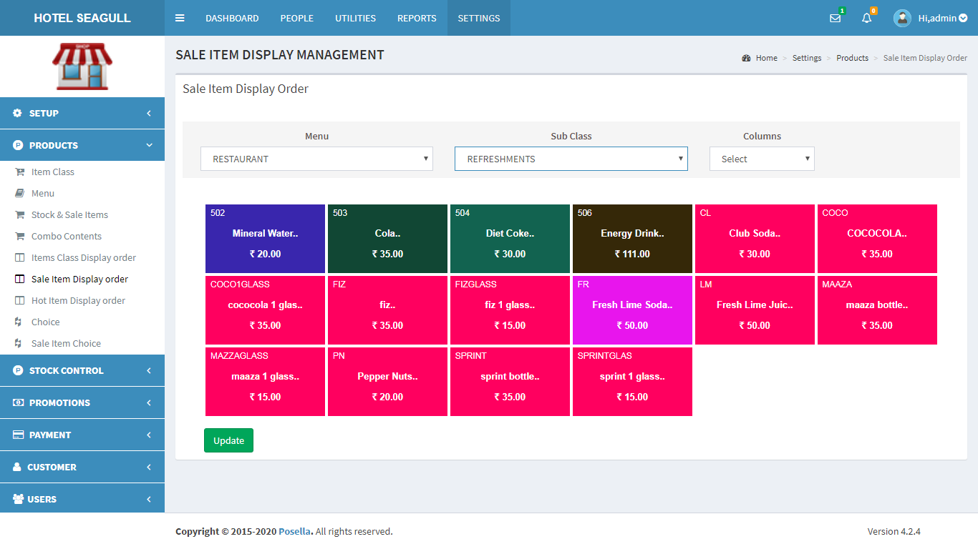

FIG 2.2.6.7 SALE ITEM DISPLAY ORDER (RESTAURANT)

If you want to choose the number of columns you need , choose it from the next option:

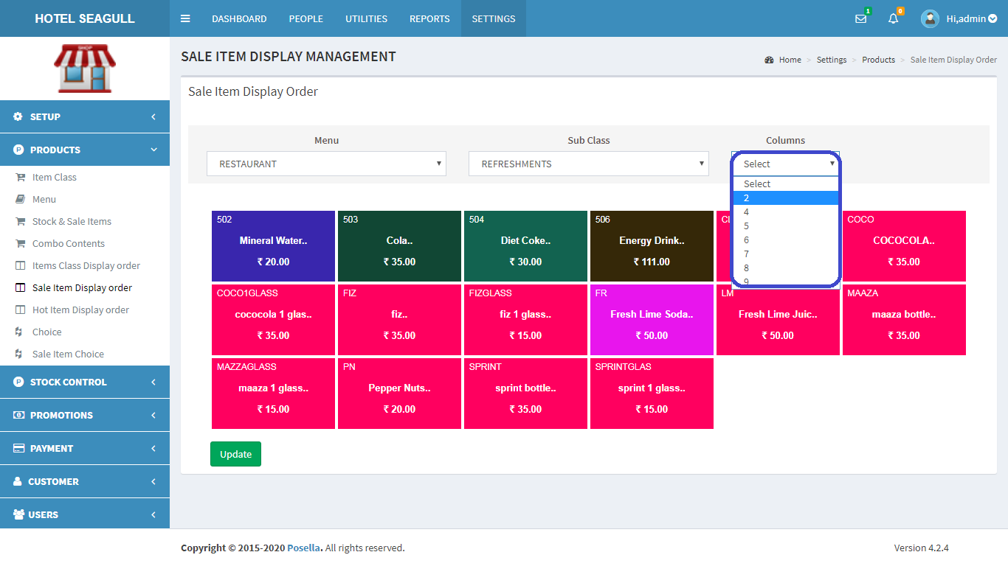

FIG 2.2.6.8 SALE ITEM DISPLAY ORDER (COLUMN)

#### 2.2.7 HOT ITEM DISPLAY ORDER

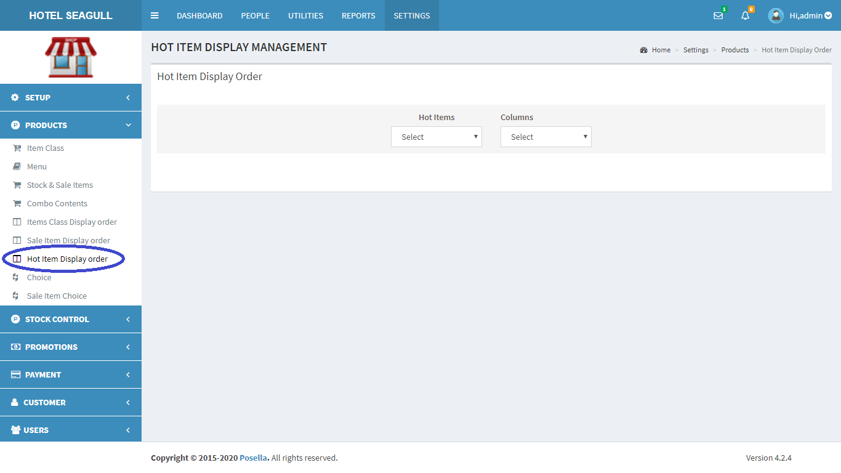

FIG 2.2.7.1 HOT ITEM DISPLAY ORDER

Click on ‘Hot Item Display Order’ and select on ‘Hot items’ to select the ‘hot item’:

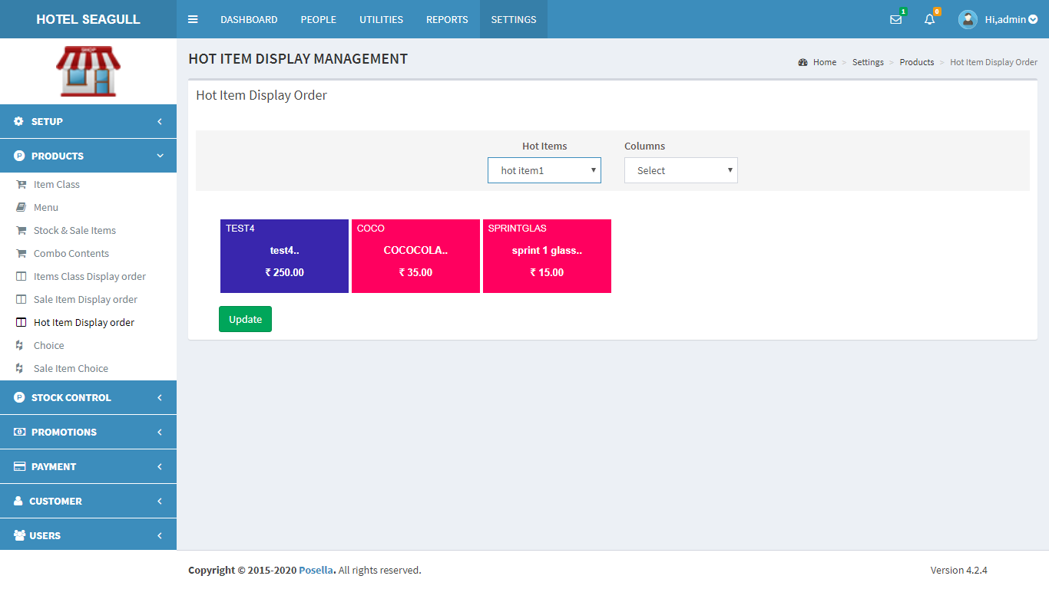

FIG 2.2.7.2 HOT ITEM DISPLAY ORDER(HOT ITEMS)

Select column from the next option:

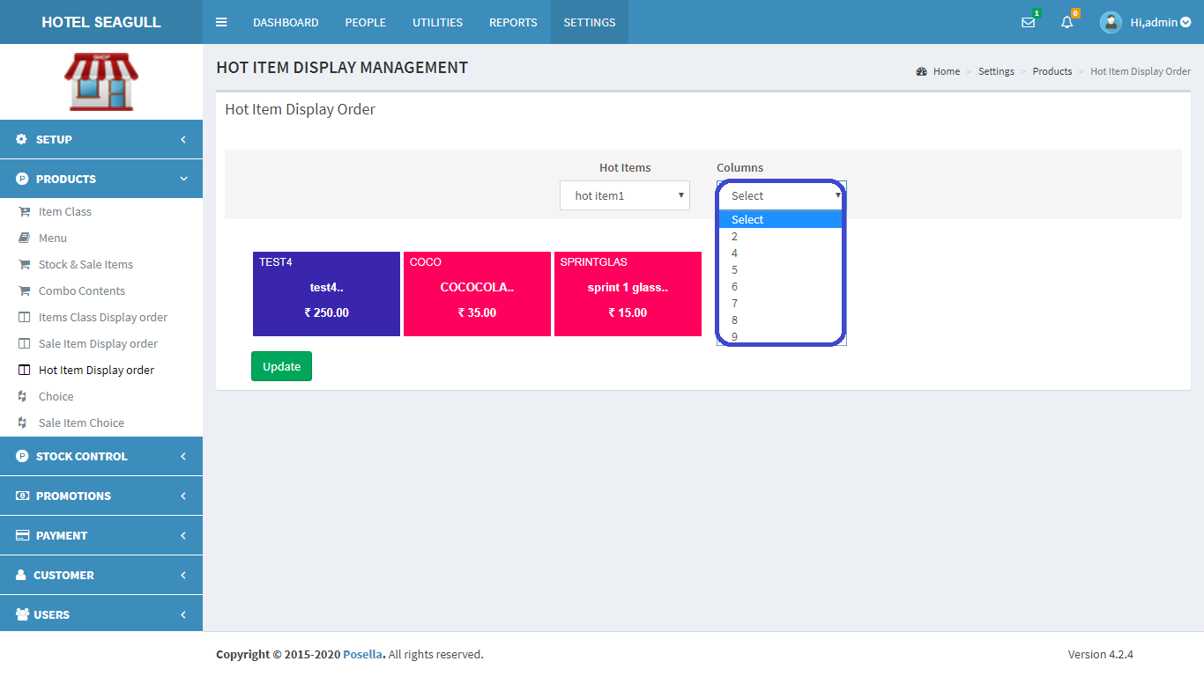

FIG 2.2.7.2 HOT ITEM DISPLAY ORDER(COLUMNS)

After selecting the column, the hot items list gets displayed and you can arrange it the way you want by dragging one from one place to another. Finally, click submit button to update changes.

#### 2.2.8 CHOICE

Click on the Choice, the list of choices gets displayed as shown in figure.

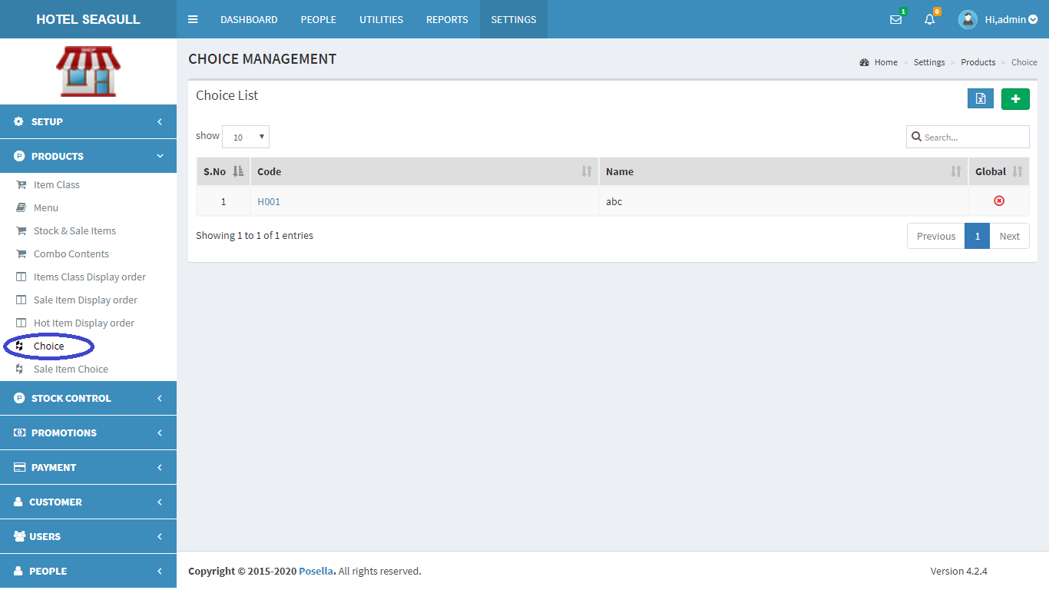

FIG 2.2.8.1 CHOICE



To **add** a new Choice, at the rightmost corner, you can see .Click on the button to add choice.The screen changes and form appears.

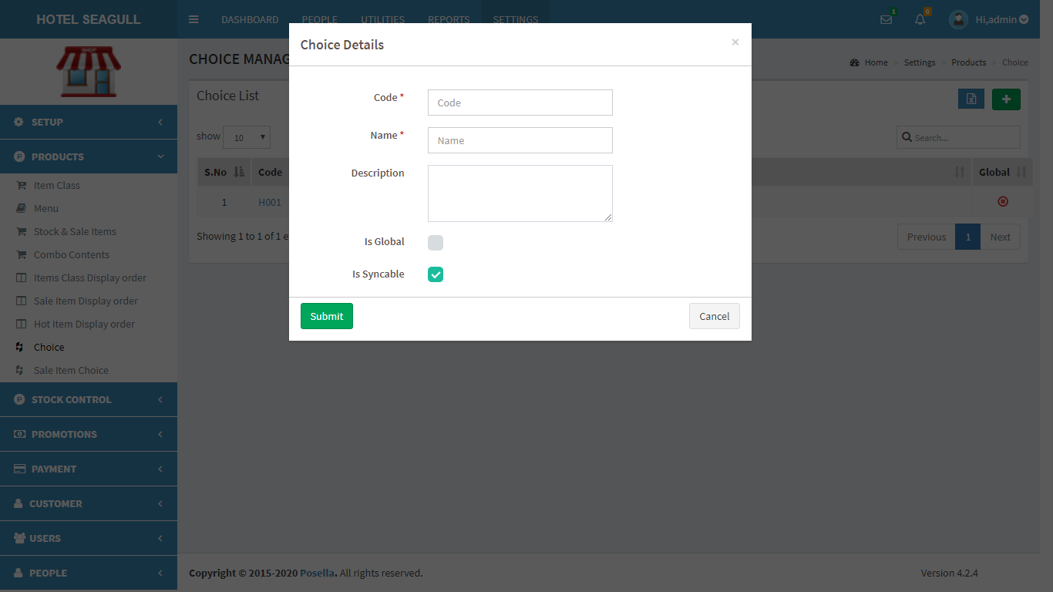

FIG 2.2.8.2 ADD CHOICE

Fill the required fields and click the update button to create a new choice. Otherwise click the cancel button. To **view** and **edit** a particular choice click on ‘code’ in fig 2.2.8.1 . A pop up window appears:

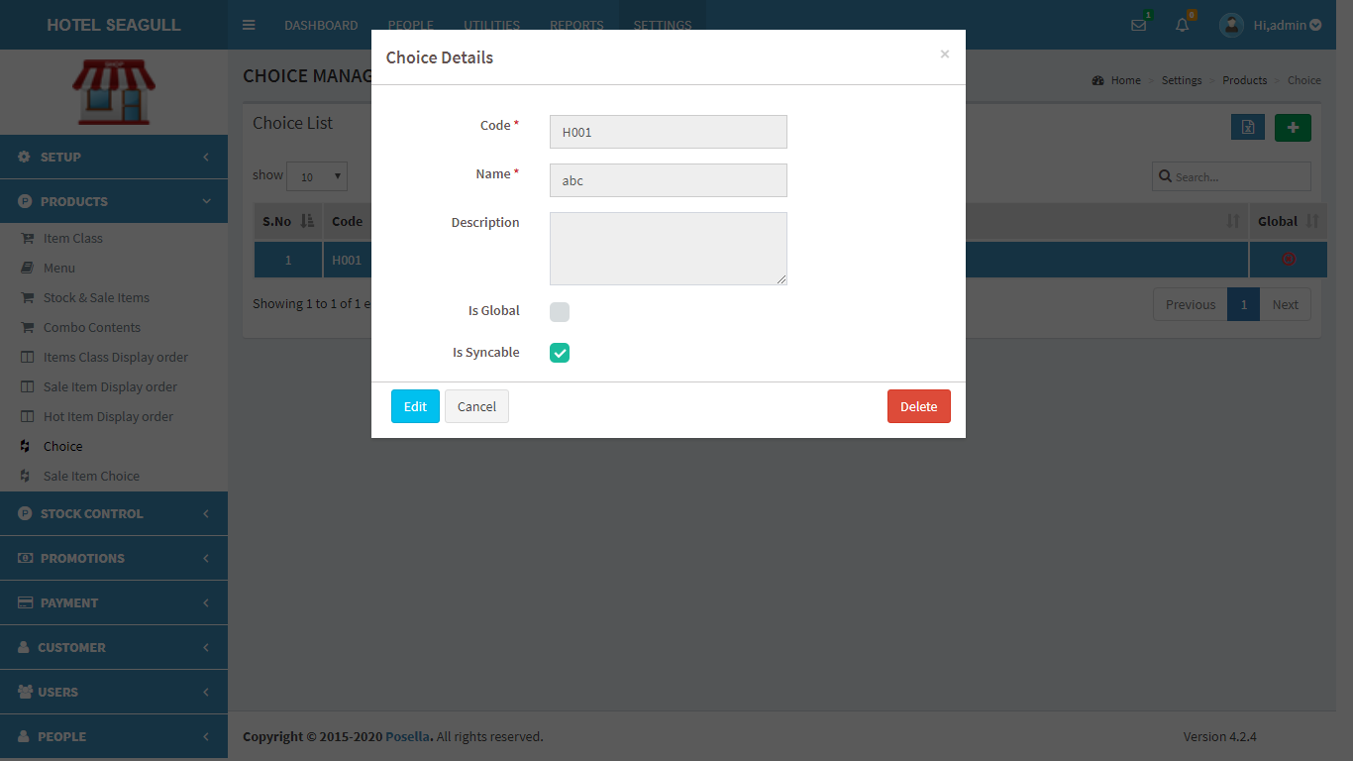

FIG 2.2.8.3 VIEW CHOICE

Click edit to update and another pop-up appears:

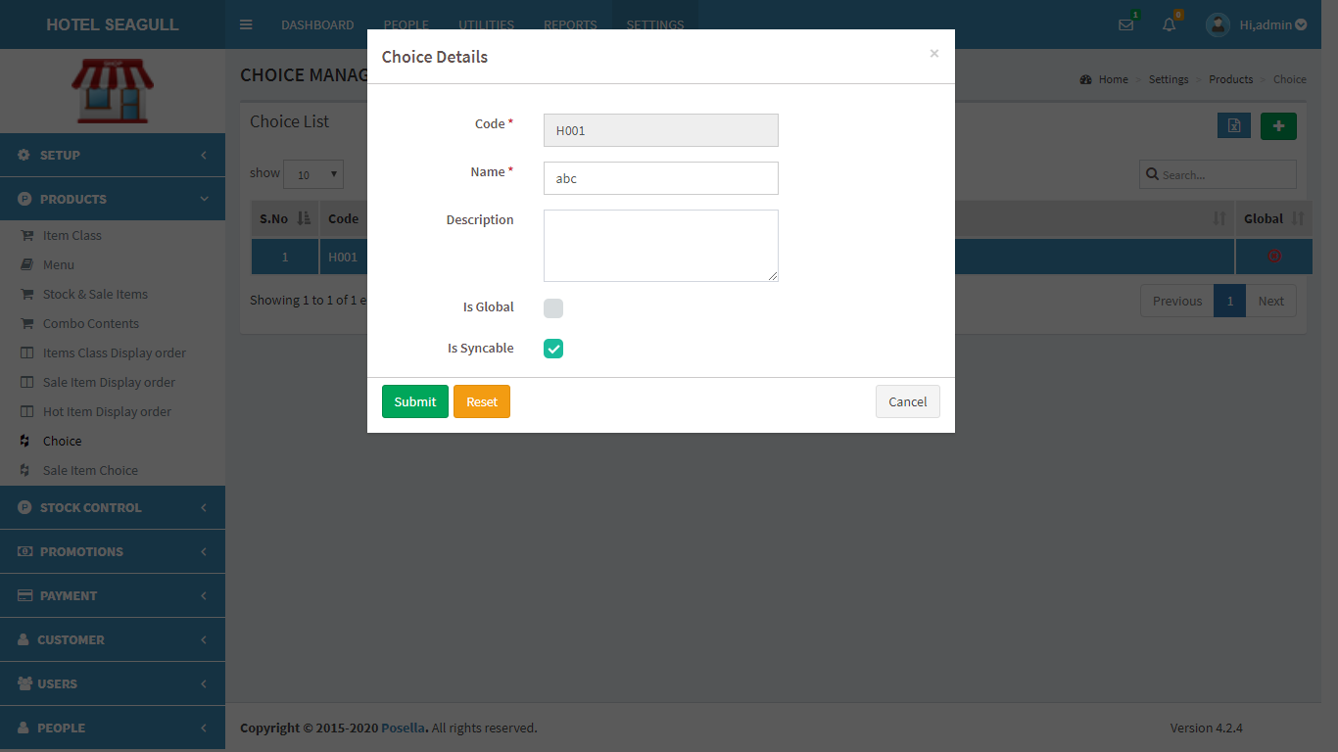

FIG 2.2.8.4 EDIT CHOICE

Click **update** to edit details.

If you want to **delete** a choice, click on the delete symbol provided in table in fig 2.2.8.3 When delete button is clicked, another pop-up appears:

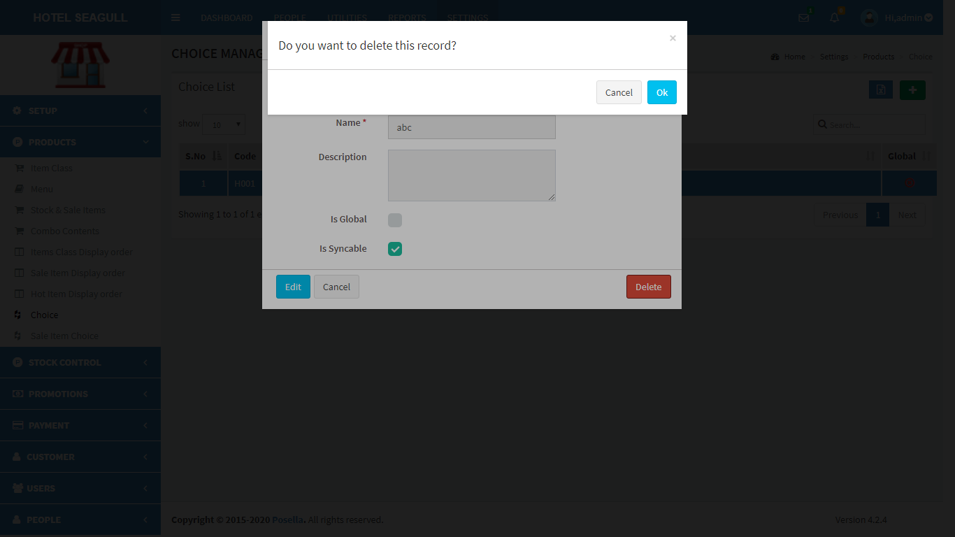

FIG 2.2.8.5 DELETE CHOICE

Confirm **delete** by clicking ‘OK’ otherwise cancel.

To **export** Choice list, click on the blue button in  the right corner. Then a pop up gets displayed .

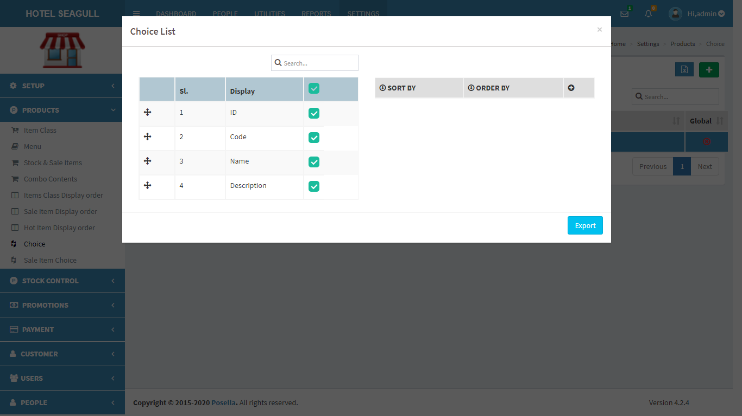

FIG 2.2.8.6 EXPORT EXCEL

Select the relevant options and click the ‘**export**’ button . The excel sheet gets downloaded.

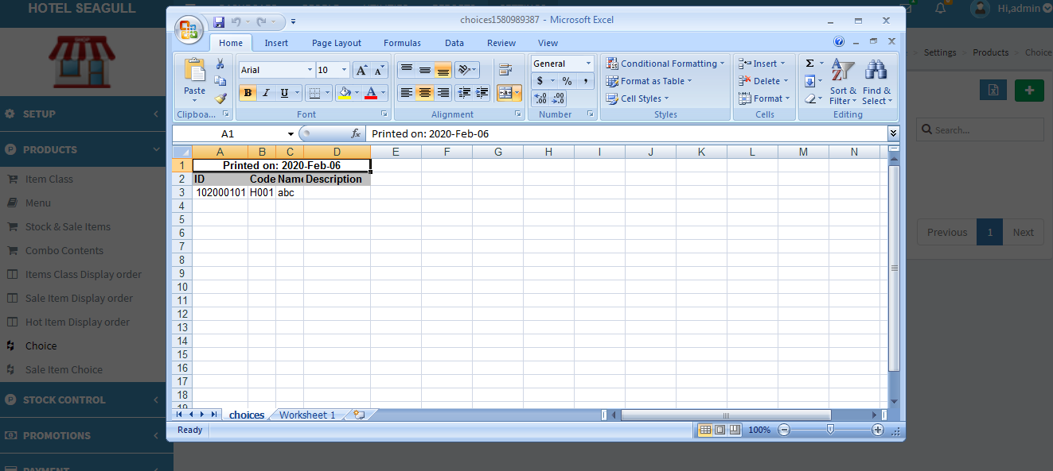

FIG 2.2.8.7 EXCEL REPORT

#### 2.2.9 SALE ITEM CHOICE

Click on the Sale Item Choice, the list of Sale Item Choices gets displayed as shown in figure.

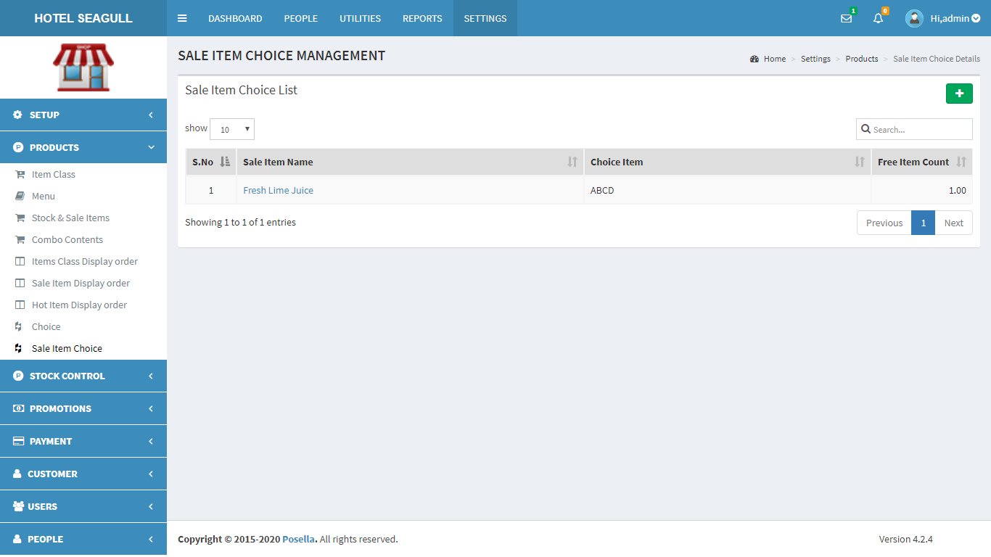

FIG 2.2.9.1 SALE ITEM CHOICE



To **add** a new Sale Item Choice, at the rightmost corner, you can see .Click on the

button to add choice.The screen changes and form appears.

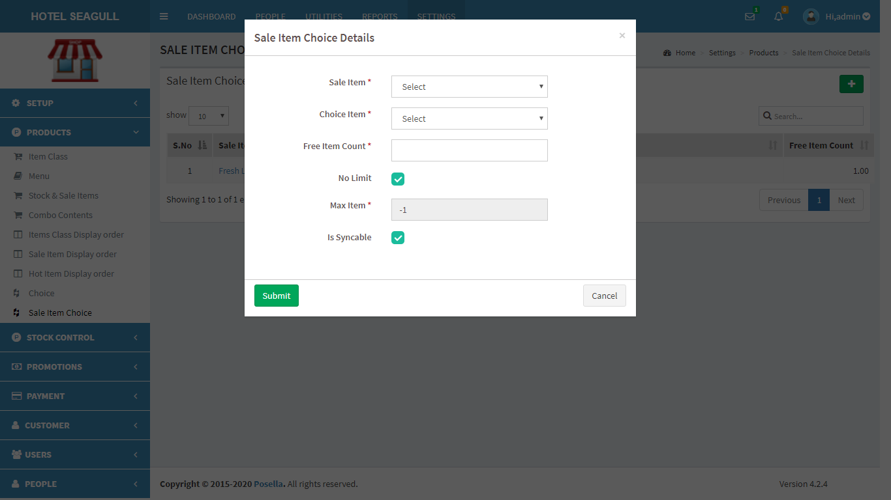

FIG 2.2.9.2 ADD SALE ITEM CHOICE

Fill the required fields and click the update button to create a new sale item choice. Otherwise click the cancel button. To **view** and **edit** a particular choice click on ‘code’ in fig 2.2.9.1 . A pop up window appears:

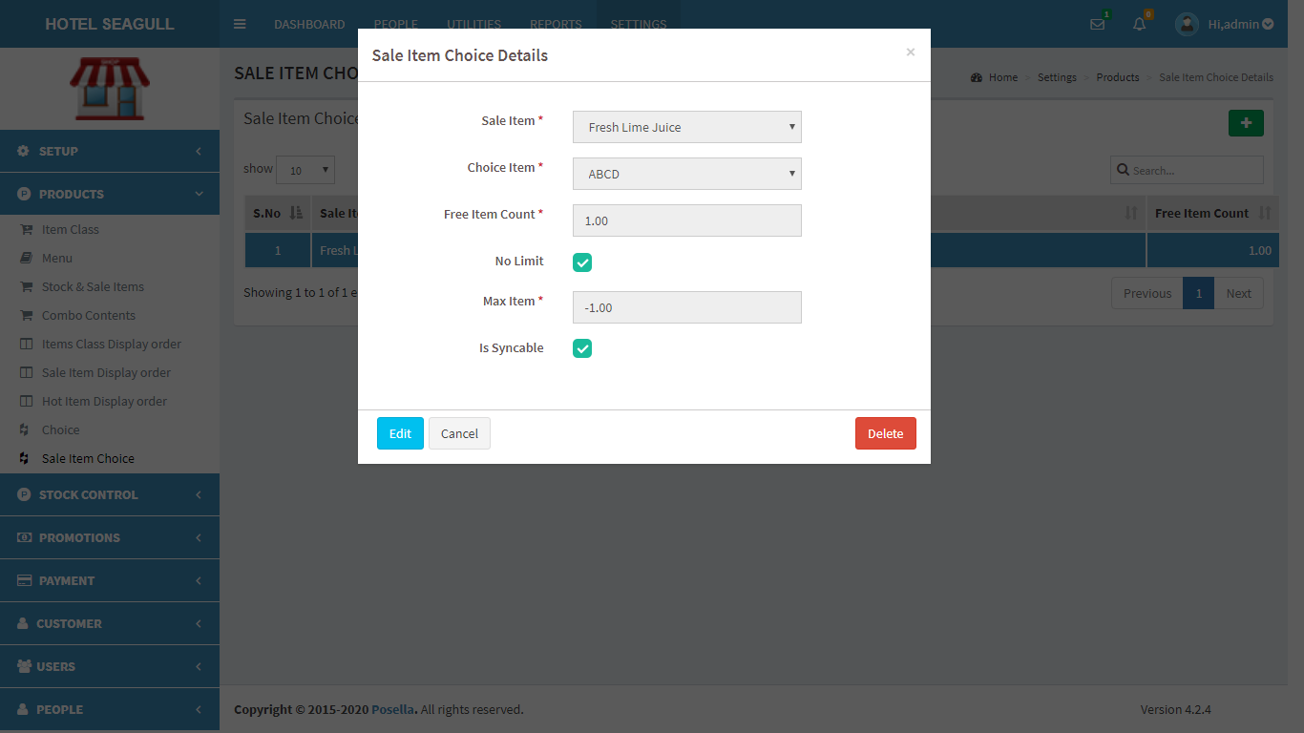

FIG 2.2.9.3 VIEW SALE ITEM CHOICE

Click edit to update and another pop-up appears:

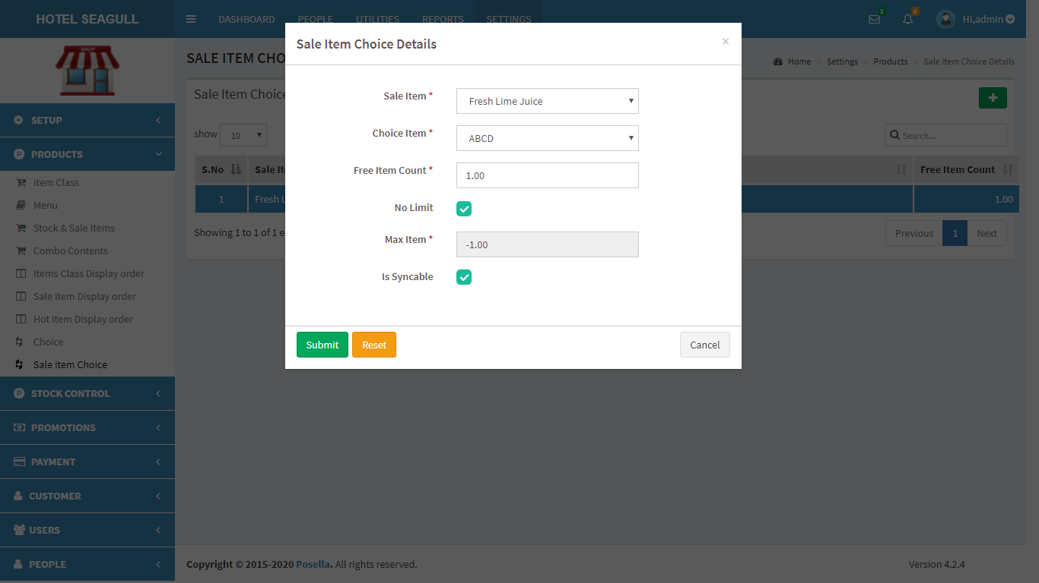

FIG 2.2.9.4 EDIT SALE ITEM CHOICE

Click **update** to edit details.

If you want to **delete** a sale item choice, click on the delete symbol provided in table in fig 2.2.9.3 When delete button is clicked, another pop-up appears:

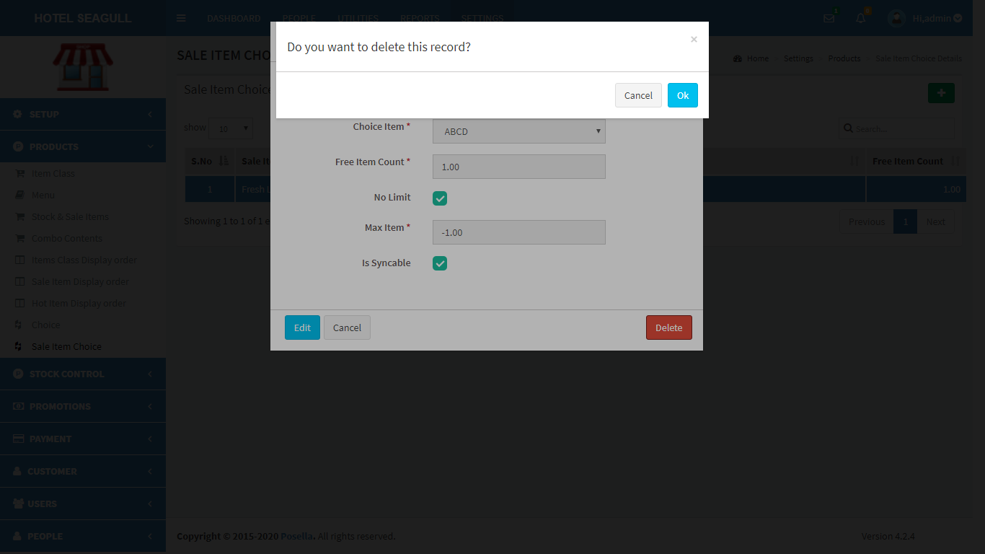

FIG 2.2.9.5 DELETE SALE ITEM CHOICE

Confirm **delete** by clicking ‘OK’ otherwise cancel.

### 2.3 STOCK CONTROL

Click the **Stock Control** in the settings menu to view the details regarding the stock.

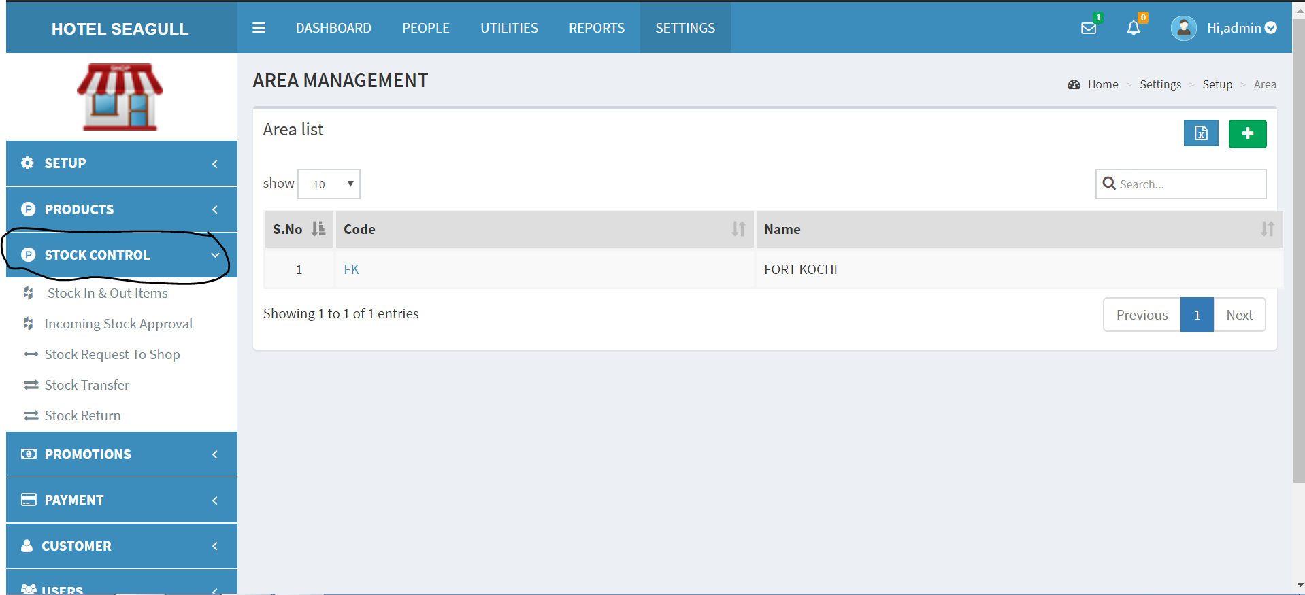

Fig 2.3 Stock Control

#### 2.3.1 STOCK IN AND OUT ITEMS

Click the **Stock In & Out Items** in the Stock Control to view the list of stock available. It can be filtered with the dates , and a search bar is given to search for a particular item.

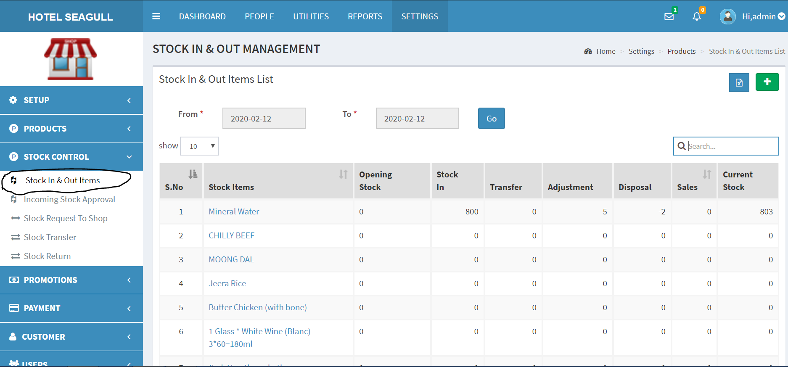

Fig. 2.3.1.1 Stock in & Out Items

To **Add** an Item , click the 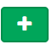 button to add it to the Stock.A pop up window will appear.

Click the add button in the pop up window to add the item and then click submit.

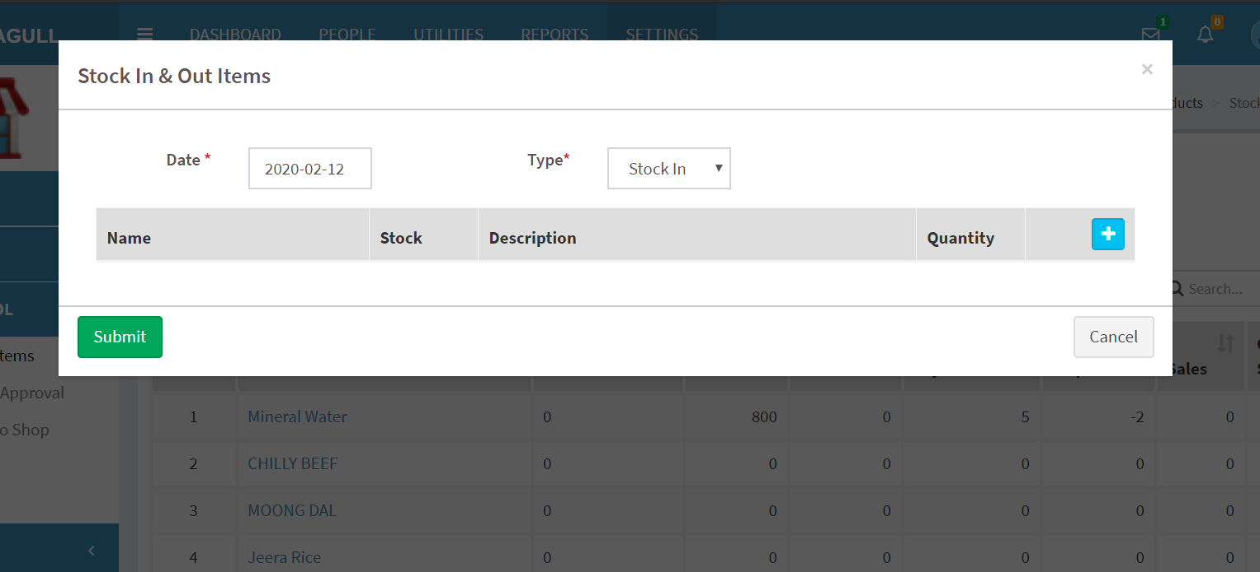

Fig 2.3.1.2 Add Item

To **Export** the report of the items in stock in a well defined excel format click the 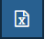 button.

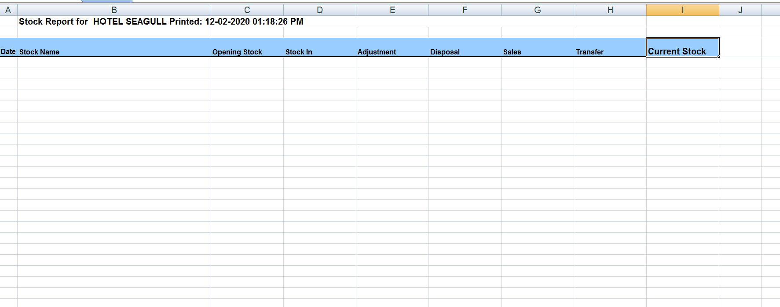

Fig 2.3.1.3 Stock Report

#### 2.3.2 INCOMING STOCK APPROVAL

Click the **incoming stock approval** in the stock control to approve the items that are requested from the production center or that are requested from other shops of the chain.

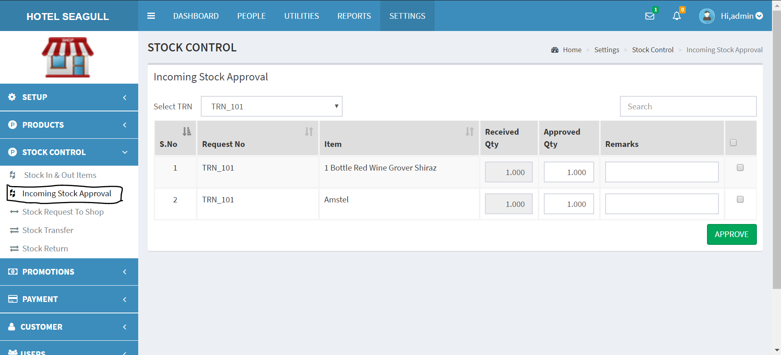

Fig. 2.3.2.1 Incoming Stock Approval

We can approve the incoming items in this page by ticking the required item and then by clicking the approve button.

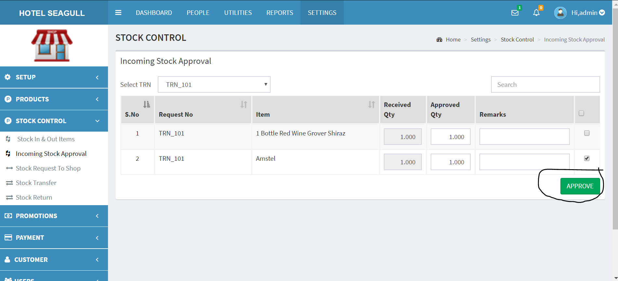

Fig. 2.3.2.2 Incoming Stock Approval

#### 2.3.3 STOCK REQUEST TO SHOP

Click the **stock request to shop** in the stock control to request for items that are needed, i.e., the items that are out of stock. The request will be sent to other shops of the chain.

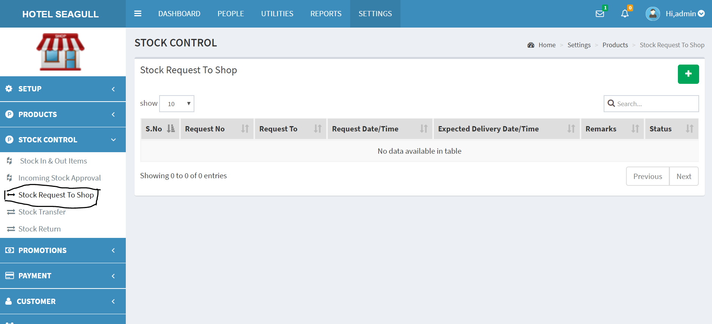

Fig 2.3.3.1 Stock Request to Shop

Click the  button to send the request to the required shop and a pop up window will appear, fill out the details like expected delivery date, time, remarks and the required item along with its quantity and then click the save button to send the request.

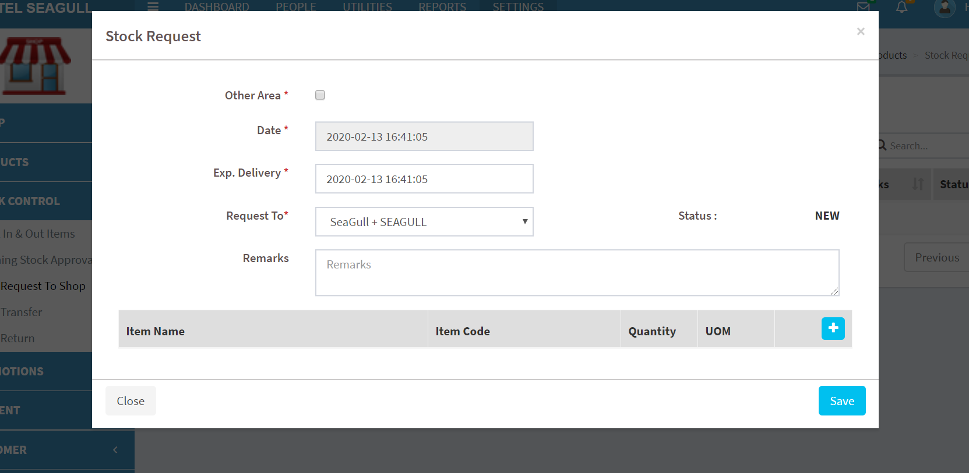

Fig. 2.3.3.2 Stock Request

By ticking the **other area** in the pop up window, we can choose the area to which we have to send the Stock Request.

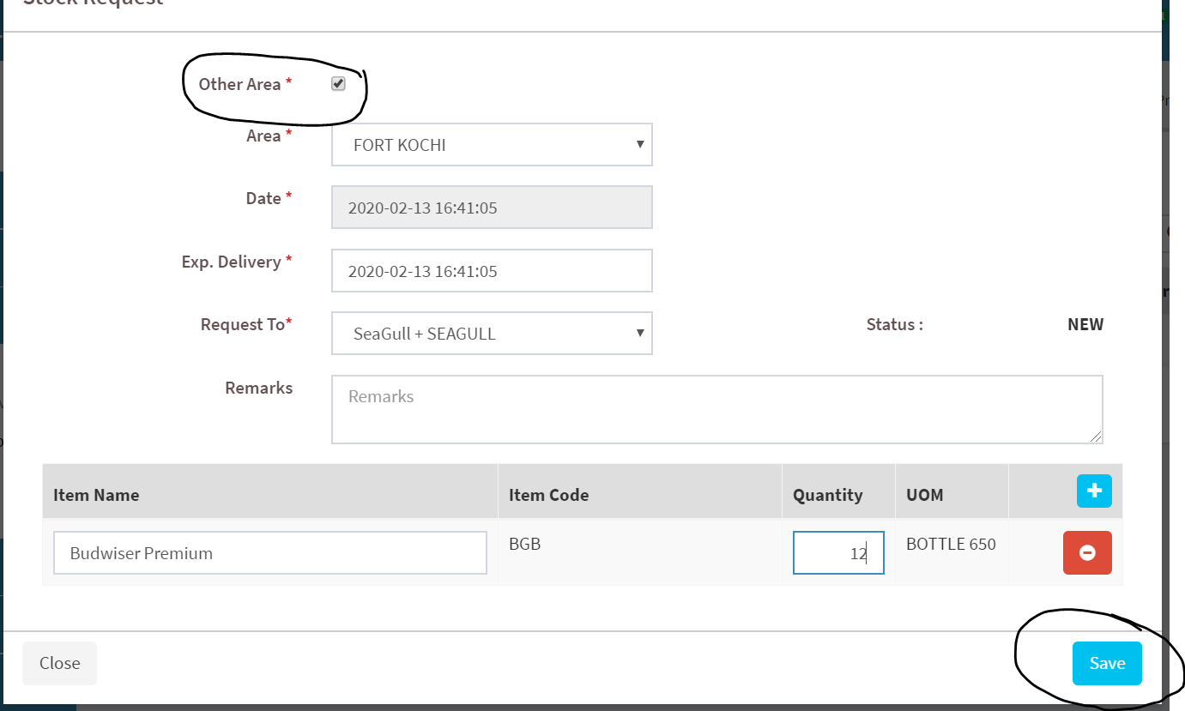

Fig. 2.3.3.3 Stock Request

#### 2.3.4 STOCK TRANSFER

Click the **stock transfer** in the stock control to view the items that we have requested from other other shops, along with the details like requested date, time, expected delivery etc.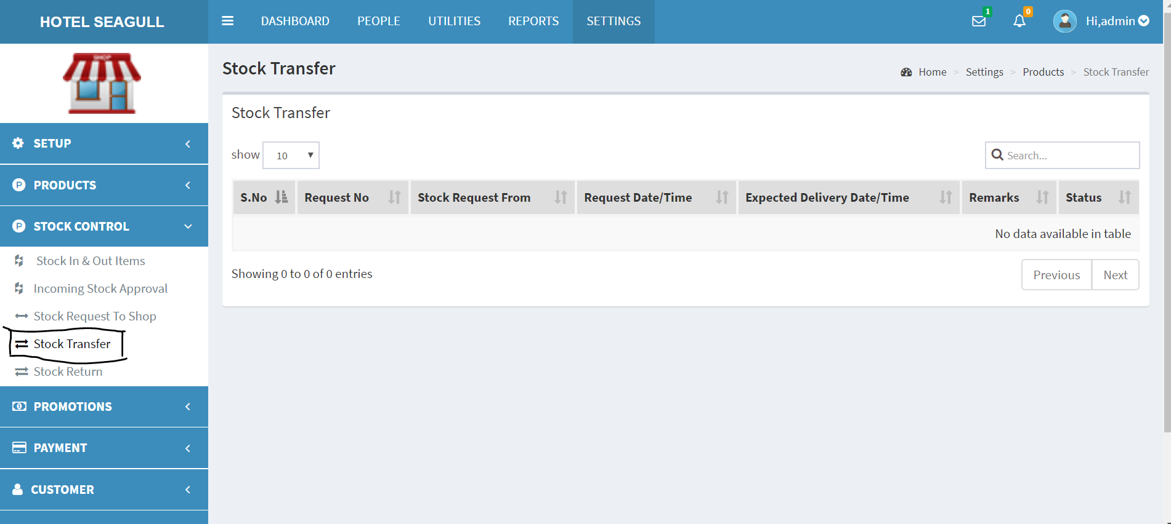

Fig. 2.3.4.1 Stock Transfer

#### 2.3.5 STOCK RETURN

Click the **stock return** in the stock control to return the defective items that we have requested from other shops.We can see the type, return date, return time, status etc., form the list.

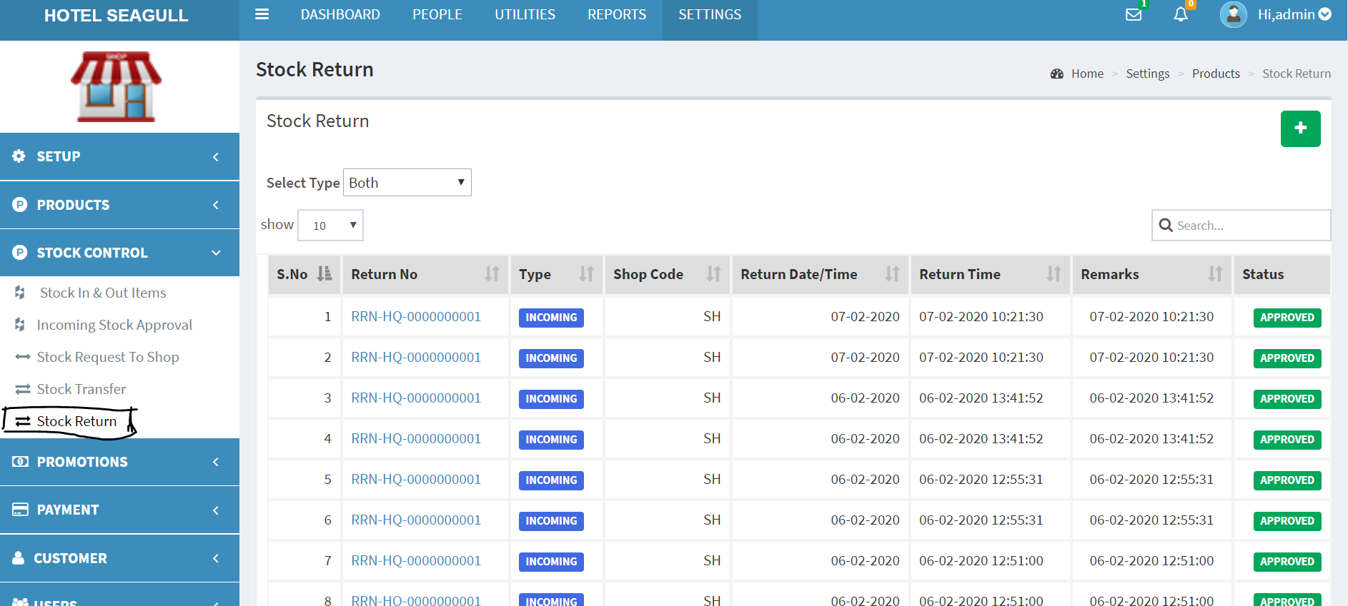

Fig 2.3.5.1 Stock Return

There are two types of stock return

1. Incoming - the items we have requested from other shops.
2. Outgoing - the items requested to us by others.

By Clicking the  button, a pop up window will come and we can add the stock return, by providing the date, shop name, area etc. We can add the items by clicking the add button along with its quantity and then click the save button to set the stock return. By clicking **other area** in the pop up window, we can select the area from it, and after filling the necessary details, click the **save** button.

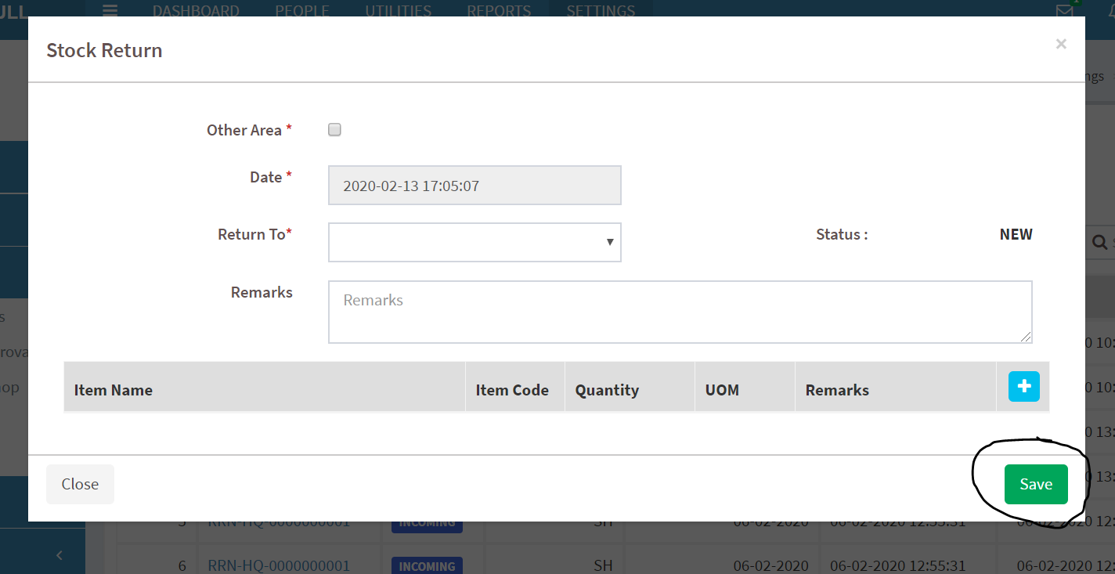

Fig 2.3.5.1 Stock Return

### 2.4 PROMOTIONS

Click the **promotions** in the settings menu to view the details regarding promotions.

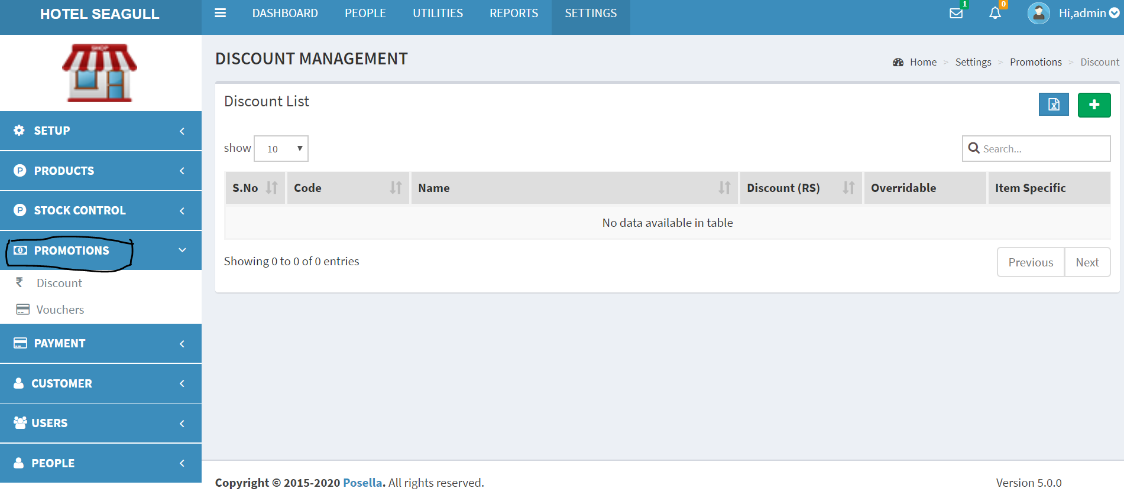

Fig. 2.4.1 Promotions

#### 2.4.1 DISCOUNT

Click the **discount** in the promotions to view the discount list along with the name, discount list etc.,

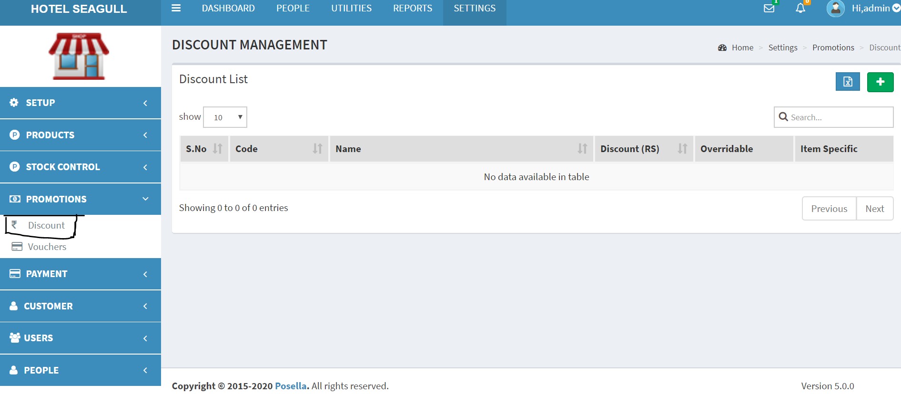

Fig. 2.4.1.1 Discount List

Click the  button to add new discount rule details. A pop up window will appear, where the details can be filled. There are 3 options for the pop up window - General, Editing, Promotion.

Where we can fill the code, name, date, validity, promotion day, promotion time etc.

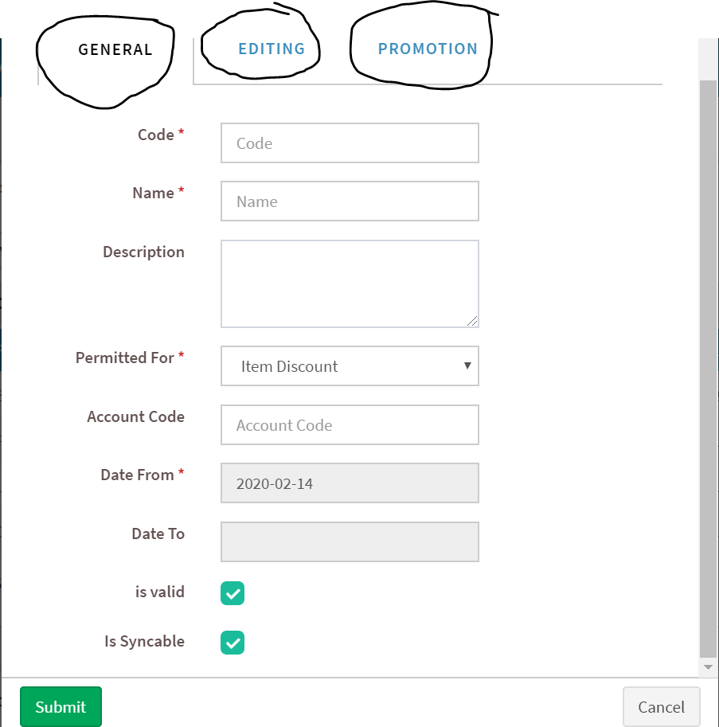

Fig. 2.4.1.2 Discount Rule Details(General)

We can fill out the required details and then click the submit button to save it.

There is also an export button in the promotions page, where we can export a well defined excel sheet containing the promotion details.

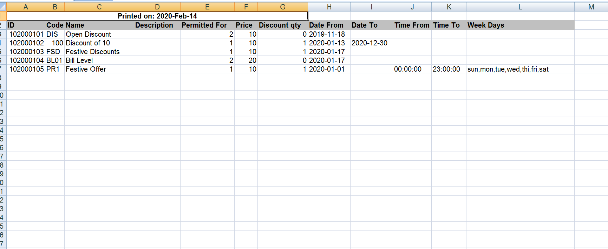

Fig. 2.4.1.3 Discount List Report

#### 2.4.2 VOUCHERS

Click the **vouchers** in the promotion to view the voucher list containing the voucher details like the name, voucher type, voucher value etc.,

Click the  button to add the voucher details, a pop up window will come where the necessary details are to be filled out. We can also export the voucher list in a well defined excel format by clicking the export button in the voucher list page.

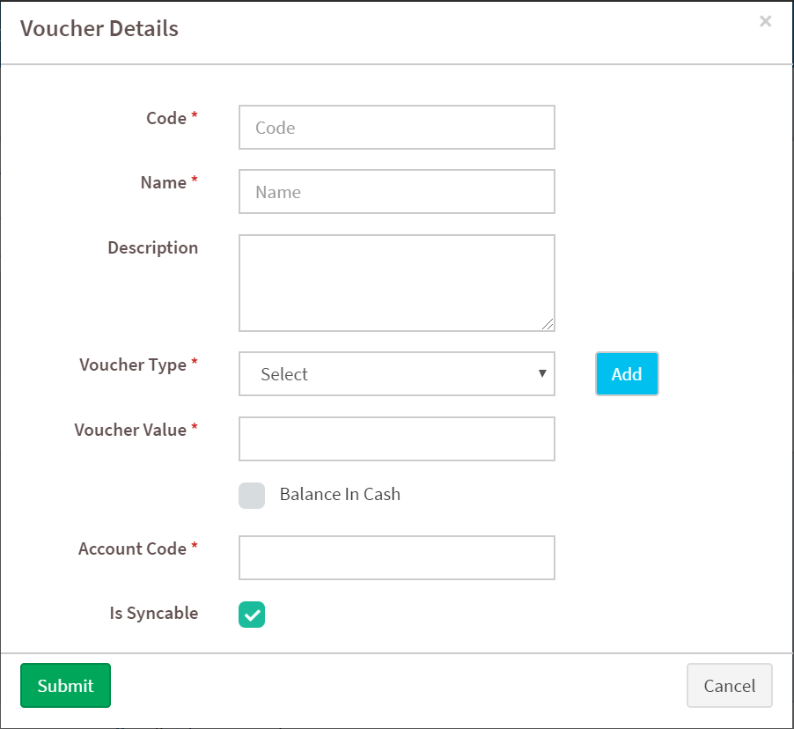

Fig. 2.4.2.1 Voucher Details

After providing the necessary details, click the submit button to save the voucher details.

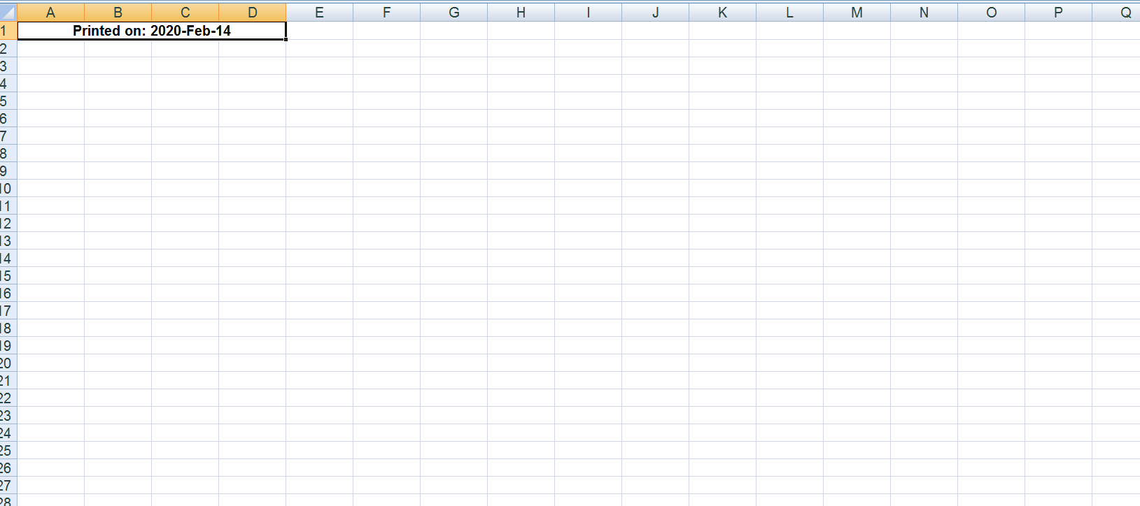

Fig. 2.4.2.2 Voucher List Report

### 2.5 PAYMENT

Click the **Payment** in the settings menu to view the details regarding payments.

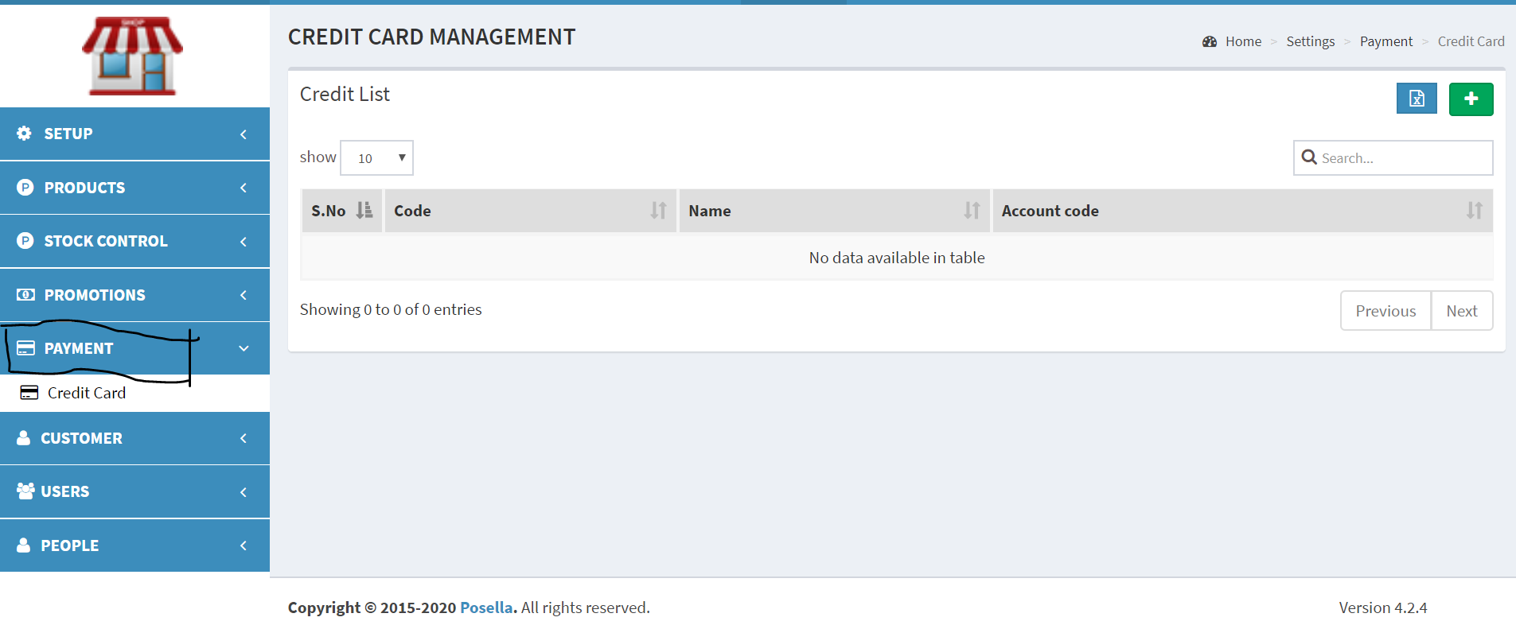

Fig. 2.5.1 Payment

#### 2.5.1 CREDIT CARD

Click the **Credit Card** in the payment to view the credit card list which consist of the name , account code etc.,

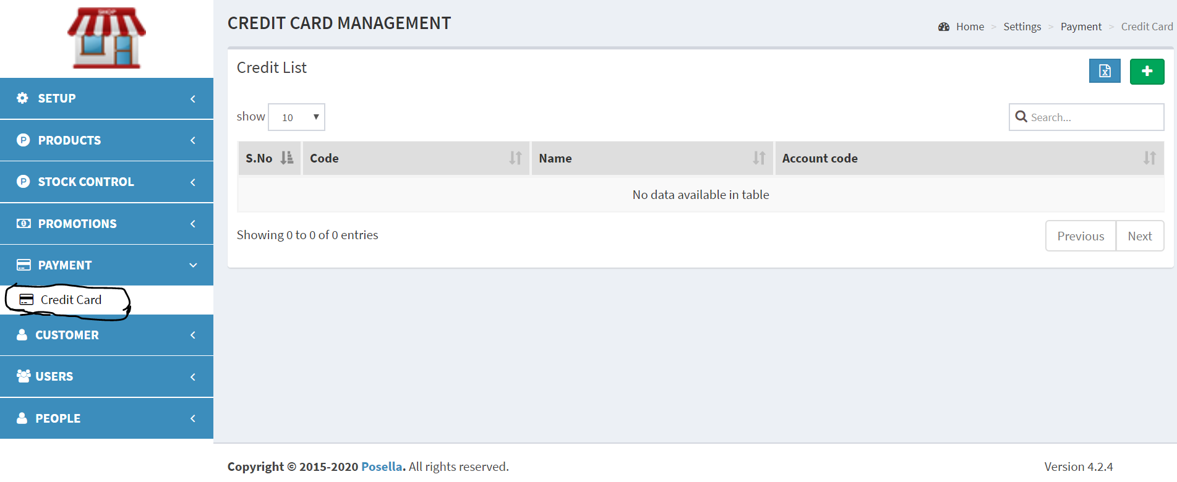

Fig. 2.5.1.1 Credit Card Management

Click the  button to add a new card, a pop up window will come which consist of several details like code, name, validity etc., which is to be filled out. There is also an export button, which will give us the well defined excel report of the list of the card types.

After entering the required details in the pop up window, click the submit button to save the credit card details.

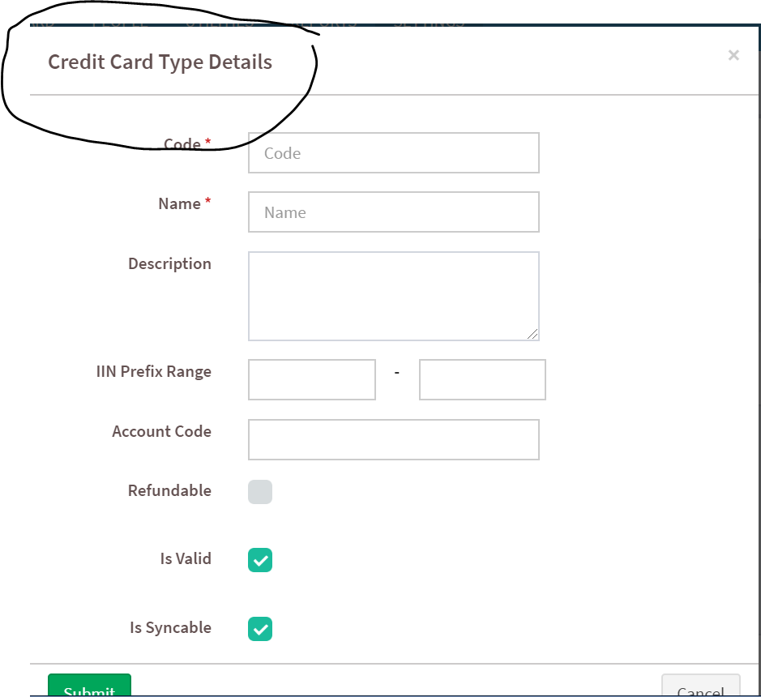

Fig. 2.5.1.2 Credit Card Type Details

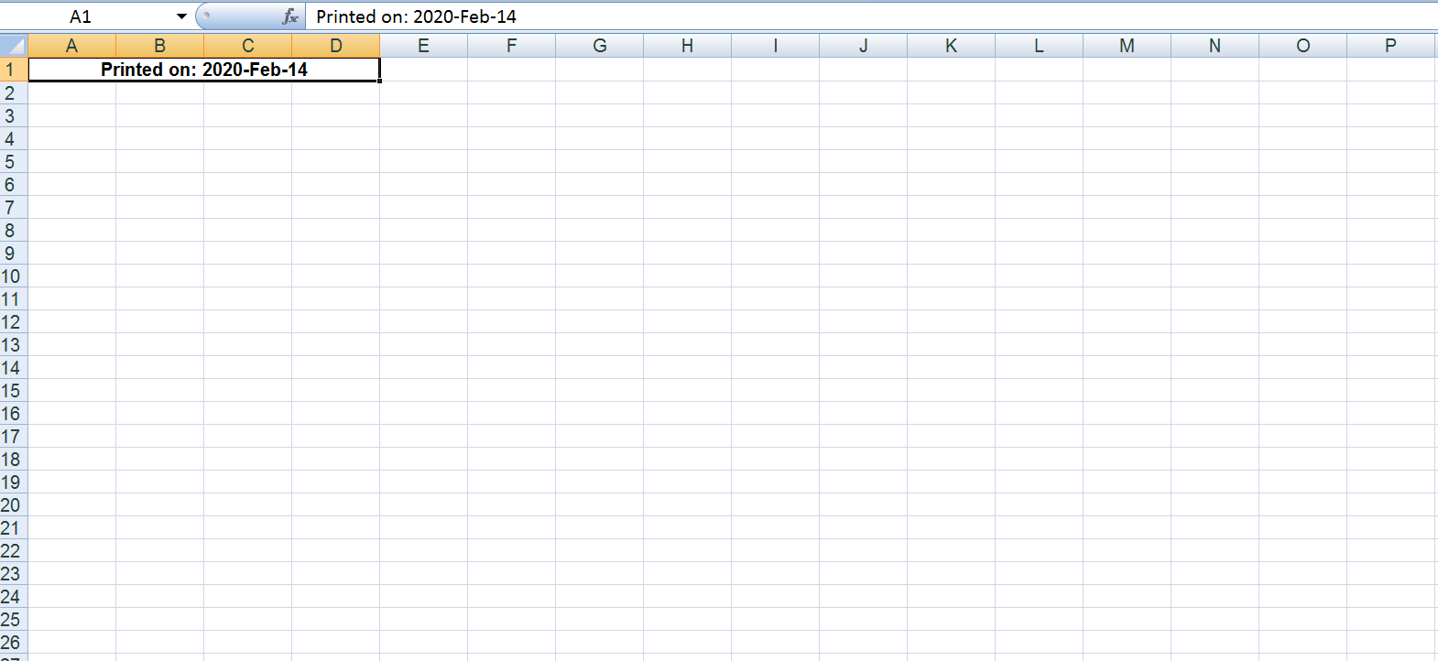

Fig. 2.5.1.3 Credit Card List Report

### 2.6 CUSTOMER

Click the **customer** in the settings menu to view the details regarding the customers.

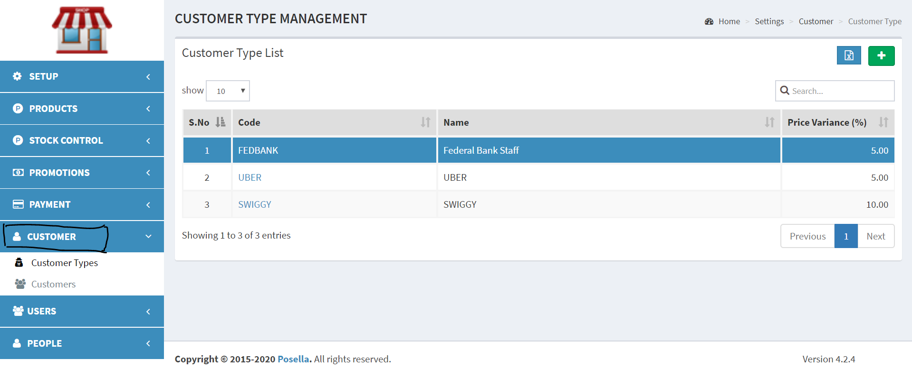

Fig 2.6.1 Customer

#### 2.6.1 CUSTOMER TYPE

Click the **Customer Types** in the customer to view the list of the customer type, which contains the code , name and price variance.

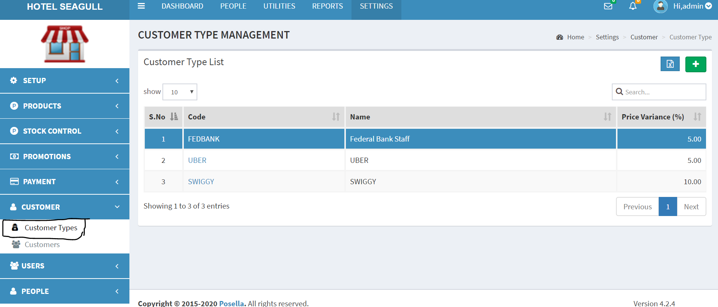

Fig. 2.6.1.1 Customer Types

Click the  button to add new customer type details, a pop up window will come which consist of some required details that has to be filled out, and then click submit to save the customer details.

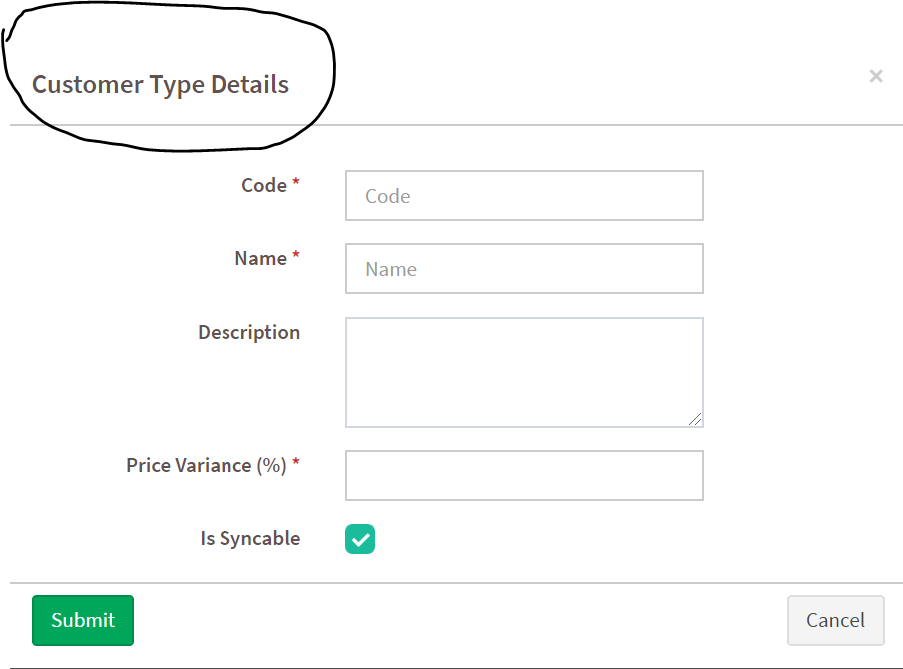

Fig 2.6.1.2 Customer Type Details

The pop up window consists of name, code, price variance etc. that has to be filled out.There is also an export button that will export a well defined excel file containing the report of the customer type list.We can also choose the contents that have to be shown in the report.

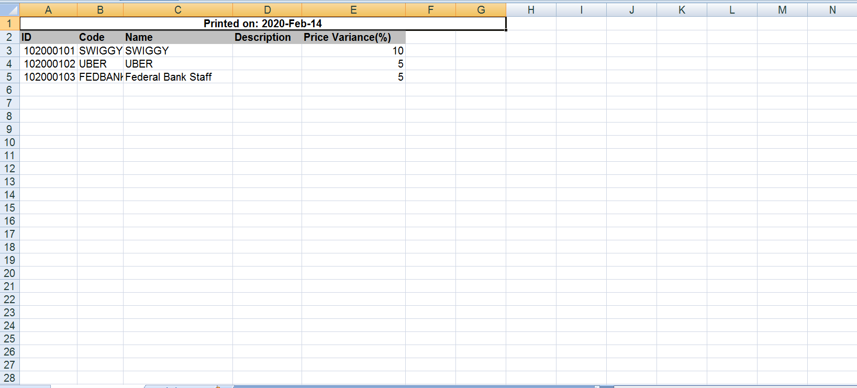

Fig 2.6.1.3 Customer Type List

#### 2.6.2 CUSTOMERS

Click the **Customers** in the customer menu to view the customer list that contains the name, card number etc.,

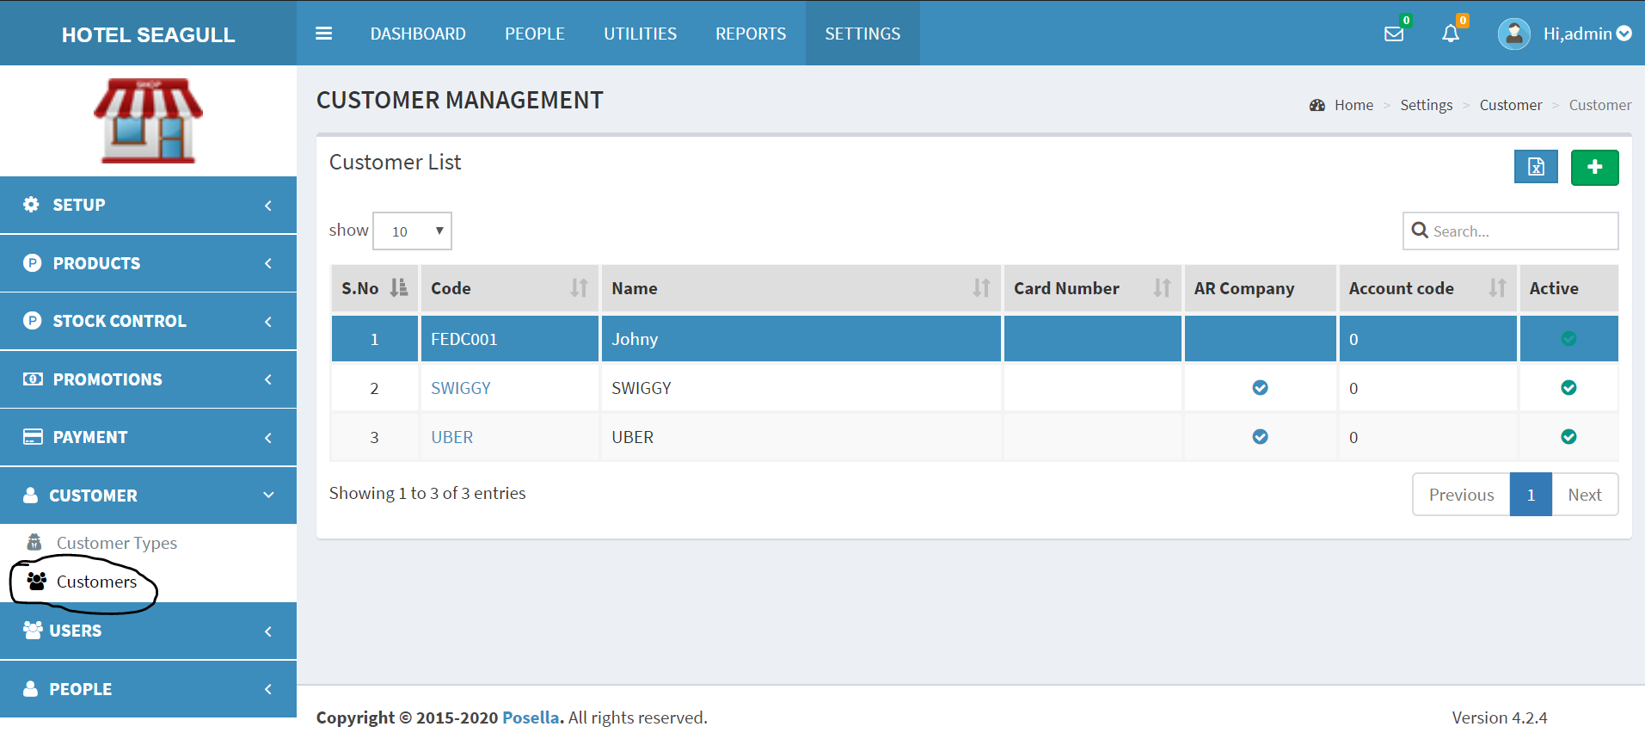

Fig 2.6.2.1 Customer List

Click the  button to add new customer details, a pop up window will come that consists of 4 options- General 1, General 2, Address, Bank Info , under which several details are required to be filled out like the name, type, address, bank informations etc.,

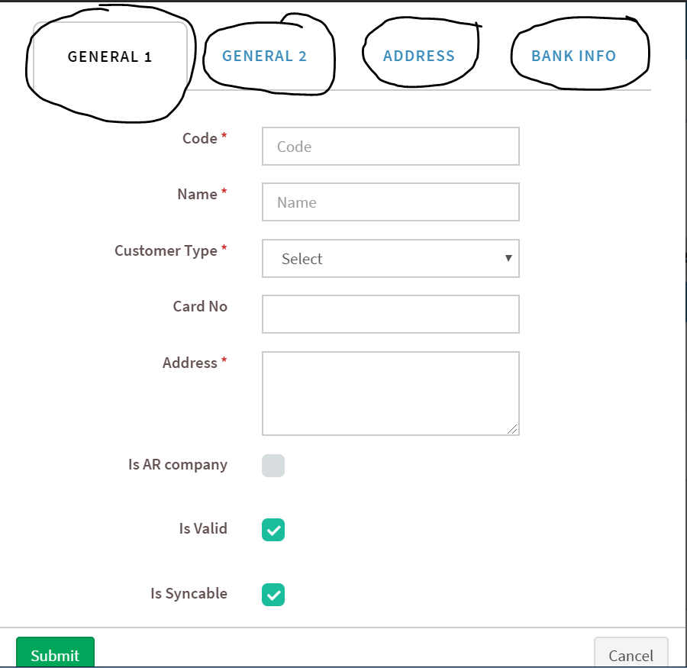

Fig. 2.6.2.2 Customer Details

There is also an export button in the customer page with which we can export a well defined excel report of the customer list. We can also choose the contents that have to be shown in the report.

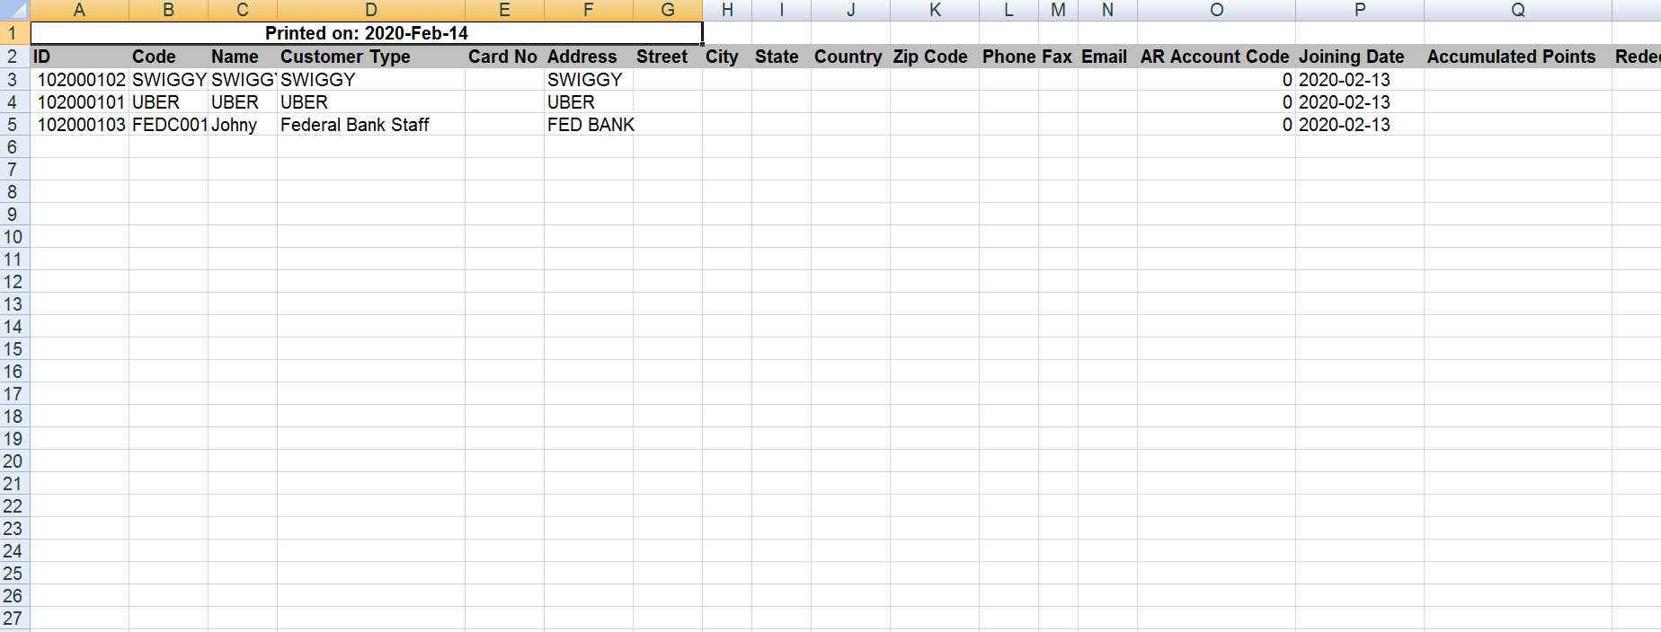

Fig. 2.6.2.3 Customer List Report

### 2.7 USERS

Click the **users** in the settings menu to view the details regarding the users.

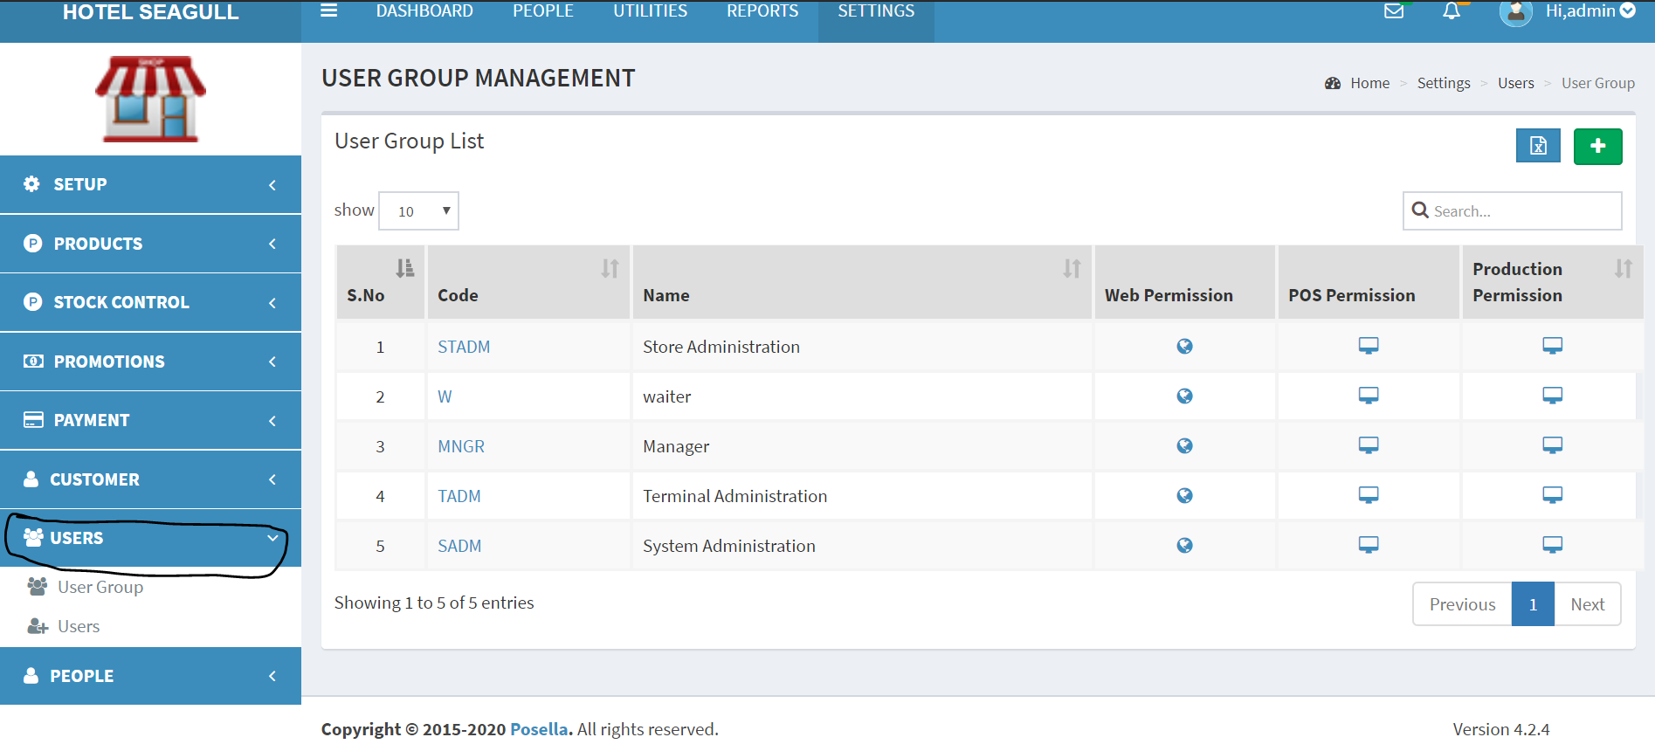

Fig. 2.7.1 Users

2.7.1 USER GROUP

Click the **user group** in the users menu to view the list of the user group. Along with the details like code, name, permissions etc., and we can set certain permissions through this page.

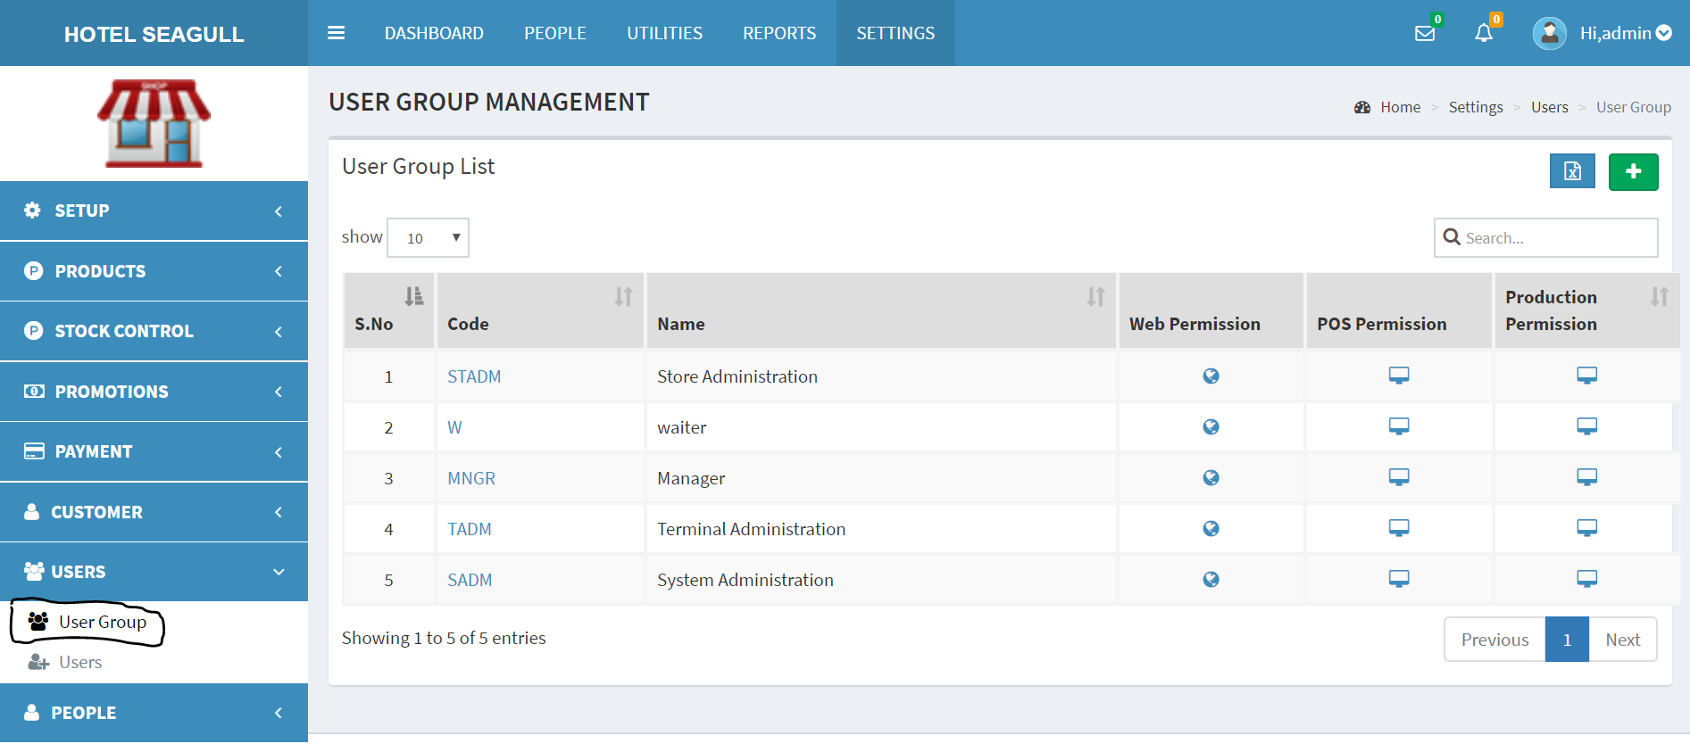

Fig.2.7.1.1 User Group List

Click the  button to add the user group details, which consist of the following details.

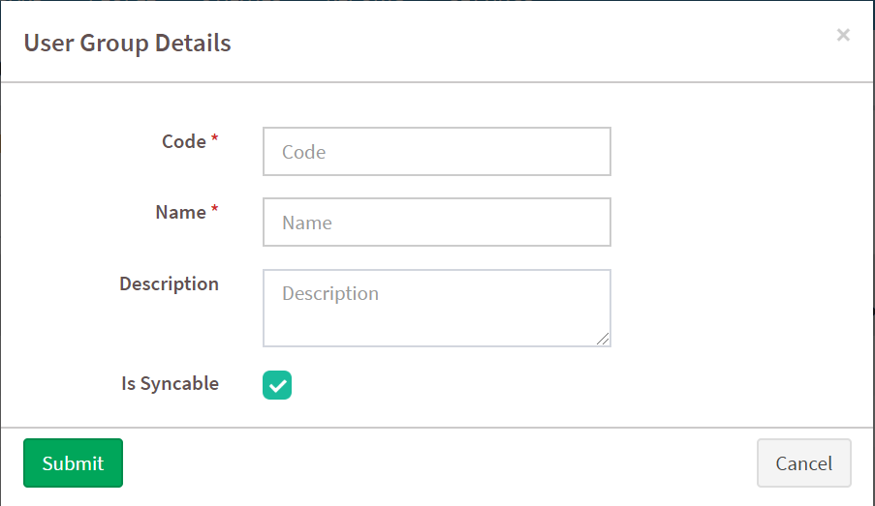

Fig. 2.7.1.2 User Group Details

A pop up will come which will have the required details to be filled out and by clicking the submit button, it will save the user group details. There is also an (export) button , which will export a well defined excel report of the user group list. We can also choose the contents that have to be shown in the report using the required fields.

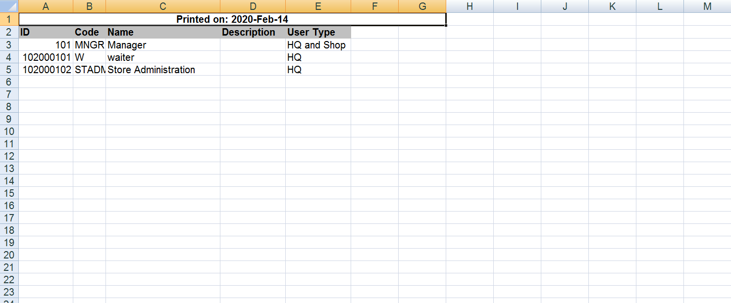

Fig. 2.7.1.3 User Group Report

In the user group we can set the permissions for each group based on the requirements. And it will ensure more security.There is WEB permission, POS permission as well as Production permission,which will allow the admin to set certain permissions to the users as well as other persons who are using the system.

#### 2.7.2 USERS

Click the **users** in the user menu to view the list of the users, with details like name, group name, status, card number etc.,Here we can also view the status of the user, i.e., active or not.We can set the status of a user by clicking the corresponding user.

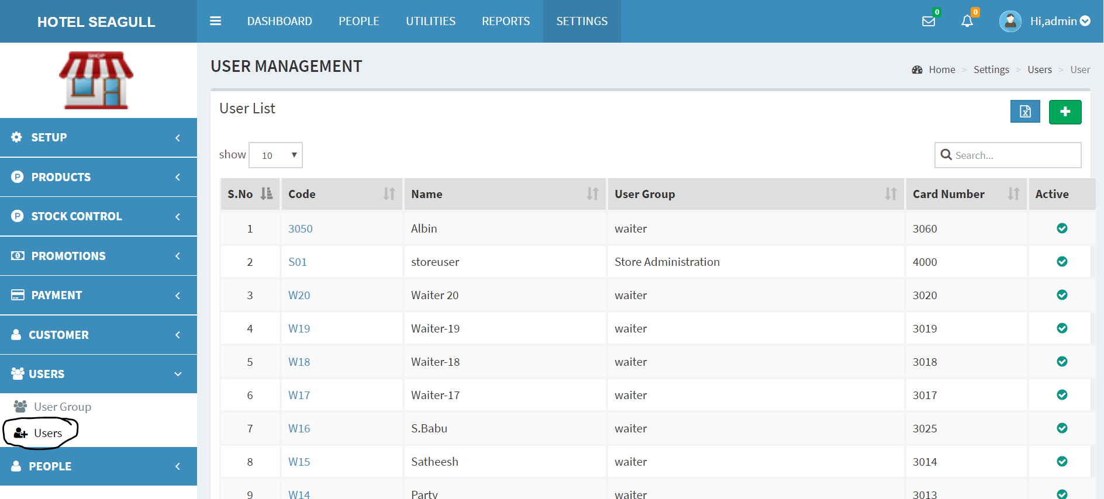

Fig.2.7.2.1 User List

Click the  button to add new user details, a pop up window will come which consist of the details like code, group name,email id password etc., which is to be filled out and then click the submit button to save the user details.

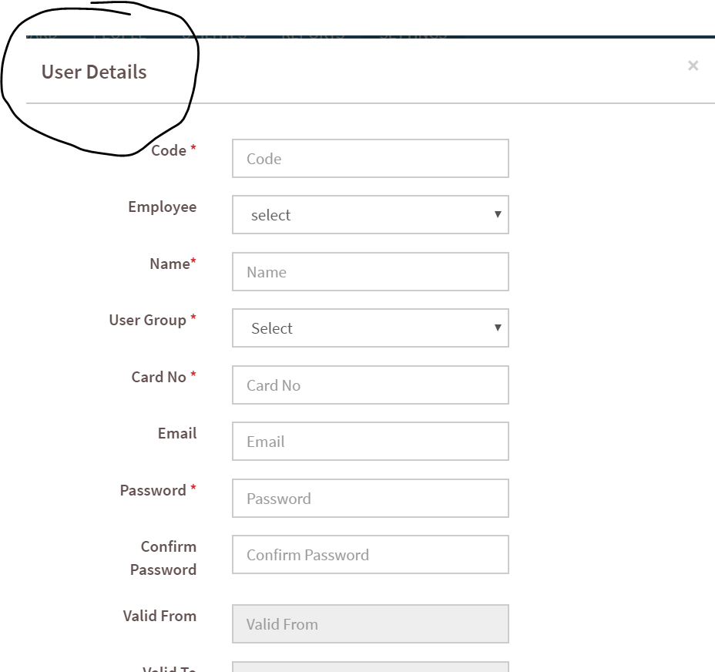

Fig.2.7.2.2 User Details

There is also an (export) button which will export a well defined excel report of the users list. We can also choose the contents that have to be shown in the report using the required fields provided.

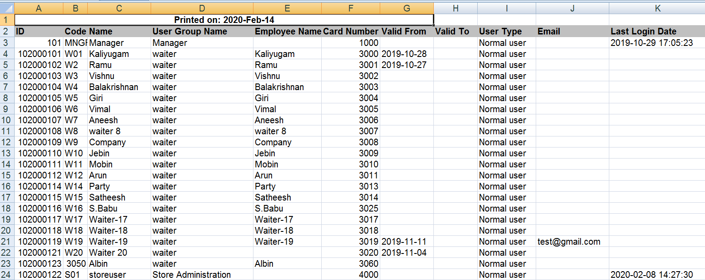

Fig. 2.7.2.3 User List Report

### 2.8 PEOPLE

Click the **people** in the settings menu to view the details regarding the employees, shift details etc.,

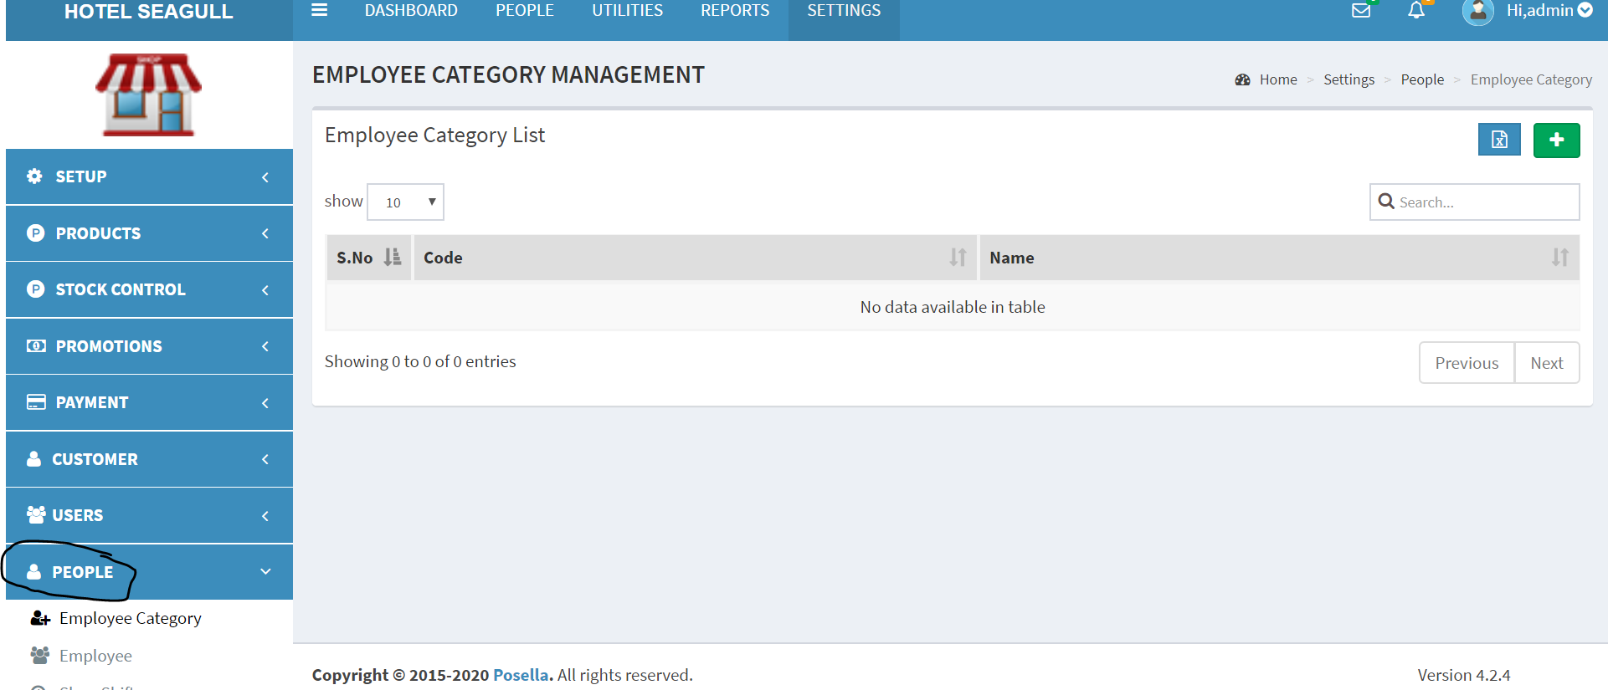

Fig. 2.8.1 People

#### 2.8.1 EMPLOYEE CATEGORY

Click the **Employee Category** in the People menu to view the Employee Category List.

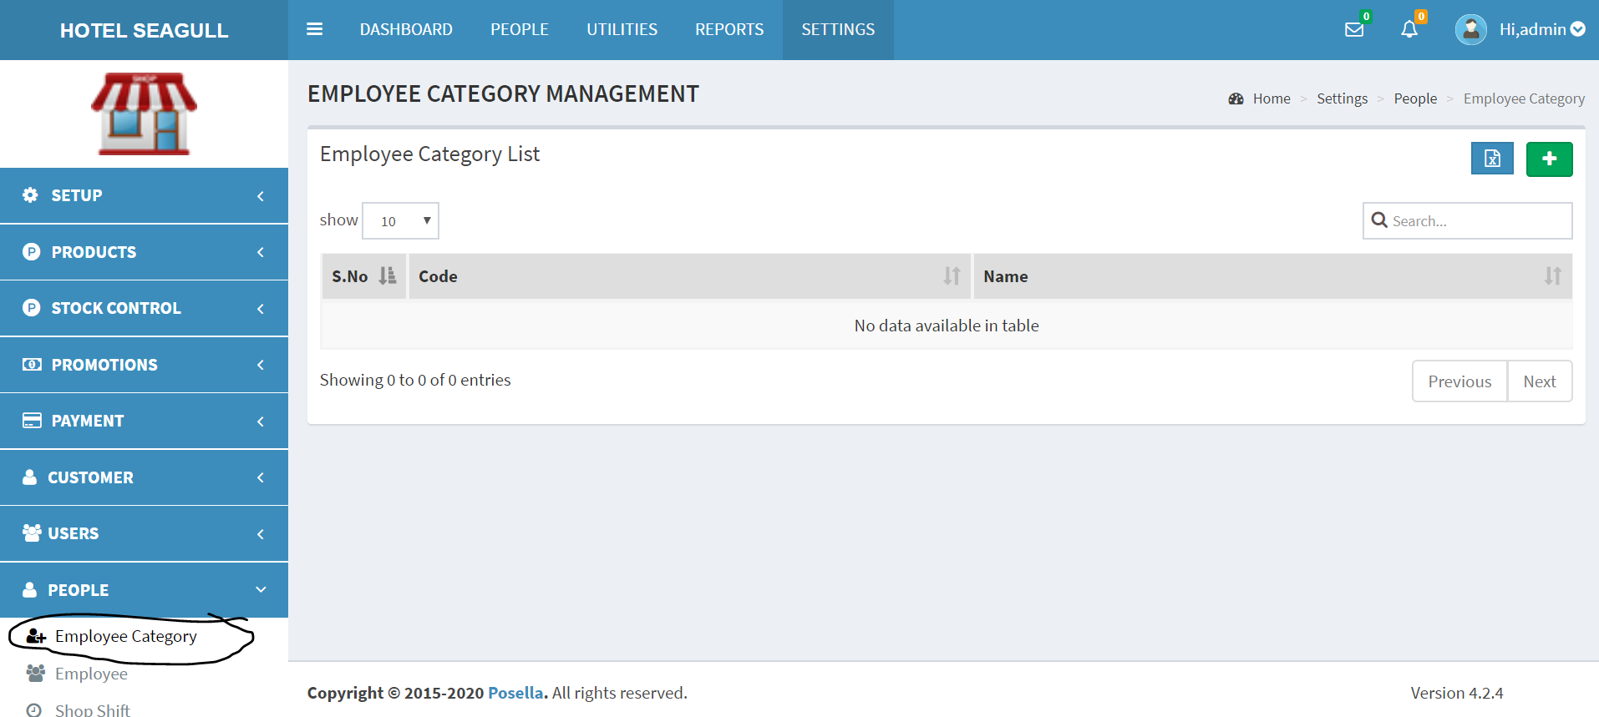

Fig.2.8.1.1 Employee Category List

Click the  button to add the Employee Category Details, a pop up will appear which contains the details like code, name etc., which has to be filled out.

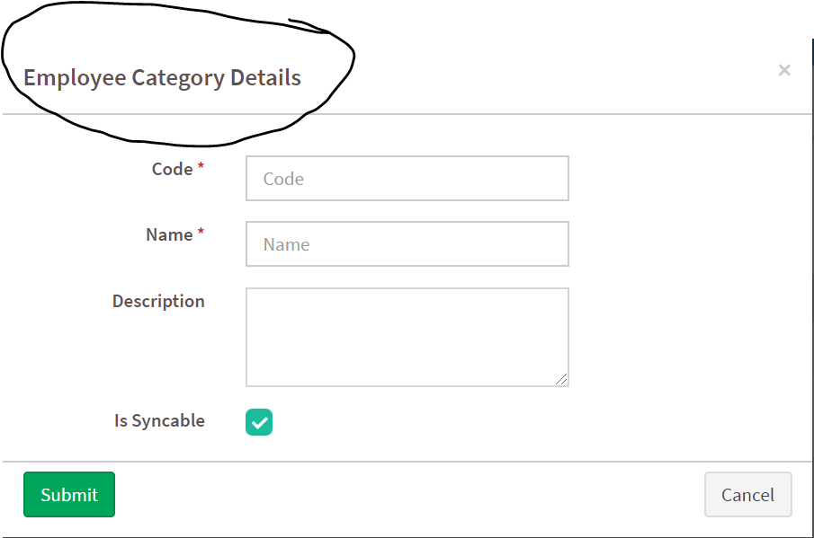

Fig.2.8.1.2 Employee Category Details

There is also an (export) button, which will export the report in a well defined excel format of the employee category list. We can also choose the contents that have to be shown in the report using the required fields.

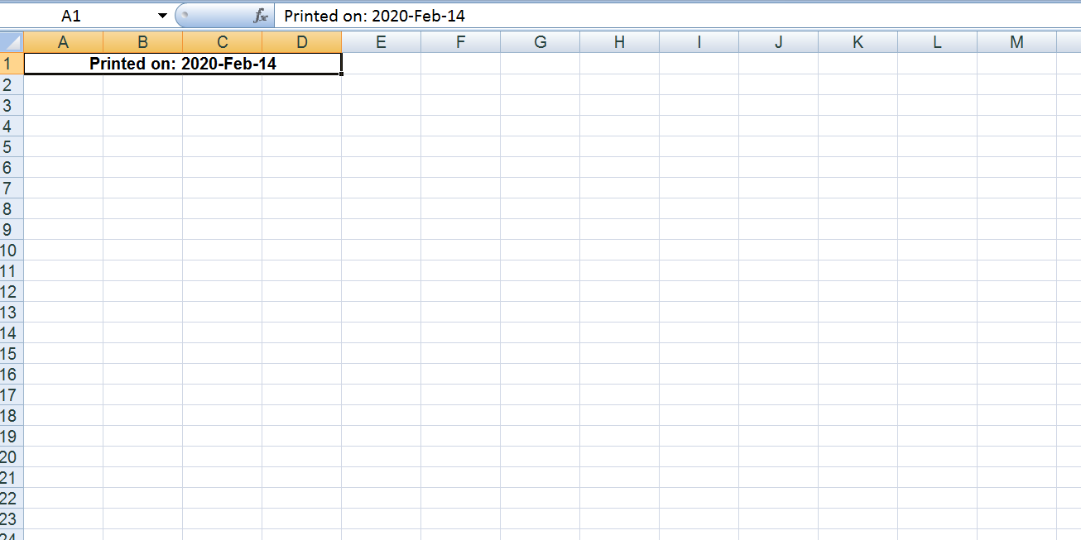

Fig.2.8.1.3 Report of Employee Category List

#### 2.8.2 EMPLOYEE

Click the **employee** in the people menu to view the employee list, which consists of the name, date of birth, gender, cost per hour, status etc., of the employees.

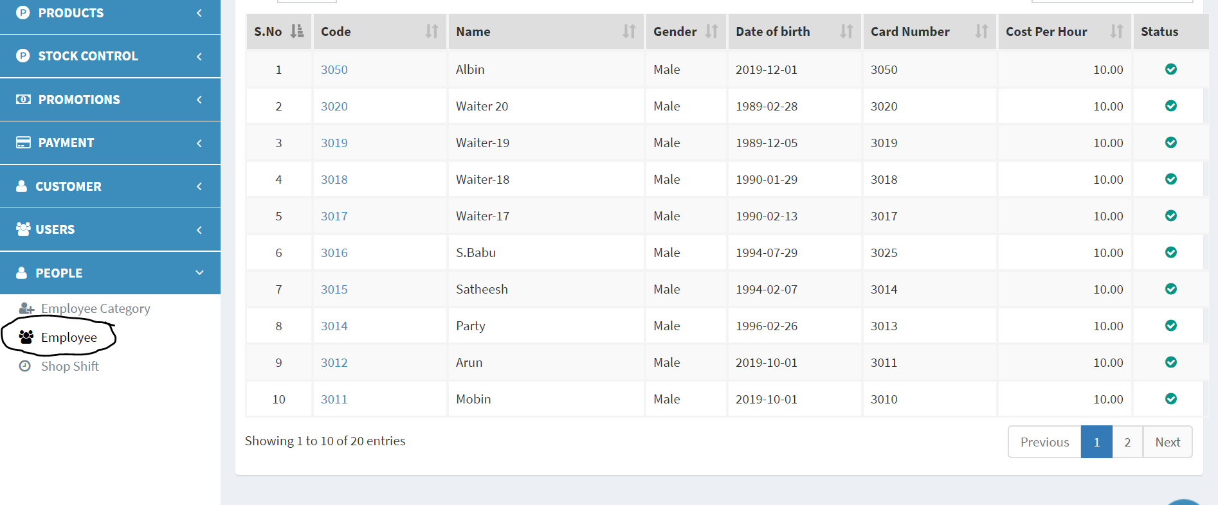

Fig.2.8.2.1 Employee list

Click the  button to add the new employee details,a pop up window will appear which contains 3 parts - General, Job, Personnel, and we have to fill the details like name, dob, gender, date of joining, address, mobile number etc., and then click the submit button to save the new employee details.There is also a search bar by which we can find an employee and edit the details.

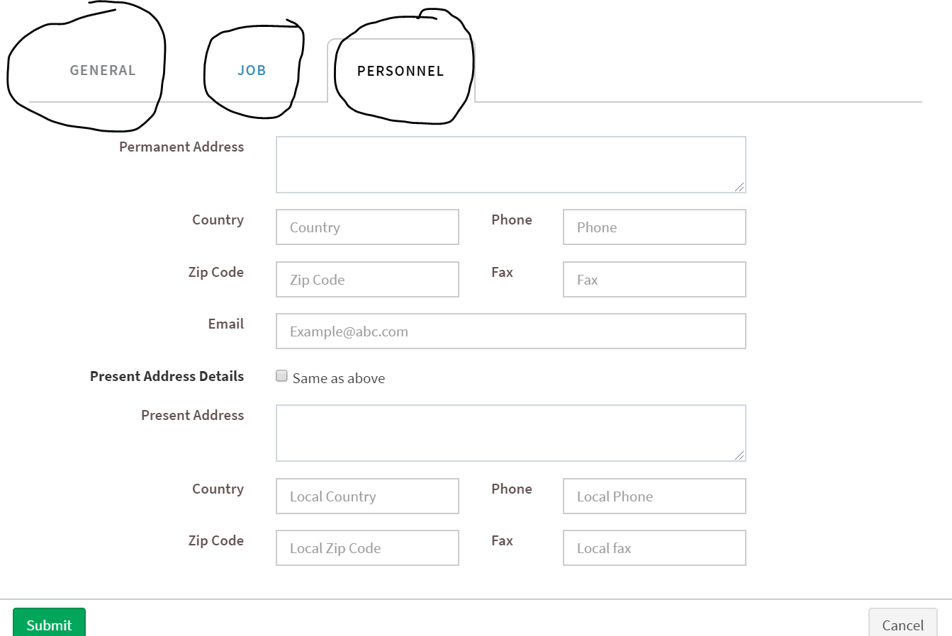

Fig.2.8.2.2 Employee Details

There is an (export) button with which we can export a well defined excel report of the employee details list.We can also choose the contents that have to be shown in the report using the required fields.

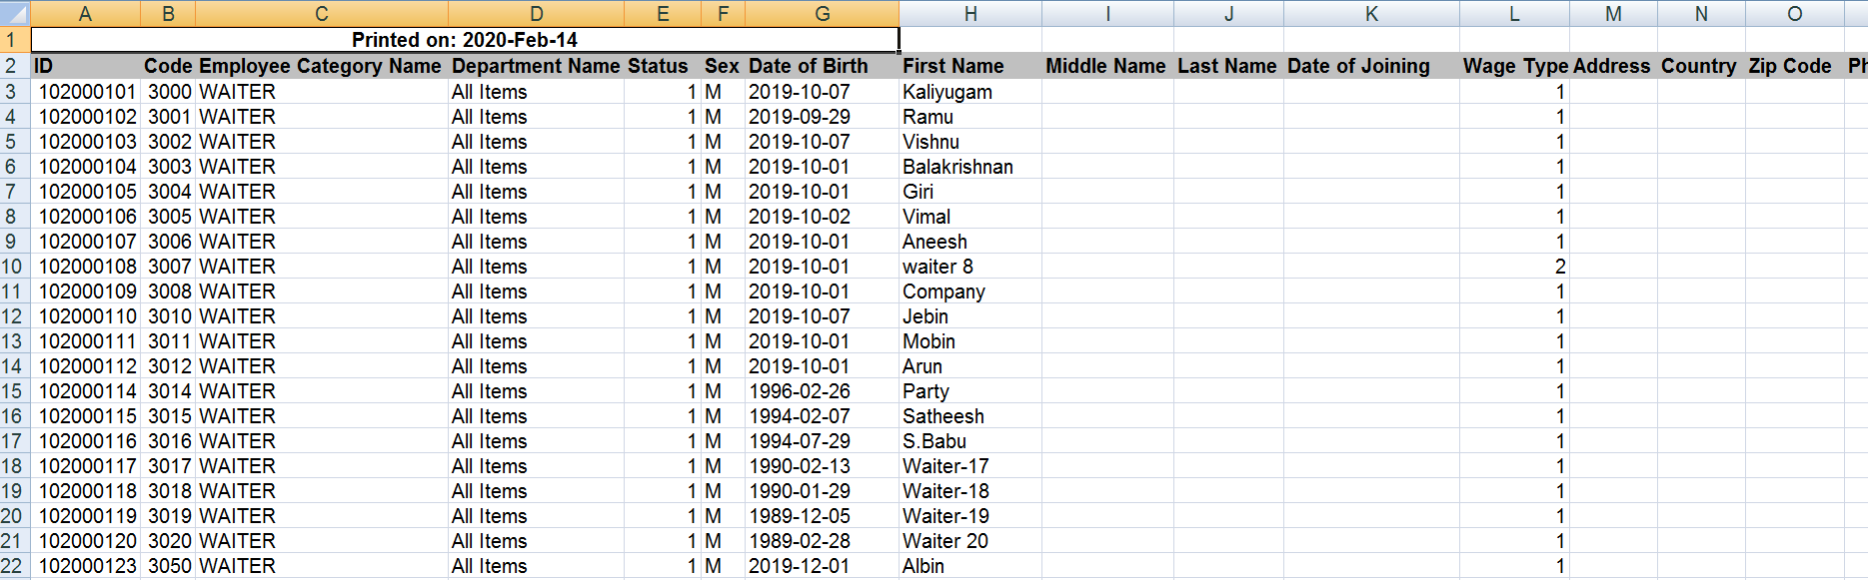

Fig.2.8.2.3 Report of Employee Details list

#### 2.8.3 SHOP SHIFT

Click the **shop shift** in the people menu to view the shop shift list that contains details like name,shift type, start and end time, status etc.This will describe the shift of the employees.

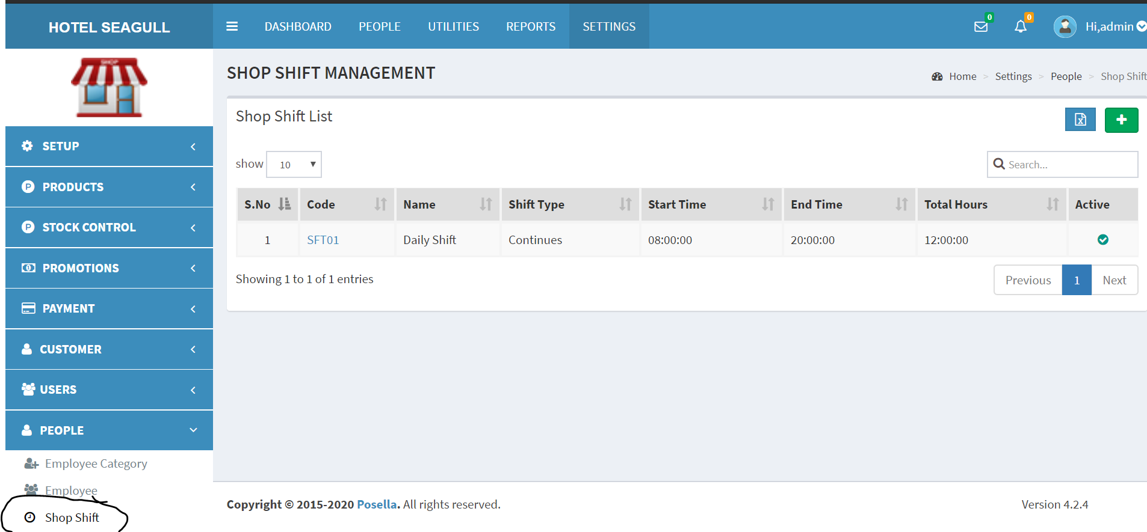

Fig.2.8.3.1 Shop Shift List

Click the  button to add new shop shift details, a pop up window will appear that contains two parts - General, Time schedule and we have to fill out the details like name, shift type, start and end time etc., and then click the submit button to save the shop shift details.There is also a search bar by which we can search a shift and make appropriate modifications.There is also an (export) button which will export a well defined excel report of the shop shift list.We can also choose the contents that have to be shown in the report using the required fields.

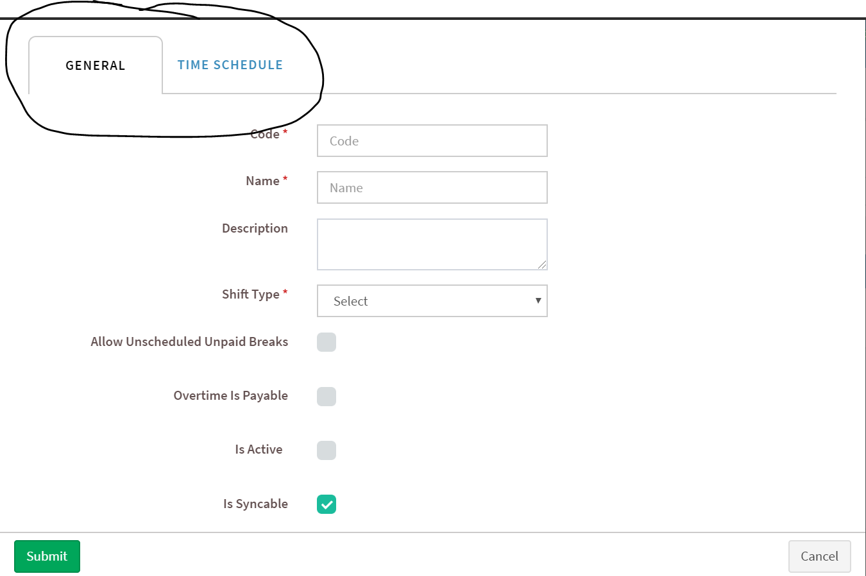

Fig.2.8.3.1 Shop Shift Details

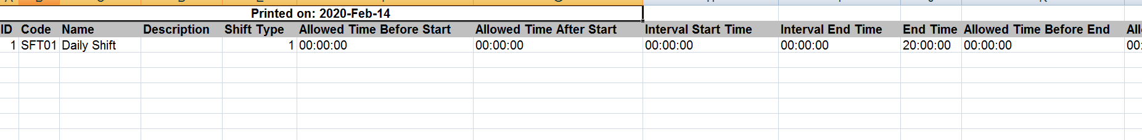

Fig.2.8.3.2 Report of Shop shift List

## **3. REPORTS**

After logging to the dashboard click the Reports menu to view the different reports as per our need.

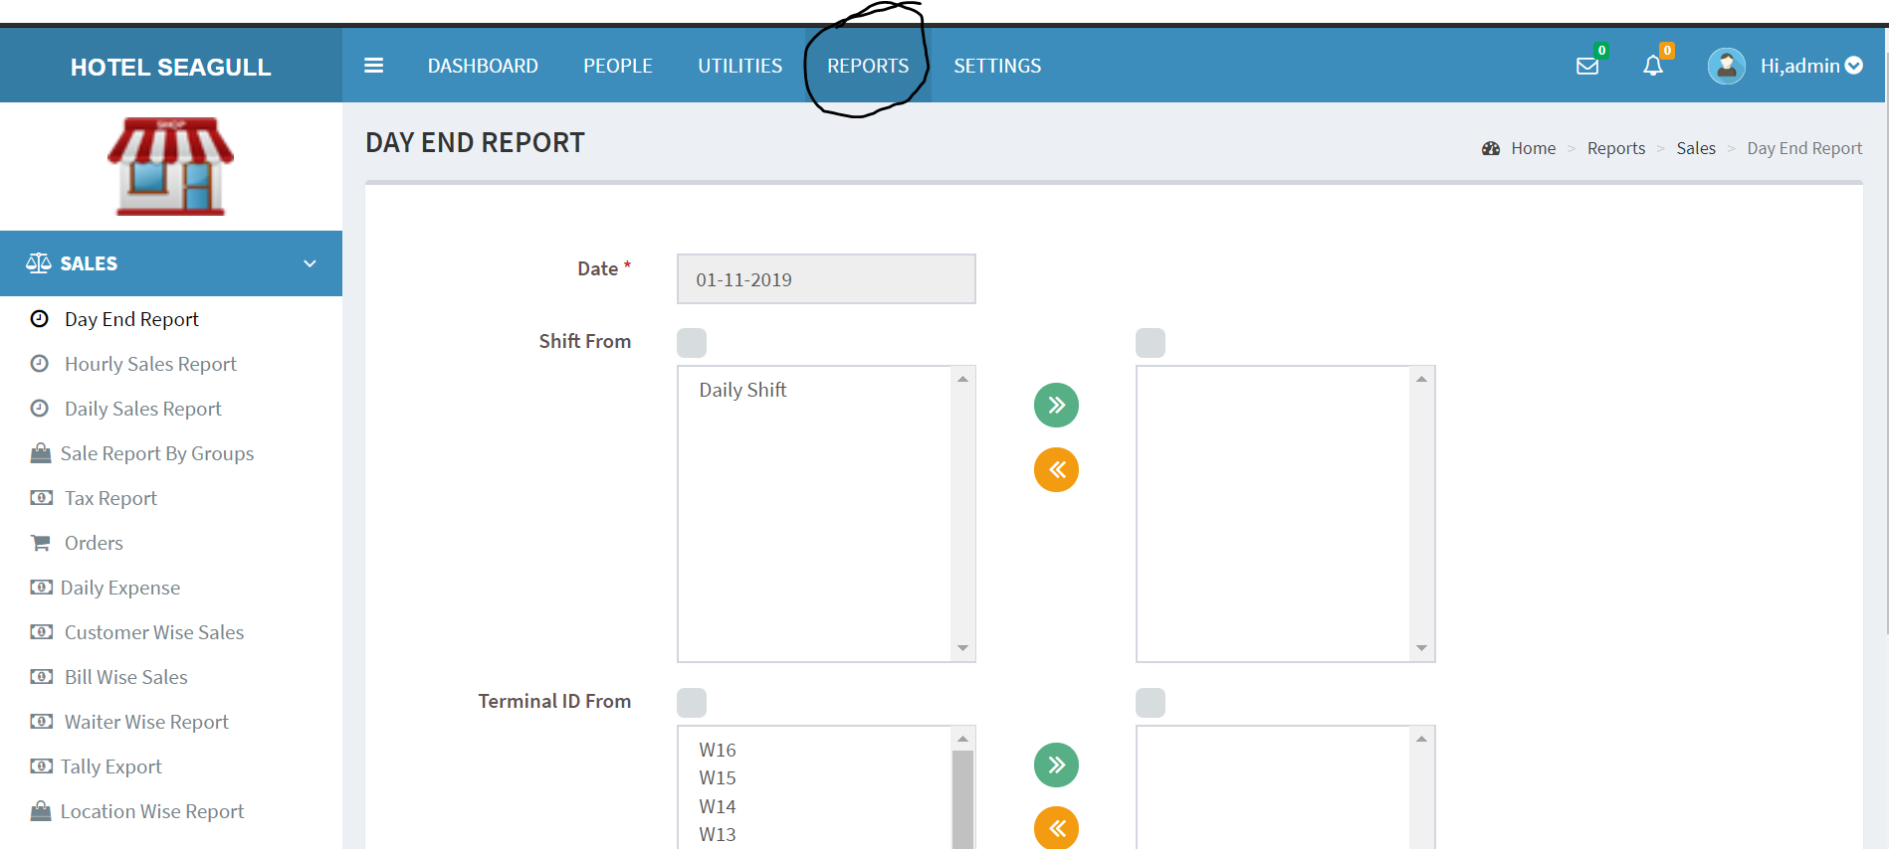

Fig. 3.1 Reports

### 3.1 DAY END REPORT

Click the **Day End Report** in the reports menu to view the end of the day report of the institution, that contains the date, shift details, id etc.,

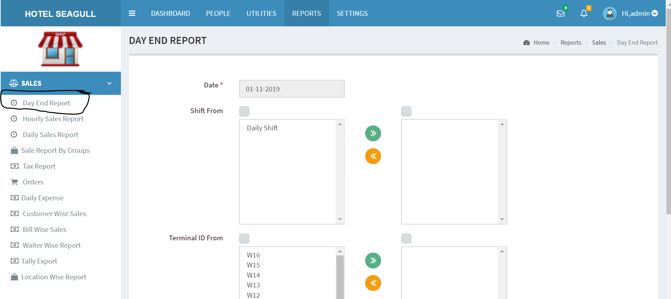

Fig.3.1.1 Day End Report

By clicking the **submit** button after providing the necessary details, we will get the end of the day report in a well defined excel format, which will contain the details about the day end sales that had happened at different terminals,by different cashiers.We can obtain the report based on our requirements, i.e., by providing the required details.

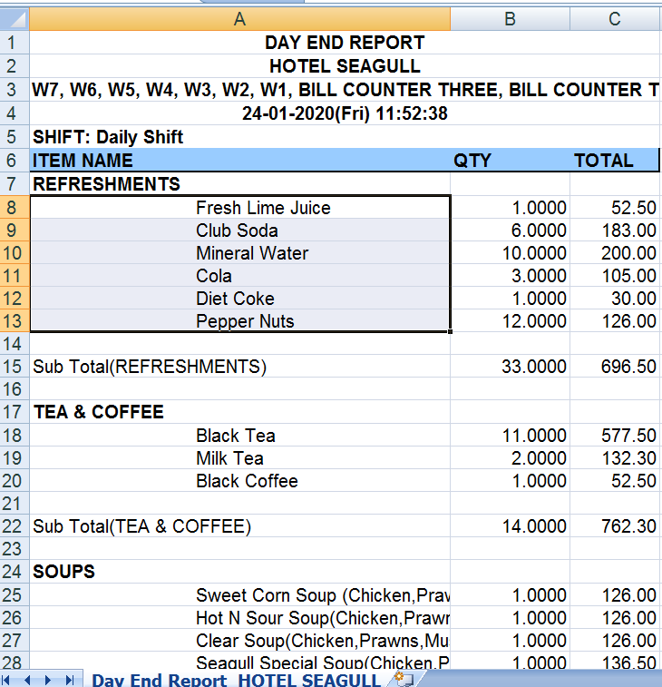

Fig.3.1.2 Day End Report

### 3.2 HOURLY SALES REPORT

Click the **Hourly Sales Report** in the reports menu to view the hourly sales report of the institution, that contains the date, time etc.,

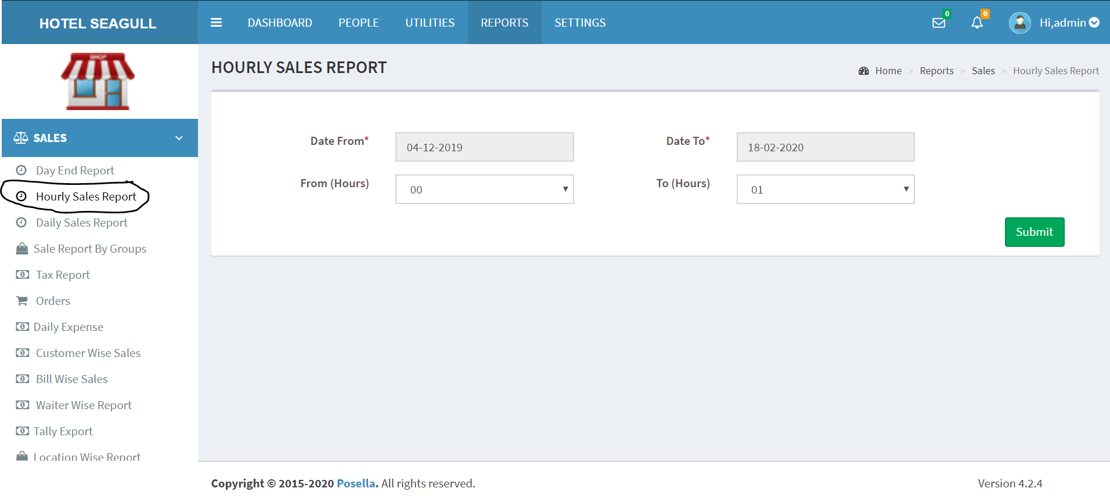

Fig.3.2.1 Hourly Sales Report

After providing the necessary details like the date and time, click the **submit** button to get the hourly sales report in a well defined excel format, which will provide the date, time, total amount, units etc.,

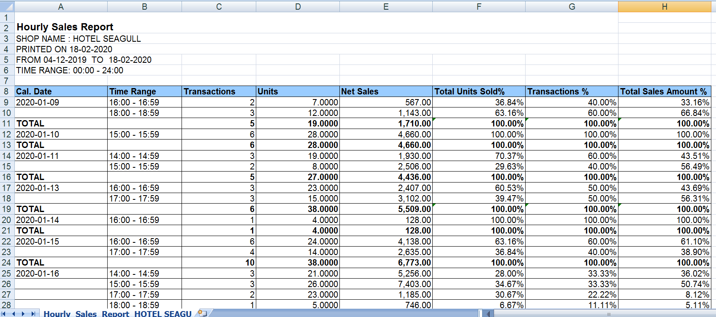

Fig. 3.2.2 Hourly Sales Report

### 3.3 DAILY SALES REPORT

Click the **Daily Sales Report** in the reports menu to view the report of the daily sales, which will give an idea about the daily sales of the institution, which contains details like the date, shift details, id etc.,

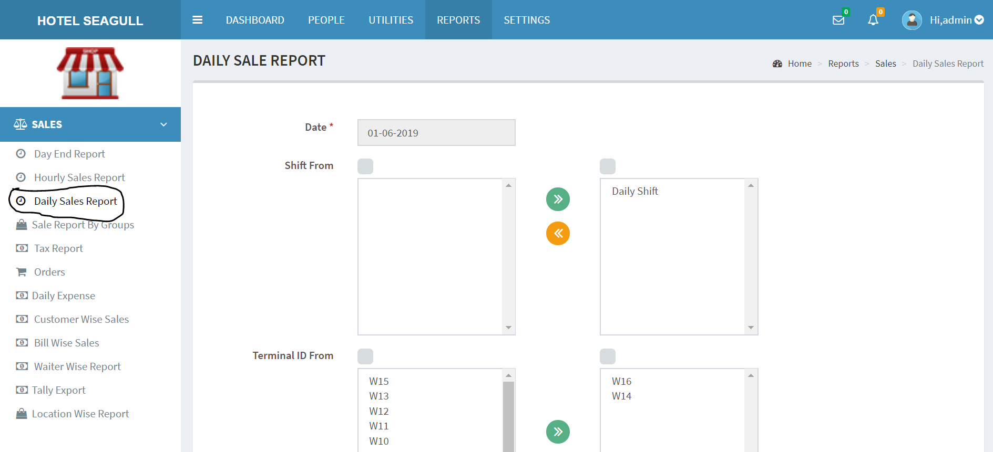

Fig. 3.3.1 Daily Sales Report

By clicking the submit button after providing the required details, we will get the report of the daily sales in a well defined excel format, which will contain the details about the daily sales that had happened at different terminals, by different cashiers. We can obtain the report based on our requirements, i.e., by providing the required details.

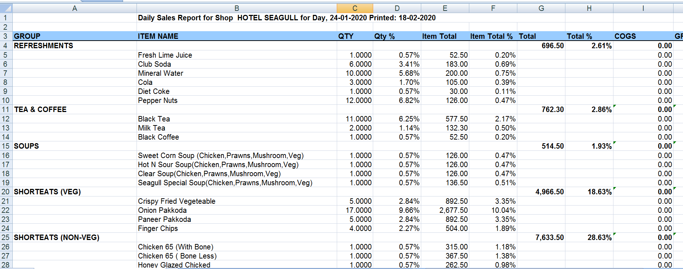

Fig.3.3.2 Daily Sales Report

### 3.4 SALES REPORT BY GROUPS

Click the **Sales Report By Groups** in the reports to view the sales report based on the category of items that were sold.

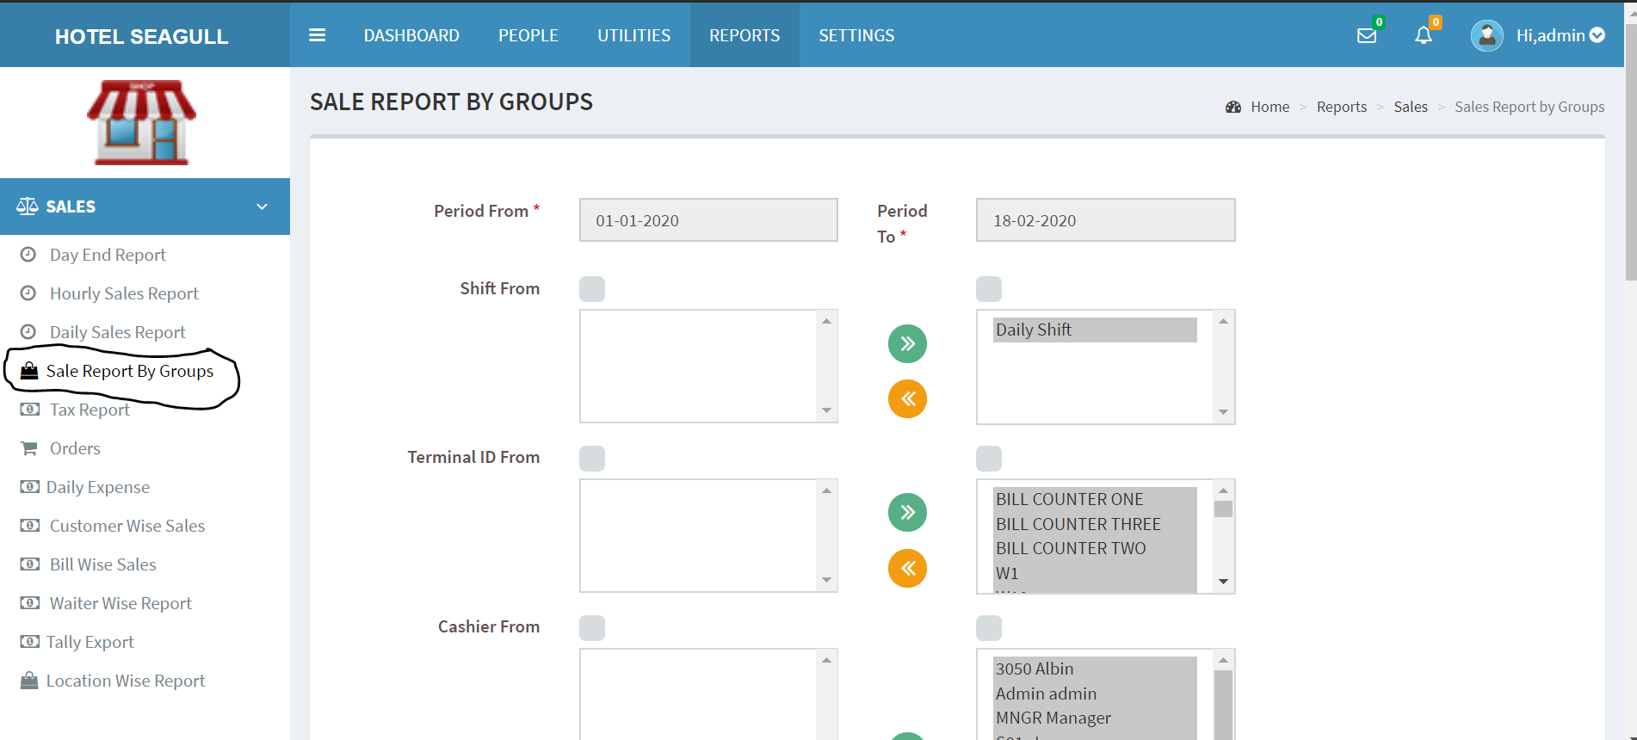

Fig.3.4.1 Sale Report by Groups

Click the **submit** button after providing the required details like the date,terminal id, cashier id, shift details,item groups etc., to get a sales report based on the group of items in a well defined excel format, which will contain the details about the sales that had happened at different terminals, by different cashiers, based on the group of the items that were sold. We can obtain the report based on our requirements, i.e., by providing the necessary details.We can also sort the items and group the items by different means.

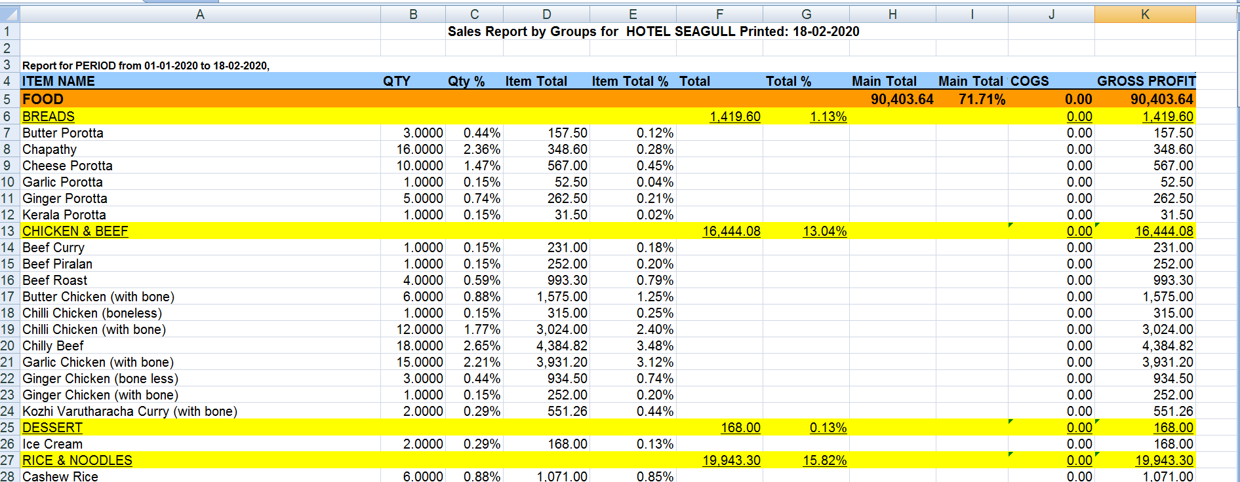

Fig. 3.4.2 Sales Report by Groups

### 3.5 TAX REPORT

Click the **Tax Repor**t in the reports menu to view the details about different taxes and to add them up with the bill to set the total amount.

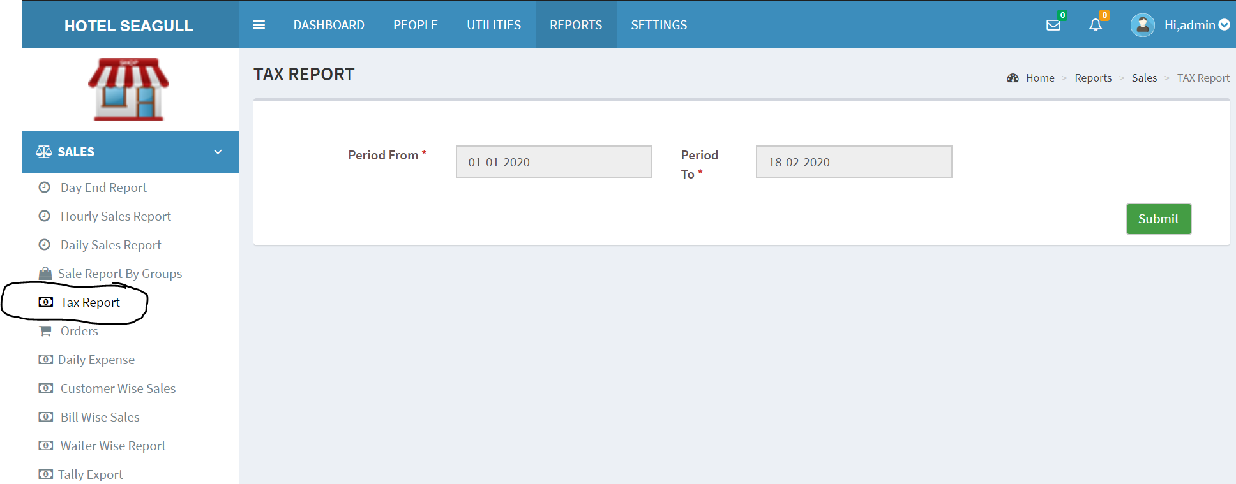

Fig. 3.5.1 Tax Report

Click the **submit** button after providing the dates, to obtain the tax report in a well defined excel format consisting of the details about the taxes, invoice informations, quantity etc., of each sales that had happened and to view the total amount along with the taxes.

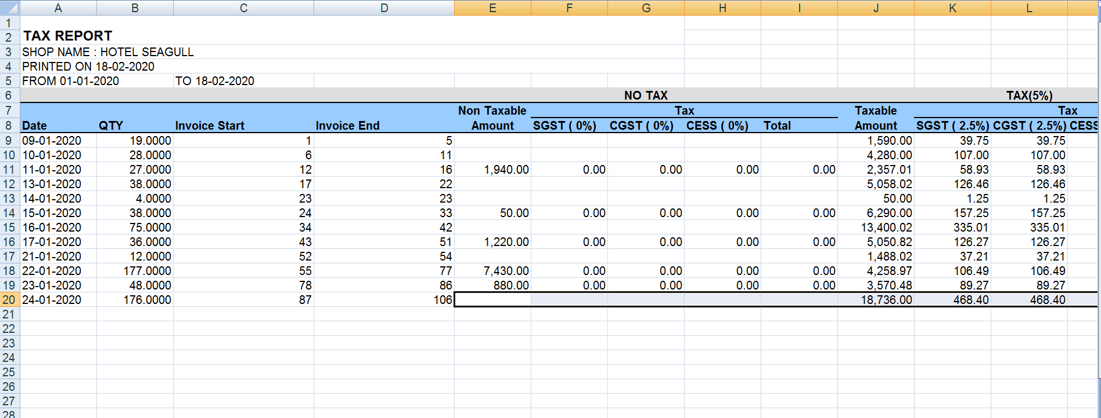

Fig. 3.5.2 Tax Report

### 3.6 ORDERS

Click the **orders** in the report menu to view the list of orders that had happened, with the informations like invoice number, order time, pos date, total amount etc.,

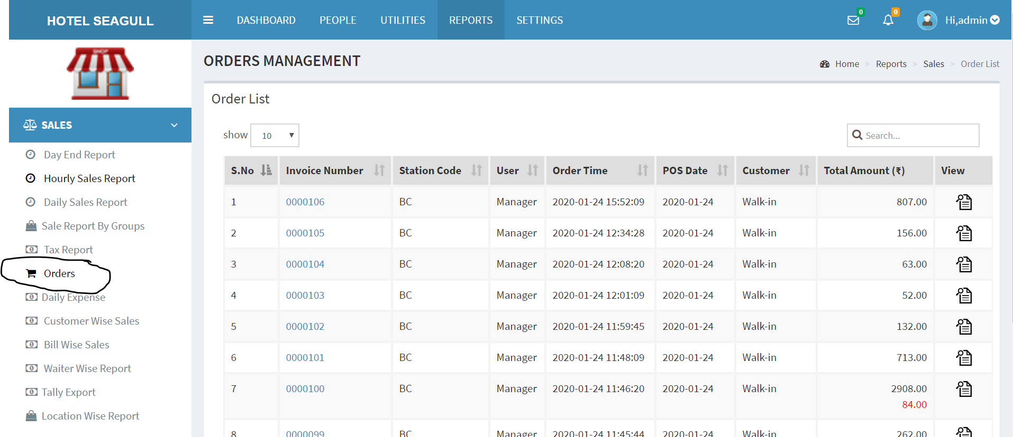

Fig. 3.6.1 Orders

We can view the order summary by clicking the button,a pop up window will appear which will show the items that were ordered, the price, quantity, and the total amount along with taxes.

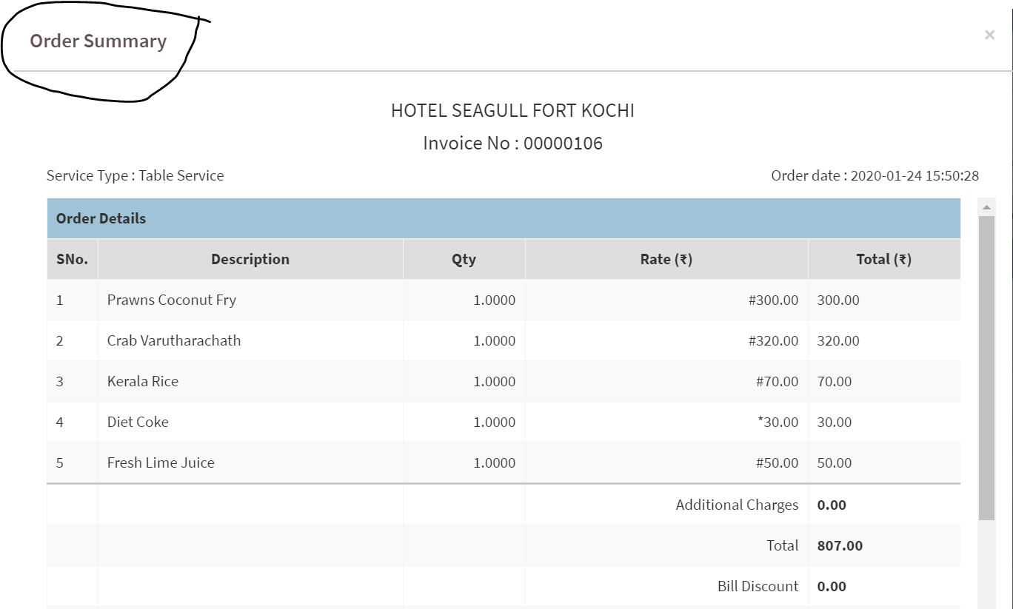

Fig.3.6.2 Order Summary

### 3.7 DAILY EXPENSES

Click the **Daily Expenses** in the reports menu to view the expense details of a particular day, which consist of the details like date, amount spent etc.,

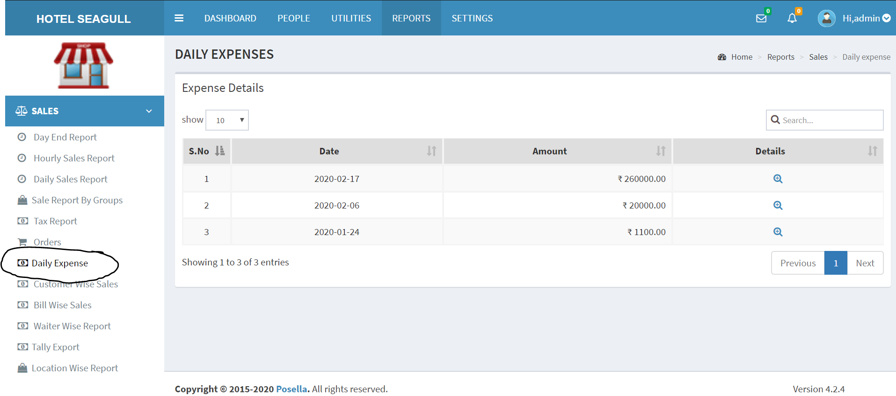

Fig. 3.7.1 Daily Expense

Click the 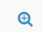 button to view the daily expenses in detail, which has the details like time, Station name, Username,Title,Amount etc.There is also a search bar on the page by which we can find a required value.

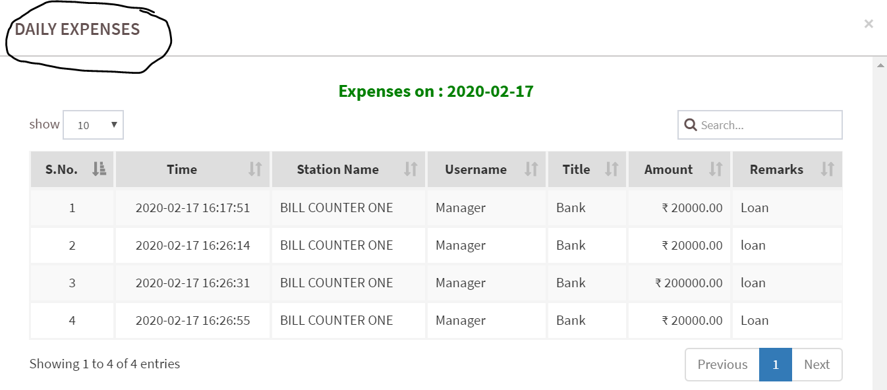

Fig.3.7.2 Daily Expenses in Detail

### 3.8 CUSTOMER WISE SALES

Click the **Customer Wise Sales** in the reports menu to view the sales details based on the customers as well as their payment mode.

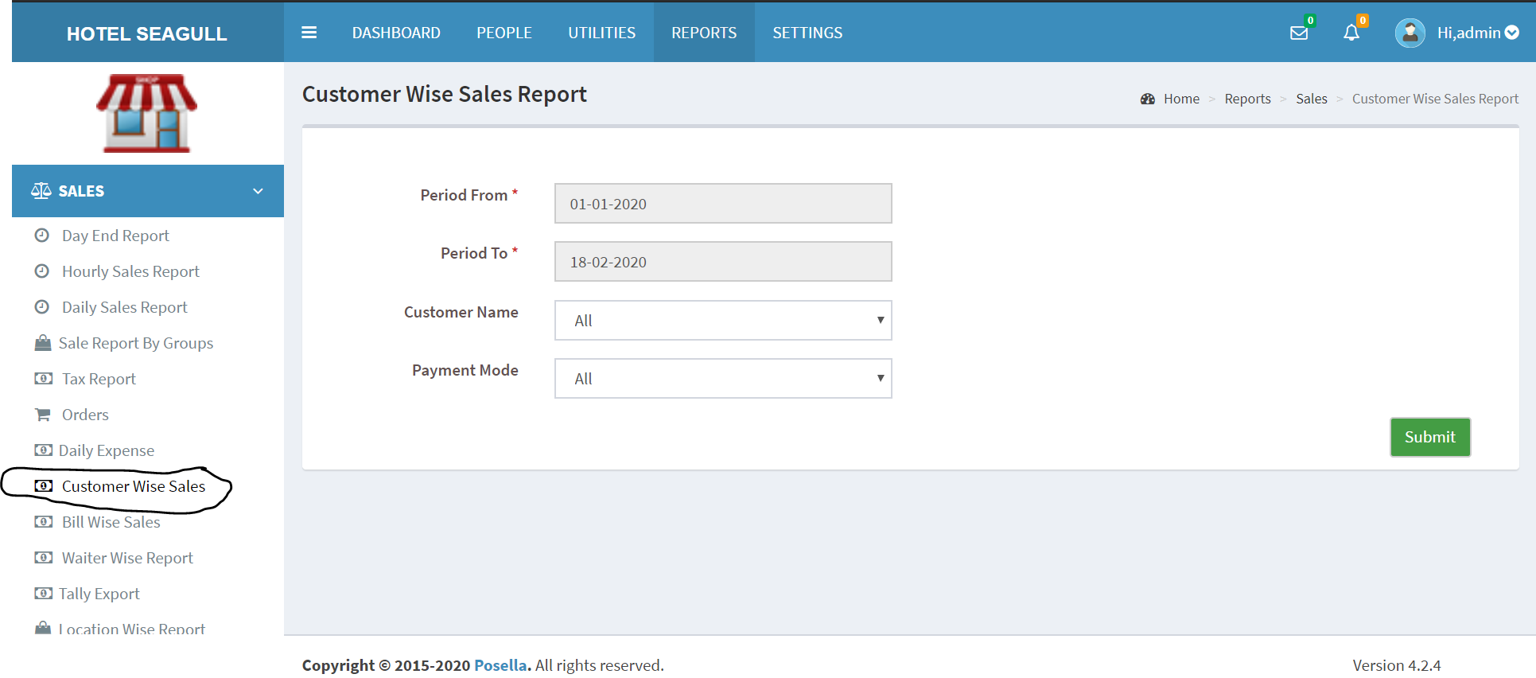

Fig. 3.8.1 Customer Wise Sales

Click the **submit** button after providing the necessary details to get the customer wise sales report in a well defined excel format, which consist of the details like invoice no. Date, Amount, tax, payment mode etc., in between two particular dates given by the user.

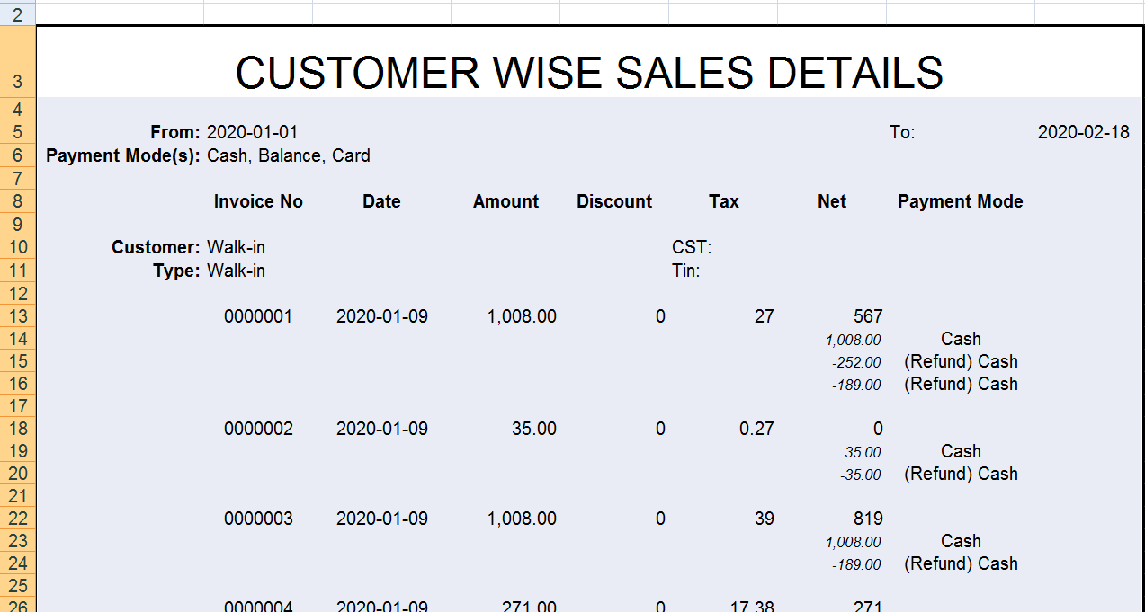

Fig. 3.8.2 Customer Wise Sales Report

### 3.9 BILL WISE SALES

Click the **Bill Wise Sales** in the reports menu to view the Bill Wise Sales report that occurred from a particular date to another.

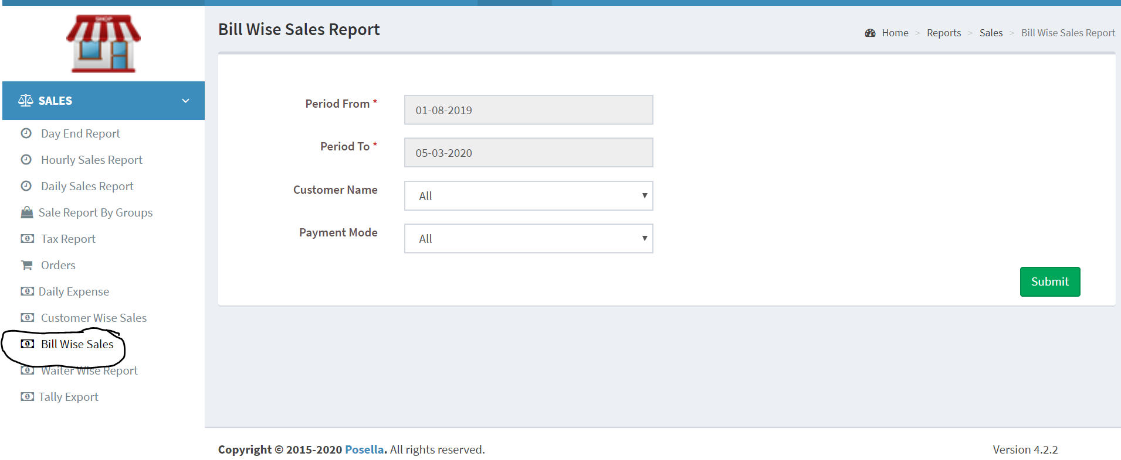

Fig.3.9.1 Bill Wise Sales

We can provide the dates, customer name and payment mode and then click the **submit** button to generate a well defined excel report of the bill wise sales, that consist of the details like Shop name,Printed Date, From Date, To Date, Payment Mode, Amount,,Discount etc.,

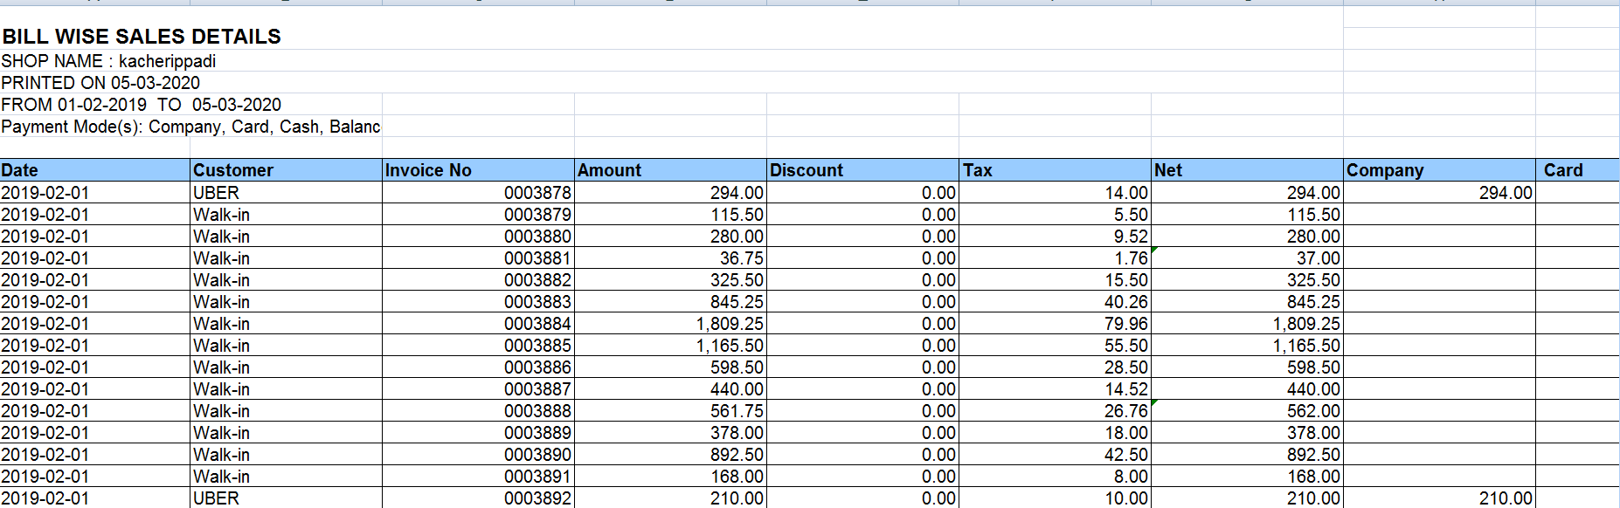

Fig.3.9.2 Bill Wise Sales Report

### 3.10 WAITER WISE REPORT

Click the **Waiter Wise Report** in the reports menu to view the report based on the waiters who served the customers.

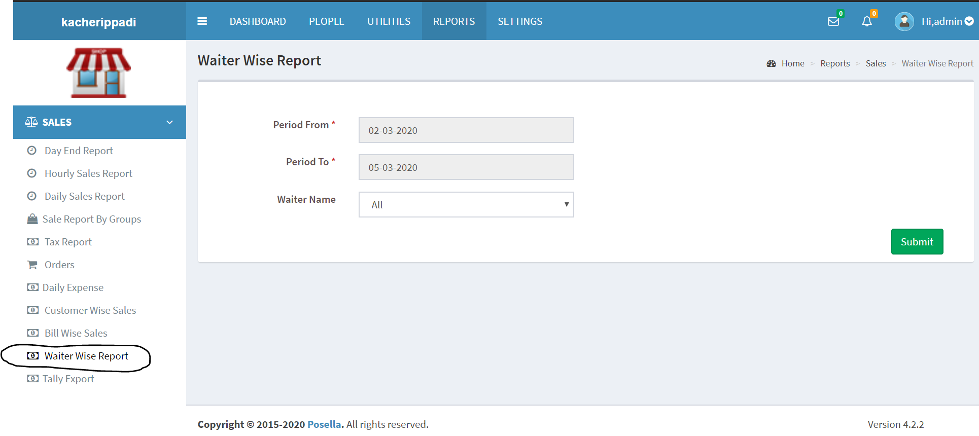

Fig.3.10.1 Waiter Wise Report

Enter the corresponding date, choose the required waiter name and then click the submit button to generate a well defined excel report of the Waiter Wise Sales, that consist of the details like Shop name,Printed Date, From Date, To Date,Tax, NeT Amount etc.,

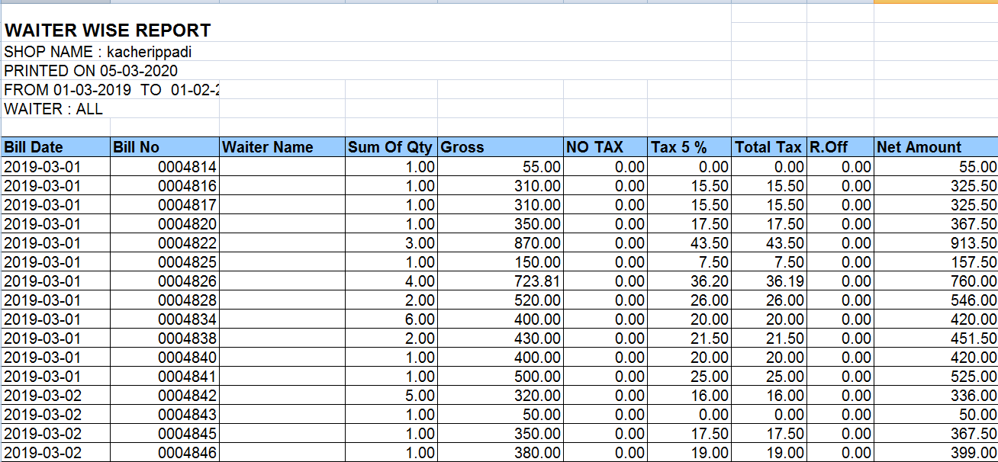

Fig.3.10.2 Waiter Wise Report

### 3.11 TALLY EXPORT

Click the **Tally Export** in the reports menu to view the Tally Report from a particular date to another.

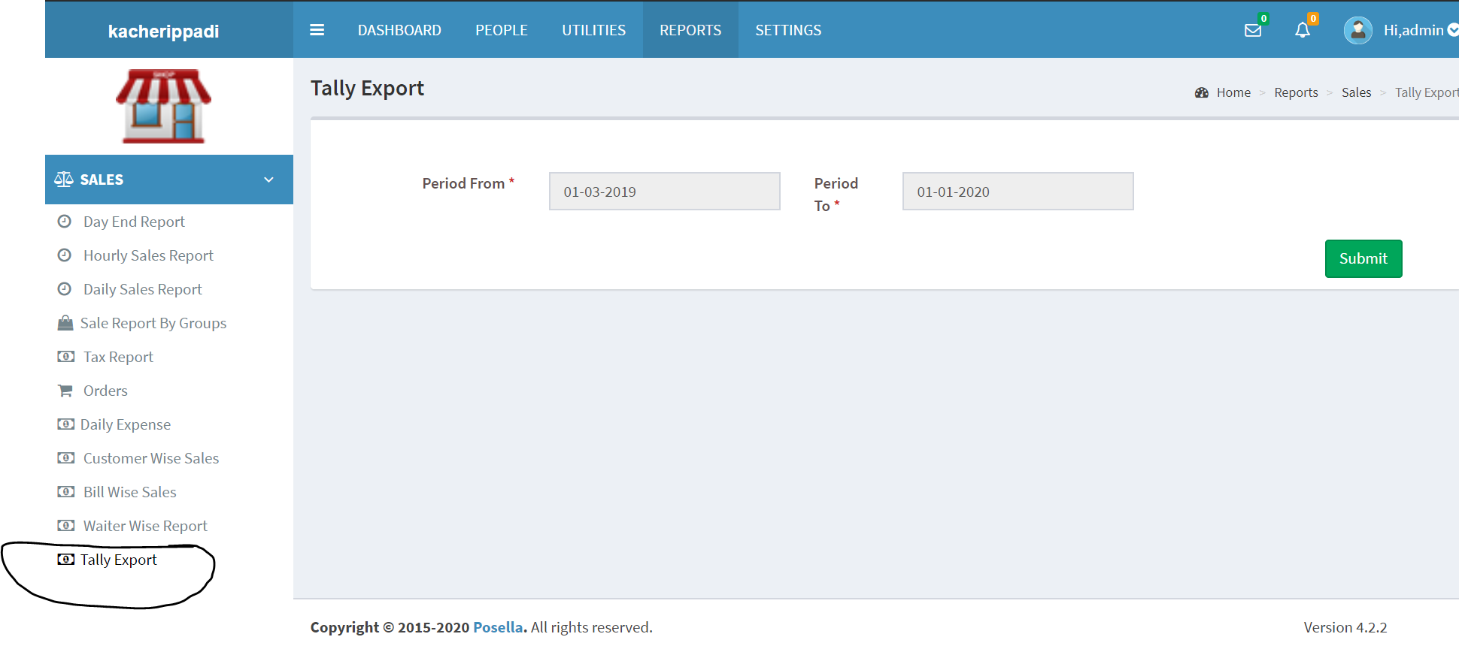

Fig.3.11.1 Tally Export

Enter the required From Date, To Date and Click the **submit** button to view the Tally Report.

### 3.12 LOCATION WISE REPORT

Click the **Location Wise Report** in the reports menu to view the report based on location wise.We can choose the Shift List, Cashier List, Waiter List, Group List etc., and select the location list through this page to generate the corresponding report.

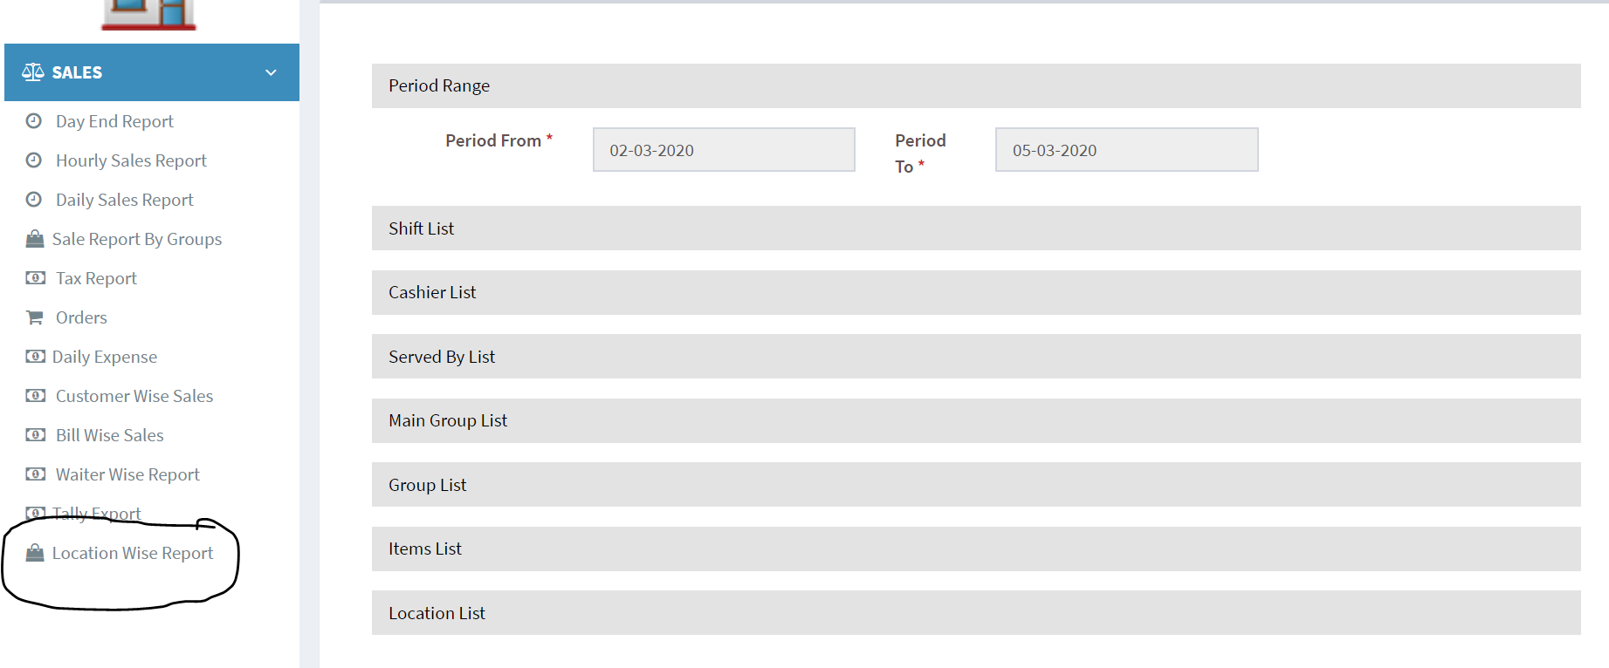

Fig.3.12.1 Location Wise Report

Enter the Shift List, Cashier List, Waiter List, Group List etc., and select the location list and click the **submit** button to generate a well defined excel report of the location wise sales.

We can group the report as well as sort the report based on our needs.

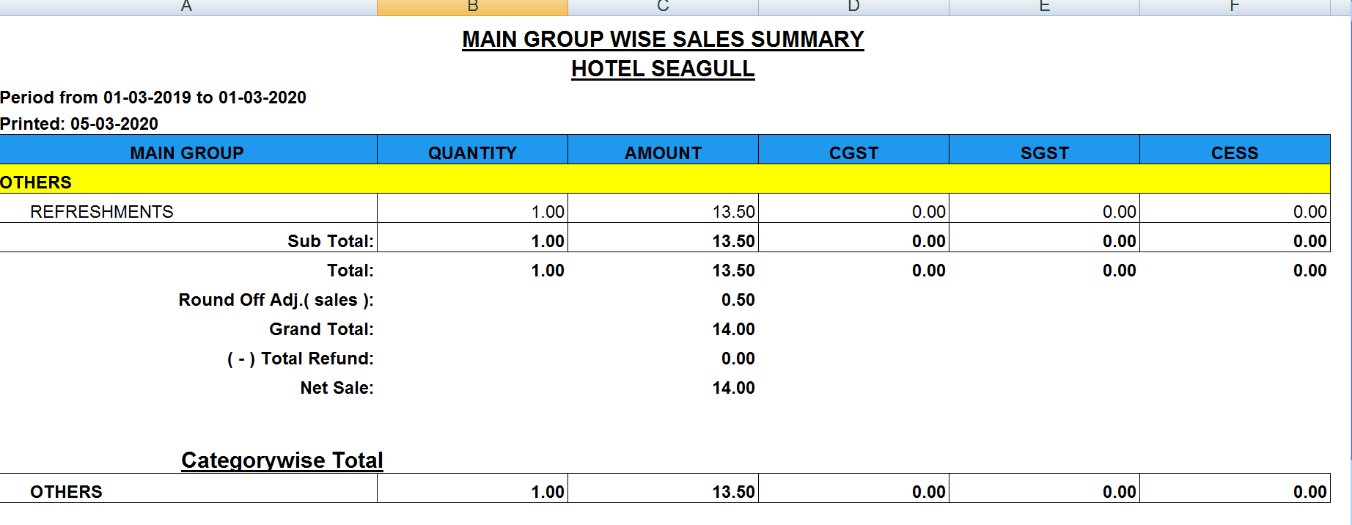

Fig.3.12.2 Location Wise Report

## **4. UTILITIES**

After logging to the dashboard click the **Utilities** menu to view the Shop Target and Table Location.

### 4.1 SHOP TARGET

Click the **Shop Target** in the utilities menu to set the sales Target of the shop for a particular year.

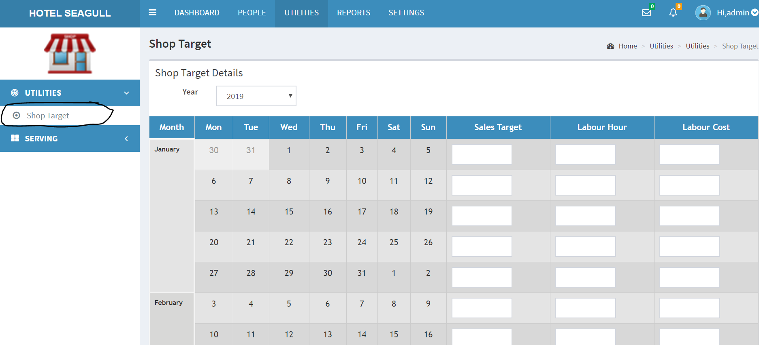

Fig.4.1.1 Shop Target

In the Shop target we can set the target that a shop wanted to achieve in a particular year. We can provide the Labour Hour and the Labour Cost and thereby checking the Sales Target of a particular month.We have to provide the sales target, labour cost and labour hour of each month of a particular year and then click the **update** button to view the corresponding details.

### 4.2 TABLE LOCATION

Click the **Table Location** from the serving menu to view the details regarding the table locations that are available in the shop.

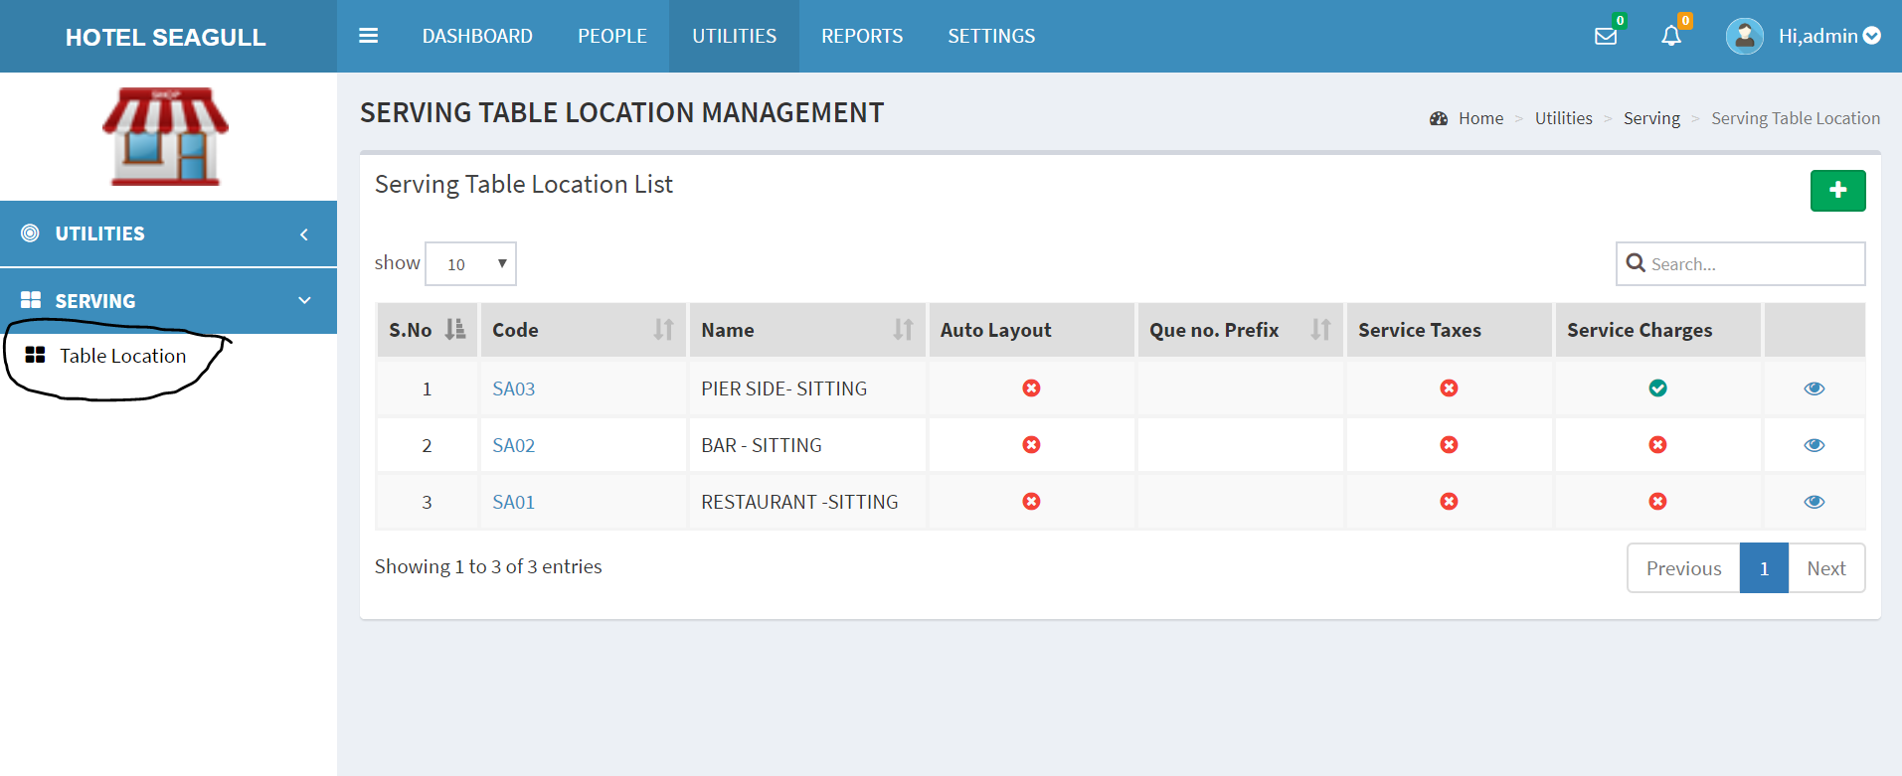

Fig.4.2.1 Serving Table Location Management

The cost of foods may increase from the normal rate if a particular location is chosen, and that cost must be added along with the bill to finalize the total amount.We can click the (view) button to view the arrangement of tables in a particular location

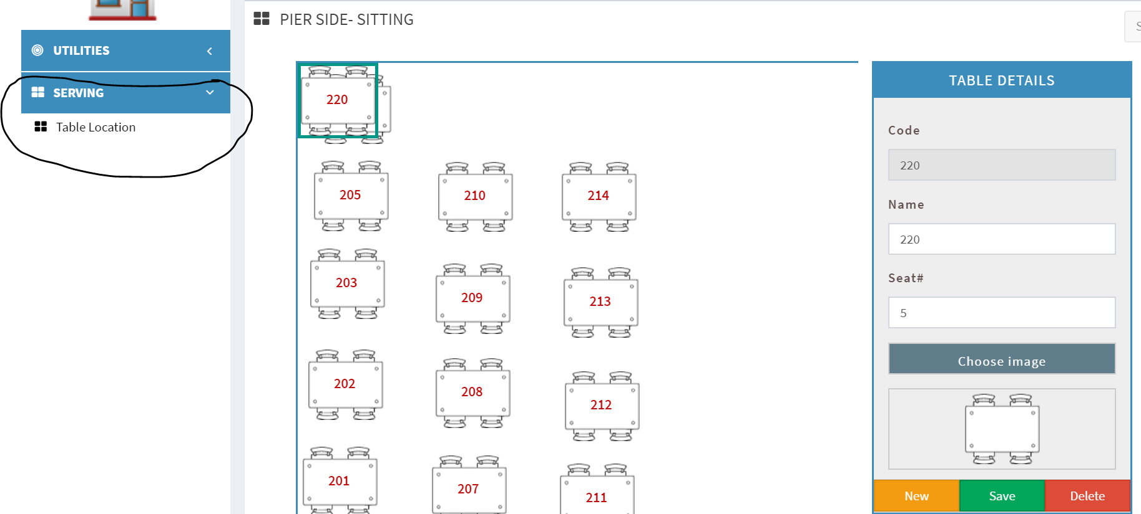

Fig.4.2.2 Pier Side Sitting Table Arrangement Details

We can even add a new location by clicking the  button, a pop up window will appear along with details like name, description, service charge, service tax, etc., we need to fill the required details and click the **submit** button to add a new location.

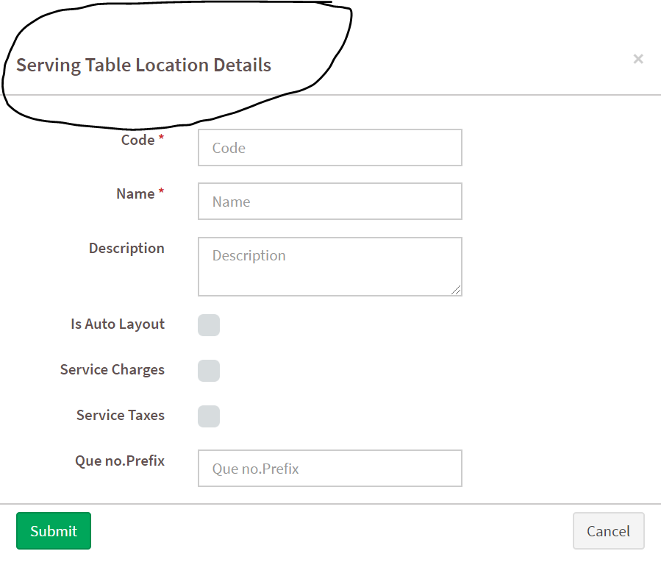

Fig. 4.2.3 Table Location Details

Here there is a Que no. prefix field, which is required to provide an idea about the location by giving a necessary prefix word along with the queue number, and thereby avoiding confusion in the kitchen on where the order was placed.